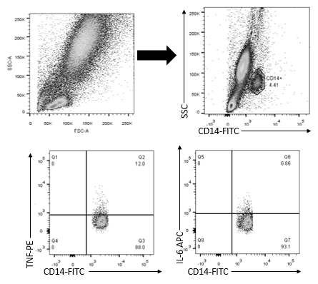
Additional file 1: Gating strategy for flow cytometry analysis. Demonstration of gating strategy for flow cytometric analysis of CD14 monocytes from PB and SFMC samples. In this example, 500 μl PB (from HC) + 500 μl cRPMI was left unstimulated for 4 hours with brefildin A. the cells were then surface stained with CD14 (FITC) monoclonal antibody and IL-6 (APC and TNF (PE) intracellular monoclonal antibodies. The CD14+ monocytes were gated on the SSC vs CD14-FITC plot. The monocytes were then analysed for CD14+TNF+ cells and CD14+IL-6+ cells. The gating was done on the basis of lymphocyte exclusion method of flow cytometry analysis.

