Supplementary Material

Supplementary Data
I. Supplementary Figure S1 Recruitment pathway for patients.
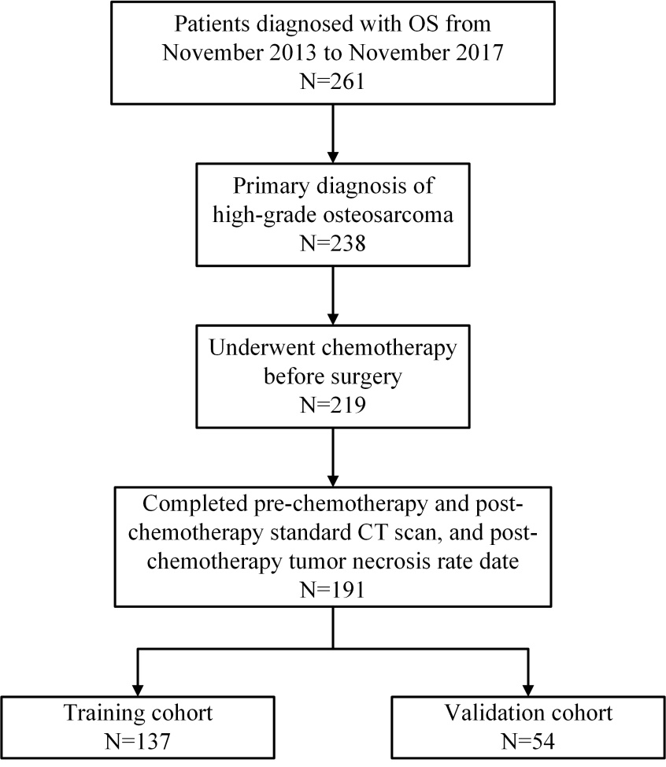
Figure S1. Recruitment pathway for patients.

II. Supplementary Figure S2 Neoadjuvant chemotherapy regimens.
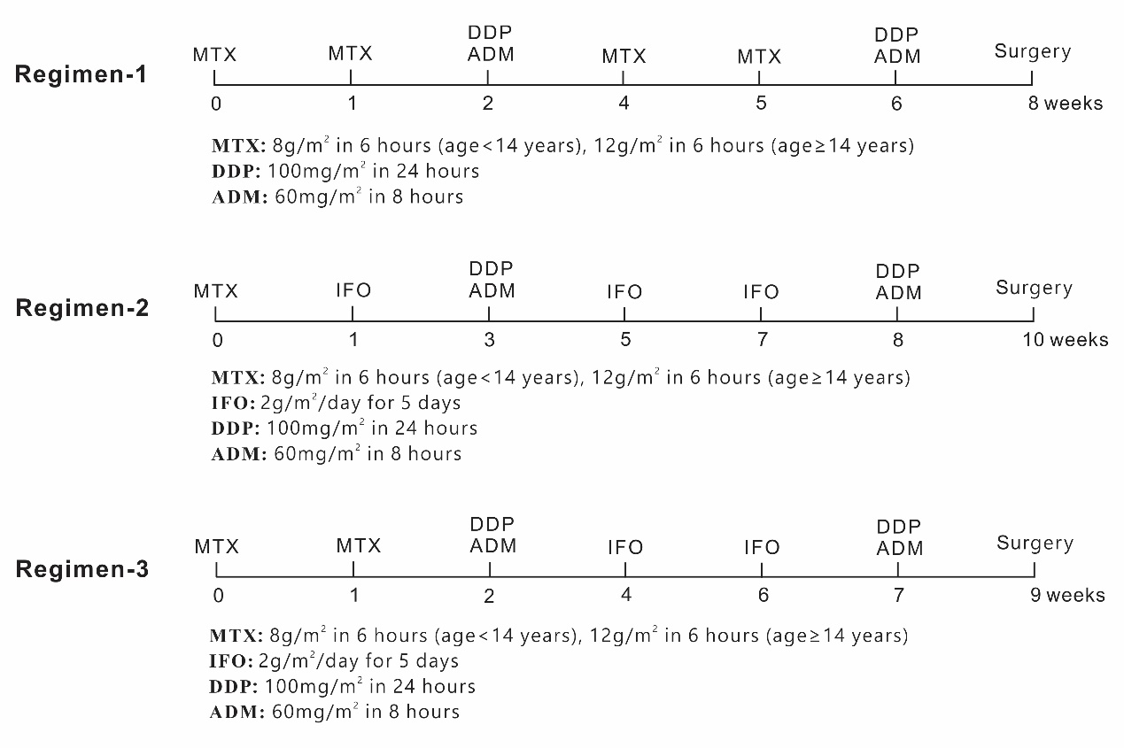
Figure S2. Regimens of preoperative treatment protocols of neoadjuvant chemotherapy. MTX: methotrexate; DDP: cisplatin; ADM: doxorubicin; IFO: ifosfamide.

III. Table S1 Patient characteristics’ distribution in the training and validation datasets
Characteristics | Training dataset | Validation dataset | p
Pathological Response |  |  | 0.6691
pGR | 57 | 25
non-pGR | 80 | 29
Age |  |  | 0.5363
≤15 y | 72 | 25
>15 y | 65 | 29
Gender |  |  | 0.3254
Male | 81 | 27
Female | 56 | 27
Location of primary tumor |  |  | 0.6721
Humerus | 19 | 6
Femur | 72 | 31
Tibia and fibula | 37 | 16
Radius and ulna | 3 | 0
Others | 6 | 1
Stage at diagnosis |  |  | 0.5816
Localized | 113 | 47
Metastatic | 24 | 7
Pathologic subtype |  |  | 0.1567
Osteoblastic | 101 | 39
Chondroblastic | 16 | 6
Fibroblastic | 8 | 8
Telangiectatic | 8 | 1
Others | 4 | 0
Type of surgery |  |  | 0.315
Limb salvage | 121 | 51
Amputation | 16 | 3
New pulmonary metastasis |  |  | 0.6821
Yes | 6 | 1
No | 131 | 53
Chemotherapy regimens |  |  | 0.2597
1MTX, DDP and ADM | 100 | 39
2MTX, IFO,DDP and ADM | 27 | 14
3MTX,IFO, DDP and ADM | 10 | 1
Note: Individual clinical factors were analyzed for significant differences using a chi-square test. P < 0.05 indicates a significant difference.
IV. Supplementary Figure S3 Heatmap for radiomic features.
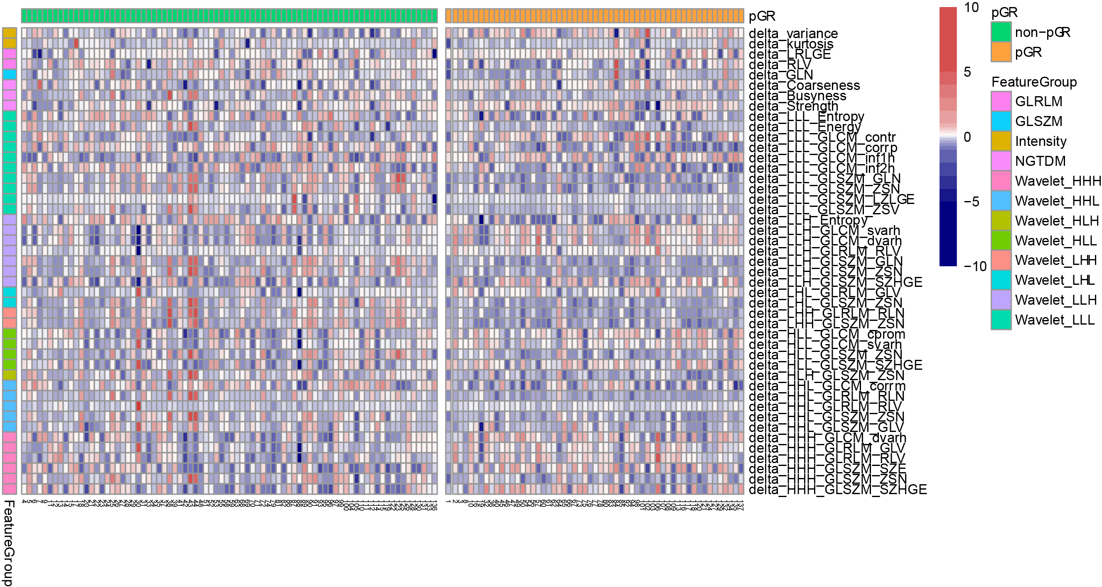
Figure S3. Heatmap for instructive radiomic features in the training set. The x-axis indicates different patients. The y-axis indicates different radiomics features. The color in the box shows the expression level of radiomic features.

V. Table S2: Interclass correlation coefficient (ICC) values of selected delta-radiomic features in the intra-observer and inter-observer reproducibility test.
Feature Name | ICC in  Intra-observer Test | ICC in  Inter-observer Test
△variance | 0.998 | 0.997
△LLL_GLCM_corrp | 0.990 | 0.983
△LLH_Entropy | 0.984 | 0.934
△LLH_GLSZM_GLN | 0.996 | 0.992
△LHH_GLSZM_ZSN | 0.945 | 0.962
△HHL_GLCM_corrm | 0.801 | 0.806
△HHH_GLSZM_SZE | 0.926 | 0.926
△HHH_GLSZM_SZHGE | 0.891 | 0.926

VI. Supplementary Figure S4 The predictive performance of the radiomic signatures from four kinds of data.
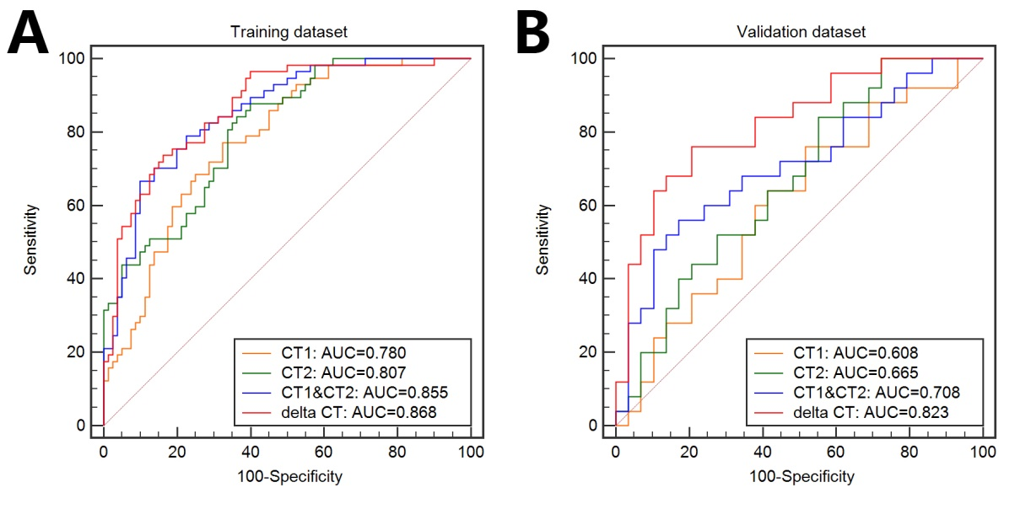
Supplementary Figure S4. The predictive performance of the radiomic signature from four kinds of data for each patient in training (A) and validation (B) sets (AUC, area under curve).

