Supplemental Figure 7. Effect of icodextrin on urine volume.

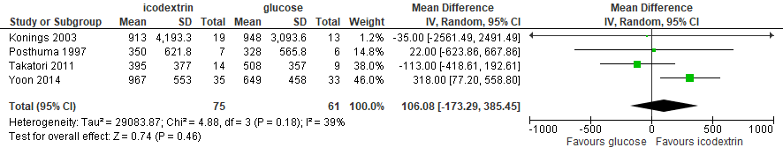

Supplemental Figure 8. Effect of icodextrin on residual renal function.

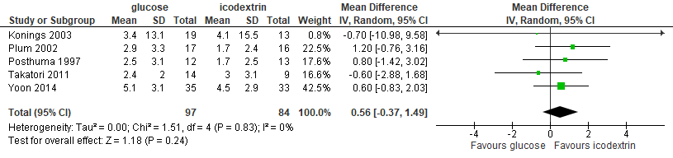

Supplemental Figure 9. Effect of icodextrin on peritoneal function.

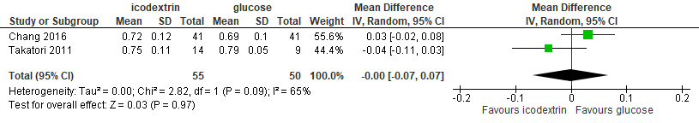

Supplemental Figure 10. Effect of icodextrin on peritonitis.

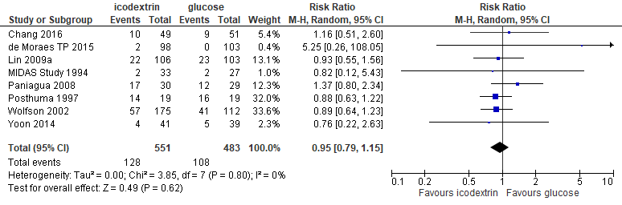

Supplemental Figure 11. Effect of icodextrin on rash.

