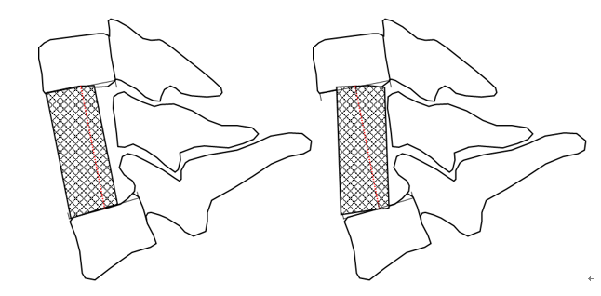
Supplementary Figure The contact area between the TMC and endplate would be reduced when the cage was placed obliquely into the intervertebral space.

