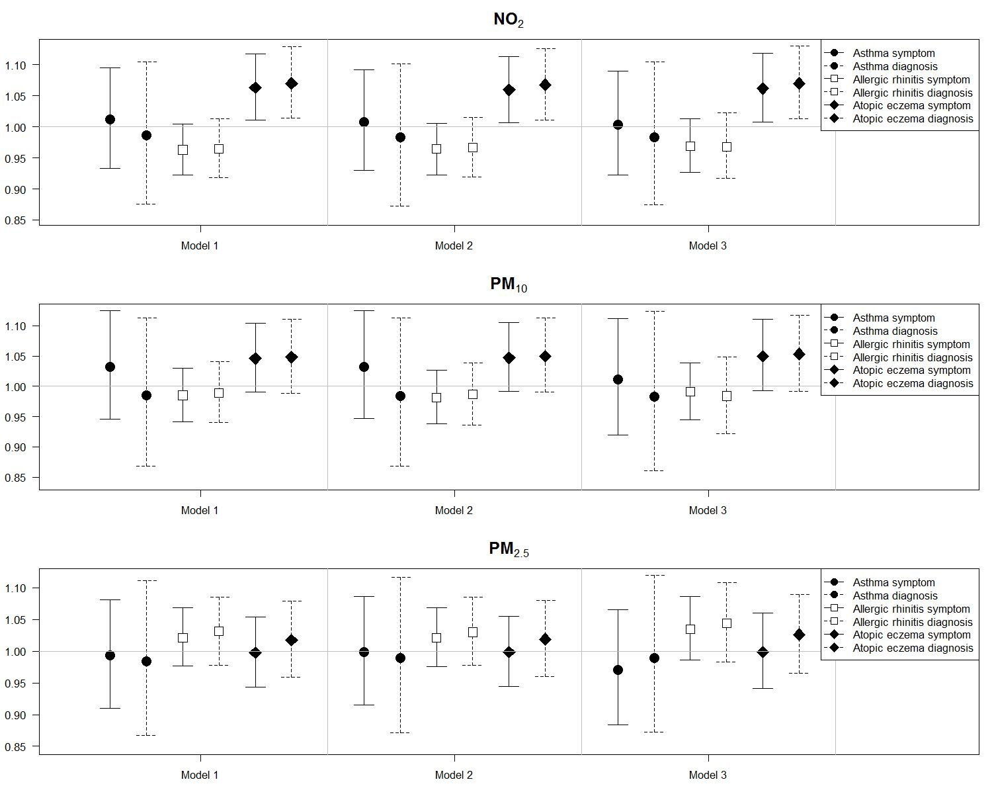
Figure S4. Odds ratios and 95% confidence intervals of symptoms and doctor-diagnoses of three allergic diseases for interquartile increases in individual-level annual average concentrations of NO2, PM10, and PM2.5 (4.7 ppm, 2.85 ug/m3, and 2.69 ug/m3, respectively) in 14,614 children at homes and schools from the Seoul Atopy Friendly School Project Survey in Seoul, Korea, for 2010
Note: We assessed individual exposures by using weighted averages with the ratio of 2 (home) to 1 (school)

