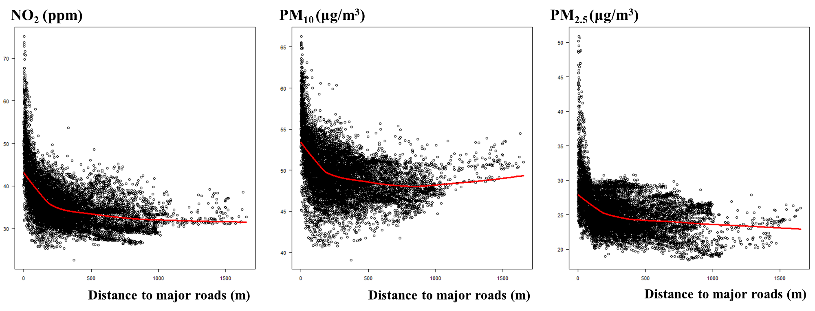
Figure S2. Scatter plots between predicted annual-average concentrations of NO2, PM10, or PM2.5 in 2010 and distances to the closest major roads (Yi et al. 2017) at home addresses of 14,614 children in the Seoul Atopy Friendly School Project Survey in Seoul, Korea, for 2010 (red lines for non-linear relationships estimated by locally-weighted smoothing)

