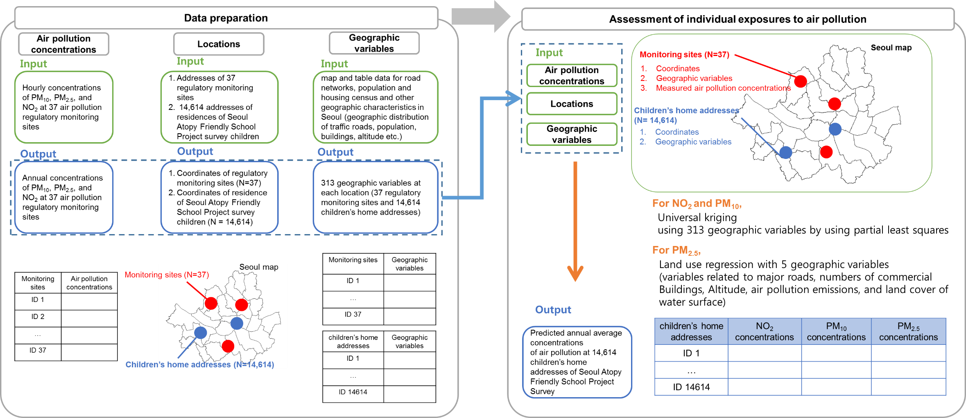
Figure S1 Data preprocessing and prediction procedure for assessing individual-level concentrations of PM10, PM2.5, and NO2 at 14,614 children’s home and school addresses in the Seoul Atopy Friendly School Project Survey in Seoul, Korea, for 2010

