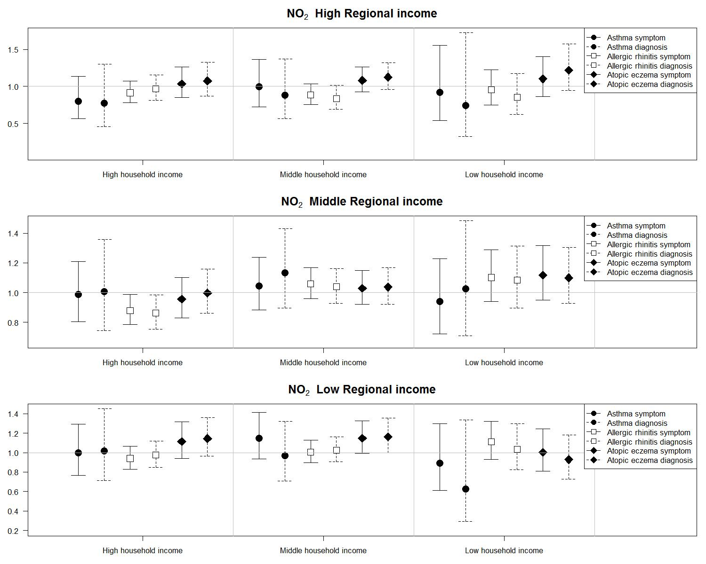
Figure S5. Odds ratios and 95% confidence intervals of symptoms and doctor-diagnoses of three allergic diseases for interquartile increases in individual-level annual average concentrations of NO2 (6.46 ppm) in 14,614 children at homes stratified by regional and household socioeconomic status from the Seoul Atopy Friendly School Project Survey in Seoul, Korea, for 2010

