Additional file
Grossard et al.

Table S1. Matching characteristics of the TD subgroups for machine learning
 |  | ASD | TD group 1 | TD group 2
Neutral | N _{videos} | 125 | 138 | 150
 | % | 37.65 | 36.03 | 34.56
Joy | N _{videos} | 101 | 109 | 118
 | % | 30.42 | 28.45 | 27.18
Anger | N _{videos} | 58 | 84 | 103
 | % | 17.46 | 21.93 | 23.73
Sadness | N _{videos} | 45 | 52 | 63
 | % | 13.55 | 13.57 | 14.51
City | Paris | 15 | 15 | 15
 | Nice | 19 | 19 | 19
School | Preschooler | 5 | 5 | 5
 | Grade 1 | 3 | 3 | 3
 | Grade 2 | 7 | 7 | 7
 | Grade 3 | 8 | 9 | 8
 | Grade 4 | 9 | 10 | 11
 | Grade 5 | 1 | 0 | 0
 | Grade 6 | 1 | 0 | 0
Gender | Male | 26 | 26 | 26
 | Female | 8 | 8 | 8
Total | N _{children} | 34 | 34 | 34
 | N _{videos} | 332 | 383 | 434

Table S2. Emotion production in children with ASD as a function of age, gender, group, order, modality, elicitation task, emotion and sites: results from the GLMM model
Variable | ß estimate | Standard error | p
Age | - 0.055 | 0.107 | 0.61
Gender (boys vs. girls) | -0.381 | 0.367 | 0.299
Order 2 vs. order 1 | 0.569 | 0.424 | 0.18
Order 3 vs. order 1 | -0.614 | 0.481 | 0.201
Order 4 vs. order 1 | -0.027 | 0.422 | 0.949
Modality (visual vs. audiovisual) | 0.146 | 0.162 | 0.37
Elicitation task (on request vs. imitation) | 0.574 | 0.176 | 0.001
Emotion (happiness vs. sadness) | 1.609 | 0.236 | <0.001
Emotion (neutral vs. sadness) | 1.481 | 0.233 | <0.001
Emotion (anger vs. sadness) | 0.678 | 0.216 | 0.001
Site (Nice vs. Paris) | - 0.603 | 0.323 | 0.062
IQ | 0.031 | 0.01 | 0.002
The GLMM formula was the following: score ~ age + gender + order + task + modality + emotion subtype + center + IQ + (1|child number).

Table S3. Durations of videos during emotion production in children with ASD and TD children
 | Estimate | CI95_low | CI95_up | p value
(Intercept) | 76.06 | 71.18 | 80.95 | < 0.001
Modality (visual vs. audiovisual) | 8.21 | 5.69 | 10.66 | < 0.001
Emotion (anger vs. sadness) | -21.59 | -25.07 | -18.13 | < 0.001
Emotion (happiness vs. sadness) | -16.22 | -19.71 | -12.76 | < 0.001
Emotion (neutral vs. sadness) | -2.02 | -5.48 | 1.52 | 0.26
Elicitation task (on request vs. imitation) | 8.32 | 5.64 | 10.88 | < 0.001
Group (TD vs. ASD) | 30.76 | 25.69 | 35.93 | < 0.001
The GLMM formula was the following: video duration ~ task + modality + emotion subtype + group + (1|child number).

In average, facial expressions had:
- A longer duration for the unimodal condition (8 ms more compared to the multimodal condition)
- A shorter duration for anger than sadness (Δ=-22 ms)
- A shorter duration for joy than sadness (Δ=-16 ms)
- A longer duration for the ‘on request task’ than the ‘imitation task’ (Δ=+8 ms)
- A longer duration for TD children than ASD (Δ=+31 ms)

Figure S1. Histogram of the videos’ duration
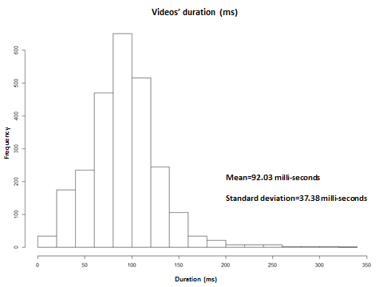

Table S4. Radom forest classifier accuracy recognition of the FE
Learning on | TDall-(TD group 1)  (N=126) | TDall-(TD group 2)  (N=126) | TDall-(TD group 1)  (N=126) | TDall-(TD group 2)  (N=126)
Testing | TD group 1  (N=34) | TD group 2  (N=34) | ASD  (N=34) | ASD  (N=34)
Neutral | 82.61 | 82.0 | 67.2 | 67.2
Happiness | 88.99 | 90.52 | 88.12 | 87.13
Anger | 84.52 | 80.81 | 58.62 | 63.79
Sadness | 61.54 | 62.3 | 48.89 | 40.0
Global accuracy | 81.98 | 81.22 | 69.6 | 69.0

Table S5. Radom forest classifier accuracy recognition of FE when learning on TD group 1 or 2
Learning on | TD group 1  (N=34) | TD group 2  (N=34)
Testing | TD group 1  (N=34) | TD group 2  (N=34)
Neutral | 82.30 | 82.87
Happiness | 87.76 | 87.76
Anger | 76.91 | 76.91
Sadness | 42.78 | 29.01

Table S6. Confusion matrix when learning and testing on TD
 | Neutral | Happiness | Anger | Sadness
Neutral | 86.64 | 3.43 | 6.09 | 3.84
Happiness | 5.06 | 90.47 | 1.64 | 2.83
Anger | 10.39 | 5.18 | 79.76 | 4.67
Sadness | 23.24 | 9.01 | 11.5 | 56.15

Table S7. Confusion matrix when learning on TSA and testing on TSA
 | Neutral | Happiness | Anger | Sadness
Neutral | 72.55 | 9.11 | 13.27 | 5.07
Happiness | 12.26 | 70.38 | 14.02 | 6.14
Anger | 21.25 | 17.25 | 58.17 | 10.52
Sadness | 15.83 | 9.76 | 32.62 | 44.44

Table S8. Confusion matrix when learning on TD and testing on TSA
 | Neutral | Happiness | Anger | Sadness
Neutral | 68.08 | 10.32 | 16.88 | 4.72
Happiness | 6.93 | 85.05 | 1.88 | 6.14
Anger | 12.24 | 18.62 | 58.62 | 10.52
Sadness | 22.67 | 9.78 | 23.11 | 44.44

Table S9. Confusion matrix when learning on TD1 and testing on TD1
 | Neutral | Happiness | Anger | Sadness
Neutral | 82.30 | 2.53 | 9.16 | 6.01
Happiness | 3.54 | 87.76 | 1.00 | 7.70
Anger | 13.58 | 7.43 | 76.91 | 2.08
Sadness | 30.39 | 13.17 | 13.67 | 42.78

Table S10. Confusion matrix when learning on TD2 and testing on TD2
 | Neutral | Happiness | Anger | Sadness
Neutral | 82.87 | 3.58 | 9.55 | 4.00
Happiness | 5.49 | 87.87 | 0.00 | 6.64
Anger | 13.63 | 7.43 | 75.09 | 3.84
Sadness | 27.78 | 11.97 | 31.25 | 29.01

Figure S2 and S3. Facial landmarks contributing to classification of anger using random forest (training and testing) in children with typical development (left) and children with autism spectrum disorder (S2: Distance; S3: HOG)
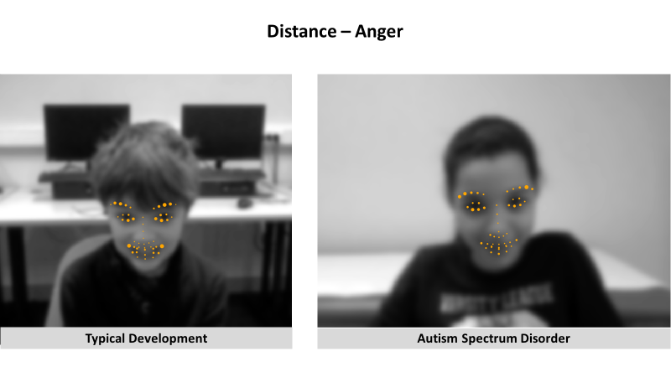
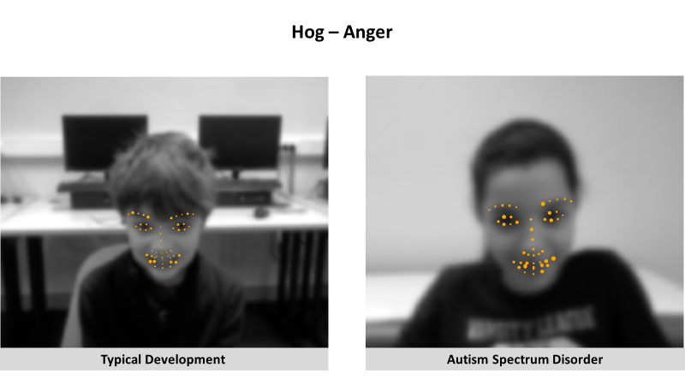

Figure S4 and S5. Facial landmarks contributing to classification of neutral facial expression using random forest (training and testing) in children with typical development (left) and children with autism spectrum disorder (S4: Distance; S5: HOG)
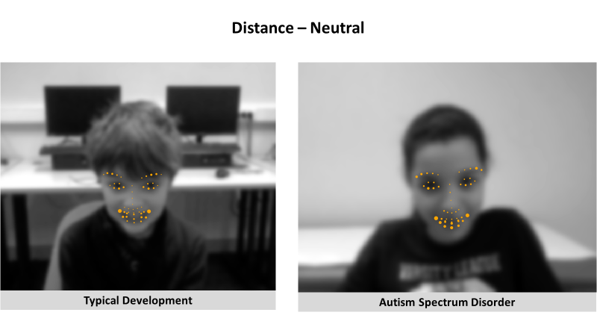
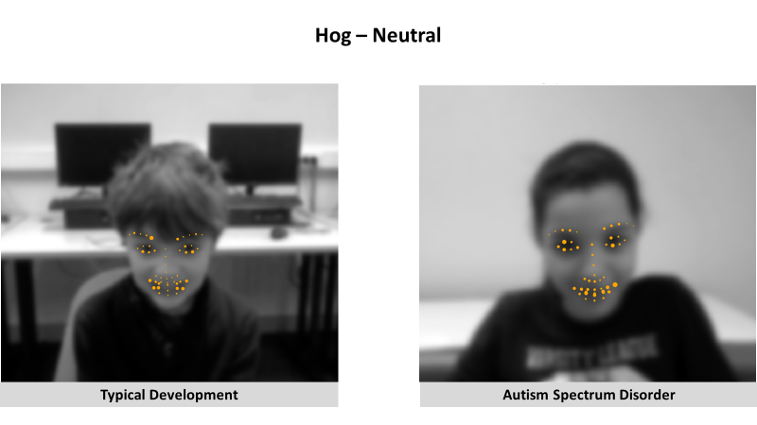

Figure S6 and S7. Facial landmarks contributing to classification of sadness using random forest (training and testing) in children with typical development (left) and children with autism spectrum disorder (S6: Distance; S7: HOG)
