A 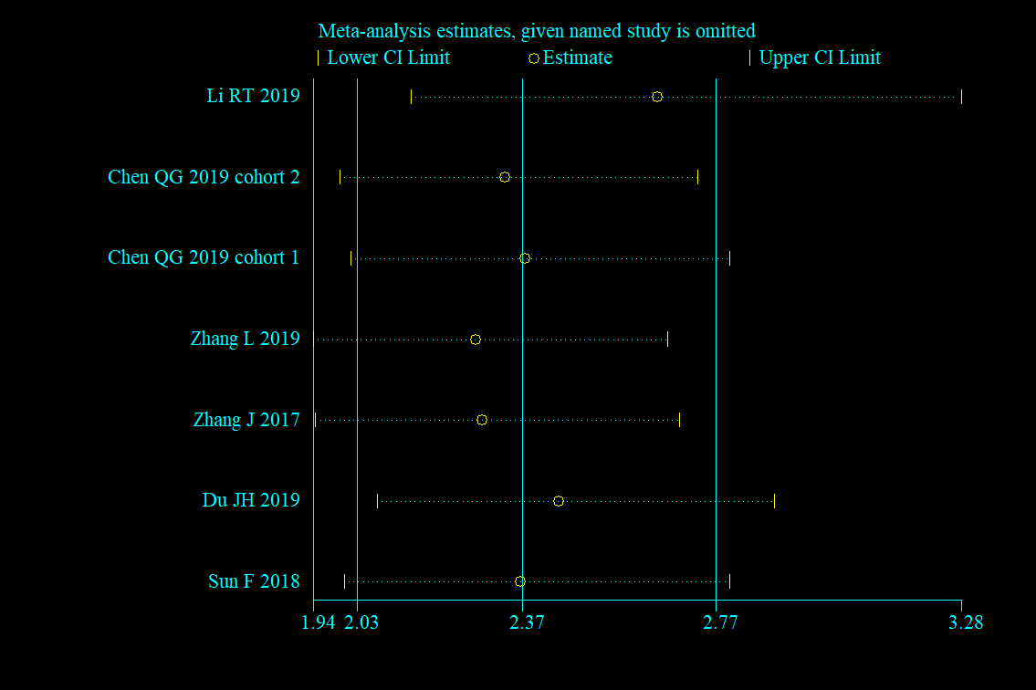
B 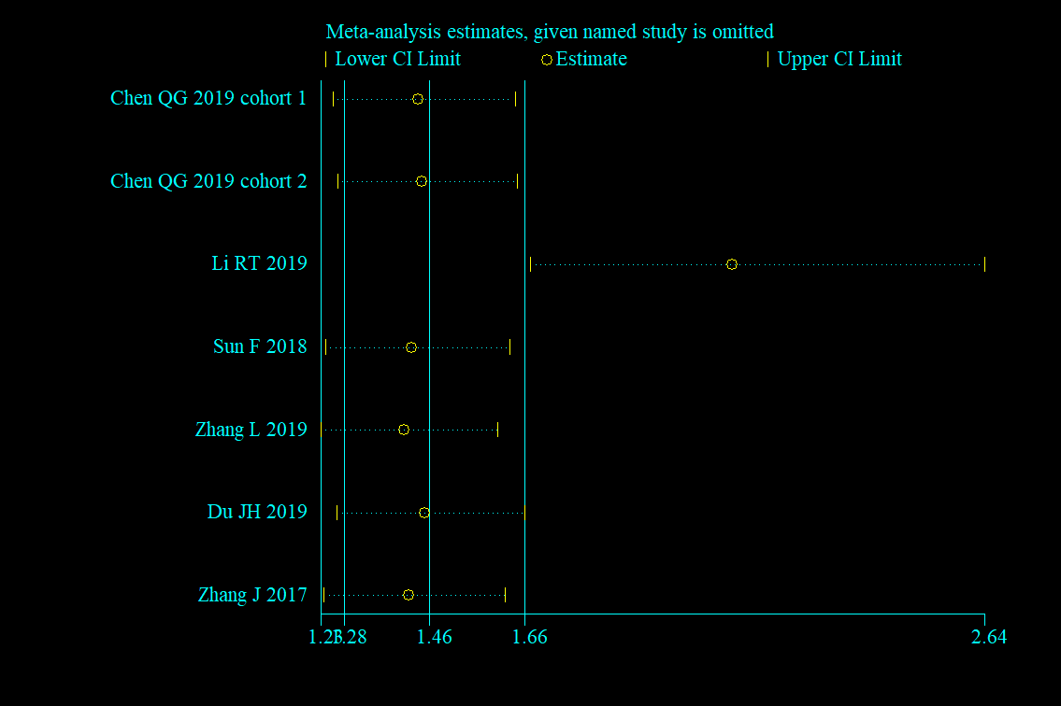
Additional file 3. Sensitivity analysis of the correlation of FPR with OS via univariate analyses (A) and multivariate analyses (B).

