A 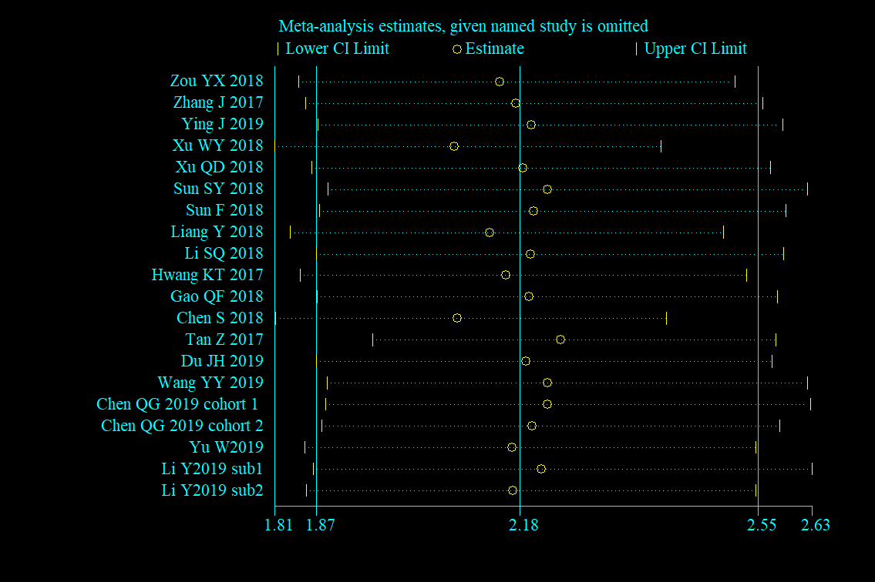
B 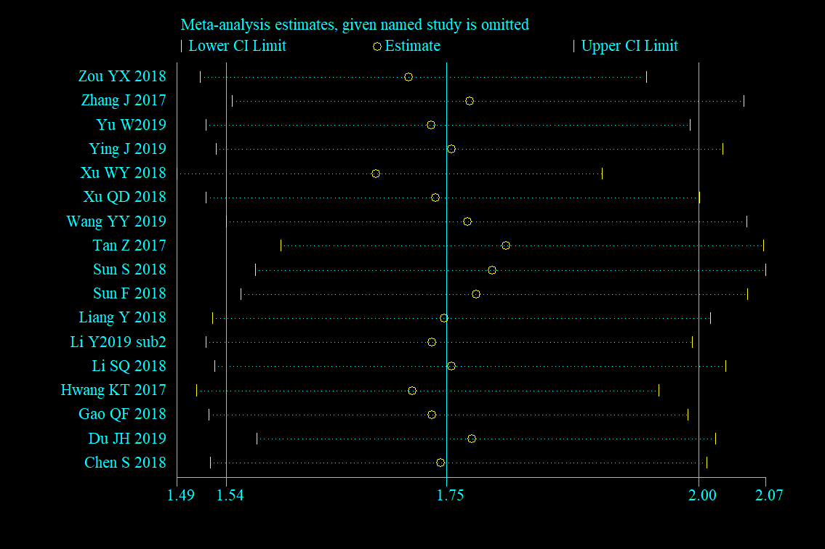
C 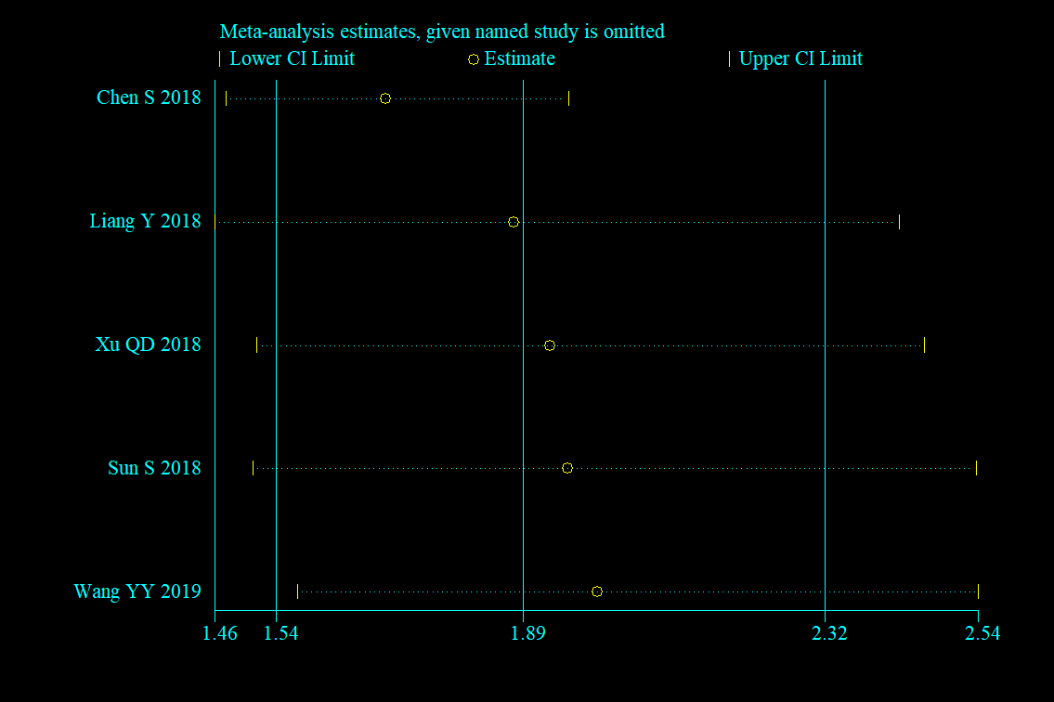
D 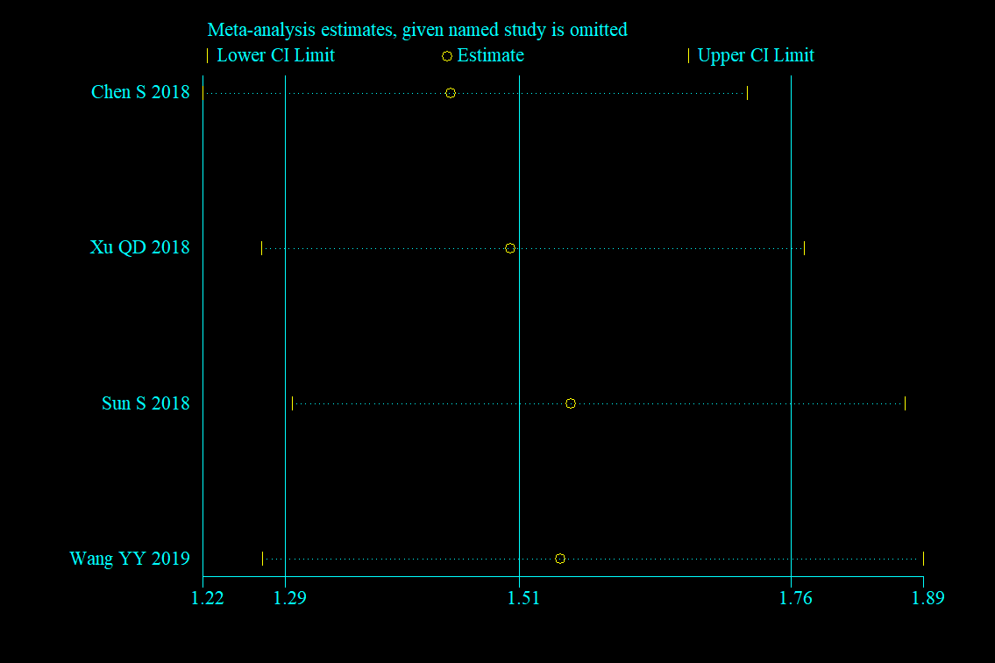
E 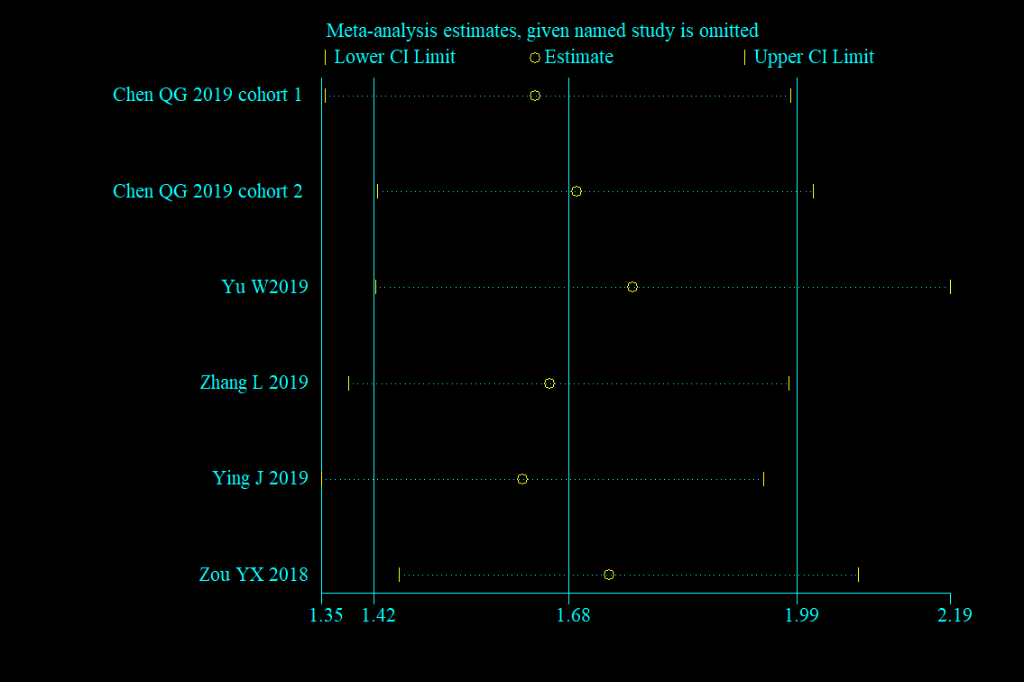
F 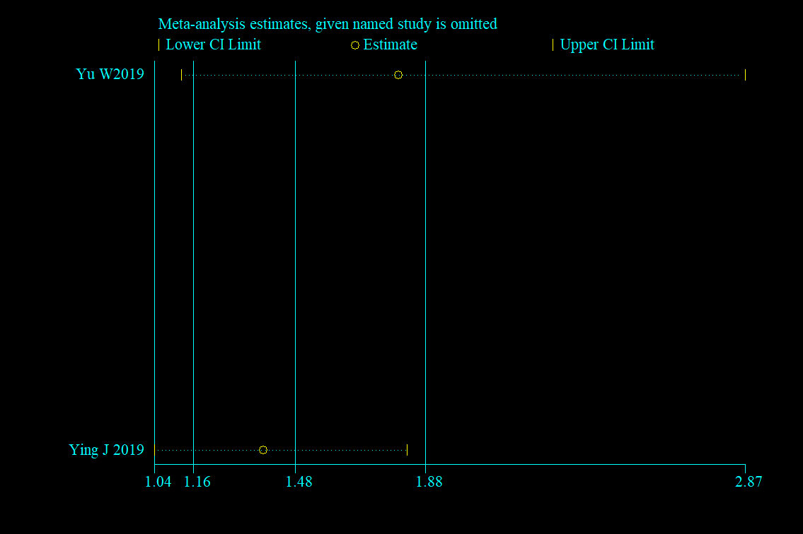
Additional File 2. Sensitivity analysis of the correlation of AFR with OS via univariate analyses (A) and multivariate analyses (B); with DFS from univariate analyses (C) and multivariate analyses (D); and with PFS from univariate analyses results (E) and multivariate analyses (F).

