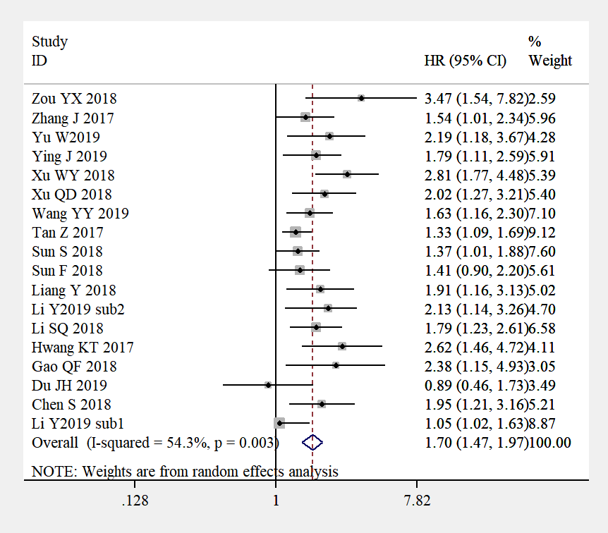
Additional File 1. Forest plots of the relationship between AFR and OS via multivariate analyses, before deleting the subgroup with paradoxical results (Li et al. 2019, subgroup 1).

