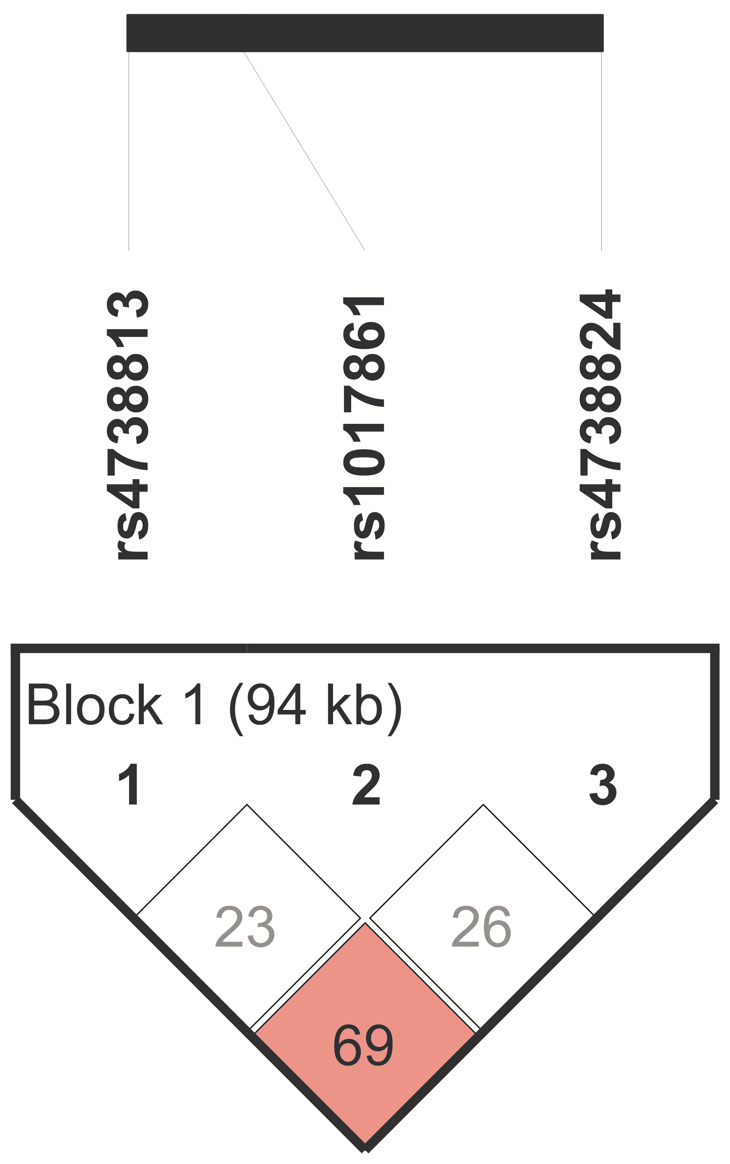
Figure S1. Standard D’/LOD display obtained from Haploview software. The values in diamonds show how many of the SNPs in the dataset have been successfully tagged by the set of chosen tests. D’<1 and LOD<2 are indicated in white. D’<1 and LOD≥2 are indicated in pink. There are no D’=1 and LOD≥2. There is strong evidence of recombination, and the highest r² value is 0.284.

Table S1. Linkage data obtained from Haploview software.
L1 | L2 | D' | LOD | r² | CI low | CI hi
rs4738813 | rs1017861 | 0.237 | 0.23 | 0.014 | 0.02 | 0.55
rs4738813 | rs4738824 | 0.694 | 8.33 | 0.284 | 0.52 | 0.82
rs1017861 | rs4738824 | 0.26 | 0.59 | 0.028 | 0.04 | 0.5
L1, L2 – linkage pairs; D’ – D prime; LOD – logarithm (base 10) of odds, r² – coefficient of determination, CI low/hi – lower and upper confidence r² intervals

