What Wild Dogs Want: Habitat Selection Differs across Life Stages and Orders of Selection in African Wild Dogs – Supplementary Materials

Life Stage Categorisation
GPS data were categorised into the following life stages: resident-denning (hereafter referred to as denning), resident-heavily-pregnant (hereafter pregnant), resident-non-breeding (hereafter resident) and dispersing.
Individuals were categorised as denning during the period of approximately three months when packs had pups in the den; the exact dates of this period were determined by mapping the GPS collar data and using the distinctive “starburst” movement pattern created by dogs leaving to hunt and then returning to the den to tend the pups twice a day (Figure S1).
Data for all individuals were categorised as pregnant for the 28 days before the start of denning. This was not in reference to whether the collared individual was pregnant, as none of the collared animals produced pups themselves; instead this categorisation refers to the weeks when the alpha female of the collared individual’s pack was heavily pregnant. This is because if the alpha female shows differing habitat selection during this time then this would be reflected for all individuals within the pack. Wild dog gestation is approximately 72 days (McNutt & Woodroffe, 2013). Wild dogs have large litters (Creel & Creel, 1991) and females are visibly pregnant less than half way through their gestation (Creel, Creel, Mills, & Monfort, 1997), which may impact on their mobility later in their pregnancy. If the changes in locomotive ability during pregnancy, as well as the need to locate potential den sites, affects wild dog habitat selection then this is likely to be most distinctive towards the end of gestation, therefore only data from the last 28 days of gestation were used for these analyses.
Individuals were categorised as resident when they were part of a pack which had an established territory and were not denning and the alpha female was not heavily pregnant.
Individuals were defined as dispersing for a period beginning when a single sex group left its natal pack permanently. This could be determined because, although only one individual in each pack was fitted with a GPS collar, other individuals in the pack were fitted with VHF (Very High Frequency) radio collars to facilitate ground tracking. Dispersals were defined as ending either when the dispersal group was seen with opposite sex dogs or when its ranging patterns became a consistent home range, whichever happened sooner. A home range was defined as being consistent when weekly home ranges (defined as minimum convex polygons drawn around all the locations recorded in a week) consistently overlapped and the overall area size plateaued (Figure S2).
Any data where the individual’s life stage did not fit into the above categories, e.g. periods around a pack break up following the death of an alpha female, were excluded from analyses

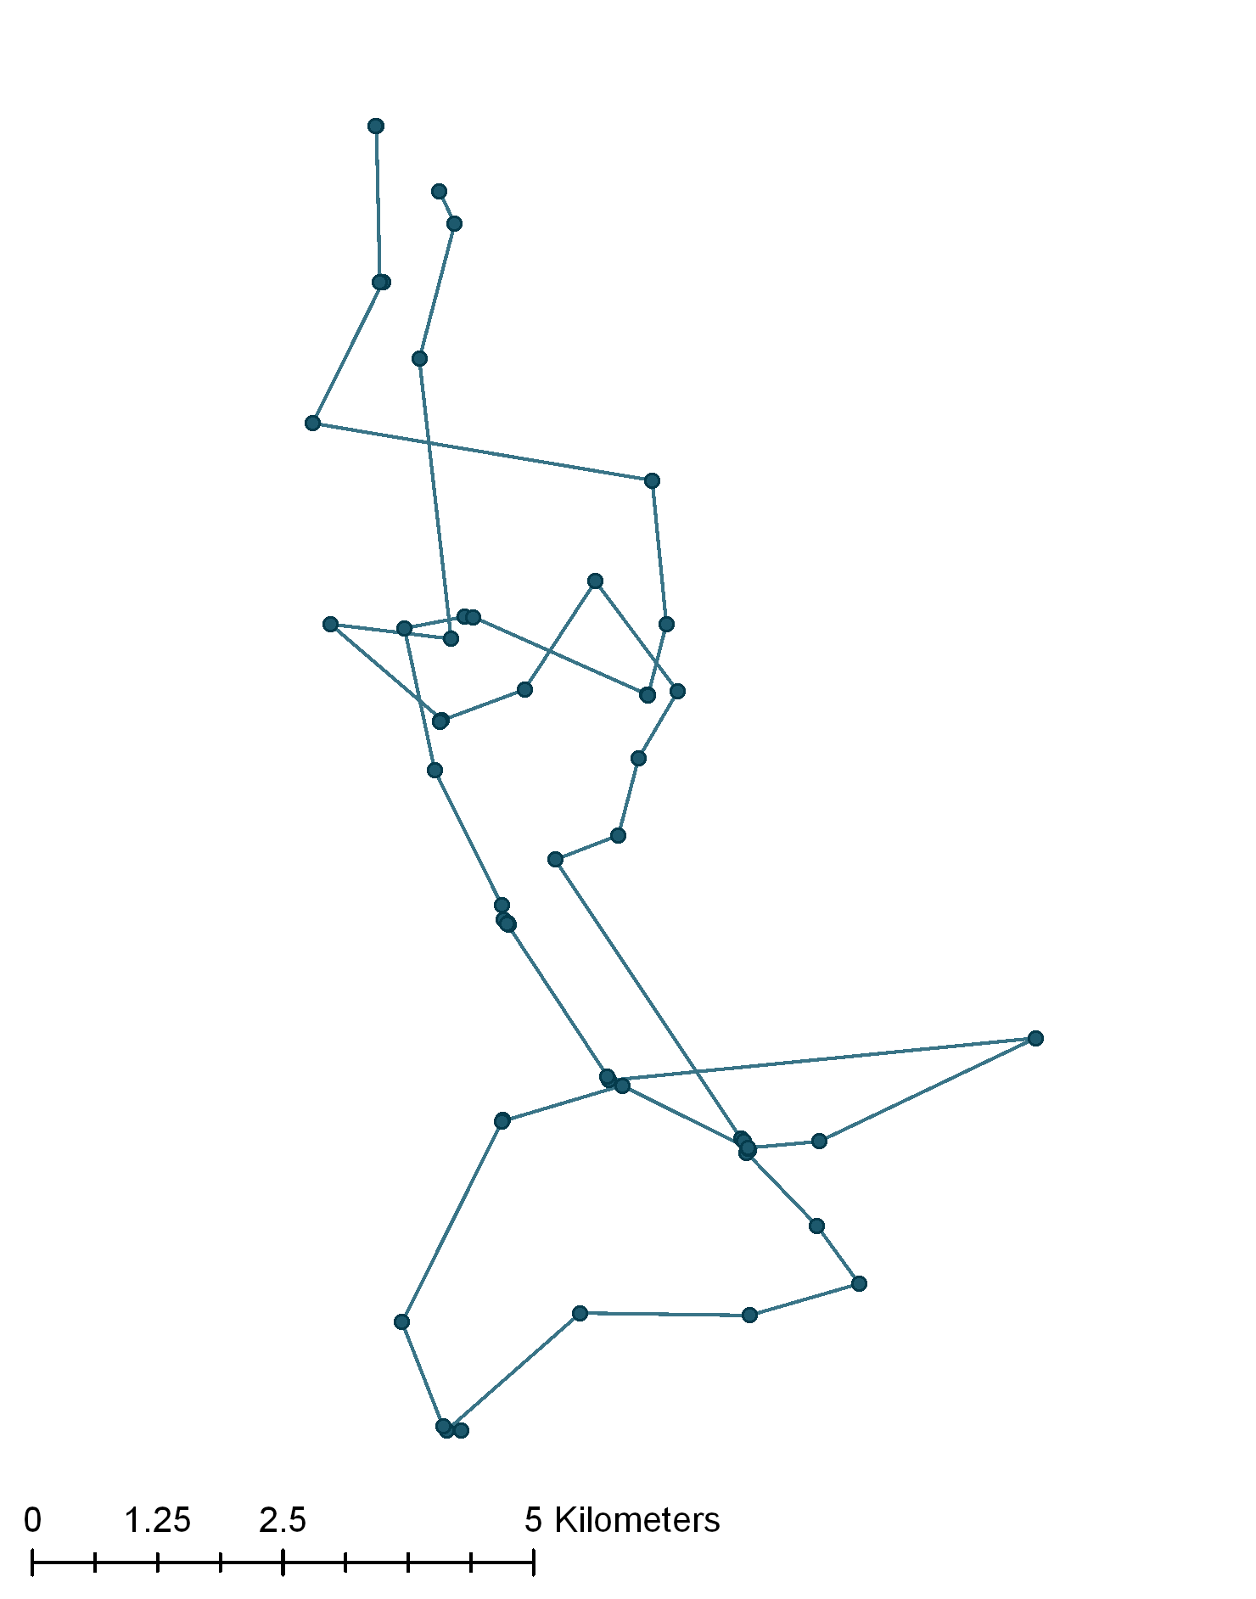
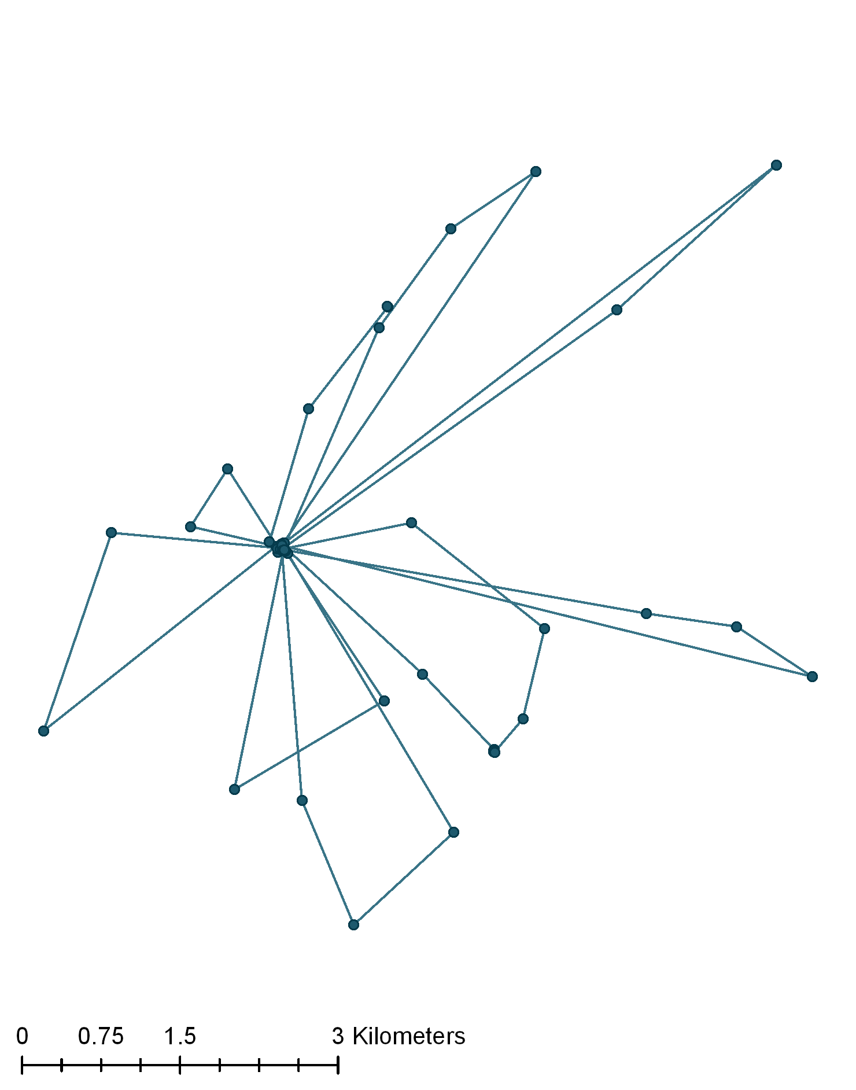
a
b
Figure S1. Maps showing 7 days of movement data from a GPS collared wild dog during a resident-non-breeding life stage (map a) and a resident-denning life stage (map b)
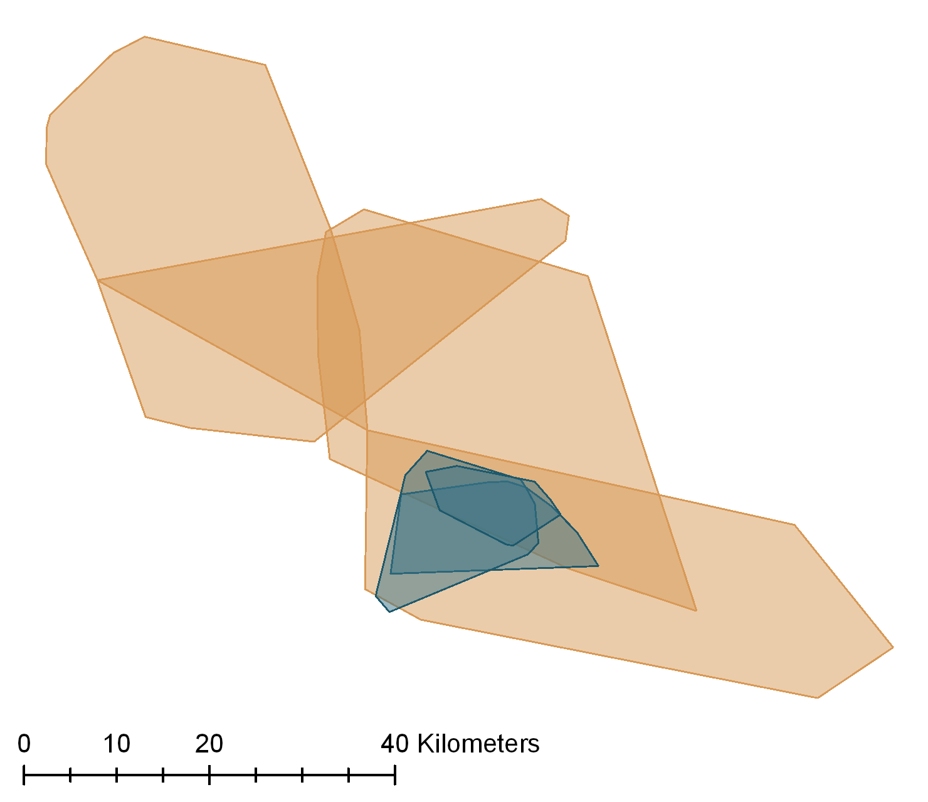
Figure S2. Minimum convex polygons drawn around weekly GPS collar data from a wild dog defined as dispersing (orange polygons) and resident (blue polygons)
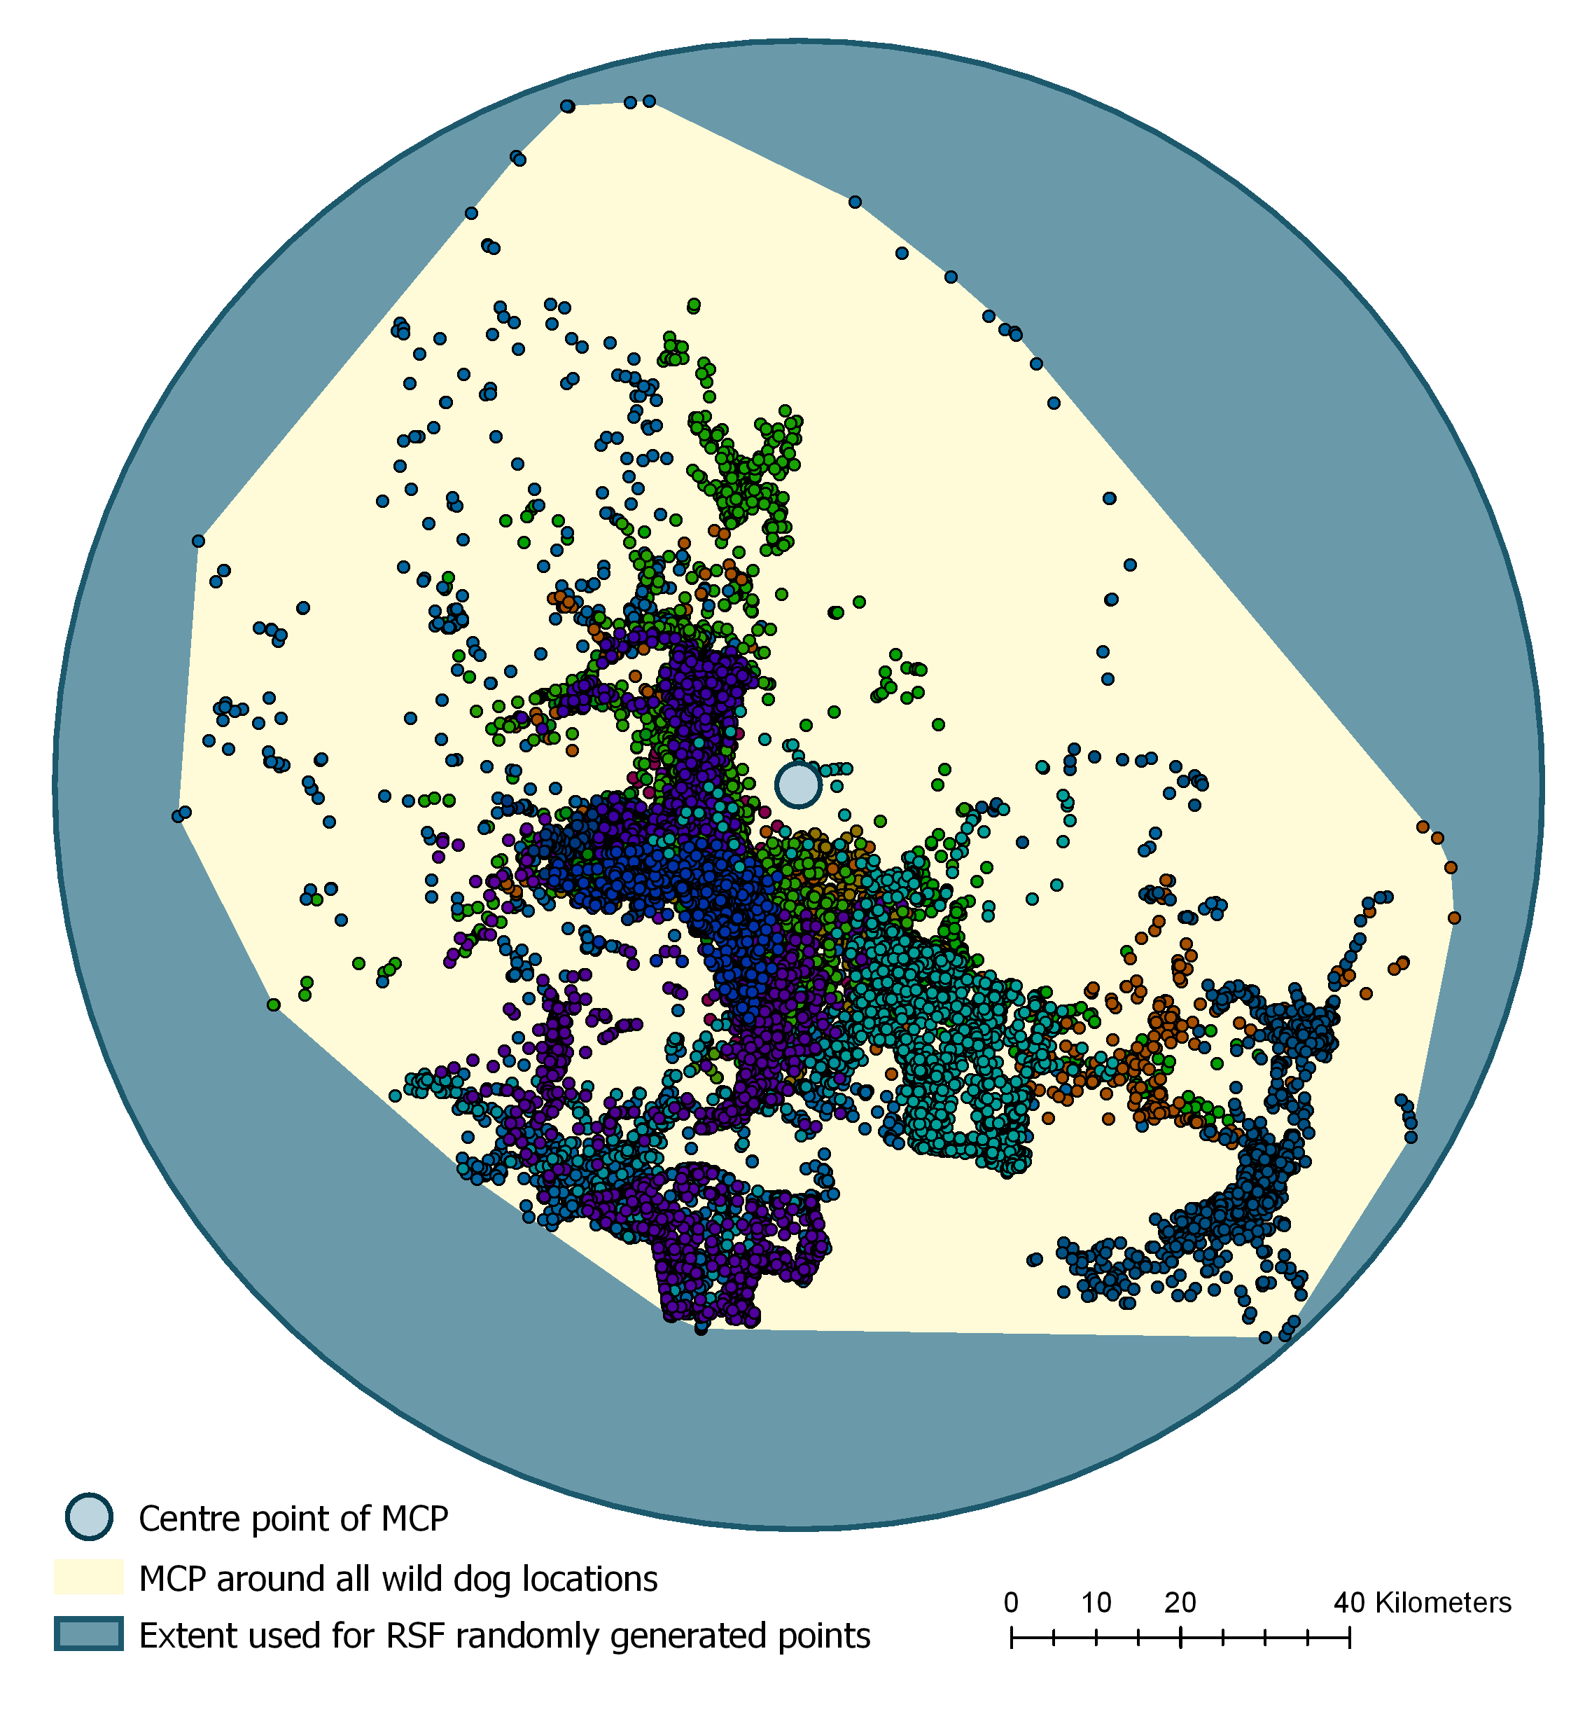
90km
Figure S3. Diagram showing how available habitat was determined for the second order habitat selection analysis. Small coloured dots show wild dog GPS collar locations; different colours represent different individuals. Yellow polygon shows the minimum convex polygon drawn around the GPS locations with a purple dot marking the central point. Blue circle shows the area used to represent the background habitat available to the wild dog packs.
Life Stage | Number of Individuals | Number of GPS Collar Locations per Individual |  | Total Number of Locations Included in Analysis
 |  | mean | range
Denning | 14 | 111.8 | 41 – 185 | 1565
Pregnant | 14 | 50.6 | 28 – 105 | 708
Resident | 16 | 235.9 | 23 – 467 | 3774
Dispersing | 7 | 125.0 | 5 – 424 | 875
Table S1. Number of days of data included in analyses for each life stage

Table S2. Habitat characteristics rasters
Variable | Description | References
Human Population Density | Number of people per square kilometre. Data were downloaded at 30 arc-second resolution and resampled using bilinear interpolation to 100m grid cells. | (CIESIN, 2016))
Distance to Roads | Shapefile downloaded (Survey of Kenya, 1997), and converted into a raster file from which a 100m resolution distance grid was calculated for use in analyses. | Survey of Kenya (1997)
Distance to Rivers | Shapefile downloaded (Japan International Cooperation Agency, 2013), and converted into a raster file from which a 100m resolution distance grid was calculated for use in analyses. | Japan International Cooperation Agency (2013)
Percentage Tree Cover | Downloaded from USGS MODIS MOD44B at 250m resolution, resampled to 100m grid cells using bilinear interpolation. | (DiMiceli & Carroll, 2017)
Terrain Ruggedness Index | A measure of the roughness of an area calculated, from a digital elevation model (DEM) raster layer (90m resolution), as the mean of the absolute differences between the value of a cell and the values of its 8 surrounding cells. Terrain Ruggedness Index was calculated in R using the terrain function in the raster package using DEM data downloaded from World Resources Institute. The terrain ruggedness raster was resampled to 100m grid cells using bilinear interpolation | (World Resources Institute, 2007)
Selection was not investigated in relation to predator and prey densities as appropriate data were not available. The study population of wild dogs subsist primarily on dikdiks and impala (Woodroffe, Lindsey, Romañach, & Ranah, 2007) for which reliable population densities and distributions are not available in the study area. Predators such as lions and hyenas are also found in the study area; however there were also not sufficient data across the study area to incorporate these into the analyses.
Table S3. Mean step lengths of different life stages for 90 minute morning and evening activity periods
Life Stage | Mean Step Length (m) | Standard Deviation (m)
Denning | 1804.3 | 1765.9
Pregnant | 2066.0 | 2124.5
Resident | 2040.0 | 2526.2
Dispersing | 3315.4 | 4183.3

References
CIESIN. (2016). Documentation for Gridded Population of the World, Version 4 (GPWv4). doi:10.7927/H4D50JX4
Creel, S., Creel, N. M., Mills, M. G., & Monfort, S. L. (1997). Rank and reproduction in cooperatively breeding African wild dogs: behavioral and endocrine correlates. Behavioral Ecology, 8(3), 298–306.
Creel, S. R., & Creel, N. M. (1991). Energetics, reproductive suppression and obligate communal breeding in carnivores. Behavioral Ecology and Sociobiology, 28(4), 263–270.
DiMiceli, C., & Carroll, M. (2017). MOD44B MODIS/Terra Vegetation Continuous Fields Yearly L3 Global 250m SIN Grid V006. NASA EOSDIS Land Processes DAAC. doi:10.5067/MODIS/MOD44B.006
Japan International Cooperation Agency. (2013). National Water Master Plan, Kenya. International Livestock Research Institute. Retrieved from http://192.156.137.110/gis/search.asp?id=382
McNutt, J. W., & Woodroffe, R. (2013). African wild dog. In J. Kingdon, D. Happold, T. Butynski, M. Hoffmann, H. Happold, & J. Kalina (Eds.), Mammals of Africa (Vol. 5). Bloomsbury, London.
Survey of Kenya. (1997). National Road Network. International Livestock Research Institute. Retrieved from http://192.156.137.110/gis/search.asp?id=381
Woodroffe, R., Lindsey, P. A., Romañach, S. S., & Ranah, S. M. K. ole. (2007). African Wild Dogs ( Lycaon pictus ) Can Subsist on Small Prey: Implications for Conservation. Journal of Mammalogy, 88(1), 181–193. doi:10.1644/05-MAMM-A-405R1.1
World Resources Institute. (2007, December). Kenya SRTM. Retrieved from http://www.wri.org/resources/data-sets/kenya-gis-data

