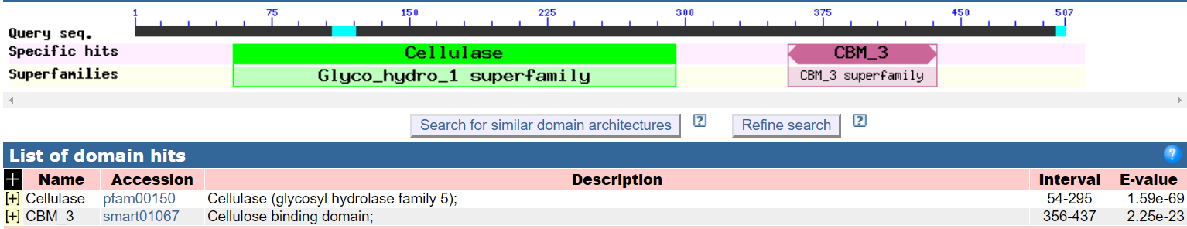
Supplementary 6

Figure S6 Domain analysis of Egl

