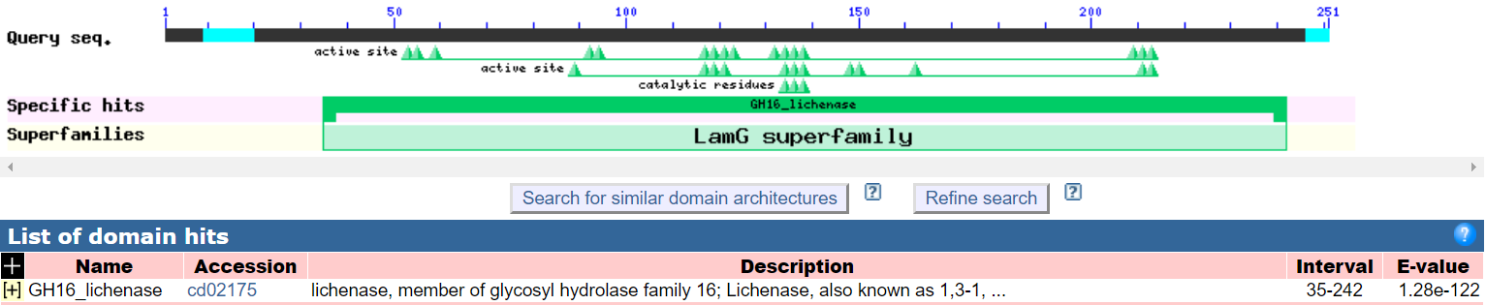
Supplementary 5

Figure S5 Domain analysis of Bgl

