**S****upplementary 3**

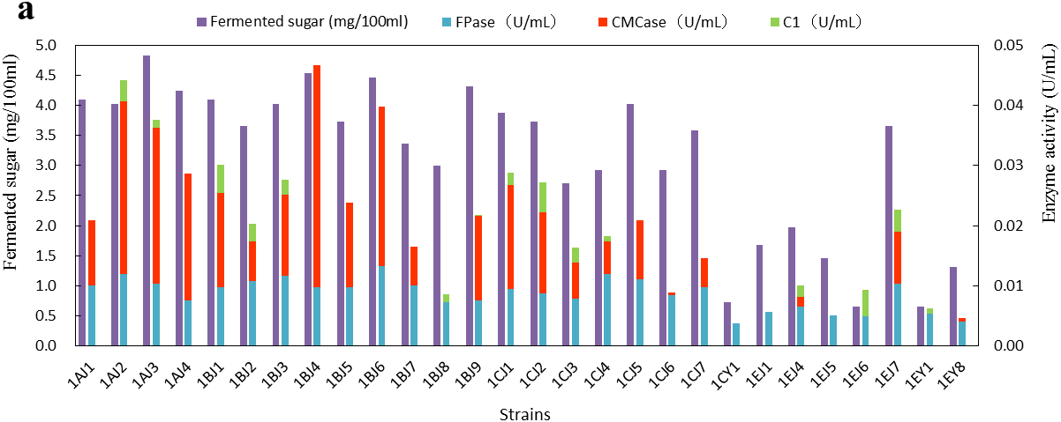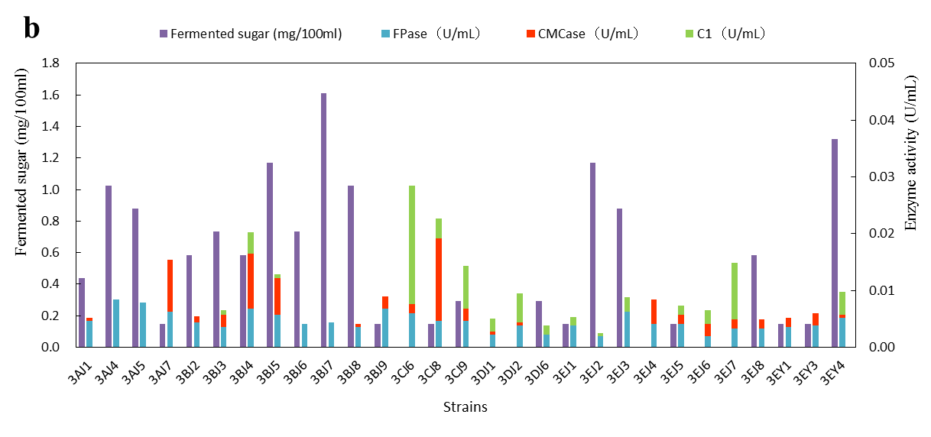

Fig.S3 Reducing sugar production and enzyme activities in CMC-Na (a) and Avicel (b) as sole carbon source medium.