Additional file 1
Synthesis of New Magnetic Hybrid Materials γFe₂O₃@Sh@Cu₂O Based on Natural Shilajit Resin and their Performance as Heterogeneous Catalyst in Reducing Agent and Base-Free Click Synthesis of 1,4-disubstituted 1,2,3-Triazoles
Fereshteh Norouzi1, Shahrzad Javanshir1*
*Shjavan@iust.ac.ir

Table of content
 | Page
Fig. S1. ¹HNMR of 1-(4-bromobenzyl)-4-(4-methoxyphenyl)-1,2,3-triazole | 2
Fig. S2. Expanded ¹HNMR spectra of 1-(4-bromobenzyl)-4-(4-methoxyphenyl)-1,2,3-triazole (aromatic region) | 2
Fig. S3. ¹³CNMR of 1-(4-bromobenzyl)-4-(4-methoxyphenyl)-1,2,3-triazole | 3
Fig. S4. ¹³CNMR of 1-(4-bromobenzyl)-4-(4-methoxyphenyl)-1,2,3-triazole | 3
Fig. S5. ¹HNMR of 1-(2-chlorobenzyl)-4-(4-methoxyphenyl)-1H-1,2,3-triazole | 4
Fig. S6. Expanded ¹HNMR spectra of 1-(2-chlorobenzyl)-4-(4-methoxyphenyl)-1H-1,2,3-triazole (aromatic region) | 4
Fig. S7. ¹³CNMR of 1-(2-chlorobenzyl)-4-(4-methoxyphenyl)-1H-1,2,3-triazole | 5
Fig. S8. Expanded ¹³CNMR spectra of 1-(2-chlorobenzyl)-4-(4-methoxyphenyl)-1H-1,2,3-triazole | 5
Fig. S9. ¹HNMR of 1-(2-chlorobenzyl)-4-(4-p-tolyl)-1H-1,2,3-triazole | 6
Fig. S10. Expanded ¹HNMR spectra of 1-(2-chlorobenzyl)-4-(p-tolyl)-1H-1,2,3-triazole (aromatic region) | 6
Fig. S11. ¹³CNMR of 1-(2-chlorobenzyl)-4-(p-tolyl)-1H-1,2,3-triazole | 7
Fig. S12. Expanded ¹³CNMR spectra of 1-(2-chlorobenzyl)-4-(p-tolyl)-1H-1,2,3-triazole | 7

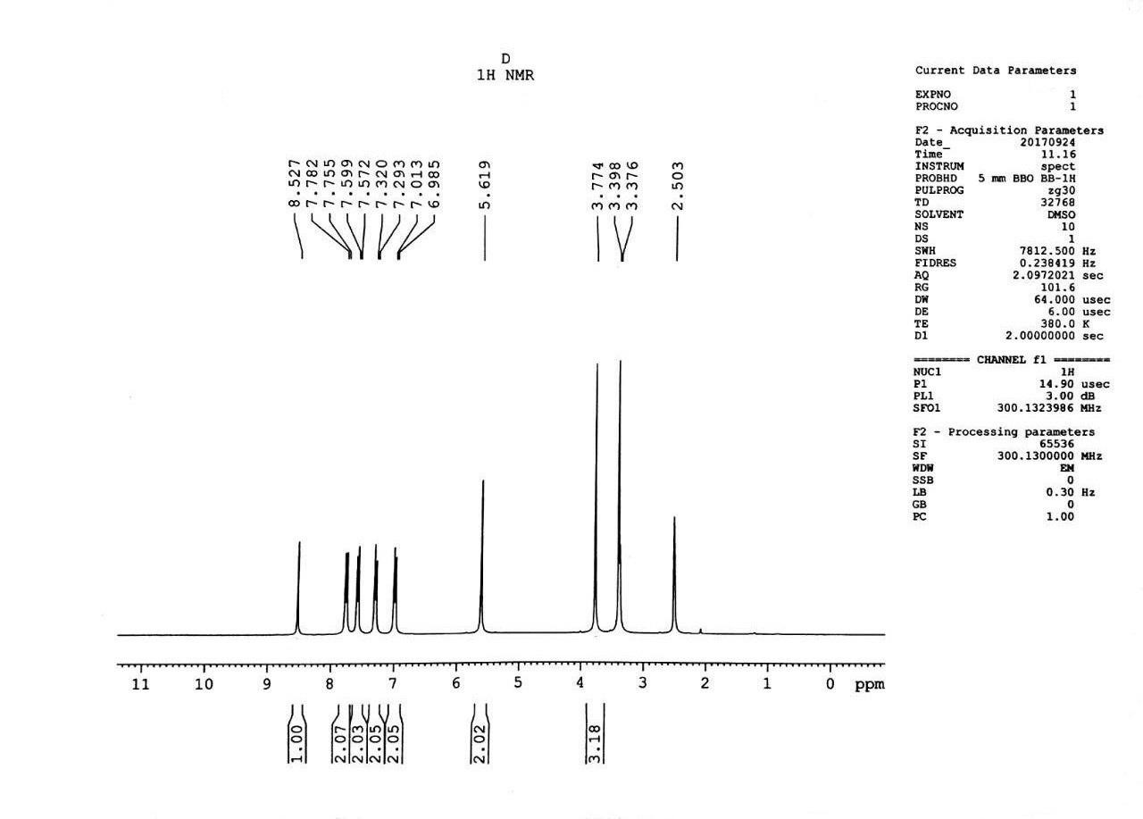

Fig. S1. ¹HNMR of 1-(4-bromobenzyl)-4-(4-methoxyphenyl)-1,2,3-triazole

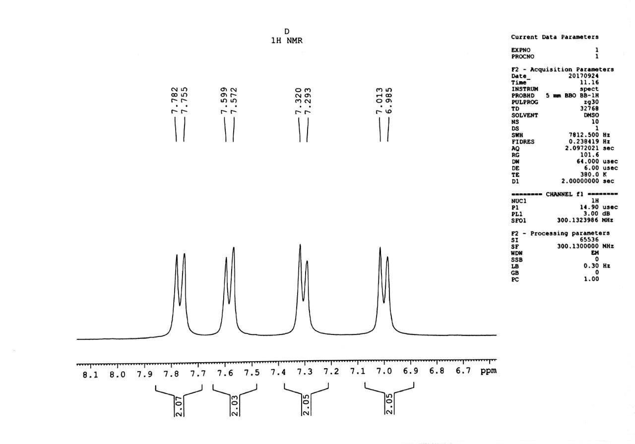
Fig. S2. Expanded ¹HNMR spectra of 1-(4-bromobenzyl)-4-(4-methoxyphenyl)-1,2,3-triazole (aromatic region)
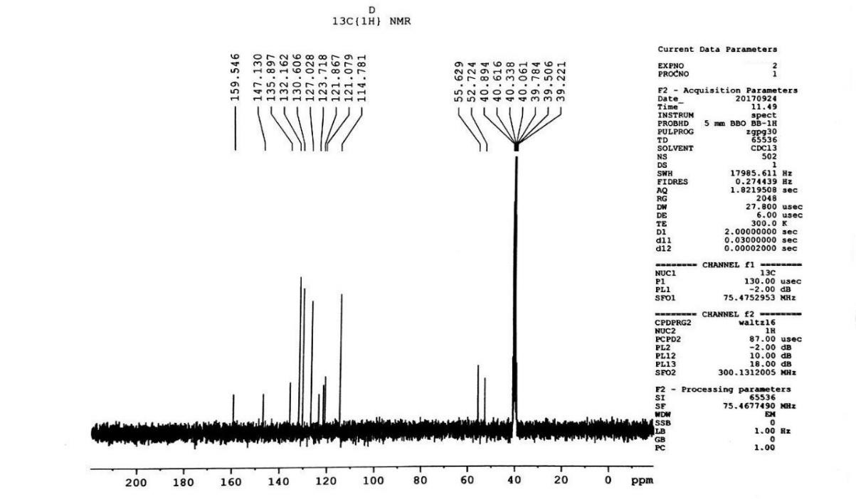
Fig. S3. ¹³CNMR of 1-(4-bromobenzyl)-4-(4-methoxyphenyl)-1,2,3-triazole

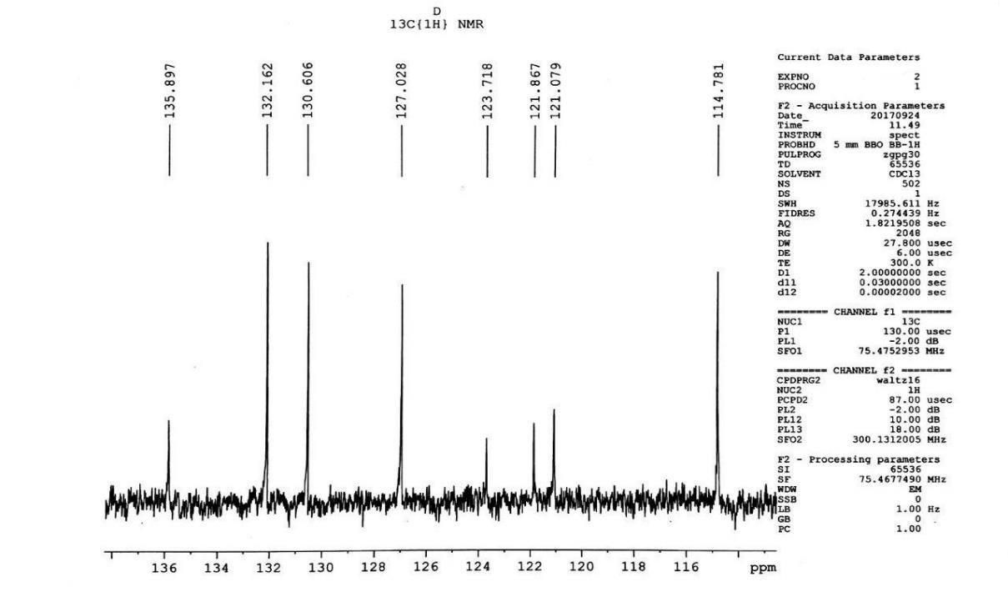
Fig. S4. ¹³CNMR of 1-(4-bromobenzyl)-4-(4-methoxyphenyl)-1,2,3-triazole

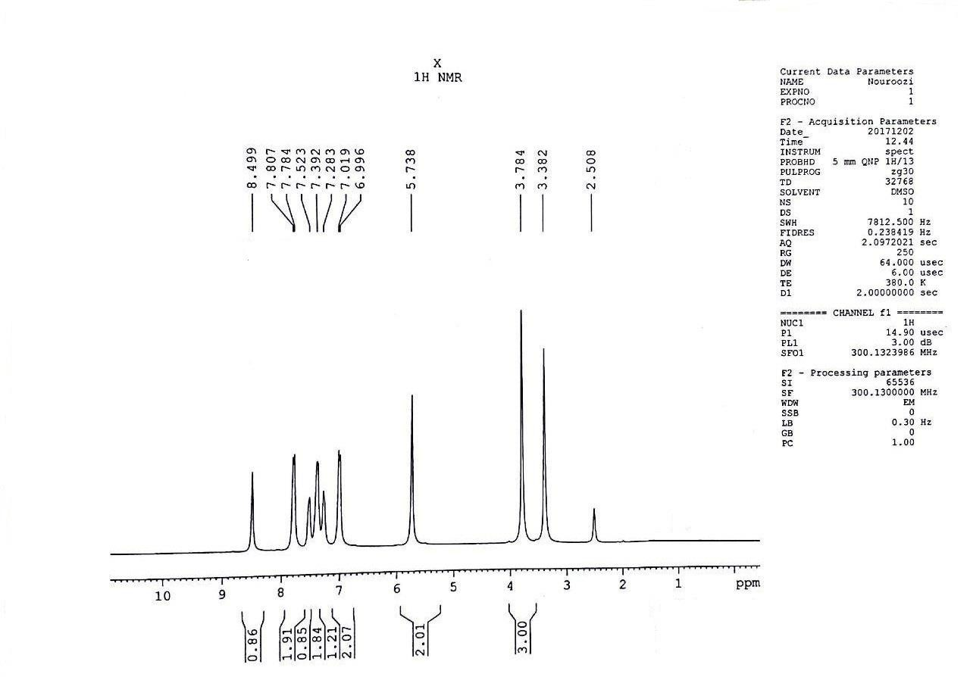
Fig. S5. ¹HNMR of 1-(2-chlorobenzyl)-4-(4-methoxyphenyl)-1H-1,2,3-triazole

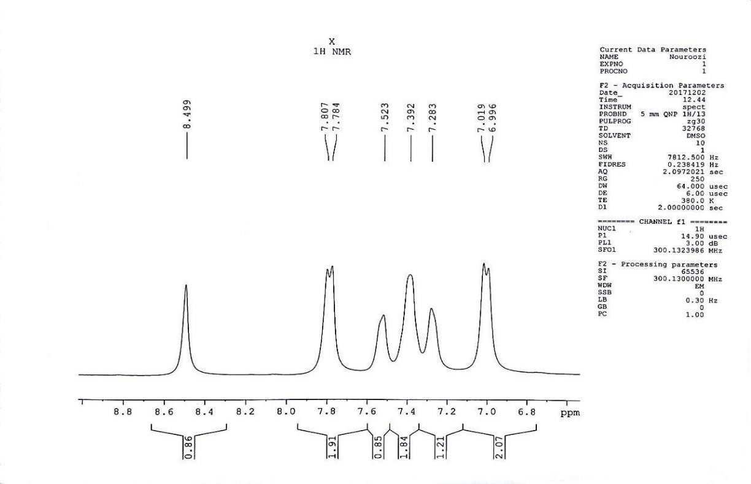
Fig. S6. Expanded ¹HNMR spectra of 1-(2-chlorobenzyl)-4-(4-methoxyphenyl)-1H-1,2,3-triazole (aromatic region)

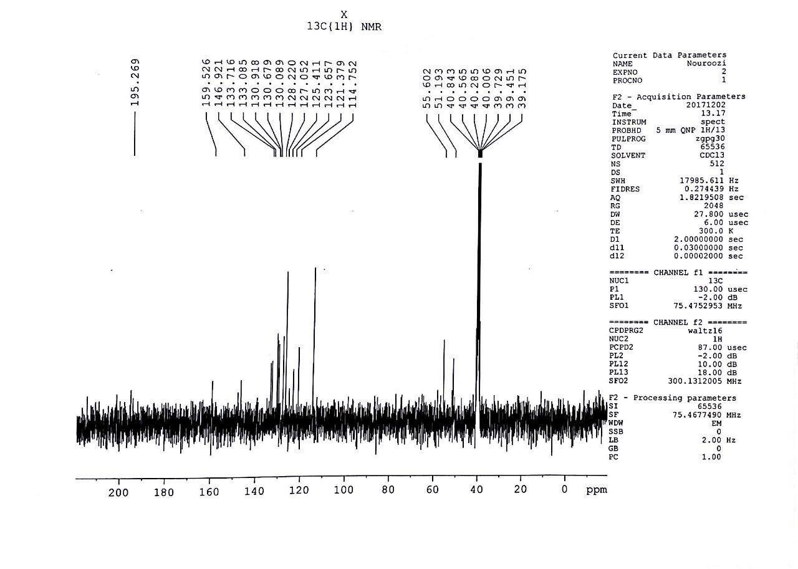

Fig. S7. ¹³CNMR of 1-(2-chlorobenzyl)-4-(4-methoxyphenyl)-1H-1,2,3-triazole

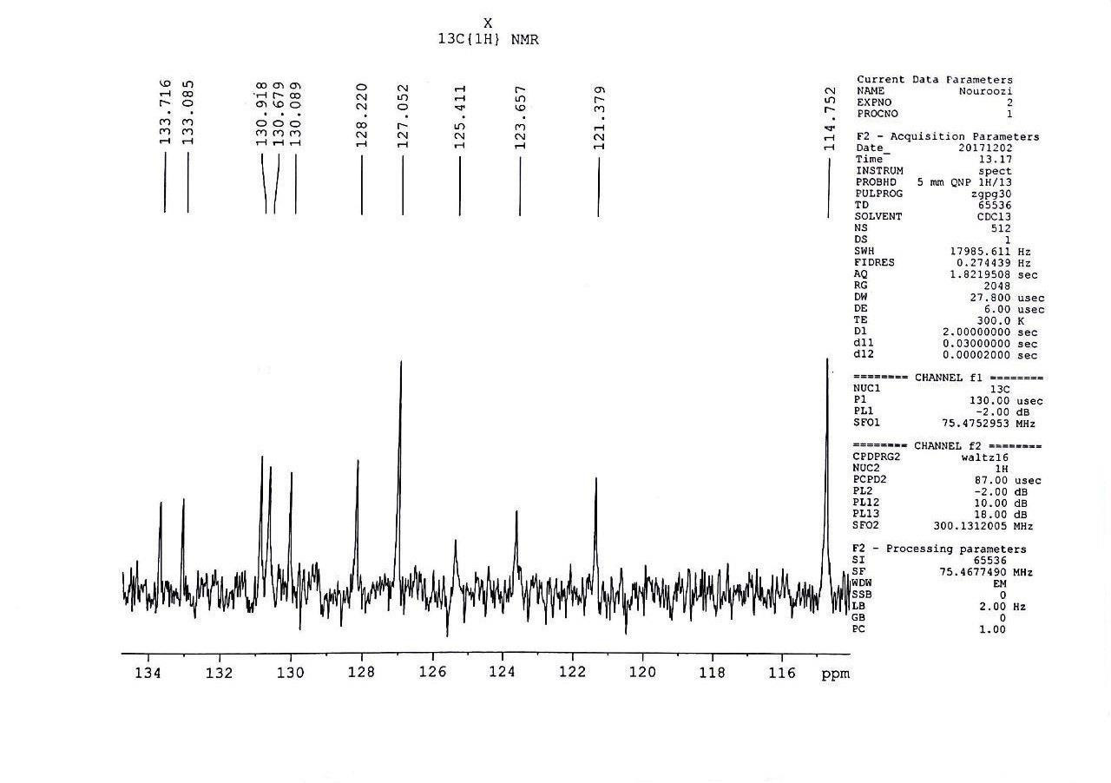
Fig. S8. Expanded ¹³CNMR spectra of 1-(2-chlorobenzyl)-4-(4-methoxyphenyl)-1H-1,2,3-triazole.
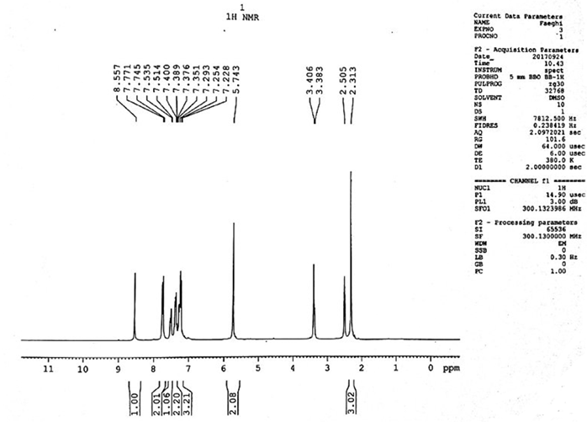
Fig. S9. ¹HNMR of 1-(2-chlorobenzyl)-4-(4-p-tolyl)-1H-1,2,3-triazole

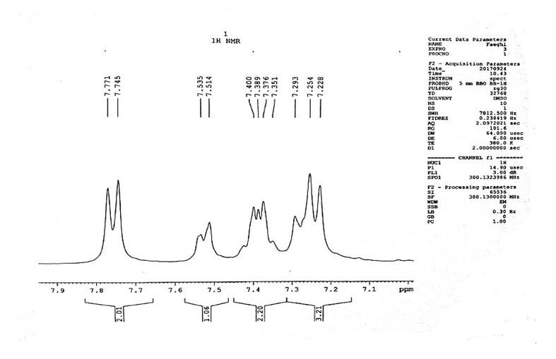
Fig. S10. Expanded ¹HNMR spectra of 1-(2-chlorobenzyl)-4-(p-tolyl)-1H-1,2,3-triazole (aromatic region)

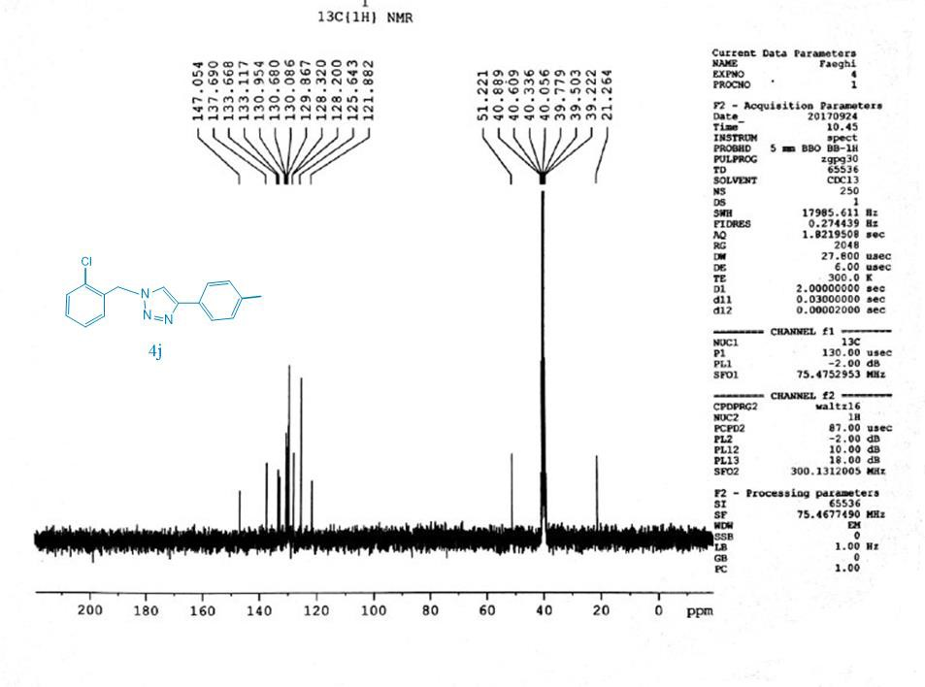
Fig. S11. ¹³CNMR of 1-(2-chlorobenzyl)-4-(p-tolyl)-1H-1,2,3-triazole

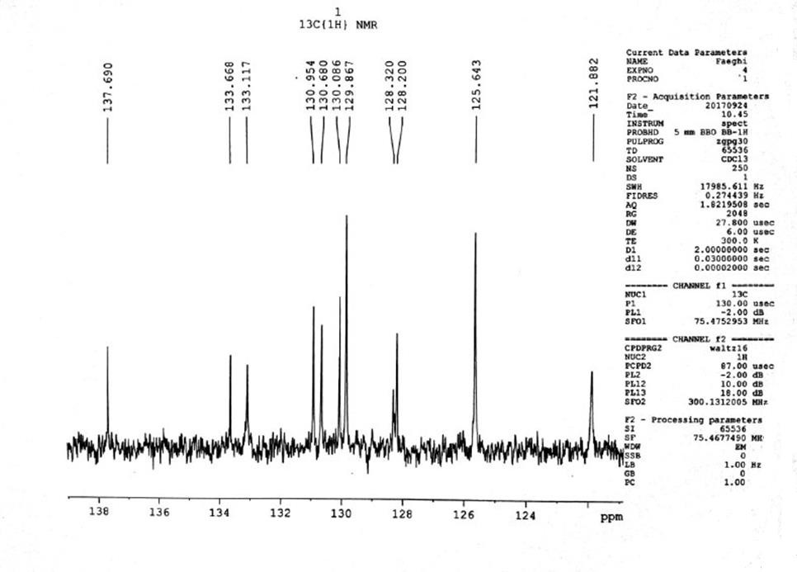
Fig. S12. Expanded ¹³CNMR spectra of 1-(2-chlorobenzyl)-4-(p-tolyl)-1H-1,2,3-triazole

