Supplementary Fig. 1 The distribution of the InDel (20-90bp) on the whole genome

Supplementary Fig. 2 The frequency of the InDel between 20-90bp

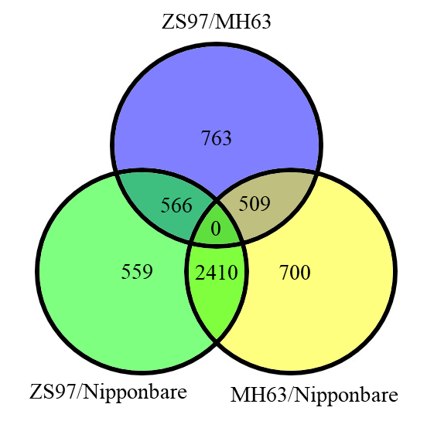
Supplementary Fig.3 Comparation of potential LInDel markers among three genomes

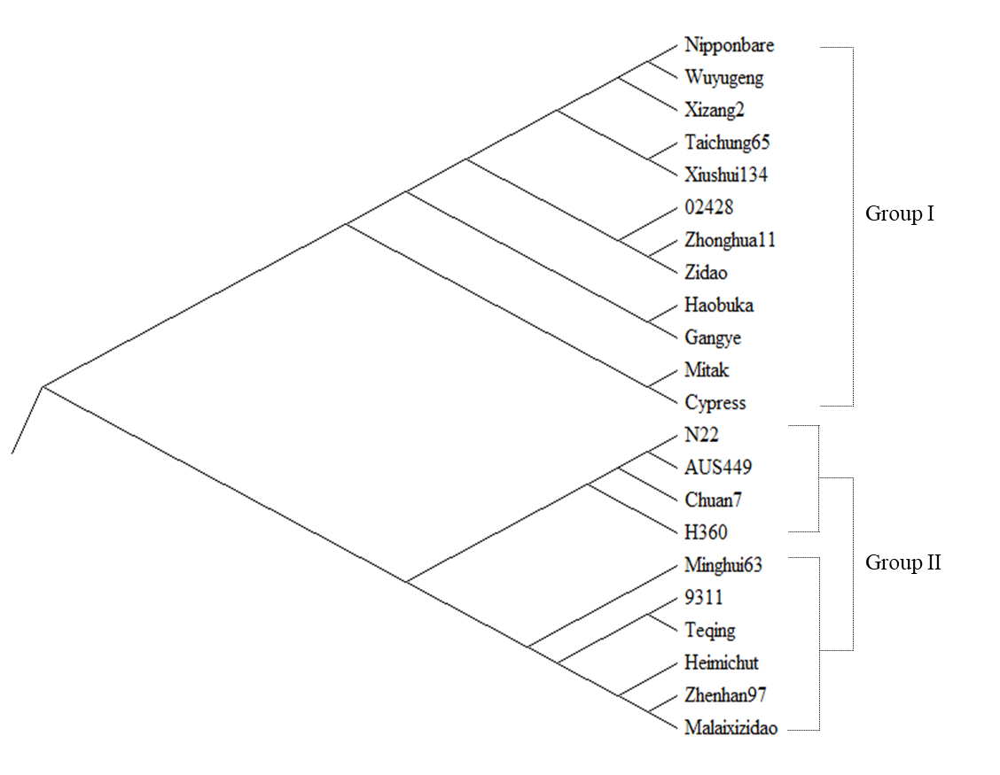

Supplementary Fig. 4 Dendrogram of 22 rice varieties derived by UPGMA from 312 LInDel markers

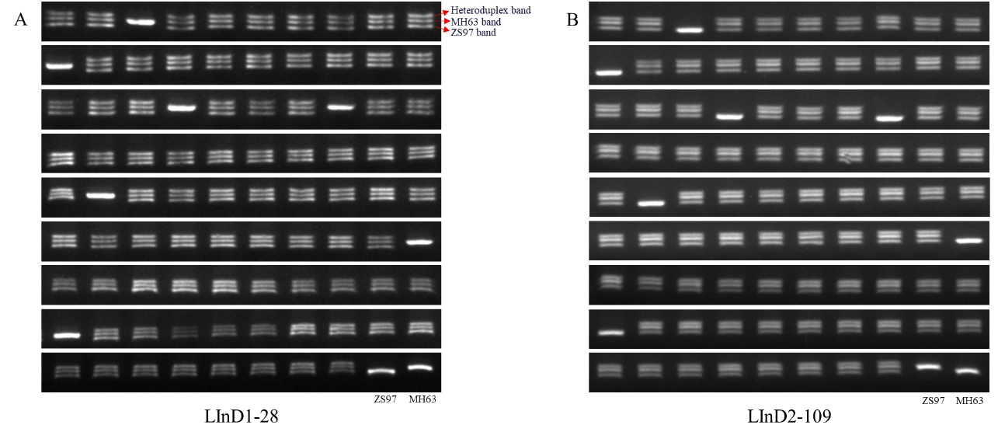
Supplementary Fig. 5 Detection of the hybrids Shanyou 63 from ZS97 and MH63 (MH63 as female parent)
90 samples, including 88 hybrid seeds and 2 parents. The last two samples were the parent ZS97 and MH63. Heterozygous genotype displayed three bands. Three different bands were explained with red arrows.
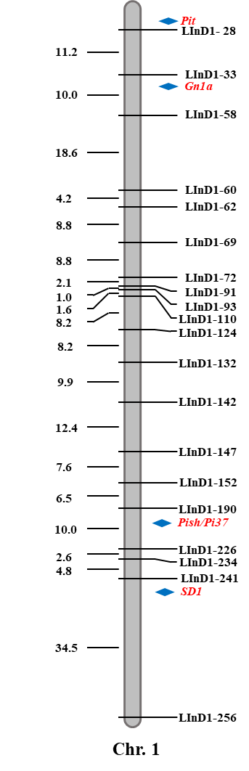
Supplementary Fig. 6 The genetic linkage map of 20 LInDel markers on chromosome 1. Four breeding markers were labeled on the corresponding position

