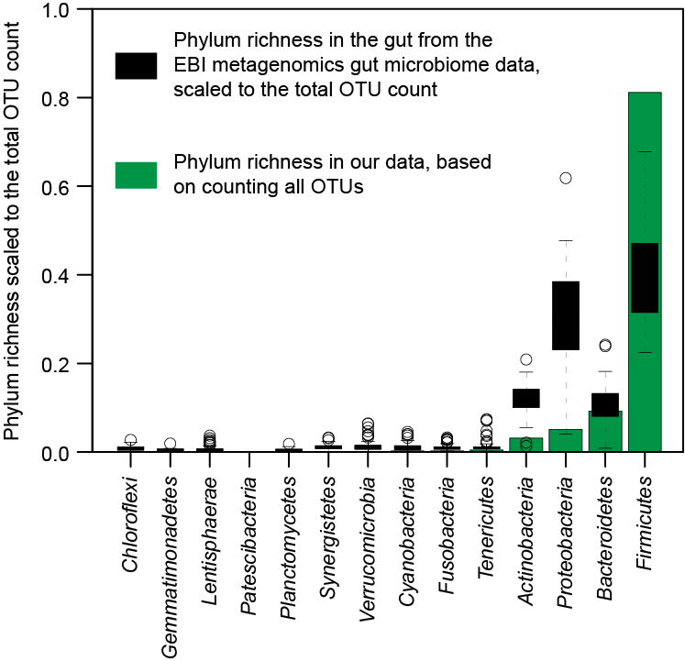
Additional file 2: Figure S1. Phylum level richness in the gut microbiota from our samples (shown in green) compared to the gut microbial species richness obtained across studies, each with more than 100 OTUs (total 81 study), from a variety of conditions (shown in black).

