Figure S1. Top 10 causes of DALYs in 2017 and percent change, 2007-2017, Scotland, all ages, number
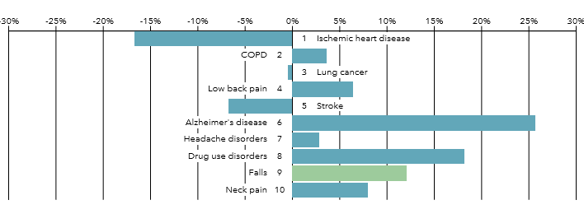
Causes of disease/injury ranked based on descending order of number of Disability-Adjusted Life Years (DALYs); Source: GBD 2017 country profile for Scotland (Accessed 27 September 2019)

Figure S2. Top 10 causes of DALYs in 2017, Scotland, all ages, age-standardised rate (GBD WSP), by location
Comparisons are made relative to the group mean; Comparison groups were chosen based on the GBD regional classifications, known trade partnerships, and socio-demographic indicators; Source: GBD 2017 country profile for Scotland (Accessed 27 September 2019)

