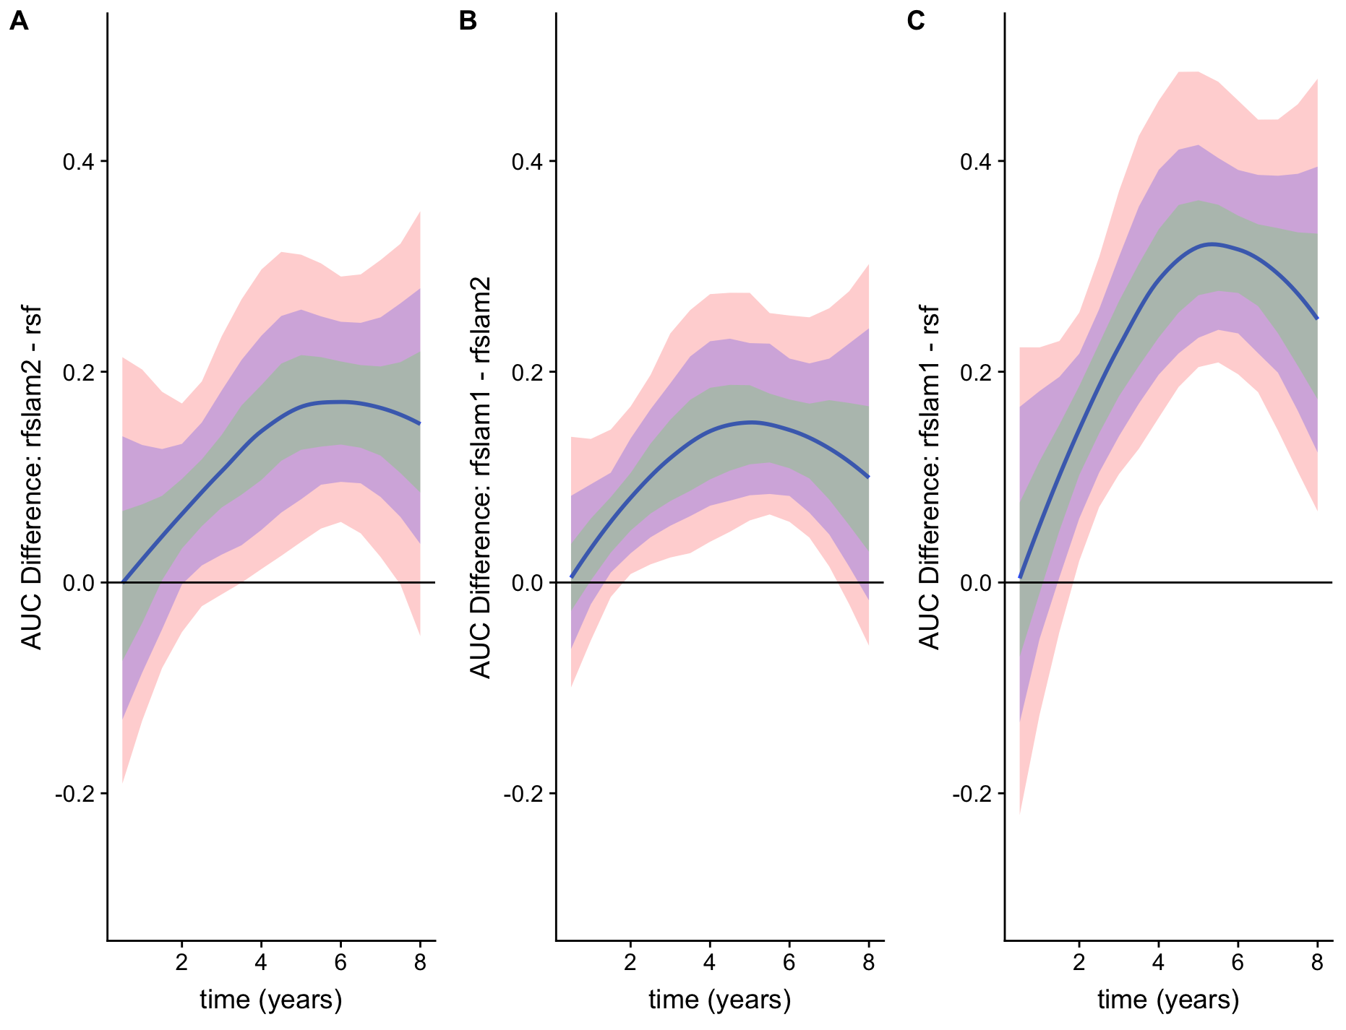

Supplementary Figure 1: Pairwise Comparisons of Time-Varying AUC Estimates

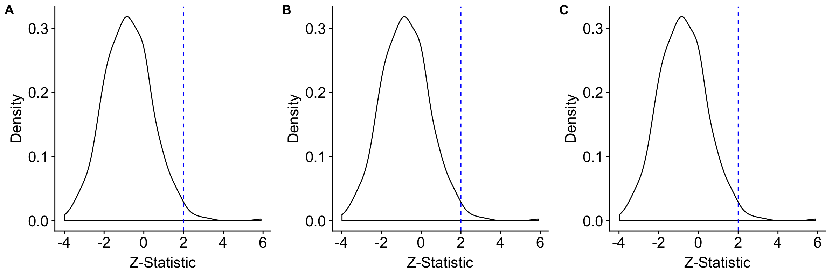
Supplementary Figure 2: Calibration Assessment with Spiegelhalter's Z-Statistic

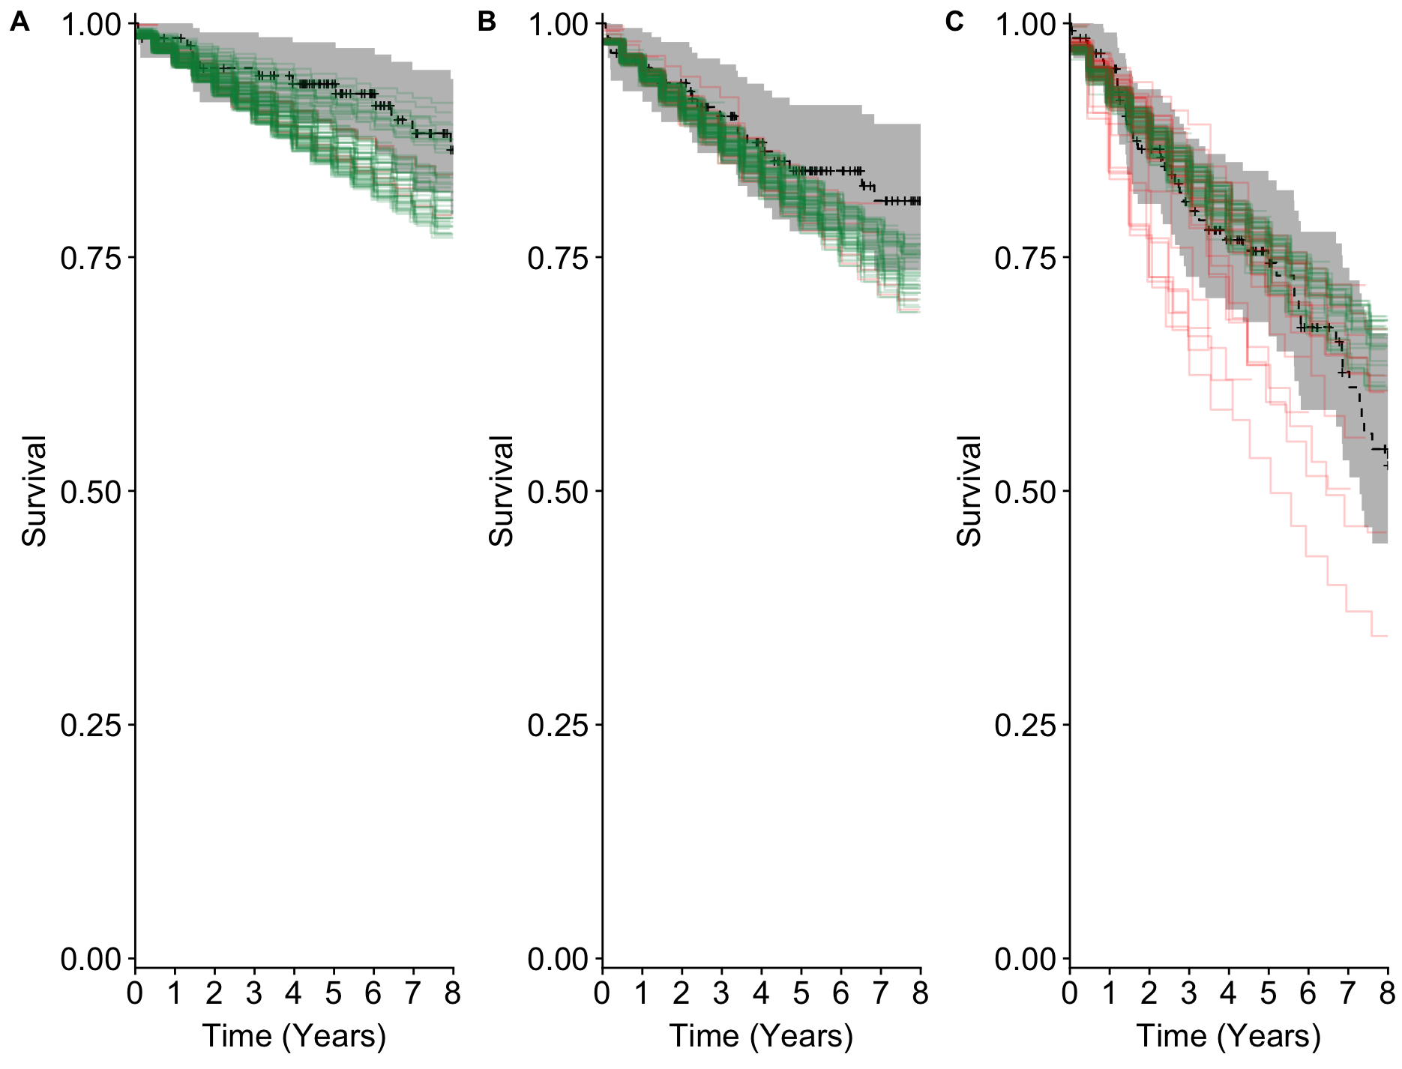

Supplementary Figure 3: Visualization of Calibration and Discrimination Through Comparison of Survival Curves by Tertile of Risk

Supplementary Table 1: Summary of Predictors in the Left Ventricular Structural Predictors of Sudden Cardiac Death (SCD) Prospective Observational Registry

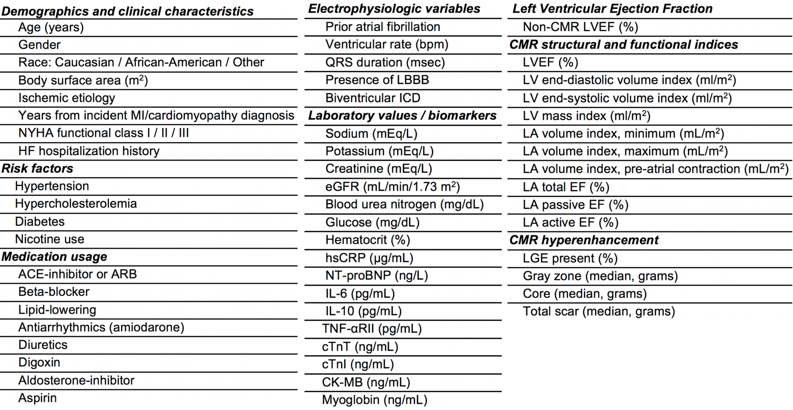

Supplementary Table 2: Summary of the Three Methods Compared
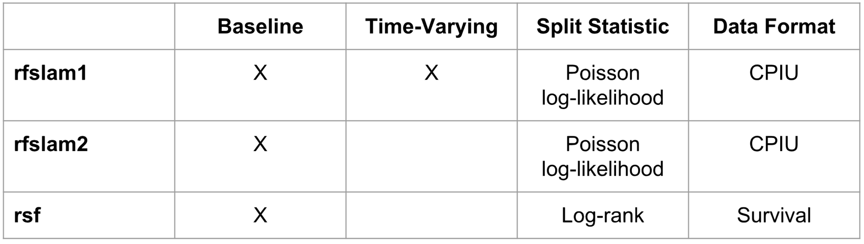

Supplementary Table 3: Comparison Between RF-SLAM and RSF
