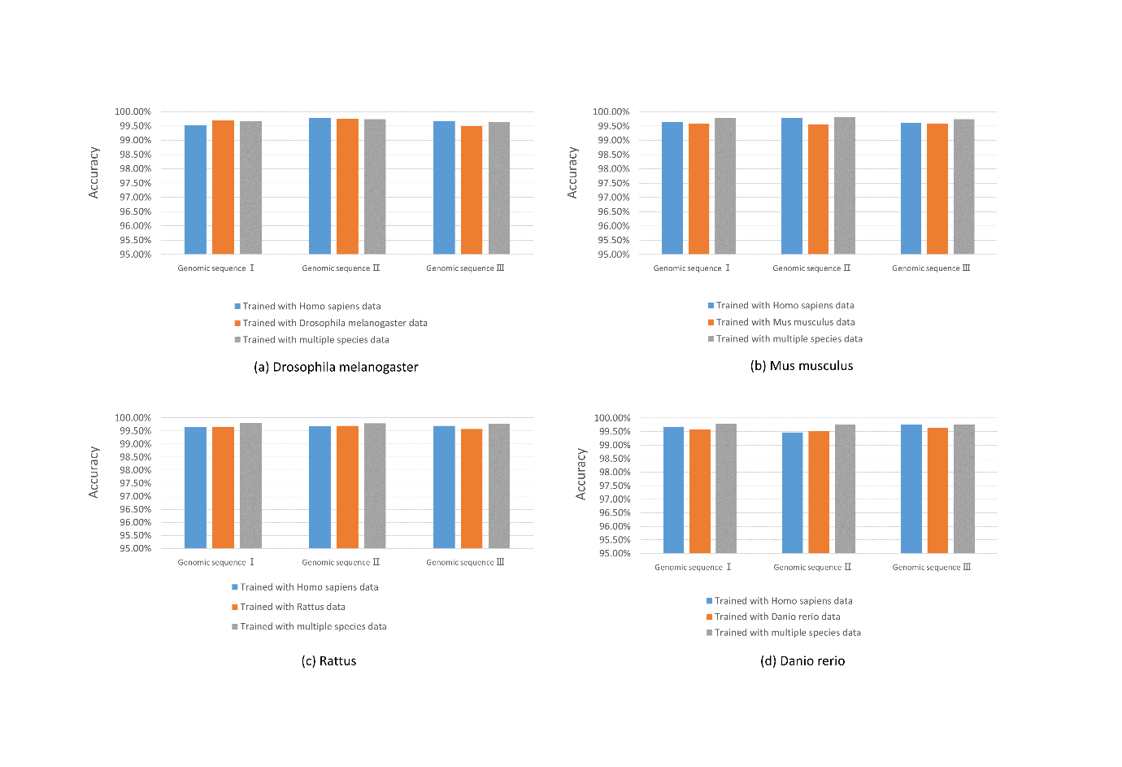
Figure S4 The performance of models trained with data of other species. The models trained with other species and multiple species are used to predict splice sites on three randomly chosen sequences of genes for (a) Drosophila melanogaster, (b) Mus musculus, (c) Rattus and (d) Danio rerio.

