Additional file
Additional Figure S1: Literature search flowchart
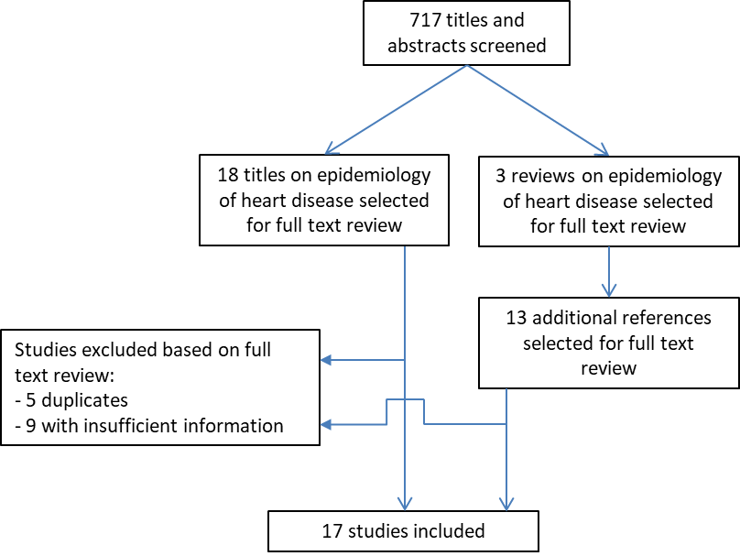

Additional Table S1: Baseline characteristics of included studies on etiologies of cardiac disease in SSA (2008-2018)
First author, year | Country | Setting | Design | Inclusion criteria | Male  % | Mean age | Number  (% HF)ª
Ansa, 2016 | Nigeria | Cardiology department of teaching hospital | RS | Patients >17 with cardiovascular admissions including stroke | 39 | 55^{b} | 339 (43)
Appiah, 2017 | Ghana | Referral/teaching hospital | RS | Adult patients with cardiac admission | 52 | 59 | 1916 (88)
Bonsu, 2017 | Ghana | Cardiology department of teaching hospital | RS | Patients >17 with first discharge for HF | 46 | 60 | 1488 (100)
Boombhi, 2017 | Cameroon | Cardiology department of teaching hospital | RS | Patients >15 admitted with acute HF | 43 | 61 | 148 (100)
Damasceno, 2012 | Multicentre^{c} | Referral/teaching hospital | POS | Patients >12 admitted with acute HF | 49 | 52 | 1006 (100)
Dokainish, 2017 | Multicentre^{d} | Hospital and outpatient clinic | POS | Patients >17 with HF | 52 | 53 | 1294 (100)
Kingery, 2017 | Tanzania | Public hospital | POS | Patients >17 admitted to medical ward | 38 | 51 | 588 (25)
Kwan, 2013 | Rwanda | District hospital | POS | Patients (all ages) with HF | 30 | 35^{b} | 192 (100)
Makubi, 2014 | Tanzania | Cardiology department of teaching hospital | POS | Patients >17 with HF | 49 | 55 | 427 (100)
Massoure, 2013 | Djibouti | Referral/teaching hospital | RS | Adults admitted with HF | 84 | 55 | 45 (100)
Mwita, 2017 | Botswana | Referral/teaching hospital | POS | Patients >17 admitted with acute HF | 54 | 54 | 193 (100)
Nkoke, 2017 | Cameroon | Semi urban regional hospital | RS | Patients (all ages) undergoing echocardiography | 43 | 58 | 529 (45)
Ogah, 2013 | Nigeria | Referral/teaching hospital | POS | Adult patients with acute HF | 55 | 56 | 452 (100)
Ojji, 2013 | Nigreria | Cardiology department of teaching hospital | POS | First referral to cardiology clinic | 49 | 49 | 1515 (31)
Onwuchekwa, 2009 | Nigeria | Referral/teaching hospital | RS | Patients >17 admitted with HF | 57 | 54 | 423 (100)
Pio, 2014 | Togo | Cardiology department of teaching hospital | RS | Admission with HF | 48 | 52 | 297 (100)
Stewart , 2008 | South Africa | Cardiology department of teaching hospital | POS | Patients with HF | 43 | 55 | 844 (100)
ª Only patients with heart failure were included in further analyses.
^{b} In these studies a median age was provided.
^{c} Including patients from Senegal, Nigeria, Cameroon, South Africa, Mozambique, Uganda, Kenya, Ethiopia, and Sudan.
^{d} Including patients from Mozambique, Nigeria, South-Africa, Sudan and Uganda.
Abbreviations: RS: retrospective study, POS: prospective observational study, HF: heart failure.

