Supplementary materials
Electrochemical study of TiO₂ in aqueous AlCl₃ electrolyte and vacuum impregnation for superior high-rate electrode performance

A.W. Holland, A. Cruden, Aysen Zerey, Andrew Hector and R.G.A. Wills

Table S1. Material and performance overview of selected high power aqueous devices using a combination of capacitive, psuedocapacitive and battery electrodes.
Paper | Electrode materials (negative//positive) | Electrolyte | Voltage range | Energy at max power | Energy at min power
Menzel et al, Prog. Nat. Sci., 25, 2015 [1] | AC//AC | KI/Mg(NO₃)₂ pH9 | 0 V – 1.8 V (linear) | 10 Wh kg⁻¹ at 3 kW kg⁻¹ | 30 Wh kg⁻¹ at 0.2 kW kg⁻¹
Zhou et al, RSC Adv, 6, 2016 [2] | AC//PB | Na₂SO₄ | 0 V – 1.8 V (linear to 1V with sharp increase after) | 10 Wh kg⁻¹ at 0.4 kW kg⁻¹ | 10 Wh kg⁻¹ at 1.2 kW kg⁻¹
Fic et al, Electro. Acta, 206, 2016 [3] | AC//AC | LiNO₃/KOH | - | 15 Wh kg⁻¹ at 10 kW kg⁻¹ | 20 Wh kg⁻¹ at 0.1 kW kg⁻¹
Lu et al, J. Mater. Chem. A, 3, 2015 [4] | Fe₃O₄-rGO//MnHCF | 0.5 M Na₂SO₄ | 0 V – 1.8 V (approx. linear) | 28 Wh kg⁻¹ at 2.2 kW kg⁻¹ | 43 Wh kg⁻¹ at 0.27 kW kg⁻¹
Zhao et al, ACS AMI, 6, 2014 [5] | rGO//CoHCF | 0.5 M Na₂SO₄ | 0 V – 2 V (curved without distinct plateau) | 6.7 Wh kg⁻¹ at 25 kW kg⁻¹ | 34 Wh kg⁻¹ at 2.4 kW kg⁻¹
Hanna et al, JPS, 354, 2017 [6] | AC//LiMn₂O₄ | 2M Li₂SO₄ | 0.5 V – 1.8 V (approx.. linear) | - | 14 Wh kg⁻¹
Pasta et al, Nat. Comms, 5, 2014 [7] | MnHCF//CuHCF | 10M NaClO₄ | 0.5 V – 1.3 V (faradaic S-curve) | 15 Wh kg⁻¹ at 0.693 kW kg⁻¹ | 27 Wh kg⁻¹ at 0.027 kW kg⁻¹
Yu et al, Ceramic. Int, 43, 2017 [8] | NaTi₂(PO₄)₃// Na_{2/3}Ni_{1/4}Mn_{3/4}O₂ | 1M Na₂SO₄/1M Li₂SO₄ | 0.6 V – 1.7 V (plateaus present) | 16.5 Wh kg⁻¹ at 0.798 kW kg⁻¹ | 36 Wh kg⁻¹ at 0.016 W kg⁻¹

…continued  Paper | Electrode materials (negative//positive) | Electrolyte | Voltage range | Energy at max power | Energy at min power
Kumar et al, Electro. Acta, 220, 2016 [9] | MnO₂//MnO₂ | 1M Na₂SO₄ | 0 V – 1 V (linear discharge) | 8 Wh kg⁻¹ at 3.6 kW kg⁻¹ | 39 Wh kg⁻¹ at 0.32 kW kg⁻¹
Zhang et al, ACS AMI, 9, 2017 | AC//SiO₂@TiO₂ | 1M KOH | 0 V – 1.5 V (triangular with curve) | 14.9 Wh kg⁻¹ at 3 kW kg⁻¹ | 29 Wh kg⁻¹ at 0.375 kW kg⁻¹
Abbas et al, JPS, 326, 2016 [10] | AC//AC | KI/Li₂SO₄ | - | 16.2 Wh kg⁻¹ at 1.7 kW kg⁻¹ | 26 Wh kg⁻¹ at 0.075 kW kg⁻¹
Mostazo-Lopez et al, Int. J. Hydrogen En, 41, 2016 [11] | Doped-C//doped-C | 1M H₂SO₄ | 0V – 1.2 V (linear) | 3.5 Wh kg⁻¹ at 10 kW kg⁻¹ | 10 Wh kg⁻¹ at 0.1 kW kg⁻¹
Pazhamalai et al, J. Ind. Eng. Chem, 64, 2018 [12] | Graphene//MnHCF | LiNO₃/KOH | 0 V – 2 V (approx. linear) | 31 Wh kg⁻¹ at 3.2 kW kg⁻¹ | 44 Wh kg⁻¹ at 0.59 kW kg⁻¹
Liu et al, Electro. Acta, 188, 2016 [13] | Graphene-Ni//Cu_{1.79}Co_{0.21}CH | 6M KOH | 0 V – 1.6 V (curve on charge) | 7.1 Wh kg⁻¹ at 4 kW kg⁻¹ | 21.5 Wh kg⁻¹ 0.2 kW kg⁻¹
Peng at al, ACS Sust. Chem. Eng, 5, 2017 [14] | Doped-C//NiSe-MoSe₂ | 2M KOH | 0 V – 1.6 V (curved) | 19.6 Wh kg⁻¹ at 8.6 kW kg⁻¹ | 32.6 Wh kg⁻¹ at 0.415 kW kg⁻¹⁻
Peng et al, JPS, 297, 2015 [15] | Co_{0.85}Se//doped-C | 2M KOH | 0 V – 1.6 V (slight curve) | 13.2 Wh kg⁻¹ at 7.5 kW kg⁻¹ | 21.1 Wh kg⁻¹ at 0.4 kW kg⁻¹

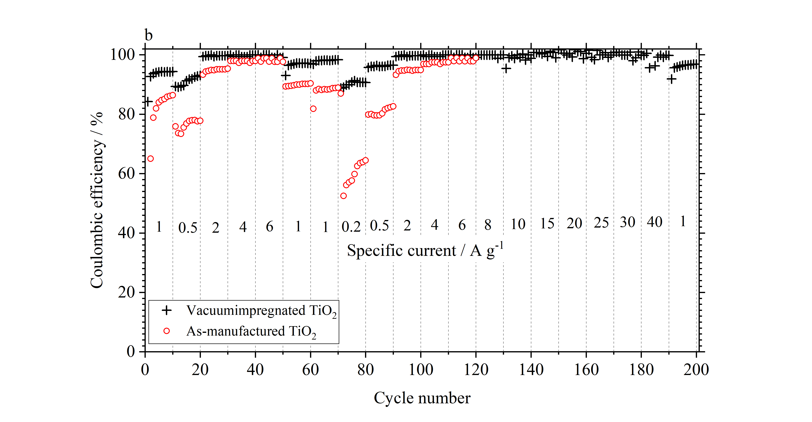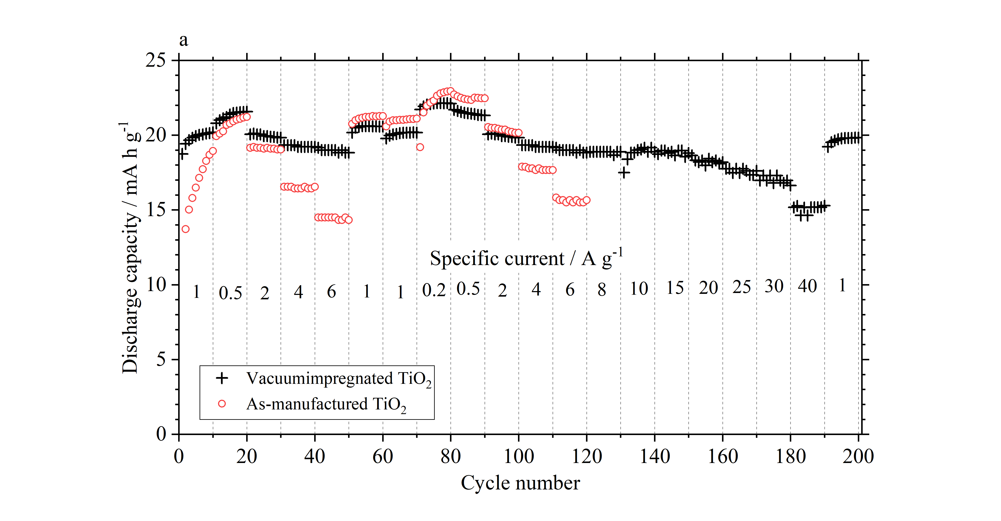

Figure S1. Capacity and coulombic efficiency vs cycle number for a vacuum (a) and non-vacuum (b) impregnated electrode cycled between +0.4 V to -1.0 V vs SCE in 1 mol dm⁻³ AlCl₃/1 mol dm⁻³ KCl.

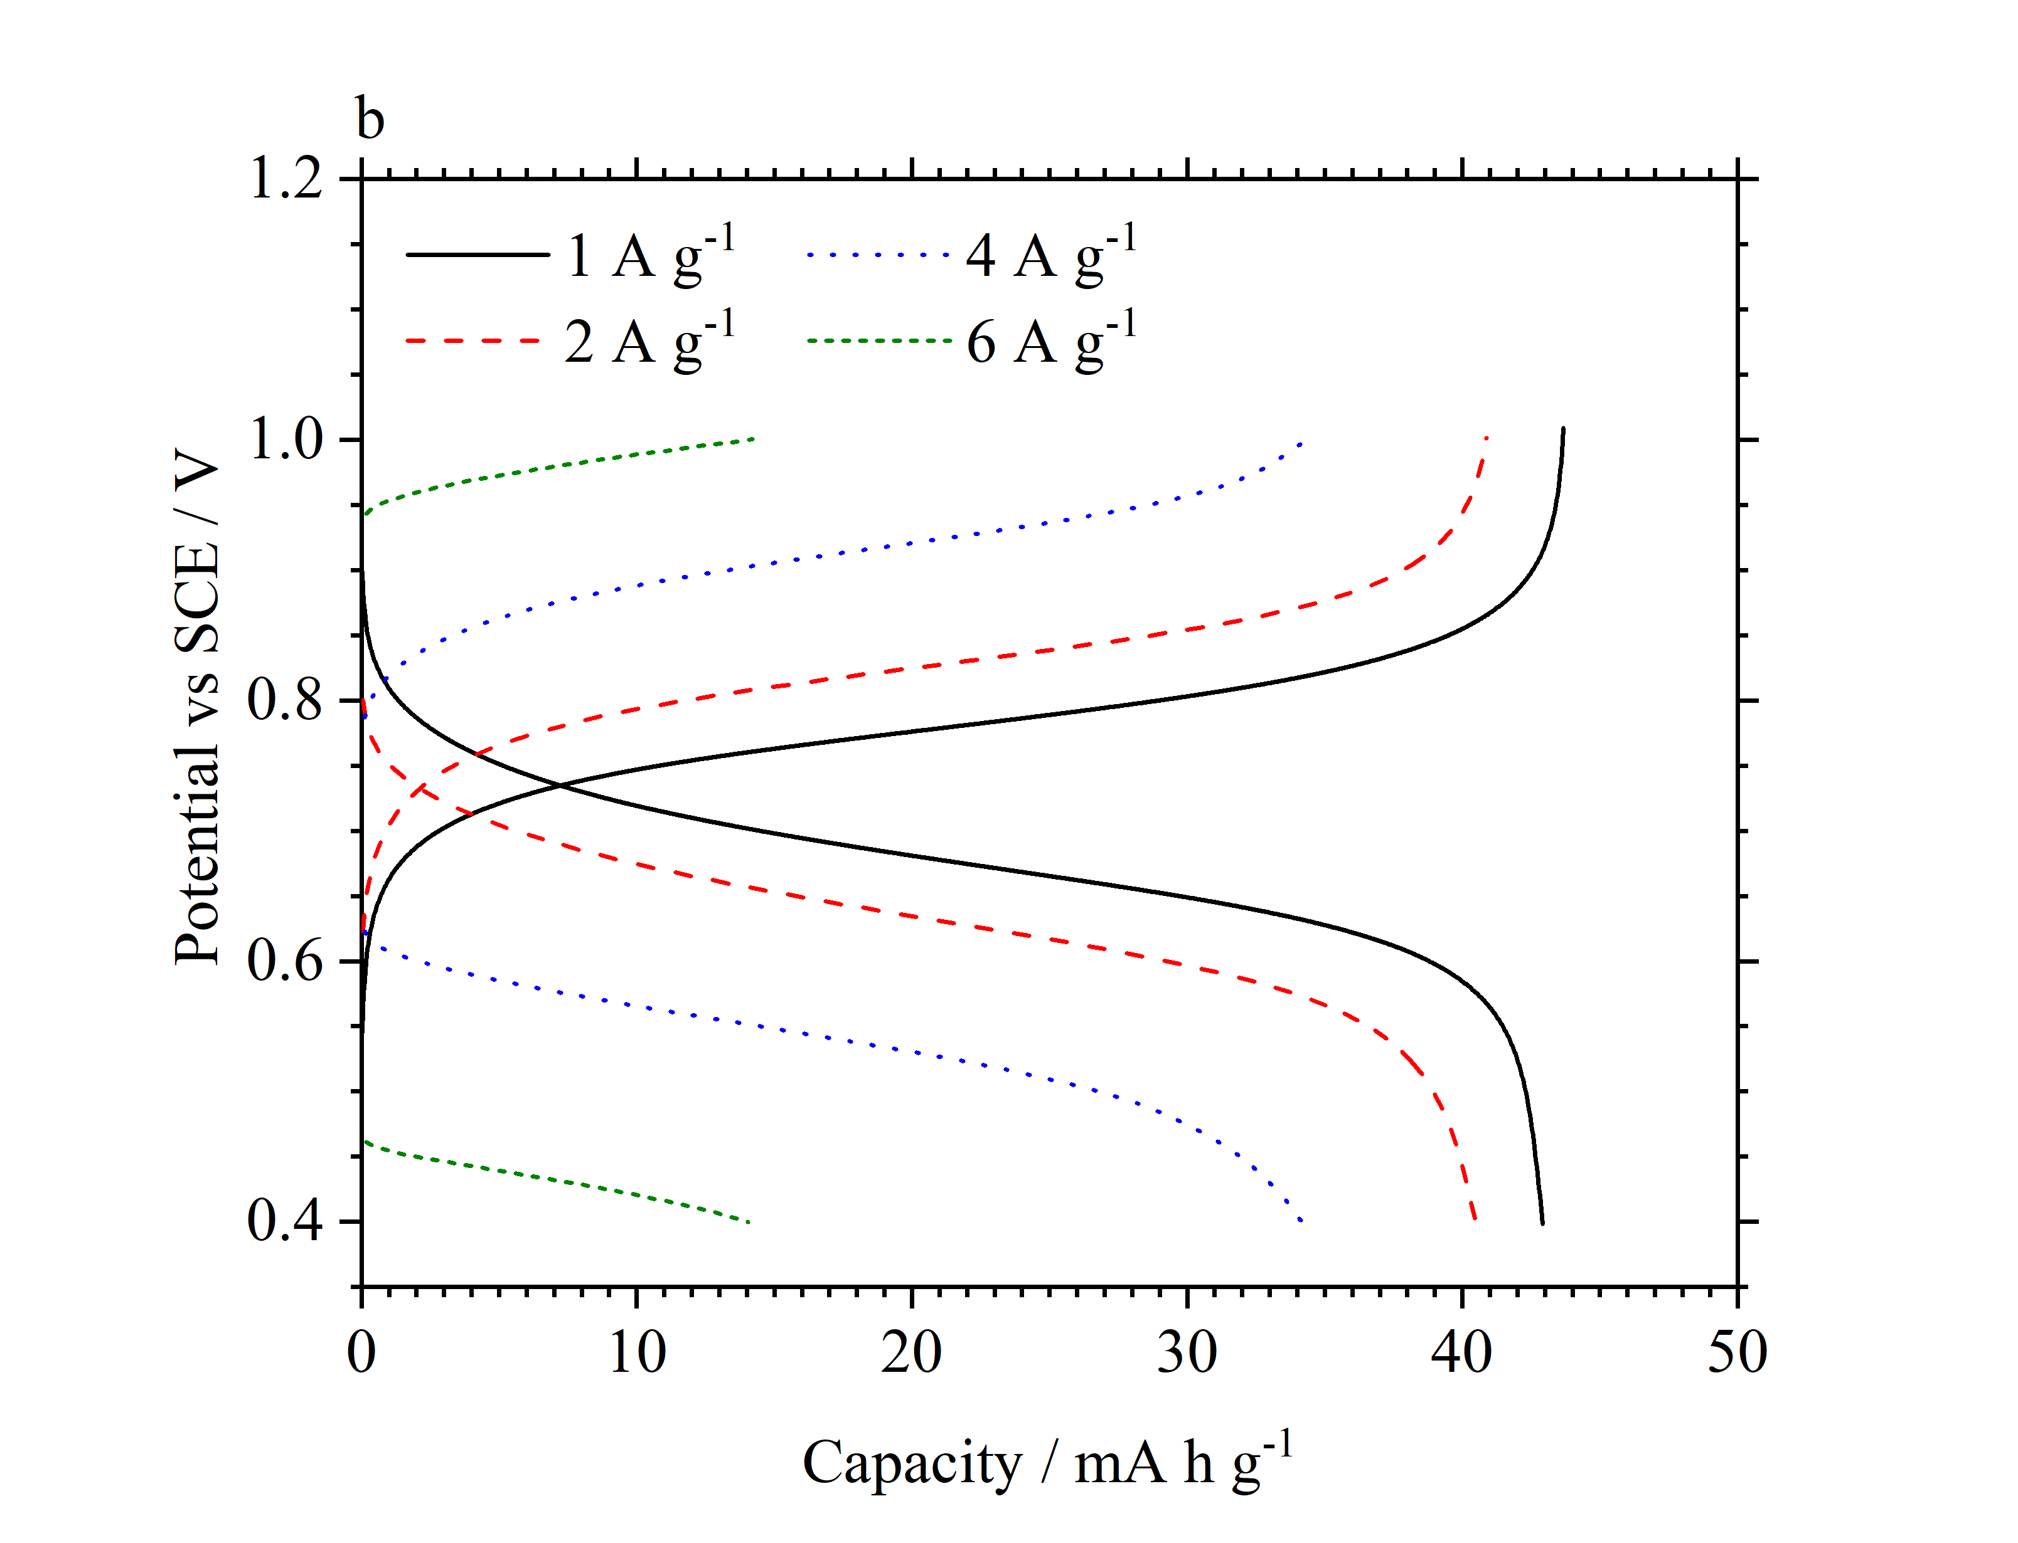
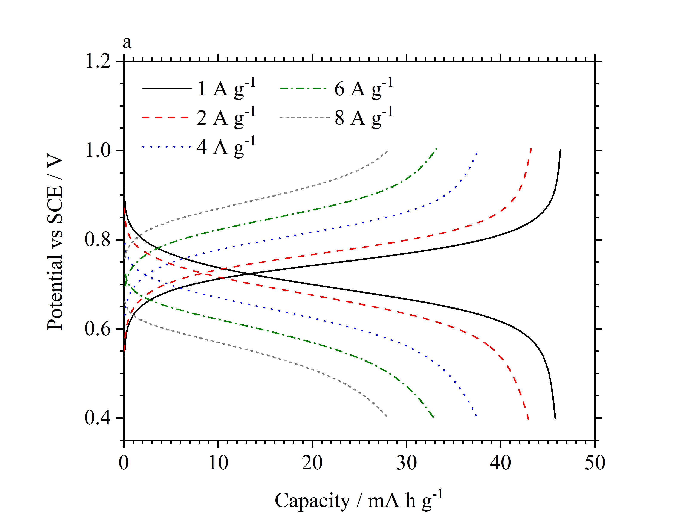
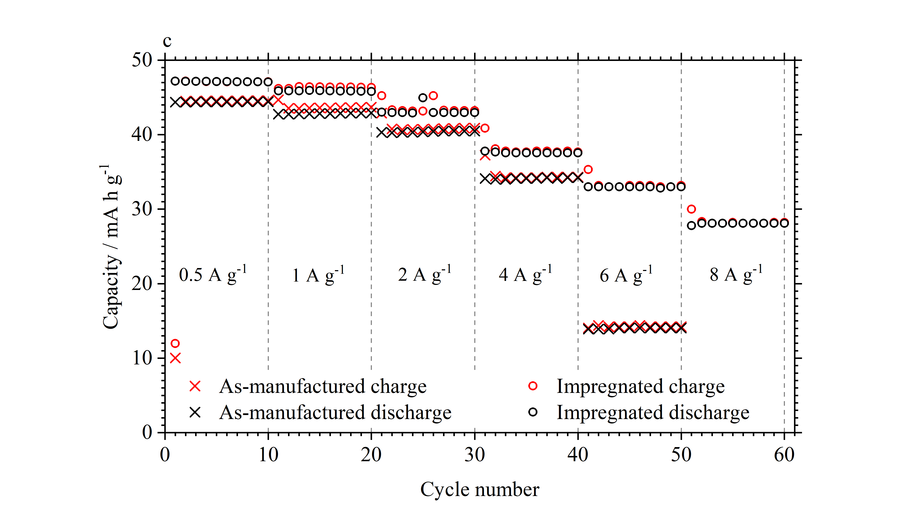
Figure S2. Voltage profiles of vacuum impregnated CuHCF (a) and as-manufactured CuHCF (b) vs SCE, in 1 mol dm⁻³ AlCl₃/1 mol dm⁻³ KCl. (c) charge and discharge capacity of the same CuHCF electrodes as a function of cycle number and specific current.

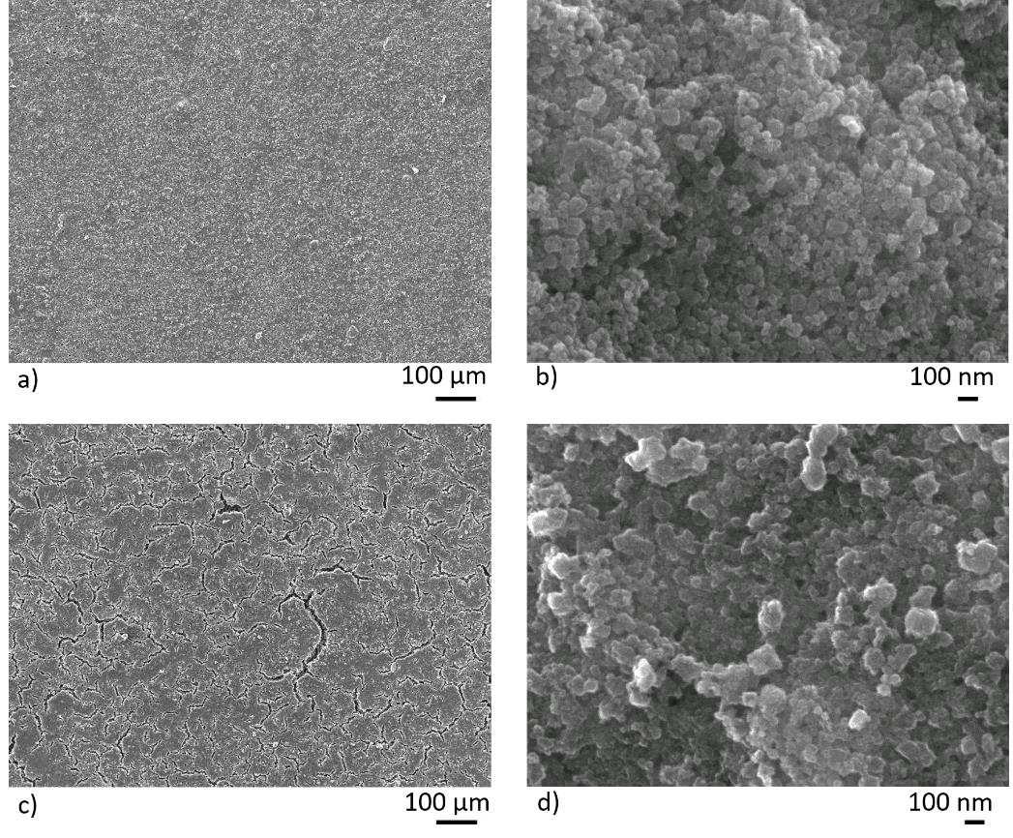
Figure S3. SEM images of two 25 nm TiO2 electrodes. (a) and (b) are of a pristine electrode with (c) and (d) taken from an electrode that had undergone 5000 cycles. Top and bottom images are at x100 and x75000 magnification respectively.

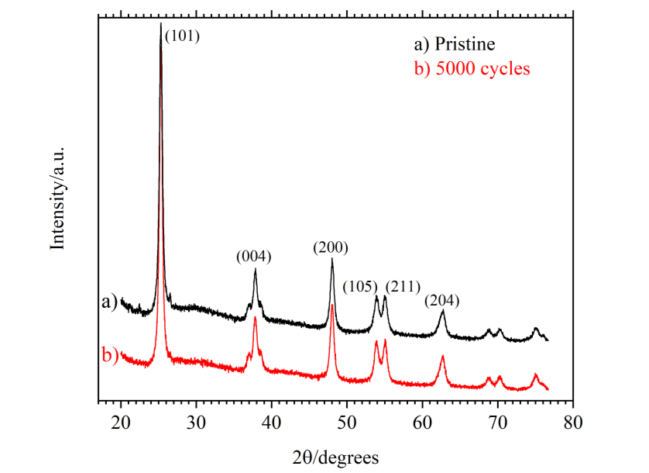
Figure S4. XRD patterns of two 25 nm TiO2 electrodes: pristine (a) and after 5000 cycles (b) at 2.0 A g-1 in 1 mol dm-3 AlCl3/1 mol dm-3 KCl.

References
1. Menzel, J., K. Fic, and E. Frackowiak, Hybrid aqueous capacitors with improved energy/power performance. Progress in Natural Science: Materials International, 2015. 25(6): p. 642-649.
2. Zhou, L., et al., Prussian blue as positive electrode material for aqueous sodium-ion capacitor with excellent performance. RSC Advances, 2016. 6(111): p. 109340-109345.
3. Fic, K., et al., Around the thermodynamic limitations of supercapacitors operating in aqueous electrolytes. Electrochimica Acta, 2016. 206: p. 496-503.
4. Lu, K., et al., An advanced aqueous sodium-ion supercapacitor with a manganous hexacyanoferrate cathode and a Fe3O4/rGO anode. Journal of Materials Chemistry A, 2015. 3(31): p. 16013-16019.
5. Zhao, F., et al., Cobalt Hexacyanoferrate Nanoparticles as a High-Rate and Ultra-Stable Supercapacitor Electrode Material. ACS Applied Materials & Interfaces, 2014. 6(14): p. 11007-11012.
6. Hanna, O., et al., Aqueous energy-storage cells based on activated carbon and LiMn2O4 electrodes. Journal of Power Sources, 2017. 354: p. 148-156.
7. Pasta, M., et al., Full open-framework batteries for stationary energy storage. Nature Communications, 2014. 5: p. 3007.
8. Yu, F., et al., Electrochemical characterization of P2-type layered Na2/3Ni1/4Mn3/4O2 cathode in aqueous hybrid sodium/lithium ion electrolyte. Ceramics International, 2017. 43(13): p. 9960-9967.
9. Kumar, A., et al., An efficient α-MnO2 nanorods forests electrode for electrochemical capacitors with neutral aqueous electrolytes. Electrochimica Acta, 2016. 220: p. 712-720.
10. Abbas, Q., et al., Sustainable AC/AC hybrid electrochemical capacitors in aqueous electrolyte approaching the performance of organic systems. Journal of Power Sources, 2016. 326: p. 652-659.
11. Mostazo-López, M.J., et al., Nitrogen doped superporous carbon prepared by a mild method. Enhancement of supercapacitor performance. International Journal of Hydrogen Energy, 2016. 41(43): p. 19691-19701.
12. Pazhamalai, P., et al., Fabrication of high energy Li-ion hybrid capacitor using manganese hexacyanoferrate nanocubes and graphene electrodes. Journal of Industrial and Engineering Chemistry, 2018. 64: p. 134-142.
13. Liu, S., et al., Facile Synthesis of Microsphere Copper Cobalt Carbonate Hydroxides Electrode for Asymmetric Supercapacitor. Electrochimica Acta, 2016. 188: p. 898-908.
14. Peng, H., et al., High-Performance Asymmetric Supercapacitor Designed with a Novel NiSe@MoSe2 Nanosheet Array and Nitrogen-Doped Carbon Nanosheet. ACS Sustainable Chemistry & Engineering, 2017. 5(7): p. 5951-5963.
15. Peng, H., et al., A novel aqueous asymmetric supercapacitor based on petal-like cobalt selenide nanosheets and nitrogen-doped porous carbon networks electrodes. Journal of Power Sources, 2015. 297: p. 351-358.

