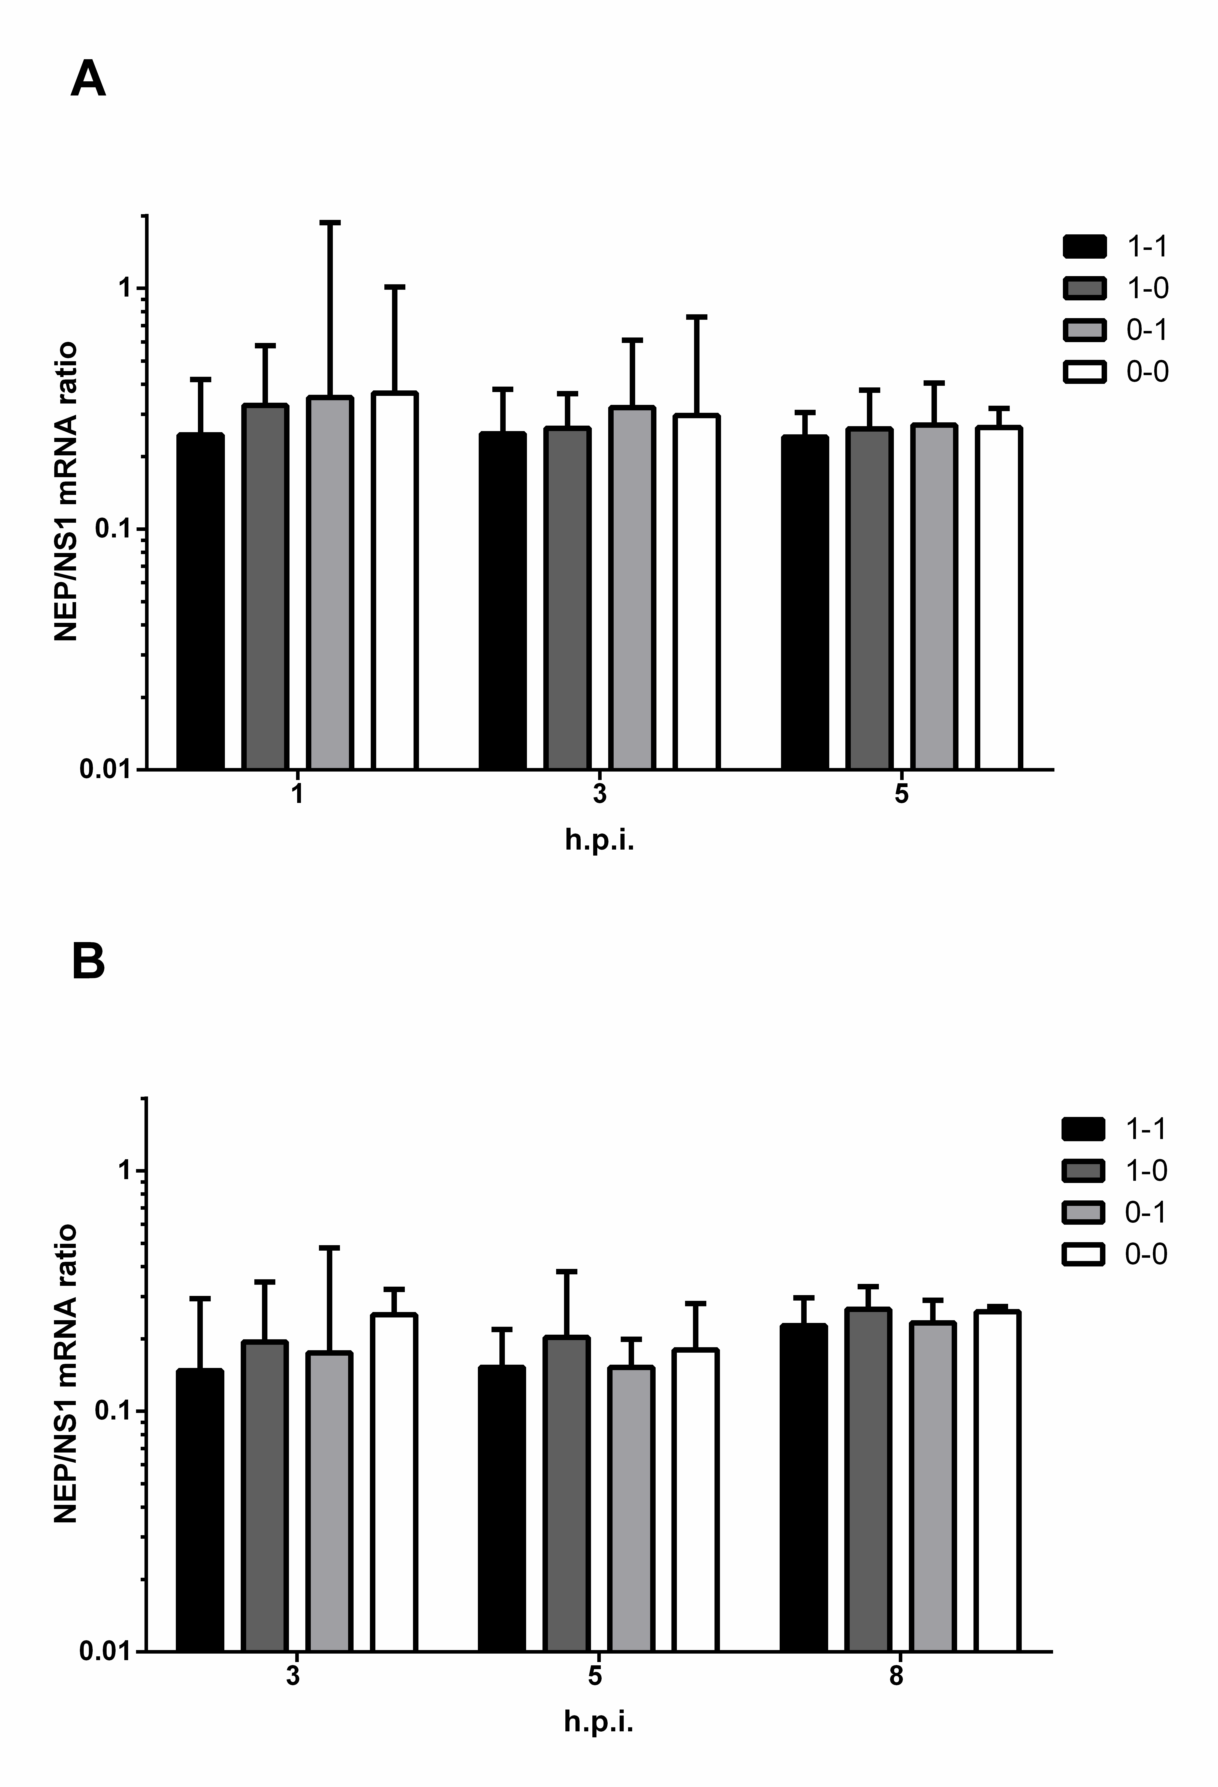
Fig. S2. Relative NEP/NS1 mRNA expression levels in cells infected by assembled viruses featuring different NS RNA secondary structures. MDCK (a) or A549 (b) cell cultures were infected at moi=1 TCID₅₀/cell. NEP and NS1 mRNA were measured at the indicated time points. NEP mRNA was quantified by qRT-PCR using primers adapted from [Jiang et al., 2016]. Relative mRNA quantity was evaluated by the 2^{−ΔCt} method. Error bars represent geometric mean ± 95% CI.

