Evaluation of an online, real-time, soft-photon ionisation (SPI) time-of-flight mass spectrometer for mainstream tobacco smoke analysis – Supplementary Figures

Jenni Hawke¹, Graham Errington¹, John McAughey¹, and Matthias Bente von Frowein²
Figure S1
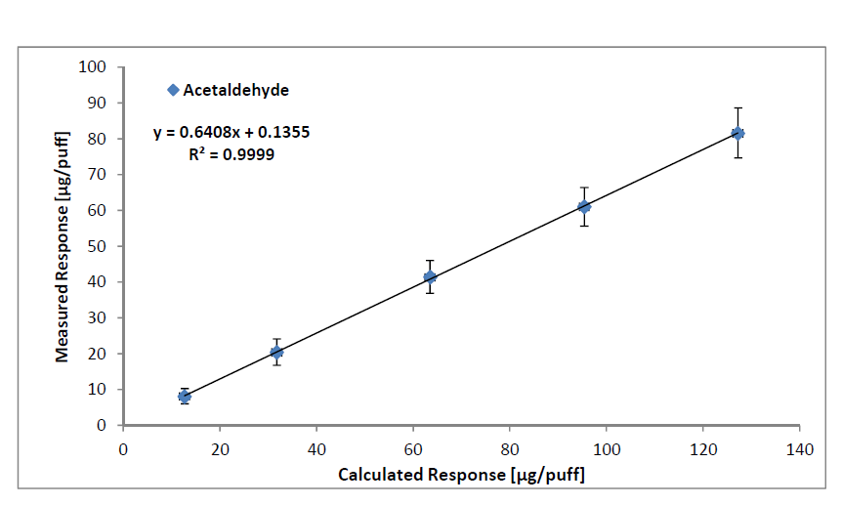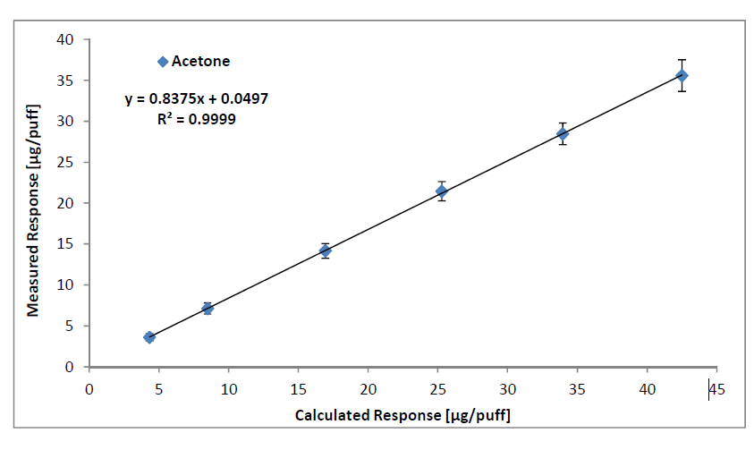
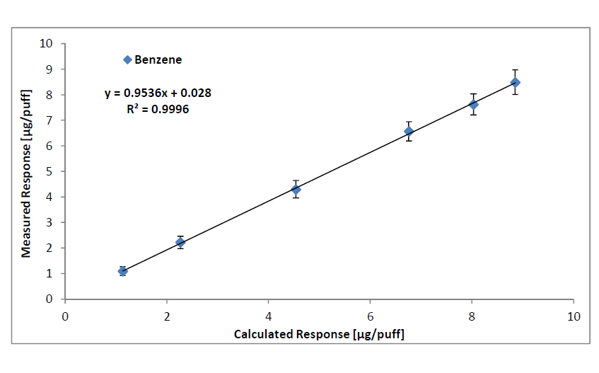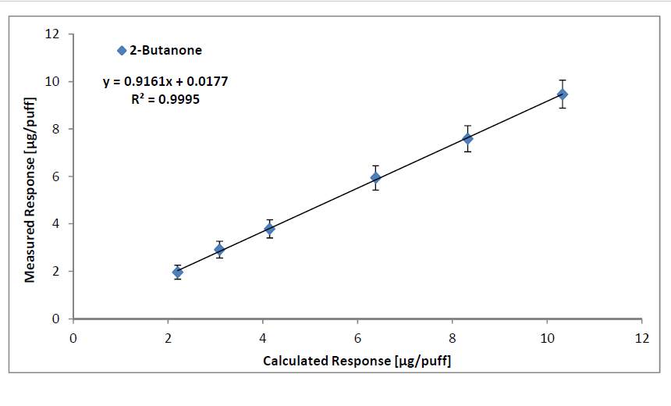
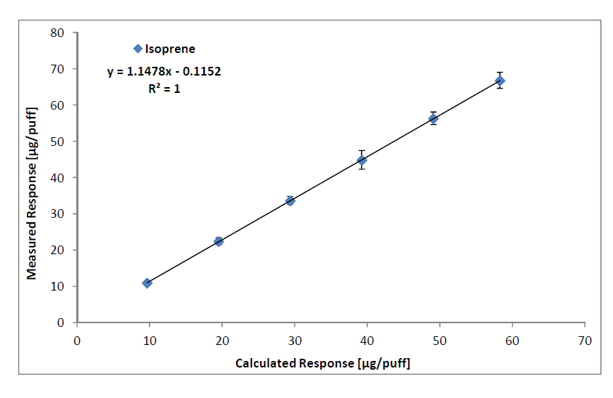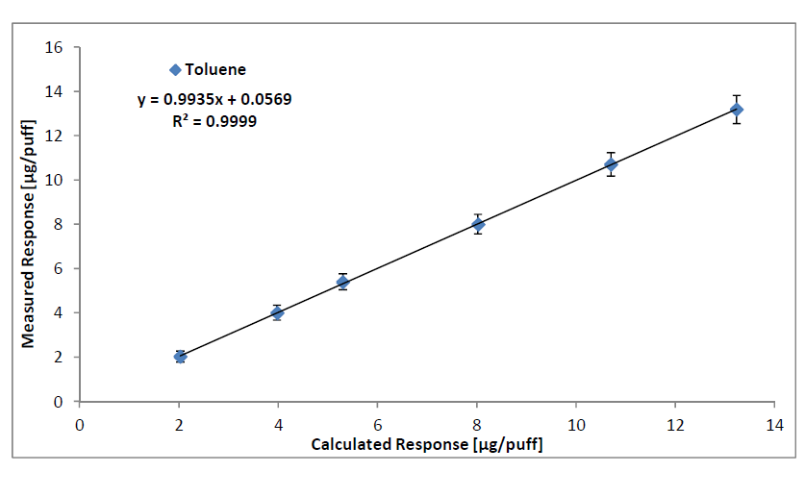
Figure S1. Linear regression of the calculated and measured yields of acetaldehyde, acetone, benzene, 2-butanone, isoprene and toluene, demonstrating the linearity of the LM2X-TOFMS.

Table S1
Table S1. Ruggedness test plan
Trial | Capillary | Ferrule | Day | Time | Run
Day 1
1 | New | New | 1 | am | 1
1 | Cut 1 | Same | 1 | am | 2
1 | Cut 2 | Same | 1 | am | 3
1 | Cut 3 | Same | 1 | am | 4
1 | No cut | Same | 1 | am | 5
2 | New | New | 1 | pm | 6
2 | Cut 1 | Same | 1 | pm | 7
2 | Cut 2 | Same | 1 | pm | 8
2 | Cut 3 | Same | 1 | pm | 9
2 | No cut | Same | 1 | pm | 10
Day 2
3 | New | New | 2 | am | 1
3 | Cut 1 | Same | 2 | am | 2
3 | Cut 2 | Same | 2 | am | 3
3 | Cut 3 | Same | 2 | am | 4
3 | No cut | Same | 2 | am | 5
4 | New | New | 2 | pm | 6
4 | Cut 1 | Same | 2 | pm | 7
4 | Cut 2 | Same | 2 | pm | 8
4 | Cut 3 | Same | 2 | pm | 9
4 | No Cut | Same | 2 | pm | 10
Day 3
5 | New | New | 3 | am | 1
5 | Cut 1 | Same | 3 | am | 2
5 | Cut 2 | Same | 3 | am | 3
5 | Cut 3 | Same | 3 | am | 4
5 | No cut | Same | 3 | am | 5
6 | New | New | 3 | pm | 6
6 | Cut 1 | Same | 3 | pm | 7
6 | Cut 2 | Same | 3 | pm | 8
6 | Cut 3 | Same | 3 | pm | 9
6 | No cut | Same | 3 | pm | 10

