Table S1 List of the specific primers used for cloning and qPCR analysis. Sequence accession numbers, primer sequences and amplicon sizes are shown.
Gene | GenBank Acc. No. | Sense primer 5’-3’ (Tm) | Antisense primer 5’-3’ (Tm) | Amplicon (bp)
Cloning
pept1a (slc15a1a) | NC_007120.7& | CTTTCACACACACACTCTCT (52 °C) | AACAGACCCCTGTATCATCAT (53 °C) | 2478
RT-PCR
actb | NM_131031.2 | CGTGACATCAAGGAGAAGCT (54 °C) | ATCCACATCTGCTGGAAGGT (55 °C) | 443
pept1a (slc15a1a) | NC_007120.7& | AGAACCGGCTGAGATGTAT (57 °C) | AAATACTGAGGAATCTGGAG (53 °C) | 351
qPCR
28S | EF417169.1 | GGTCTAAGTCCTTCTGATGG (55 °C) | GGCTGCATTCCCAAACAAC (55 °C) | 112
pept1a (slc15a1a) | NC_007120.7& | AGAACCGGCTGAGATGTAT (57 °C) | GAAGGCTGAAGGCTGGACT (56 °C) | 132
pept1b (slc15a1b) | NM_198064.1 | TGTGACCATCTCTGCTGGAG (56°C) | CCGCGTGCACATTATCAGAC (56°C) | 206
GC content, end stability, self/cross-dimer formation, and melting temperature of the oligonucleotides were analyzed by using the software AmplifX version 1.7.0 (https://inp.univ-amu.fr/en/amplifx-manage-test-and-design-your-primers-for-pcr). Amplification products from the primer pairs were sequenced and identified by alignment with the reference mRNAs. &From GRCz11 (RefSeq Acc. No. GCF_000002035.6; GenBank Acc. No. GCA_000002035.4) Genome Assembly, Chr 9 (NC_007120.7): 1,136,369-1,163,151. Tm, melting temperature.

-44 ctttcacacacacactctctcacacacacgctcctgctgccaac

1 ATGCCAGACTCAAAGATGGACGAGACGAAGAAGAAGAAGAAAAAG
1 M P D S K M D E T K K K K K KK

46 ACGGCTGAGTGCTGTGGATATCCCATCAGCATCTTCTTCATTGTG
16 T A E C C G Y P I S I F F I V
<--------------------------------I-

91 GTCAATGAGTTCTGTGAGAGATTCTCCTATTATGGGATGCGCGCT
31 V N E F C E R F S Y Y G M R A
------------------------------->

136 GTGCTGGTGCTGTATTTCCGCTATTTTCTGCTGTGGGACGATGAT
46 V L V L Y F R Y F L L W D D D

181 CTGGCAACCTCCATCTACCATGCGTTCGTGGCGCTCTGCTACCTG
61 L A T S I Y H A F V A L C Y L
<--------------------------------II---------

226 ACGCCCATCCTGGGGGCCATCATCGCCGACTCCCGGCTCGGCAAG
76 T P I L G A I I A D S R L G K
---------------------->

271 TTCAAGACCATCATATACCTGTCTATAGTGTACGCAGTGGGGCAG
91 F K T I I Y L S I V Y A V G Q
<-------------------------------

316 GTGGTCATGGCCGTCAGCACTATTCATGACATCACTGACGCTAAC
106 V V M A V S T I H D I T D A N
III------------------------------->

361 AGAGACGGCACACCGGACAACTTCACCTTACACATTGCTCTCTCT
121 R D G T P D N F T L H I A L S
<-------------------------

406 ATGCTGGGTTTGGTCCTCATAGCTCTGGGCACCGGAGGAATTAAA
136 M L G L V L I A L G T G G I K
-------IV------------------------------->

451 CCGTGTGTTGCAGCGTTTGGTGGAGATCAGTTTCAGGAGCATCAG
151 P C V A A F G G D Q F Q E H Q

496 AGTCGGCAGCTCAACACTTTTTTCTCAGTGTTTTATTTGTGCATC
166 S R Q L N T F F S V F Y L C I
<-------------------------------

541 AACGCTGGAAGTCTGCTTTCCACACTCATCACGCCTGTGCTCAGA
181 N A G S L L S T L I T P V L R
V------------------------------>

586 GCTCAGGAGTGTGGCATCCACACGCAGCAGCAGTGCTATCCGCTT
196 A Q E C G I H T Q Q Q C Y P L

631 GCTTTCGGGGTCCCGGCAGCTCTCATGGTGGTGTCTCTGGTGGTG
211 A F G V P A A L M V V S L V V
<--------------------------------VI---------

676 TTTATTGCGGGCAGTGGCATGTACACCAAAACTGCTCCAGAGGGA
226 F I A G S G M Y T K T A P E G
---------------------->

721 AACATTATGGGCTCTGTGTGTAAATGCATATGGTTTGCTCTGAAT
241 N I M G S V C K C I W F A L N

766 AACCGTTTCAGACACCGAAGCGATATTTATCCAAAGAGGGAGCAC
256 N R F R H R S D I Y P K R E H

811 TGGATGGACTGGGCGGAGGAGAAATATGATAAACTCCTCATTGCG
271 W M D W A E E K Y D K L L I A
<----------

856 CAGATAAAGATGGTGCTGAAGGTGTTGTTCCTCTACATCCCCCTG
286 Q I K M V L K V L F L Y I P L
---------------------VII---------------------

901 CCCATGTTTTGGACCCTGTTTGACCAGAAGGGCTCCCGCTGGACT
301 P M F W T L F D Q K G S R W T
---------->

946 CTACAAGCCACCACCATGACCGGAGACTTTGGAGGGTTCGTCCTG
316 L Q A T T M T G D F G G F V L

991 CAGCCAGACCAGATGCAGACGGTGAACCCCATCCTCATCTTGACC
331 Q P D Q M Q T V N P I L I L T
<----------------------------

1036 CTGGTGCCCATCATGGACAGAATTGTTTTCCCTCTCATAAAAAAG
346 L V P I M D R I V F P L I K K
---VIII------------------------------>

1081 TGTGGCCTCAATTTCAGCCCTTTGAAGAGAATGACGGTCGGCATG
361 C G L N F S P L K R M T V G M
<-------------

1126 TTGTTCGCTGCCACAGCGTTTATTGCTGCTGCTCTGGTGCAGATG
376 L F A A T A F I A A A L V Q M
-----------IX------------------------>

1171 GAGGTTGATAAAACCTTGCCGAATTTCCCATCATCCTCTGAGAGC
391 E V D K T L P N F P S S S E S

1216 CAGCTGAAGGTGGTGAATATGCACAGCGAGTCTCTCATAGTGACT
406 Q L K V V N M H S E S L I V T

1261 GTGCCGTCCCAAGAGCCTCTACTGATCGGCTCATTTGAGAGCAGT
421 V P S Q E P L L I G S F E S S

1306 CCAGATTACATTACGTTTGGCCAGCAGGACATCAGGTTAGCCTTT
436 P D Y I T F G Q Q D I R L A F

1351 TACACAACTCCTGCGATCAATAAAGATTTGAGTTTAATCAAAGGC
451 Y T T P A I N K D L S L I K G

1396 AGCCGTCAGACCCTGATCATCCCCTCAGAACCGGCTGAGATGTAT
466 S R Q T L I I P S E P A E M Y

1441 CTGAAAGAAGACATCAAGTCTAAACCAAAGGAAGGGAAGAATGCT
481 L K E D I K S K P K E G K N A

1486 GTCAGGTTTGTAAACGGCTGGACTGCATATCTGAACATCACTAAC
496 V R F V N G W T A Y L N I T NN

1531 CTGGAGTCCAGCCTTCAGCCTTCAGAAACGTCAAACTACACGCTG
511 L E S S L Q P S E T S N Y T LL

1576 GTCTCTCAGGGCATGCGTAAGTTCACGCTAACCAATGGTATTCAG
526 V S Q G M R K F T L T N G I Q

1621 TCGTGTGAGTTTTCACGGAAGTTTGGCTTCGGTTCCTCCTACACT
541 S C E F S R K F G F G S S Y T

1666 TTCCTGATCCCCAGCGATCTGTTCTCCACTGATTGTGAGTCTATA
556 F L I P S D L F S T D C E S I

1711 AAGGAGATTGAAGACATGCAGCCCAACTCGGTGCACATGGCTCTC
571 K E I E D M Q P N S V H M A L
<-------

1756 CAGATTCCTCAGTATTTCCTCATCACTACGGGAGAGGTCATGTTC
586 Q I P Q Y F L I T T G E V M F
-------------------------X-------------------

1801 TCCGTCACCGGTCTGCAGTTCTCATACTCACAGGCTCCCAAAAAC
601 S V T G L Q F S Y S Q A P K N
------------->

1846 ATGAAGTCGGTGCTGCAGGCCGGCTGGCTGTGCACTAACGCAGTG
616 M K S V L Q A G W L C T N A V
<--------------------------------XI

1891 GGAAACATCATCGTGCTGATCGTGGCGGAGCTGGGGAAACTTCCC
631 G N I I V L I V A E L G K L P
------------------------------->

1936 AAACAGTGGGCAGAGTATGTGCTGTTTGCGTCGCTGCTAGTAGCT
646 K Q W A E Y V L F A S L L V A
<----------------------------

1981 GTTAGCATCATCTTCTCCATCATGGCGTATTTCTACACCTACATC
661 V S I I F S I M A Y F Y T Y I
--XII-------------------------------->

2026 GACCCAGCGGAGATTGAAGCCGAGATCCTGAAACAGCAAGAGACT
676 D P A E I E A E I L K Q Q E T

2071 GATCCAGACAAGAAGAAGAAGAAGGAGACTCTAGAAATGGAGGAA
691 D P D K K K K K E T L E M E E

2116 AAGGAGAACGAGCAGGAAATCAAACAAACCAAGATTTAAgacttg
706 K E N E Q E I K Q T K I *

2161 aagattgagttacgctcatgctaatatcttccctttacttccgta

2206 tttattaaagcaggtttgaaggactgtgagcagacgtgtgtgtgt

2251 ttatgattgatttgcatctgttgttgatacatttagatgattatt

2296 gatgagagccaattgagtcgacaatcatatgtagcattaaacatt

2341 taatgtgtaaaataaactttgttatggatatggattgtgatgtag

2386 atggactttagtgagtgtttttgtgtgtgttttgacttttttaag

2431 ctaataatcaatggactatgatgatacaggggtctgtt

Fig. S1 Nucleotide and predicted amino acid sequence of zebrafish pept1a (slc15a1a) obtained using ORFfinder (https://www.ncbi.nlm.nih.gov/orffinder/). Numbers on the left refer to the nucleotide (upper row) and amino acid (lower row) positions. Nucleotides are numbered, starting from the first ATG initiation codon. * indicates the stop codon. The specific primers used for cloning and PCR analyses (Table S1) are indicated in red and green, respectively. In the amino acid sequence, putative transmembrane domains, obtained using the TMHMM v. 2.0 program as implemented in SMART, are indicated and named I to XII. Potential extracellular N-glycosylation sites (white boxes), potential cAMP/cGMP-dependent protein kinase phosphorylation sites at the cytoplasmic surface (light gray boxes) and potential protein kinase C phosphorylation sites at the cytoplasmic surface (dark gray boxes) were obtained using the ScanProsite tool.

Fig. S2 Current-voltage relationships of transport-associated currents in zebrafish PepT1a, in the presence of 3 mmol/L Gly-Gln in sodium (NaCl) saline buffer (black square) and tetramethylammonium (TMACl) saline buffer (empty circle) at pH 7.6 (see Methods for details). Values are means ± SEM from 5 oocytes from one batch each group. The transport-associated current values reported were obtained by subtracting the current recorded in the absence of the substrate to that recorded in its presence.

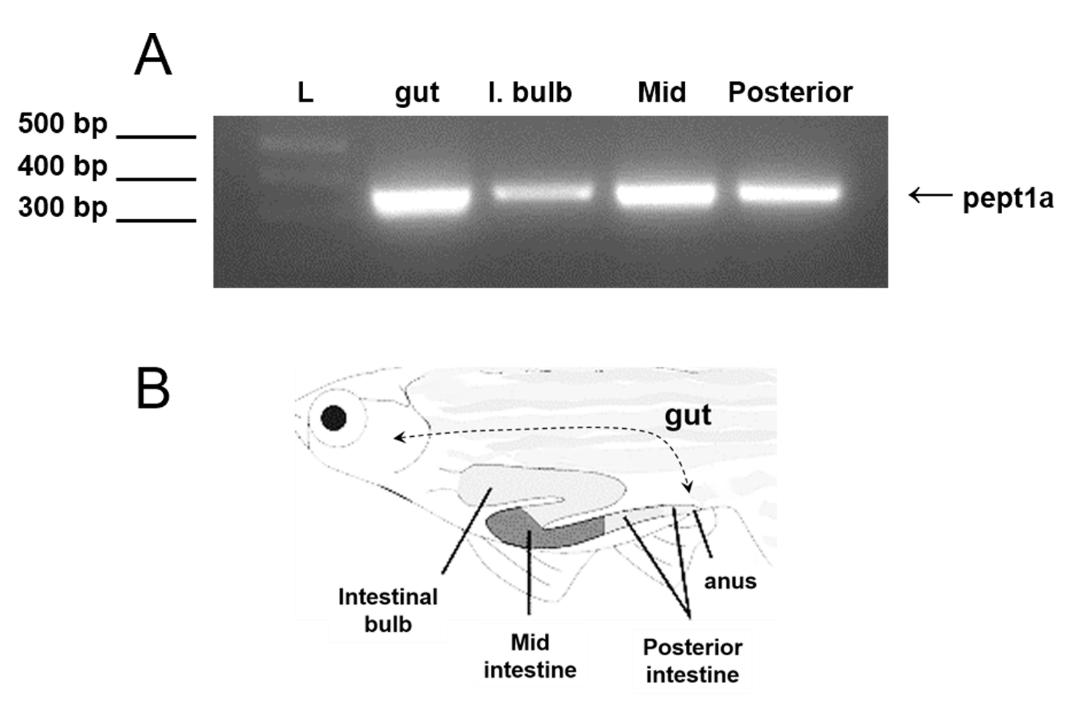

Fig. S3 Expression analysis by RT-PCR on pept1a (slc15a1a) mRNA in different sections of adult zebrafish intestine. a RT-PCR assay on cDNA templates from total RNA extracted from whole gut (gut), intestinal bulb (I. bulb), mid intestine (mid) and posterior intestine (posterior); a PCR product of ~350 bp related to pept1a (slc15a1a) mRNA is present in all intestinal samples; L: 1 Kb Plus DNA ladder (Thermo Fisher Scientific). b A graphic representation of the adult zebrafish gut anatomy with its major adjacent tracts.

