Additional Information on “Quantitative proteome analysis of Merkel cell carcinoma cell lines using SILAC”

HPLC Separation
The nano HPLC Separation was performed using a nanoRSLC UltiMate 3000 HPLC system by Thermo Fisher.
Mobile phases applied for sample loading, desalting, and separation were:
- 0.1% aqueous TFA solution cooled to 3°C and delivered to the trap column in the column oven at 30µl/min
- Mobile phases for peptide separation on the nano separation column were:
A: 95% Acetonitrile, 5% Water, 0.1% Formic acid
B: 50% Acetonitrile, 30% Methanol, 10% 2,2,2-Trifluoroethanol, 10% Water, 0.1% Formic acid
- Autosampler loading solvent was 0.1% aqueous TFA
- Injector and trap column wash were performed with 100% 2,2,2-Trifluoroethanol
A cleaning run was performed between each sample in order to prevent carryover. The Chromelon v. 6.8 parameters are shown below as a text file. It can be copied and pasted in any Chromeleon v. 6.8, or earlier. For newer Chromeleon versions or different LC control systems this has to be adapted accordingly.
Nano Separation Gradient
Retention time (min) | Flow (µl/min) | %A | %B
0 | 0.30 | 95.00 | 5.00
10 | 0.30 | 95.00 | 5.00
100 | 0.30 | 90.00 | 10.00
200 | 0.30 | 75.00 | 25.00
275 | 0.30 | 60.00 | 40.00
285 | 0.30 | 40.00 | 60.00
290 | 0.30 | 10.00 | 90.00
295 | 0.30 | 10.00 | 90.00
296 | 0.30 | 95.00 | 5.00
300 | 0.30 | 95.00 | 5.00
Column Valve Switching Times
Retention time (min) | Valve A | Valve B
0 | 1_2 | 1_2
10 | 1_2 | 10_1
286 | 1_2 | 1_2

Mascot Search parameters used in ProteinScape are shown below:
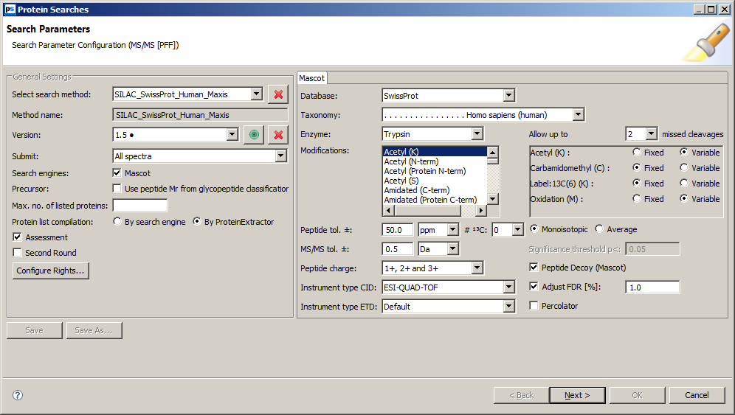

HPLC Program
Sampler.TempCtrl = On
Sampler.Temperature.Nominal = 5.0 [°C]
Sampler.Temperature.LowerLimit = 4.0 [°C]
Sampler.Temperature.UpperLimit = 45.0 [°C]
Sampler.ReadyTempDelta = None
ColumnOven.TempCtrl = On
ColumnOven.Temperature.Nominal = 60.0 [°C]
ColumnOven.Temperature.LowerLimit = 20.0 [°C]
ColumnOven.Temperature.UpperLimit = 75.0 [°C]
EquilibrationTime = 0.5 [min]
ColumnOven.ReadyTempDelta = 1.0 [°C]
LoadingPump.Pressure.LowerLimit = 0 [bar]
LoadingPump.Pressure.UpperLimit = 500 [bar]
LoadingPump.MaximumFlowRampDown = 10 [µl/min²]
LoadingPump.MaximumFlowRampUp = 10 [µl/min²]
LoadingPump.%A.Equate = "%A"
LoadingPump.%B.Equate = "%B"
%C.Equate = "%C"
NC_Pump.Pressure.LowerLimit = 0 [bar]
NC_Pump.Pressure.UpperLimit = 800 [bar]
NC_Pump.MaximumFlowRampDown = 0.500 [µl/min²]
NC_Pump.MaximumFlowRampUp = 0.500 [µl/min²]
NC_Pump.%A.Equate = "%A"
NC_Pump.%B.Equate = "%B"
DrawSpeed = 1000 [nl/s]
DrawDelay = 5000 [ms]
DispSpeed = 2000 [nl/s]
DispenseDelay = 2000 [ms]
WasteSpeed = 4000 [nl/s]
WashSpeed = 4000 [nl/s]
LoopWashFactor = 2.000
SampleHeight = 3.000 [mm]
PunctureDepth = 7.000 [mm]
WashVolume = 100.000 [µl]
RinseBetweenReinjections = No
LowDispersionMode = Off
InjectMode = UserProg
LoadingPump_Pressure.Step = 0.01 [s]
LoadingPump_Pressure.Average = On
NC_Pump_Pressure.Step = 0.01 [s]
NC_Pump_Pressure.Average = On
NC_Pump_Press_RightBlk.Step = 0.01 [s]
NC_Pump_Press_RightBlk.Average = On
NC_Pump_Press_LeftBlk.Step = 0.01 [s]
NC_Pump_Press_LeftBlk.Average = On
ColumnOven_Temp.Step = 0.01 [s]
ColumnOven_Temp.Average = Off
UV.Data_Collection_Rate = 2.0 [Hz]
TimeConstant = 1.20 [s]
UV_VIS_1.Wavelength = 214 [nm]

ValveRight = 1_2
ReagentAVial= R1
ReagentBVial= R2
Start_MS.State Off
ValveLeft = 1_2
PrepVial= B5
UdpInjectValve Position=Inject
UdpSyringeValve Position=Needle
UdpDraw From=ReagentAVial, Volume=15.000, SyringeSpeed=1000, SampleHeight=4.000
UdpMixWait Duration=2
UdpDraw From=ReagentAVial, Volume=0.000, SyringeSpeed=GlobalSpeed, SampleHeight=4.000
UdpInjectValve Position=Load
UdpDraw From=SampleVial, Volume=Volume, SyringeSpeed=GlobalSpeed, SampleHeight=4.000
UdpMixWait Duration=2
UdpDraw From=SampleVial, Volume=0.000, SyringeSpeed=GlobalSpeed, SampleHeight=4.000
UdpDraw From=ReagentAVial, Volume=15.000, SyringeSpeed=1000, SampleHeight=4.000
UdpMixWait Duration=2
UdpDraw From=ReagentAVial, Volume=0.000, SyringeSpeed=GlobalSpeed, SampleHeight=4.000
UdpInjectValve Position=Inject
UdpInjectMarker
UdpMixNeedleWash Volume=100.000
UdpMixWait Duration=800
UdpDraw From=ReagentBVial, Volume=25.000, SyringeSpeed=4000, SampleHeight=4.000
UdpMixWait Duration=2
UdpDispense To=Drain, Volume=10.000, SyringeSpeed=GlobalSpeed, SampleHeight=4.000
UdpInjectValve Position=Load
UdpDraw From=ReagentBVial, Volume=25.000, SyringeSpeed=4000, SampleHeight=4.000
UdpMixWait Duration=2
UdpDraw From=ReagentBVial, Volume=0.000, SyringeSpeed=GlobalSpeed, SampleHeight=4.000
UdpInjectValve Position=Inject
UdpMixWait Duration=300
UdpInjectValve Position=Load
UdpDraw From=ReagentAVial, Volume=25.000, SyringeSpeed=4000, SampleHeight=4.000
UdpMixWait Duration=2
UdpDraw From=ReagentAVial, Volume=0.000, SyringeSpeed=GlobalSpeed, SampleHeight=4.000
UdpInjectValve Position=Inject
UdpMixNeedleWash Volume=300.000

0.000 Autozero
NC_Pump.Flow = 0.300 [µl/min]
NC_Pump.%B = 5.0 [%]

LoadingPump.Flow = 20.000 [µl/min]
LoadingPump.%B = 0.0 [%]
%C = 0.0 [%]

Wait UV.Ready and LoadingPump.Ready and NC_Pump.Ready and ColumnOven.Ready and Sampler.Ready and PumpModule.Ready
Inject
LoadingPump_Pressure.AcqOn
NC_Pump_Pressure.AcqOn
NC_Pump_Press_RightBlk.AcqOn
NC_Pump_Press_LeftBlk.AcqOn
ColumnOven_Temp.AcqOn
UV_VIS_1.AcqOn
NC_Pump.Flow = 0.300 [µl/min]
LoadingPump.Flow = 20.000 [µl/min]
LoadingPump.%B = 0.0 [%]
%C = 0.0 [%]
NC_Pump.%B = 5.0 [%]

10.000 NC_Pump.%B = 5.0 [%]
ValveLeft = 1_2
ValveRight = 10_1
NC_Pump.Flow = 0.300 [µl/min]

15.000 Start_MS.State On

15.100 Start_MS.State Off

30.000 LoadingPump.Flow = 20.000 [µl/min]
LoadingPump.%B = 0.0 [%]
%C = 0.0 [%]

32.000 LoadingPump.Flow = 2.000 [µl/min]
LoadingPump.%B = 0.0 [%]
%C = 0.0 [%]

100.000 NC_Pump.%B = 10.0 [%]
NC_Pump.Flow = 0.300 [µl/min]

200.000 NC_Pump.%B = 25.0 [%]
NC_Pump.Flow = 0.300 [µl/min]

275.000 NC_Pump.%B = 40.0 [%]
NC_Pump.Flow = 0.300 [µl/min]

280.000 LoadingPump.Flow = 2.000 [µl/min]
LoadingPump.%B = 0.0 [%]
%C = 0.0 [%]

285.000 NC_Pump.%B = 60.0 [%]
NC_Pump.Flow = 0.300 [µl/min]

286.000 ValveLeft = 1_2
LoadingPump.Flow = 20.000 [µl/min]
LoadingPump.%B = 0.0 [%]
%C = 0.0 [%]
ValveRight = 1_2

290.000 NC_Pump.%B = 90.0 [%]
NC_Pump.Flow = 0.300 [µl/min]

295.000 NC_Pump.%B = 90.0 [%]
NC_Pump.Flow = 0.300 [µl/min]

296.000 NC_Pump.%B = 5.0 [%]
NC_Pump.Flow = 0.300 [µl/min]

300.000 NC_Pump.Flow = 0.300 [µl/min]
NC_Pump.%B = 5.0 [%]

LoadingPump_Pressure.AcqOff
NC_Pump_Pressure.AcqOff
NC_Pump_Press_RightBlk.AcqOff
NC_Pump_Press_LeftBlk.AcqOff
ColumnOven_Temp.AcqOff
UV_VIS_1.AcqOff
End

HPLC Program used for column cleaning

Sampler.TempCtrl = On
Sampler.Temperature.Nominal = 15.0 [°C]
Sampler.Temperature.LowerLimit = 4.0 [°C]
Sampler.Temperature.UpperLimit = 45.0 [°C]
Sampler.ReadyTempDelta = None
ColumnOven.TempCtrl = On
ColumnOven.Temperature.Nominal = 60.0 [°C]
ColumnOven.Temperature.LowerLimit = 20.0 [°C]
ColumnOven.Temperature.UpperLimit = 75.0 [°C]
EquilibrationTime = 0.5 [min]
ColumnOven.ReadyTempDelta = 1.0 [°C]
LoadingPump.Pressure.LowerLimit = 0 [bar]
LoadingPump.Pressure.UpperLimit = 500 [bar]
LoadingPump.MaximumFlowRampDown = 10 [µl/min²]
LoadingPump.MaximumFlowRampUp = 10 [µl/min²]
LoadingPump.%A.Equate = "%A"
LoadingPump.%B.Equate = "%B"
%C.Equate = "%C"
NC_Pump.Pressure.LowerLimit = 0 [bar]
NC_Pump.Pressure.UpperLimit = 800 [bar]
NC_Pump.MaximumFlowRampDown = 0.300 [µl/min²]
NC_Pump.MaximumFlowRampUp = 0.300 [µl/min²]
NC_Pump.%A.Equate = "%A"
NC_Pump.%B.Equate = "%B"
DrawSpeed = 1000 [nl/s]
DrawDelay = 5000 [ms]
DispSpeed = 20000 [nl/s]
DispenseDelay = 2000 [ms]
WasteSpeed = 40000 [nl/s]
WashSpeed = 40000 [nl/s]
LoopWashFactor = 2.000
SampleHeight = 3.000 [mm]
PunctureDepth = 7.000 [mm]
WashVolume = 300.000 [µl]
RinseBetweenReinjections = No
LowDispersionMode = Off
InjectMode = UserProg
LoadingPump_Pressure.Step = 0.01 [s]
LoadingPump_Pressure.Average = On
NC_Pump_Pressure.Step = 0.01 [s]
NC_Pump_Pressure.Average = On
NC_Pump_Press_RightBlk.Step = 0.01 [s]
NC_Pump_Press_RightBlk.Average = On
NC_Pump_Press_LeftBlk.Step = 0.01 [s]
NC_Pump_Press_LeftBlk.Average = On
ColumnOven_Temp.Step = 0.01 [s]
ColumnOven_Temp.Average = Off
UV.Data_Collection_Rate = 2.0 [Hz]
TimeConstant = 1.20 [s]
UV_VIS_1.Wavelength = 214 [nm]
LoadingPump.Flow = 5.000 [µl/min]
LoadingPump.%B = 0.0 [%]
%C = 0.0 [%]
LoadingPump.Curve = 5
ReagentAVial= R1
ReagentBVial= R2
Start_MS.State Off
ValveLeft = 10_1
PrepVial= B5
UdpInjectValve Position=Inject
UdpSyringeValve Position=Needle
UdpDraw From=ReagentBVial, Volume=16.000, SyringeSpeed=1000, SampleHeight=4.000
UdpMixWait Duration=2
UdpDraw From=ReagentBVial, Volume=0.000, SyringeSpeed=GlobalSpeed, SampleHeight=4.000
UdpInjectValve Position=Load
UdpDraw From=ReagentBVial, Volume=20.000, SyringeSpeed=1000, SampleHeight=4.000
UdpMixWait Duration=2
UdpInjectValve Position=Inject
UdpInjectMarker
UdpMixNeedleWash Volume=300.000

0.000 Autozero
NC_Pump.Flow = 0.300 [µl/min]
NC_Pump.%B = 99.0 [%]
Wait UV.Ready and LoadingPump.Ready and NC_Pump.Ready and ColumnOven.Ready and Sampler.Ready and PumpModule.Ready
Inject
LoadingPump_Pressure.AcqOn
NC_Pump_Pressure.AcqOn
NC_Pump_Press_RightBlk.AcqOn
NC_Pump_Press_LeftBlk.AcqOn
ColumnOven_Temp.AcqOn
UV_VIS_1.AcqOn
NC_Pump.Flow = 0.300 [µl/min]
NC_Pump.%B = 99.0 [%]

8.000 ValveLeft = 10_1

13.000 Start_MS.State On

13.100 Start_MS.State Off

40.000 NC_Pump.Flow = 0.300 [µl/min]
NC_Pump.%B = 99.0 [%]

41.000 NC_Pump.Flow = 0.300 [µl/min]
NC_Pump.%B = 3.0 [%]

45.000 ValveLeft = 1_2

60.000 NC_Pump.Flow = 0.300 [µl/min]
UV_VIS_1.AcqOff
LoadingPump_Pressure.AcqOff
NC_Pump_Pressure.AcqOff
NC_Pump_Press_RightBlk.AcqOff
NC_Pump_Press_LeftBlk.AcqOff
ColumnOven_Temp.AcqOff
NC_Pump.%B = 3.0 [%]
End

