Extracellular metabolites analysed from bioreactor cultivations

Bioreactor cultivations were performed in 15-unit bioreactor (Medicel, Finland) in the defined minimal medium described by Verdyun et al. [40], with 5 g/L glycerol or 10 g/L yeast extract and 32 g/L methanol as carbon source. BDH silicon antifoam was used to prevent foaming of the cultures. The culture conditions were as follows: 200 ml volume, pH 5.0, +30°C and with 0.5 vvm air.

- Cultivations with 5 g/L glycerol and 32 g/L methanol as a carbon source

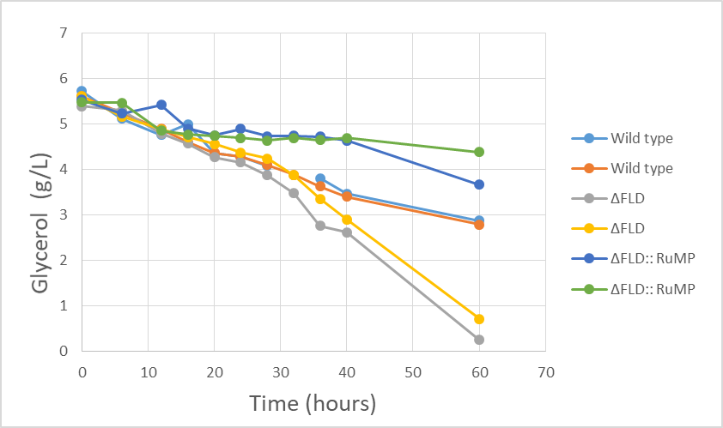
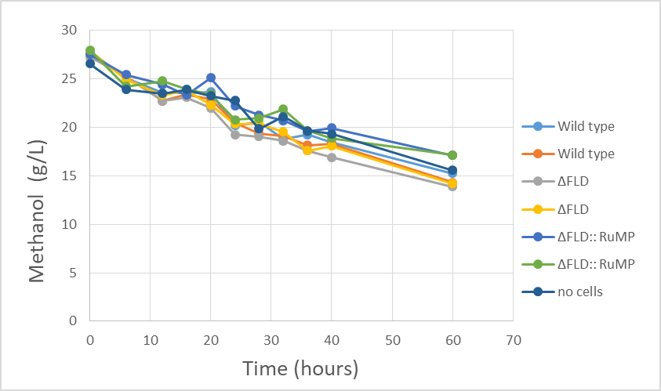
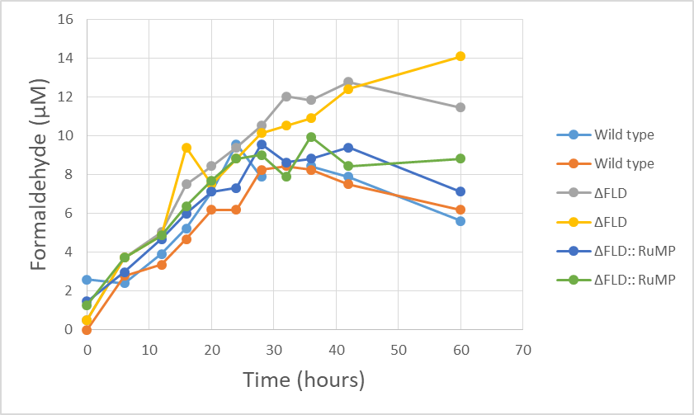

- Cultivations with 10 g/L glycerol and 32 g/L methanol as a carbon source

