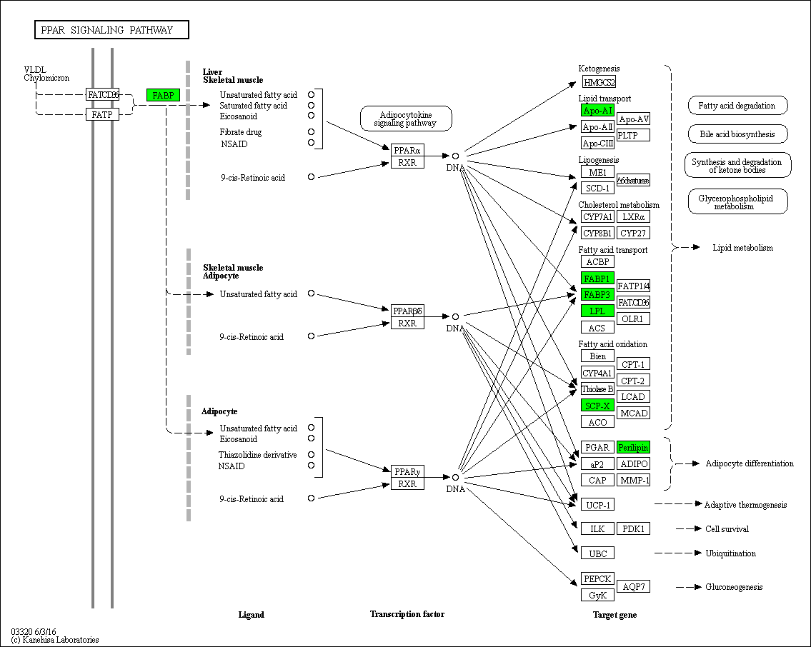
Additional file 3 Sketch map of peroxisome proliferators-activated receptors (PPAR) signaling pathway.

