Supplemental Figures

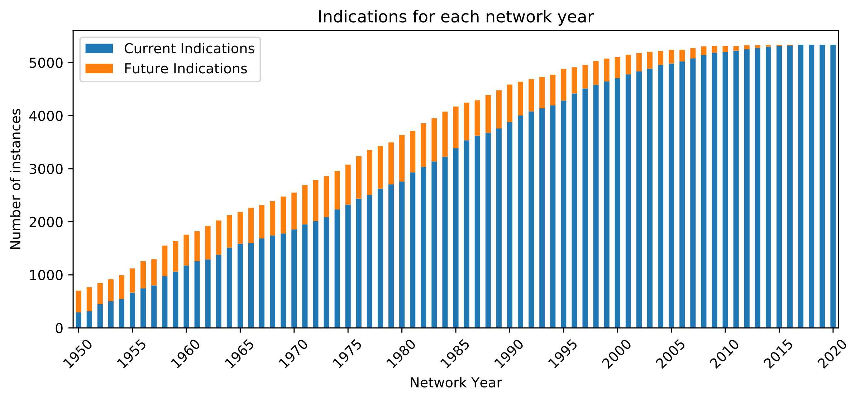
Supplemental Figure S1) Number of indications mappable to each network year, split by approval year, with current indications mean those approved up-to and including the network year, and future those approved after the network year.

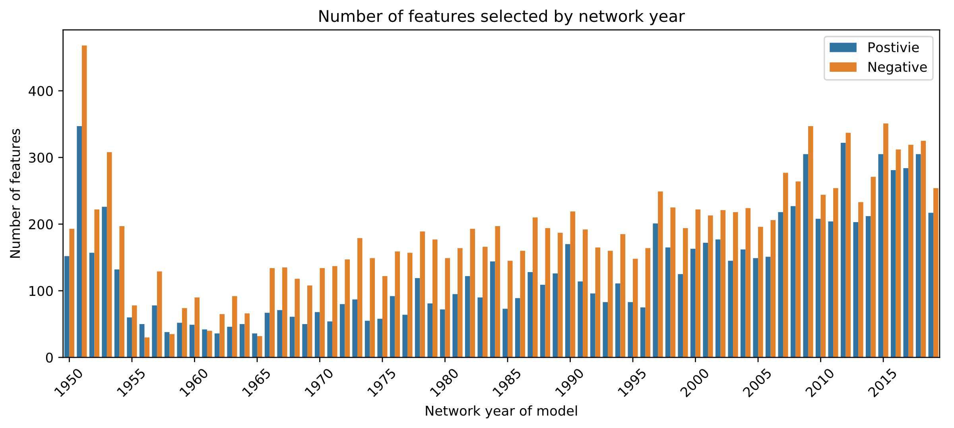
Supplemental Figure S2) Number of features selected in the models for each of the different network years.

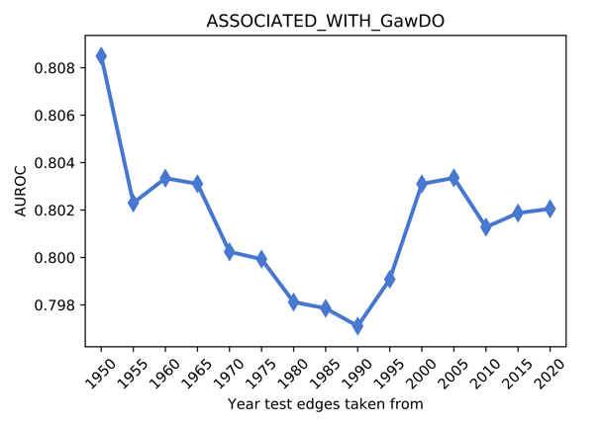
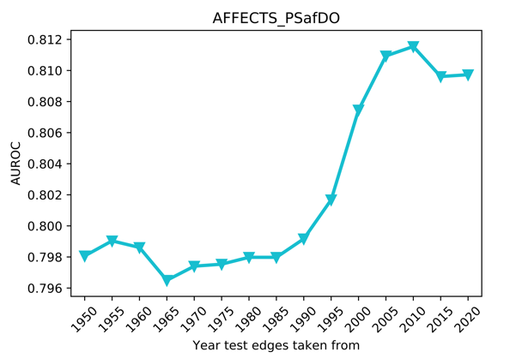
Supplemental Figures S3 & S4) Edge substitution analysis results for edges AFFECTS_PSafDO and ASSOCIATED_WITH_GawDO respectively.

Supplemental Tables

Supplemental Table S1: Number of training and testing examples in time-resolved analysis
Network Year | Training Positives | Testing Positives | Total Positives | Training Negatives | Testing Negatives | Total Negatives
1950 | 274 | 321 | 595 | 4760 | 1190 | 5950
1951 | 296 | 341 | 637 | 5096 | 1274 | 6370
1952 | 424 | 286 | 710 | 5680 | 1420 | 7100
1953 | 471 | 301 | 772 | 6176 | 1544 | 7720
1954 | 512 | 332 | 844 | 6752 | 1688 | 8440
1955 | 627 | 338 | 965 | 7720 | 1930 | 9650
1956 | 665 | 386 | 1051 | 8408 | 2102 | 10510
1957 | 703 | 371 | 1074 | 8592 | 2148 | 10740
1958 | 869 | 449 | 1318 | 10544 | 2636 | 13180
1959 | 948 | 429 | 1377 | 11016 | 2754 | 13770
1960 | 1099 | 435 | 1534 | 12272 | 3068 | 15340
1961 | 1132 | 465 | 1597 | 12776 | 3194 | 15970
1962 | 1220 | 529 | 1749 | 13992 | 3498 | 17490
1963 | 1289 | 535 | 1824 | 14592 | 3648 | 18240
1964 | 1398 | 496 | 1894 | 15152 | 3788 | 18940
1965 | 1470 | 482 | 1952 | 15616 | 3904 | 19520
1966 | 1498 | 520 | 2018 | 16144 | 4036 | 20180
1967 | 1579 | 504 | 2083 | 16664 | 4166 | 20830
1968 | 1644 | 537 | 2181 | 17448 | 4362 | 21810
1969 | 1665 | 590 | 2255 | 18040 | 4510 | 22550
1970 | 1726 | 590 | 2316 | 18528 | 4632 | 23160
1971 | 1822 | 590 | 2412 | 19296 | 4824 | 24120
1972 | 1884 | 624 | 2508 | 20064 | 5016 | 25080
1973 | 1956 | 652 | 2608 | 20864 | 5216 | 26080
1974 | 2106 | 603 | 2709 | 21672 | 5418 | 27090
1975 | 2189 | 642 | 2831 | 22648 | 5662 | 28310
1976 | 2289 | 692 | 2981 | 23848 | 5962 | 29810
1977 | 2363 | 724 | 3087 | 24696 | 6174 | 30870
1978 | 2455 | 698 | 3153 | 25224 | 6306 | 31530
1979 | 2532 | 693 | 3225 | 25800 | 6450 | 32250
1980 | 2604 | 783 | 3387 | 27096 | 6774 | 33870
1981 | 2742 | 695 | 3437 | 27496 | 6874 | 34370
1982 | 2848 | 730 | 3578 | 28624 | 7156 | 35780
1983 | 2939 | 725 | 3664 | 29312 | 7328 | 36640
1984 | 3018 | 766 | 3784 | 30272 | 7568 | 37840
1985 | 3140 | 708 | 3848 | 30784 | 7696 | 38480
1986 | 3272 | 651 | 3923 | 31384 | 7846 | 39230
1987 | 3387 | 616 | 4003 | 32024 | 8006 | 40030
1988 | 3440 | 656 | 4096 | 32768 | 8192 | 40960
1989 | 3497 | 659 | 4156 | 33248 | 8312 | 41560
1990 | 3602 | 658 | 4260 | 34080 | 8520 | 42600
1991 | 3707 | 590 | 4297 | 34376 | 8594 | 42970
1992 | 3788 | 561 | 4349 | 34792 | 8698 | 43490
1993 | 3864 | 549 | 4413 | 35304 | 8826 | 44130
1994 | 3925 | 537 | 4462 | 35696 | 8924 | 44620
1995 | 4005 | 539 | 4544 | 36352 | 9088 | 45440
1996 | 4141 | 450 | 4591 | 36728 | 9182 | 45910
1997 | 4215 | 410 | 4625 | 37000 | 9250 | 46250
1998 | 4280 | 425 | 4705 | 37640 | 9410 | 47050
1999 | 4343 | 404 | 4747 | 37976 | 9494 | 47470
2000 | 4413 | 374 | 4787 | 38296 | 9574 | 47870
2001 | 4475 | 351 | 4826 | 38608 | 9652 | 48260
2002 | 4532 | 314 | 4846 | 38768 | 9692 | 48460
2003 | 4580 | 295 | 4875 | 39000 | 9750 | 48750
2004 | 4643 | 242 | 4885 | 39080 | 9770 | 48850
2005 | 4674 | 229 | 4903 | 39224 | 9806 | 49030
2006 | 4715 | 194 | 4909 | 39272 | 9818 | 49090
2007 | 4745 | 167 | 4912 | 39296 | 9824 | 49120
2008 | 4772 | 140 | 4912 | 39296 | 9824 | 49120
2009 | 4814 | 104 | 4918 | 39344 | 9836 | 49180
2010 | 4826 | 96 | 4922 | 39376 | 9844 | 49220
2011 | 4855 | 71 | 4926 | 39408 | 9852 | 49260
2012 | 4879 | 58 | 4937 | 39496 | 9874 | 49370
2013 | 4896 | 42 | 4938 | 39504 | 9876 | 49380
2014 | 4916 | 23 | 4939 | 39512 | 9878 | 49390
2015 | 4928 | 15 | 4943 | 39544 | 9886 | 49430
2016 | 4930 | 13 | 4943 | 39544 | 9886 | 49430
2017 | 4943 | 0 | 4943 | 39544 | 9886 | 49430

