**Economic Feasibility of Gasoline Production from Lignocellulosic Feedstocks in Hong Kong**

**— Supplementary Information—**

**Weixiang Guan1, Sim-Ying Chua2, Chi-Wing Tsang2,*, Xiao Chen1, Carol Sze Ki Lin3,*, Raymond Sze Wai Fu2, Haoquan Hu1 and Changhai Liang1,\***

1State Key Laboratory of Fine Chemicals, Laboratory of Advanced Materials and Catalytic Engineering, School of Chemical Engineering, Dalian University of Technology, Dalian 116024, China

2Faculty of Science and Technology, Technological and Higher Education Institute of Hong Kong, 20A Tsing Yi Road, Tsing Yi, Hong Kong

3School of Energy and Environment, City University of Hong Kong, Kowloon Tong, Hong Kong

**Table of Contents**

1. **Materials**3
2. **Extraction of Lignin by OrganoCat Process from Ashwood**3
3. **Characterization of Lignin**

Elemental Analysis………………………………………………………………….3

Gel Permeation Chromatography…………………………………………………...4

FT-IR Spectroscopy…………………………………………………………………5

Thermogravimetric Analysis………………………………………………………..5

1. **Simulation of Catalytic Conversion of Lignin**

by Ru/Nb2O5………………………………………………………………………...6

by Ru/C……………………………………………………………………………...6

by Amberlyst-15 with Pt/CNT……………………………………………………....7

Preparation of 5wt% Pt/CNT Catalyst……………………………………..……7

Catalytic Tests…………………………………………………………………...7

Product Distribution of Catalytic Conversion of Lignin by

Amberlyst-15/Pt/CNT…………………………………………………………..8

1. **Stream Data**………………………………………………………………………9
2. **Catalyst Cost Estimation**

Ru/Nb2O5…………………………………………………………………………..14

Ru/C………………………………………………………………………………..15

Amberlyst-15 + Pt/CNT…………………………………………………………...16

1. **The Blending Method, Estimation of the Physical Properties of the Bio-gasoline Products**
2. **Estimation of the Physical Properties of the Bio-gasoline Products**

Calculation of API Gravity…………………………………………………...........17

Calculation of Mean Average Boiling Point……………………………………….18

Calculation of Reid Vapor Pressure………………………………………………..19

Calculation of Octane Number…………………………………………………….19

1. **Materials**

Oxalic acid and 2-methyltetrahydrofuran (2-MTHF) were purchased from Sigma-Aldrich. Sawdust of ashwood of defined size (0.5-0.8 mm) was used. CNTs were obtained from Shenzhen Nanotech. Port. Co. Ltd. and pretreated with aqueous HNO3 solution following literature procedure [1, 2]. H2PtCl6∙6H2O was purchased from Sigma-Aldrich as used as received.

1. **Extraction of Lignin by OrganoCat Process from Ashwood**

Procedure: The reaction procedure follows the literature with slight modification [3]. In a 1,000 mL of stainless steel high pressure reactor equipped with an agitator, sawdust of Ashwood (20 g, 0.5-0.8 mm) was suspended in water with oxalic acid (0.1 M) (250 mL). 2-MTHF (250 mL) was then added to the mixture and the reactor was sealed. The temperature of the reaction was set at 150oC for 3 hours and pressure of about 1 MPa was reached at this temperature. After the reaction was cooled down and depressurized, the organic phase was decanted and the solvent was evaporated to obtain an oily residue. Lignin (1.8 g) was then precipitated from the oily residue using ice water at 0°C. Theoretically, ashwood contains about 26-27 wt% of lignin and it can reach up to 35 wt% [4-6]. In the SuperPro Designer study, the best scenario of 27 wt% lignin was chosen for comparison of the three different catalysis cases.

1. **Characterization of Lignin**

The composition of C, H and N in ash wood lignin were determined by elemental analysis, which is essential for evaluating the higher heating value of lignin. The test was performed by Elemental Analyzer (Vario EL). Isolated lignin sample (0.1 g) was used in each run and repeated twice. Compared with the wood starting materials, both the H/C and O/C ratio has been reduced slightly, which leads to a higher HHV of the extracted lignin.

Table 1. Elemental Composion and HHV of ash wood lignin

|  |  |  |  |  |  |  |  |  |  |  |
| --- | --- | --- | --- | --- | --- | --- | --- | --- | --- | --- |
| Sample |  |  | | Elemental composion (wt %) | | | | |  |  |
|  | C | | H | | O | N | S | H/C | O/C | HHV*a*(MJ/kg) |
| Ash Wood | 47.65 | | 6.21 | | 46.03 | 0 | 0.11 | 1.56 | 0.72 | 19.43 |
| Lignin | 52.70 | | 6.01 | | 41.24 | 0.01 | 0.04 | 1.37 | 0.58 | 21.36 |

*a*HHV (MJ/kg) = (34C+124.3H+6.3N+19.3S-9.8O)/100, where C, H, N, S and O are the content of the carbon, hydrogen, nitrogen, sulfur and oxygen, respectively [7, 8].

Gel Permeation Chromatography (GPC) was used to determine the molecular weight distribution of ash wood lignin. The samples were first dissolved in tetrahydrofuran (THF) at a concentration of ca. 1.5 mg/mL and ultrasonic treatment were performed for half an hour followed by filtration through a 0.45μm Teflon syringe filter before injection. The GPC used in this analysis was equipped with a Waters 1515 isocratic HPLC pump and Waters 2414 refractive index detector. Three columns with a 7.8×300 mm (HR 4E THF) were used for separation. The flowing phase was THF and introduced at 1 mL/min. Fig. 1 shows the GPC analysis on the molecular weight distribution of the lignin-soluble fractions of the extracted lignin in THF, suggesting the broad weight-average molecular weight distribution.

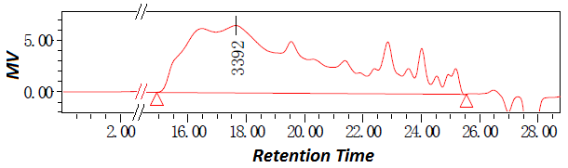

Fig. 1 GPC trace of lignin-soluble fractions of the extracted lignin.

Table 2. Number-average molecular weight (Mn), weight-average molecular weight (Mw), and polydispersity (PDI) of the THF soluble-lignin extracted from ash wood by GPC analysis

|  |  |  |  |
| --- | --- | --- | --- |
| Lignin | Mn(g/mol) | Mw(g/mol) | PDI(Mw/Mn) |
| From Ashwood | 845 | 4009 | 4.74 |

Fourier translation infrared spectroscopy (FT-IR) technique was used to analyze the functional groups present in the lignin products [9]. The wavelength of the light absorbed reveals the characteristic of the chemical bond. Analysis was performed on ThermoFisher 6700 spectrometer, USA. The lignin sample was dissolved in tetrahydrofuran (THF) and tested. It can be seen that at region between 3400 - 3600 cm-1, a large amount of hydroxyl group was detected. The region between 2700 - 3100 cm-1 can be assigned to the C-H stretching vibration in alkanes and alkyl groups and C-H stretching in the aldehydes group [10]. The peaks observed in the range of 1400 - 1600 cm-1 can be attributed to the occurrence of C=C stretching in aromatics [10, 11], while the peaks between 1000 - 1300 cm-1 can be attributed to the presence of S (syringyl) units and G (guaiacyl) units respectively [11, 12].

The oxidative decomposition behaviors of ash wood and ash wood lignin samples were investigated using thermogravimetric analysis (TGA). TGA was conducted using a SDT 650 (TA instruments, USA). TGA apparatus over the temperature range 50 – 800 °C at the heating rate of 10 oC/min. Sample (5 - 10 mg) was employed with gas flow rate fixed at 100 mL/min. The compositions of the gases produced were detected using a ThermoStar GSD320 gas analysis system.

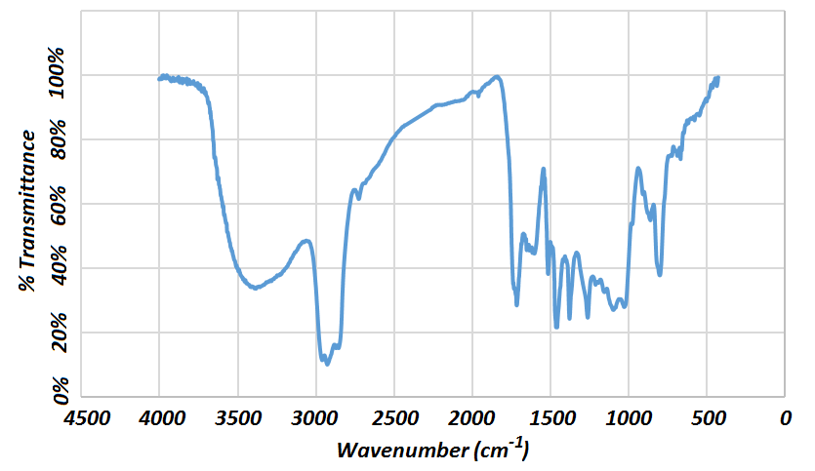

Fig. 2 FTIR spectra of ash wood lignin.

The TGA profile of ash wood lignin shows rapid weight loss above 220oC, which was verified by the DTG curve of lignin (black colour line). This may be due to volatilization of low molecular weight species and evaporation of H2O. The total weight loss was about 76 wt% of lignin from 50oC-800oC.

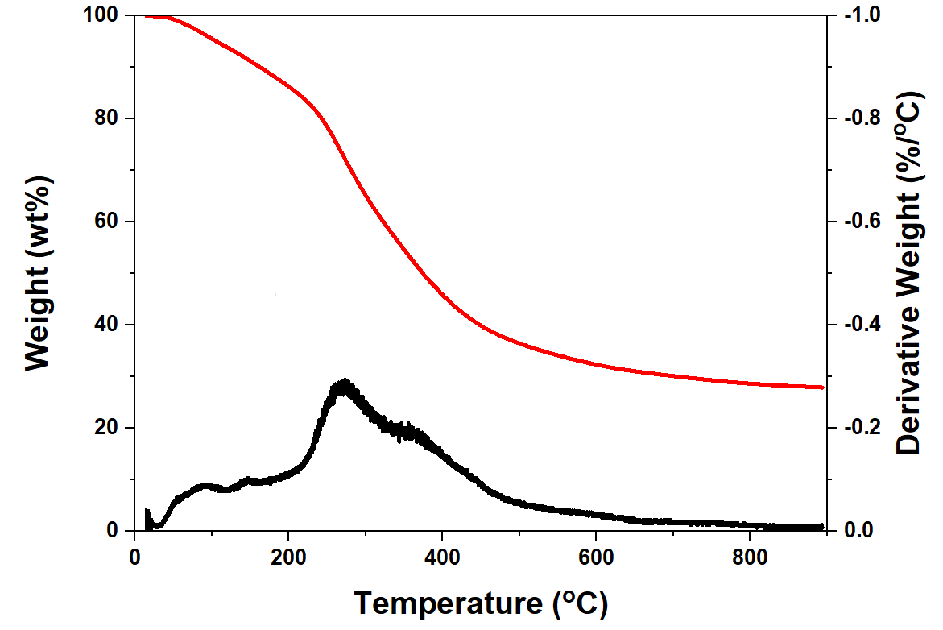

Fig. 3 TGA and DTG profiles collected under Arflow conditions for ash wood lignin.

1. **Simulation of Catalytic Conversion of Lignin**

**Simulation of Catalytic Conversion of Lignin by Ru/Nb2O5**

The reaction condition being simulated for the part of direct hydrodeoxygenation of lignin in SuperPro Designer follows the literature that was published [13]. Only six major liquid products were considered, i.e. toluene, ethylbenzene, n-propylbenzene, methyl cyclohexane, ethyl cyclohexane, n-propyl cyclohexane. C10 - C15 components were ignored in the simulation due to small amount. In the SuperPro model for batch stirred-tank reactor, the catalyst usage is 1 wt% catalyst (Ru/Nb2O5) per batch.

Table 3. RVP and mass flow of each components

|  |  |  |  |  |  |
| --- | --- | --- | --- | --- | --- |
|  |  |  | **Antoine Constants (mmHg and K)(a)** | | |
|  | **RVP (kPa)(b)** | **wt(kg/h)** | **A** | **B** | **C** |
| toluene | 9.7 | 224.4 | 7.14 | 1457.29 | -41.32 |
| Ethylbenzene | 5.0 | 729.3 | 7.16 | 1559.55 | -44.57 |
| Propylbenzene | 3.3 | 681.2 | 7.18 | 1655.21 | -47.54 |
| Methylcyclohexane | 13.4 | 48.1 | 7.00 | 1375.13 | -40.33 |
| Ethylcyclohexane | 5.6 | 352.6 | 6.97 | 1473.05 | -44.32 |
| Propylcyclohexane | 3.3 | 288.5 | 6.96 | 1537.01 | -52.08 |

1. Antoine constants obtained from the “The Yaws Handbook of Vapor Pressure”[14]
2. RVP is of each pure component.

**Simulation of Catalytic Conversion of Lignin by Ru/activated carbon**

The reaction condition being simulated for the part of direct hydrodeoxygenation of lignin in SuperPro Designer® follows the literature that was published [13]. Only the three major liquid products were considered, i.e. methyl cyclohexane, ethyl cyclohexane, n-propyl cyclohexane. C10 - C15 components were ignored in the simulation due to small amount. In the SuperPro model for batch stirred-tank reactor, the catalyst usage was 1 wt% catalyst (Ru/C) per batch.

Table 4. Mass flow of each components

|  |  |  |
| --- | --- | --- |
|  | **RVP (kPa) (a)** | **wt(kg/h)** |
| Methylcyclohexane | 255.1 | 48.19 |
| Ethylcyclohexane | 1148.1 | 352.6 |
| Propylcyclohexane | 932.8 | 288.5 |

1. RVP is of each pure component

**Simulation of Catalytic Conversion of Lignin by Amberlyst-15/Pt/CNT**

*Preparation of 5wt% Pt/CNT catalyst*

The 5wt% Pt/CNT catalyst was prepared according to the literature procedure [2, 15]. In a typical experiment, the acid pre-treated CNTs were immersed in Pt colloidal solution. HCl was added to adjust the pH to below 3 and the solution was cooled to 80oC. The mixture was then heated to 140oC and was kept stirring for an hour. After the mixture was cooled to room temperature, the resulting solid product was filtered, washed with ethanol, and dried at 60°C for 18 h to obtain a black color solid.

*Catalytic tests*

The catalytic degradation of the extracted lignin was carried out in a 50 mL autoclave equipped with a pressure indicator and magnetically coupled stirrer drive. In a typical run, 0.05 g pre-reduced catalyst, 0.1 g of Amberlyst-15 and 0.1 g of extracted lignin were dispersed in 20 mL water and transferred into reactor with 0.3 g dodecane as an internal standard. The autoclave was then sealed, purged with N2 three times and heated to 240oC under magnetic stirring (700 rpm) in 3.0 MPa of H2 atmosphere. After 6 hour, the reactor was cooled to room temperature. The products were detected by an Agilent 7890B GC (HP-5, 30 m×0.32 mm×0.25 μm) with 5977A MSD. The injection temperature was 300oC. The temperature of the oven was initially set at 60 oC and subsequently increased at 140 oC at a heating rate of 3 oC/min, then 10 oC/min reached at 300 oC. The chemical species were identified by the NIST mass spectral library. For the conversion of ash wood lignin, the selectivity to the identified products have been calculated as follows:

$C\left(\%\right)=\frac{C_{original lignin-}C_{residue lignin}}{C_{original lignin}}×100$ (3)

$S_{i}\left(\%\right)=\frac{m_{i}}{\sum_{i=1}^{n}{m_{i}}}×100$ (4)

where the selectivity of each product was determined by the ratio of their individual peak areas to total peak areas of GC-MS spectra.

Table 5. Product distribution of catalytic conversion of lignin by Amberlyst-15 + Pt/CNTs

|  |  |  |  |  |
| --- | --- | --- | --- | --- |
| **Name** | **wt %** | **b.p.** | **density**  **(kg/m3)** | |
| ethylbenzene | 2.41 | 136.1619 | 863.686 | |
| 1,2,3-trimethylcyclohexane | 0.33 | 151.084 | 737.025 | |
| 3-cyclohexylpropan-1-ol | 0.25 | 218.95 | 903.124 | |
| cumeme | 0.41 | 152.38 | 857.764 | |
| 2-isopropyl-5-methylcyclohexyl pentanoate | 0.2 | 229.1(a) | 900(b) | |
| 4-ethylresorcinol | 0.18 | 273.8(a) | 1200(b) | |
| 2,4-dimethylhexan-3-ol | 0.16 | 159.39 | 699.341 | |
| 1,2,4-trimethylbenzene | 0.41 | 169.351 | 873.034 | |
| propoxybenzene | 0.14 | 190.331 | 989.891 | |
| 1-isopropyl-3,5-dimethylbenzene | 3.21 | 196.4 | 851.056 | |
| 1,2-diisopropylbenzene | 2.71 | 204.724 | 739.506 | |
| 2-isobutyl-1,4-dimethylcyclohexane | 0.75 | 198.46 | 838.458 | |
| 1,4-diisopropylbenzene | 0.12 | 210.2744 | 852.892 | |
| 1,5-diisopropyl-2,4-dimethylbenzene | 2.06 | 254.45 | 881.482 | |
| 1,4-di-tert-butylbenzene | 3.22 | 237.2956 | 855.578 | |
| 1,3,5-triisopropylbenzene | 9.35 | 258.55 | 906.485 | |
| 1,1,4-trimethylcyclohexane | 0.44 | 134.531 | 740.282 | |
| Total | 26.21 |  |  | |
| (a) estimated from ChemDraw chemical properties | | | |
| (b) data from ChemSpider | | | |
| (c) all the other properties obtained from the DataBank of ASPEN Plus | | | |

Table 6. Product distribution of catalytic conversion of lignin by Amberlyst-15 + Pt/CNTs and mass flow (S-111) after distilled off the light portions (C8 – C12, 31.85 - 220.85oC) by flash drum (before blending)

|  |  |  |  |  |  |
| --- | --- | --- | --- | --- | --- |
|  |  |  | **Antoine Constants**  **(mmHg and K)(a)** | | |
| **Name** | **RVP (kPa)(b)** | **wt(kg/h)** | **A** | **B** | **C** |
| ethylbenzene | 5.0045869 | 221.2815 | 7.1561 | 1559.545 | -44.568 |
| 1,2,3-trimethylcyclohexane | 3.4748881 | 30.30148 | 7.10977 | 1545.37 | -58.786 |
| 3-cyclohexylpropan-1-ol | 2.0612697 | 22.95576 | 7.17403 | 1540.213 | -109.245 |
| cumeme | 3.5578087 | 37.64721 | 7.10691 | 1577.97 | -52.173 |
| 2,4-dimethylhexan-3-ol | 2.5402267 | 14.69145 | 8.4945 | 2537.837 | 17.88 |
| 1,2,4-trimethylbenzene | 2.8997965 | 37.64721 | 7.29329 | 1763.351 | -42.902 |
| propoxybenzene | 2.5125506 | 12.85428 | 7.82815 | 2210.725 | -16.199 |
| 1-isopropyl-3,5-dimethylbenzene | 2.1593536 | 294.7417 | 7.0694 | 1660.965 | -71.105 |
| 1,2-diisopropylbenzene | 1.7302232 | 248.8272 | 6.61333 | 1420.412 | -96.599 |
| 2-isobutyl-1,4-dimethylcyclohexane | 2.0923731 | 68.86433 | 7.03131 | 1677 | -72.92 |
| 1,4-diisopropylbenzene | 1.9375484 | 11.01712 | 6.71671 | 1617.693 | -75.424 |
| 1,1,4-trimethylcyclohexane | 5.5185128 | 40.40002 | 6.96164 | 1488.327 | -43.487 |

1. Antoine constants obtained from the “The Yaws Handbook of Vapor Pressure”[14]
2. RVP is of each pure component.

In the SuperPro model for batch stirred-tank reactor, the catalyst usage is 1 wt% catalyst (Amberlyst-15 + Pt/CNT) per batch.

1. **Stream Data**

Table 7.Result obtained in the product stream of Fractionation Process (P-6)

|  |  |  |
| --- | --- | --- |
| **Components** | **Flow Rate (kg/batch)** | **Mass Composition (%)** |
| Water | 30443.25 | 29.64 |
| Cellulose, Pulp | 28000.00 | 27.26 |
| Lignin | 21000.00 | 20.44 |
| 2-Methyltetrahydrofuran | 6.08 | 0.0060 |
| Oxalic Acid | 2274.06 | 2274.06 |
| Xylose | 21000.00 | 20.44 |

Table 8.Light Phase Stream Composition (S-110)

|  |  |  |
| --- | --- | --- |
| **Components** | **Flow Rate (kg/batch)** | **Mass Composition (%)** |
| 2-Methyltetrahydrofuran | 116.374 | 0.17 |
| Oxalic Acid | 2274.06 | 3.25 |
| Water | 46589.40 | 66.58 |
| Xylose | 21000.00 | 30.01 |

Fig. 4 Process flow diagram for Scenario II (without lignin conversion).



Fig. 5 Process flow diagram for Case I (Ru/Nb2O5).



Fig. 6 Process flow diagram for Case II (Ru/C).



Fig. 7 Process flow diagram for Case III (Pt/CNT + Amberlyst-15).



Table 9. Result obtained after Distillation Process (S-113)

|  |  |  |
| --- | --- | --- |
| **Components** | **Flow Rate (kg/h)** | **Mass Composition (%)** |
| 2-Methyltetrahydrofuran | 5.82 | 0.0083 |
| Water | 46589.40 | 66.68 |
| Xylose | 21000.00 | 30.056 |
| Oxalic acid | 2274.06 | 3.25 |

Table 10. Heavy Stream Composition (S-117)

|  |  |  |
| --- | --- | --- |
| **Components** | **Flow Rate (kg/batch)** | **Mass Composition (%)** |
| Lignin | 21000.00 | 99.45 |
| 2-Methyltetrahydrofuran | 116.37 | 0.55 |

Table 11. Mass Yield of Liquid Hydrocarbons (Scenario I, straight out from S-133)

|  |  |  |
| --- | --- | --- |
| **Components** | **Flow Rate (kg/batch)** | **Mass Composition (%)** |
| Ethyl Cyclohexane | 955.86 | 1.34 |
| Ethylbenzene | 1976.90 | 2.76 |
| Methyl Cyclohexane | 130.34 | 0.18 |
| Propyl Cyclohexane | 782.06 | 1.09 |
| Propylbenzene | 1846.56 | 2.58 |
| Toluene | 608.28 | 0.85 |

Table 12. Final result obtained after Blending Process (Scenario I, P-31)

|  |  |  |
| --- | --- | --- |
| **Components** | **Flow Rate (kg/batch)** | **Mass Composition (%)** |
| Ethyl Cyclohexane | 955.86 | 6.978 |
| Ethylbenzene | 1976.90 | 14.43 |
| Methyl Cyclohexane | 130.34 | 0.95 |
| Propyl Cyclohexane | 782.06 | 5.71 |
| Propylbenzene | 1846.56 | 13.48 |
| Toluene | 608.28 | 4.44 |
| Benzene | 87.60 | 0.64 |
| Reformate | 1537.90 | 11.23 |
| Isopentene | 1052.80 | 7.69 |
| MTBE | 1924.00 | 14.05 |
| n-Octane | 1124.80 | 8.21 |
| Butane | 960.00 | 7.01 |
| Ethyl alcohol | 710.10 | 5.18 |

1. **Catalyst Cost Estimation**

Several methods on catalyst cost estimation have been found on the literatures, such as the step method [16] which was based on the estimating techniques that contract manufacturers of industrial catalysts use to develop price quotes for their services developed by the National Renewable Energy Laboratory (NREL) and the Pacific Northwest National Laboratory (PNNL), and the approximation methods reported by Dutta et al. [17]. Since the process was estimated at the conceptual stage, we have adopted the latter method. The effect of the catalyst cost variations would be reflected in the sensitivity analysis. The raw materials cost was obtained using the publicly available consumer pricing from Sigma-Aldrich website [18]. The processing cost of catalyst manufacturing was estimated from the supplementary materials of the reported literature [17].

**Calculation of Catalyst Cost (in US$)**

**Cost of 2wt%Ru/Nb2O5**

|  |  |  |  |  |  |
| --- | --- | --- | --- | --- | --- |
| ***Main Material Cost*** |  |  |  |  |  |
|  | MW | Usage (mol) | amount needed for 1 g Cat | Unit Price per gram | Remarks[9] |
| Nb2O5 | 265.81 | 0.01 | 0.98 | 0.926 | (208515-500G) |
| RuCl3 | 207.43 | 0.000536726 | 0.0410468 | 35.9 | 208523-50G |

|  |  |  |
| --- | --- | --- |
| ***Processing Cost*** |  |  |
| Process | Process Severity | Std Cost  ($/lb catalyst) |
| Mixing | Solvents | 1 |
| Ramping | (<250oC) | 3 |
| Ramping | (>250oC) | 4 |
| Heating | (<350oC) | 2 |
| Heating | (>350oC) | 3 |
| Cooling |  | 1 |
| Filtration |  | 3 |
| Supporting |  | 2 |
| Drying |  | 1 |
| Passivation |  | 1 |
| Total Processing Cost |  | 21 |

|  |  |  |
| --- | --- | --- |
| ***Price of Catalyst*** |  |  |
|  | Standard Cost  ($/lb catalyst) | Standard Cost ($/kg catalyst) |
| **Processing Cost** | 21 | 46.29707506 |
| **Materials Cost** |  | 2381.060093 |
| **Total Cost** |  | 2427.36 |

**Calculation of Catalyst Cost (in US$)**

**Cost of** **2wt%Ru/C**

|  |  |  |  |  |  |
| --- | --- | --- | --- | --- | --- |
| ***Main Material Cost*** |  |  |  |  |  |
|  | MW | Usage (mol) | amount needed for 1 g Cat | Unit Price per gram | Remarks[9] |
| C | 12 | 0.01 | 0.98 | 0.1144 | (242268-1kg) |
| RuCl3 | 207.43 | 2.414E-05 | 0.0410468 | 35.9 | 208523-50G |

|  |  |  |
| --- | --- | --- |
| ***Processing Cost*** |  |  |
| Process | Process Severity | Std Cost  ($/lb catalyst) |
| Mixing | Solvents | 1 |
| Ramping | (<250oC) | 3 |
| Ramping | (>250oC) | 4 |
| Heating | (<350oC) | 2 |
| Heating | (>350oC) | 3 |
| Cooling |  | 1 |
| Filtration |  | 3 |
| Supporting |  | 2 |
| Drying |  | 1 |
| Passivation |  | 1 |
| Total Processing Cost |  | 21 |

|  |  |  |
| --- | --- | --- |
| ***Price of Catalyst*** |  |  |
|  | *Std Cost*  *($/lb catalyst)* | *Std Cost*  *($/kg catalyst)* |
| ***Processing Cost*** | *21* | *46.297075* |
| ***Materials Cost*** |  | *1585.6921* |
| ***Total Cost*** |  | *1631.9892* |

**Calculation of Catalyst Cost (Dollars in US$)**

**Cost of Amberlyst-15 + 5%Pt/CNTs (5%)**

***Main Material Cost***

|  |  |  |  |  |  |
| --- | --- | --- | --- | --- | --- |
|  | MW | Usage (mol) | g needed for 1 g Cat | Unit Price per gram | Remarks |
| CNT (multi-walled) | 12 | 0.01 | 0.94996833 | 11.912 | 901019-25g |
| H2PtCl6•6H2O | 517.9 | 3.2397E-05 | 0.13282448 | 86.02 | 206083-25g |
| Amberlyst-15 | 314.399 | N/A | N/A | 0.28796 | 216380-2.5kg |

|  |  |  |
| --- | --- | --- |
| ***Processing Cost*** |  |  |
| Process | Process Severity | Std Cost  ($/lb catalyst) |
| Mixing | Solvents | 1 |
| Ramping | (<250oC) | 3 |
| Ramping | (>250oC) | 4 |
| Heating | (<350oC) | 2 |
| Heating | (>350oC) | 3 |
| Cooling |  | 1 |
| Filtration |  | 3 |
| Supporting |  | 2 |
| Drying |  | 1 |
| Passivation |  | 1 |
| Total Processing Cost |  | 21 |

|  |  |  |
| --- | --- | --- |
| **Price of Catalyst** |  |  |
|  | Std Cost  ($/lb catalyst) | Std Cost  ($/kg catalyst) |
| **Processing Cost** | 21 | 46.3 |
| **Pt/CNT + Amberlyst-15 Cost** |  | 23,317.5 |
| **Total Cost** |  | 23,363.8 |

1. **The Blending Method, Estimation of the Physical Properties of the Bio-gasoline Products**

**The Blending Method**

The flowchart of the blending procedure was shown in Fig. 8.

Fig. 8 Blending methodology for the bio-based components to produce gasoline.

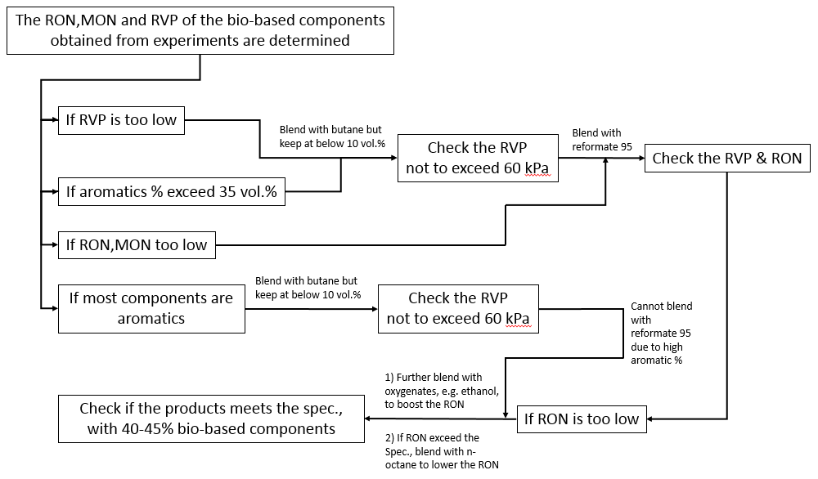

**API gravity of the Blends**

The API gravity, method for determining RVP, octane number, mean average boiling point of blended gasoline products follows the API Technical Data Book [19].

The Average Specific Gravity of the gasoline mixtures was first average by volume%, then the API gravity of the mixtures was calculated according to the following equation.

Average Specific Gravity = (vol.% of component A) (SGA) + (vol.% of component B) (SGB)

The API gravity of the bio-gasoline products was calculated for Case III as an example:

Table 13. Specific gravity of each components of bio-gasoline in Case III.

|  |  |  |  |
| --- | --- | --- | --- |
| **Name** | **SG** | **vol (L/batch)** | **vol%** |
| ethylbenzene | 860 | 256.2 | 8.57 |
| 1,2,3-trimethylcyclohexane | 737.03 | 41.1 | 1.37 |
| 3-cyclohexylpropan-1-ol | 903.12 | 25.4 | 0.85 |
| cumeme | 857.76 | 43.9 | 1.47 |
| 2,4-dimethylhexan-3-ol | 699.34 | 21.0 | 0.70 |
| 1,2,4-trimethylbenzene | 873.03 | 43.1 | 1.44 |
| propoxybenzene | 989.89 | 13.0 | 0.43 |
| 1-isopropyl-3,5-dimethylbenzene | 851.06 | 346.3 | 11.58 |
| 1,2-diisopropylbenzene | 739.51 | 336.5 | 11.24 |
| 2-isobutyl-1,4-dimethylcyclohexane | 838.46 | 82.18 | 2.75 |
| 1,4-diisopropylbenzene | 852.89 | 12.92 | 0.43 |
| 1,1,4-trimethylcyclohexane | 740.28 | 54.59 | 1.82 |
| butane | 603.17 | 599.87 | 8.77 |
| ethanol | 798.51 | 286.59 | 4.19 |
| methyl-Cyclohexane | 770.00 | 1492.82 | 21.82 |
| Cyclohexane | 770.00 | 1479.30 | 21.62 |
| Benzene | 870.00 | 65.57 | 0.96 |

API gravity = 42.65

Table 14. Gasoline components of Case I

|  |  |  |  |
| --- | --- | --- | --- |
| **Class** | **Components** | Vol (L/batch) | Vol% |
| Hydrocarbons | butane | 54.52 | 0.30 |
|  | isopentane | 115.39 | 0.64 |
|  | n-pentane | 114.42 | 0.64 |
|  | methylpentane | 228.44 | 1.28 |
|  | n-hexane | 105.23 | 0.59 |
|  | methylhexanes | 75.48 | 0.42 |
|  | n-heptane | 49.80 | 0.28 |
|  | methylheptanes | 123.19 | 0.69 |
|  | n-octane | 15.76 | 0.09 |
| Naphthenes | methylcyclopentane | 12.39 | 0.07 |
|  | cycloheptanes | 26.90 | 0.15 |
|  | Ethyl Cyclohexane | 1217.62 | 6.80 |
|  | Methyl Cyclohexane | 169.92 | 0.95 |
|  | Propyl Cyclohexane | 989.95 | 5.53 |
| Aromatics | benzene | 77.59 | 0.43 |
|  | toluene | 1013.71 | 5.66 |
|  | xylenes | 502.37 | 2.80 |
|  | C8 aromatics | 2280.93 | 12.73 |
|  | C9 aromatics | 2339.37 | 13.06 |
| **Additional** | Ethanol | 900.00 | 5.02 |
|  | benzene | 100.00 | 0.56 |
|  | MTBE | 2600.00 | 14.51 |
|  | isopentene | 1600.00 | 8.93 |
|  | n-octane | 1600.00 | 8.93 |
|  | butane | 1600.00 | 8.93 |
| Sulphur | Organo-Sulphur | 0.001 | wt% |
|  |  | 17912.99 | 100.00 |

*Components in red color are from lignin.*

Table 15. Gasoline components of Case II

|  |  |  |  |
| --- | --- | --- | --- |
| **Class** | **Components** | Vol (L/batch) | Vol% |
| Hydrocarbons | butane | 89.96 | 0.47 |
|  | isopentane | 190.39 | 1.00 |
|  | n-pentane | 188.79 | 1.00 |
|  | methylpentane | 376.93 | 1.99 |
|  | n-hexane | 173.63 | 0.92 |
|  | methylhexanes | 124.54 | 0.66 |
|  | n-heptane | 82.17 | 0.43 |
|  | methylheptanes | 203.27 | 1.07 |
|  | n-octane | 26.01 | 0.14 |
| Naphthenes | methylcyclopentane | 20.45 | 0.11 |
|  | cycloheptanes | 44.38 | 0.23 |
|  | Ethyl Cyclohexane | 3931.20 | 20.75 |
|  | Methyl Cyclohexane | 895.20 | 4.72 |
|  | Propyl Cyclohexane | 3173.60 | 16.75 |
| Aromatics | benzene | 128.03 | 0.68 |
|  | toluene | 510.61 | 2.69 |
|  | xylenes | 828.91 | 4.37 |
|  | C9 aromatics | 311.93 | 1.65 |
| **Additional** | Ethanol | 500.00 | 2.64 |
|  | benzene | 50.00 | 0.26 |
|  | toluene | 4000.00 | 21.11 |
|  | MTBE | 1600.00 | 8.44 |
|  | isopentene | 0.00 | 0.00 |
|  | n-octane | 0.00 | 0.00 |
|  | butane | 1500.00 | 7.92 |
| Sulphur | Organo-sulphur | 0.001 |  |
|  |  | 18950.00 | 100.00 |

*Components in red color are from lignin.*

**Blending for Reid Vapor Pressure (RVP)**

The theoretical method for blending of pure components and/or petroleum fractions to the desired RVP follows the procedure described in Procedure 5B1.3 - Blending Method for Reid Vapor Pressure in the API Technical Data Book [19], or simulated using ASPEN Plus.

$${RVP}_{m}=\frac{{\left[\sum_{i=0}^{n}{(V_{i}{RVP}_{i}^{1.25})}\right]}^{0.8}}{V_{m}}$$

where:

RVP*m* = Reid vapor pressure of the blend in psi,

Vi = volume fraction of stream and/or component i,

RVP*i* = Reid vapor pressure of the stream and/or component i, in psi. For pure component, RVPi is taken as the pure component true vapor pressure at 100oF.

**Blending of Octane Number**

The octane number of the blended mixtures was estimated and calculated using the online calculator provide by the CloudFlame online resources and the literature reported method [20, 21]. Octane numbers are blended on a volumetric basis. For blending with reformate (RON = 95) and additional components, the components in the reformate and additional components were first classified as different types, then the corresponding vol% of each type were input to the online calculator.

If n-butane alone is insufficient to increase the final octane number of the gasoline, different ways could be used to improve the octane number.

1. Increase the blending with reformate (RON = 95) numbered additional aromatics.
2. Use oxygenates such as MTBE or ETBE to improve the pool octane.

Table 16. Blending values of octane improvers (boosters/additives).

|  |  |  |  |  |  |  |
| --- | --- | --- | --- | --- | --- | --- |
| Compound | MW | API | b.p. | RVP (kPa) | RON | MON |
| Methanol | CH4O | 46.2 | 64.7 | 40 | 135 | 105 |
| Ethanol | C2H6O | 46.1 | 78.3 | 11 | 132 | 106 |
| t-Butanol | C4H10O | 47.4 | 82.4 | 6 | 106 | 89 |
| MTBE | C5H12O | 58.0 | 55.2 | 9 | 118 | 101 |
| ETBE | C6H14O | 56.7 | 71 | 4 | 118 | 102 |
| TAME | C6H14O | 53.7 | 85 | 1.5 | 111 | 98 |

**References**

1. Chen W, Pan X, Bao X: **Tuning of Redox Properties of Iron and Iron Oxides via Encapsulation within Carbon Nanotubes**. *J Am Chem Soc* 2007, **129**:7421-7426.

2. Li C, Shao Z, Pang M, Williams CT, Liang C: **Carbon nanotubes supported Pt catalysts for phenylacetylene hydrogenation: effects of oxygen containing surface groups on Pt dispersion and catalytic performance**. *Catal Today* 2012, **186**(1):69-75.

3. vom Stein T, Grande PM, Kayser H, Sibilla F, Leitner W, Domínguez de María P: **From biomass to feedstock: one-step fractionation of lignocellulose components by the selective organic acid-catalyzed depolymerization of hemicellulose in a biphasic system**. *Green Chem* 2011, **13**(7).

4. Colares CJG, Pastore TCM, Coradin VTR, Camargos JAA, Moreira ACO, Rubim JC, Braga JWB: **Exploratory Analysis of the Distribution of Lignin and Cellulose in Woods by Raman Imaging and Chemometrics**. *J Braz Chem Soc* 2015, **26**(6):1297-1305.

5. Brauns FE, Brauns DA: **The Chemistry of Lignin. Covering the Literature for the Years 1949–1958**. London: Academic Press; 1960.

6. Wisogel A, Tyson S, Johnson D: **Handbook On Bioethanol: Production and Utilization**. Washington D.C.: Taylor & Francis; 1996.

7. Hidajata MJ, Riazb A, Kim J: **A two-step approach for producing oxygen-free aromatics from lignin using formic acid as a hydrogen source**. *Chem Eng J* 2018, **348**:799–810.

8. Zhou M, Sharma BK, Liu P, Ye J, Xu J, Jiang J-C: **Catalytic in Situ Hydrogenolysis of Lignin in Supercritical Ethanol: Effect of Phenol, Catalysts, and Reaction Temperature**. *ACS Sustain Chem Eng* 2018, **6**:6867−6875.

9. Bikovens O, Telysheva G, Iiyama K: **Comparative studies of grass compost lignin and the lignin component of compost humic substances**. *Chem Ecol* 2010, **26**:67–75.

10. Deepa AK, Dhepe PL: **Lignin Depolymerization into Aromatic Monomers over Solid Acid Catalysts**. *ACS Catal* 2015, **5**:365−379.

11. Guo H, Zhang B, Qi Z, Li C, Ji J, Dai T, Wang A, Zhang T: **Valorization of Lignin to Simple Phenolic Compounds over Tungsten Carbide: Impact of Lignin Structure**. *ChemSusChem* 2017, **10**(3):523-532.

12. Watkins D, Nuruddin M, Hosur M, Tcherbi-Narteh A, Jeelani S: **Extraction and characterization of lignin from different biomass resources**. *J Mater Res Technol* 2015, **4**(1):26–32.

13. Shao Y, Xia Q, Dong L, Liu X, Han X, Parker SF, Cheng Y, Daemen LL, Ramirez-Cuesta AJ, Yang S *et al*: **Selective production of arenes via direct lignin upgrading over a niobium-based catalyst**. *Nat Commun* 2017, **8**:9.

14. Yaws CL: **The Yaws Handbook of Vapor Pressure - Antoine coefficients**, Second Edition edn: Elsevier - Gulf Professional Publishing; 2015.

15. Christina Bock, Paquet C, Couillard M, Botton GA, MacDougall BR: **Size-Selected Synthesis of PtRu Nano-Catalysts: Reaction and Size Control Mechanism**. *J Am Chem Soc* 2004, **126**:8028-8037.

16. Baddour FG, Snowden-Swan L, Super JD, Van Allsburg KM: **Estimating Precommercial Heterogeneous Catalyst Price: A Simple Step-Based Method**. *Org Process Res Dev* 2018, **22**(12):1599-1605.

17. Dutta A, Schaidle JA, Humbird D, Baddour FG, Sahir A: **Conceptual Process Design and Techno-Economic Assessment of Ex Situ Catalytic Fast Pyrolysis of Biomass: A Fixed Bed Reactor Implementation Scenario for Future Feasibility**. *Top Catal* 2015, **59**(1):2-18.

18. **Sigma-Aldrich Online Product Database**. In*.*: Sigma-Aldrich Company Website.

19. **API Technical Data Book**; 1999.

20. **ExxonMobil Gasoline Composition-Based Octane Model Calculator**. In: *CloudFlame - Fuel Tools.* Saudi Arabia: King Abdullah University of Science and Technology; 2013-2016.

21. Ghosh P, Hickey KJ, Jaffe SB: **Development of a Detailed Gasoline Composition-Based Octane Model**. *Ind Eng Chem Res* 2006, **45**:337-345.