Aberdeen Varicose Veins Questionnaire
YOUR VARICOSE VEINS

1. Please draw in your varicose veins in the diagram(s) below:-

Legs viewed Legs viewed
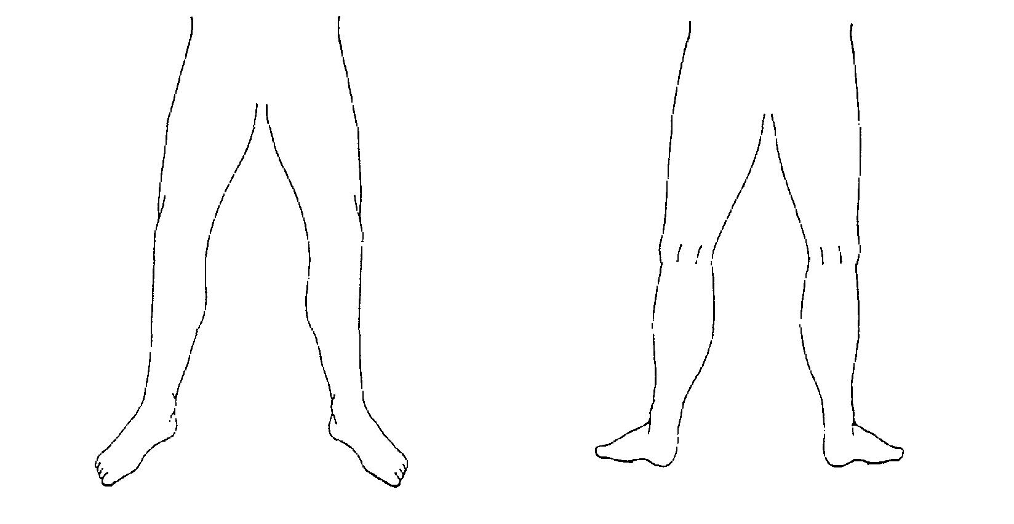
from front from back

2. In the last two weeks, for how many days did your varicose veins cause you pain or ache?
(Please tick one box for each leg) | R Leg |  |  | L Leg
None at all
Between 1 and 5 days
Between 6 and 10 days
For more than 10 days

3. During the last two weeks, on how many days did you take painkilling tablets for your varicose veins?
(Please tick one box for each leg) | R Leg |  |  | L Leg
None at all
Between 1 and 5 days
Between 6 and 10 days
For more than 10 days

4. In the last two weeks, how much ankle swelling have you had?
(Please tick one box) None at all
Slight ankle swelling

Moderate ankle swelling (eg. causing you
to sit with your feet up whenever possible)

Severe ankle swelling (eg. causing you
difficulty putting on your shoes)

5. In the last two weeks, have you worn support stockings or tights?
(Please tick one box for each leg) | R Leg |  |  | L Leg
No

Yes, those I bought myself without
a doctor's prescription

Yes, those my doctor prescribed for
me which I wear occasionally

Yes, those my doctor prescribed for
me which I wear every day

6. In the last two weeks, have you had any itching in association with your varicose veins?
(Please tick one box for each leg) | R Leg |  |  | L Leg
No
Yes, but only above the knee
Yes, but only below the knee
Both above and below the knee

7. Do you have purple discolouration caused by tiny blood vessels in the skin, in association with your varicose veins?
(Please tick one box for each leg) | R Leg |  |  | L Leg
No
Yes

8. Do you have a rash or eczema in the area of your ankle?
(Please tick one box for each leg) | R Leg |  |  | L Leg
No

Yes, but it does not require any treatment
from a doctor or district nurse

Yes, and it requires treatment from
my doctor or district nurse

9. Do you have a skin ulcer associated with your varicose veins?
(Please tick one box for each leg) | R Leg |  |  | L Leg
No
Yes

10. Does the appearance of your varicose veins cause you concern?
(Please tick one box) No

Yes, their appearance causes
me slight concern

Yes, their appearance causes
me moderate concern

Yes, their appearance causes
me a great deal of concern

11. Does the appearance of your varicose veins influence your choice of clothing including tights?
(Please tick one box) No
Occasionally
Often
Always

12. During the last two weeks, have your varicose veins interfered with your work/ housework or other daily activities?
(Please tick one box) No

I have been able to work but my work
has suffered to a slight extent

I have been able to work but my work
has suffered to a moderate extent

My veins have prevented me from
working one day or more

13. During the last two weeks, have your varicose veins interfered with your leisure activities (including sport, hobbies and social life)?
(Please tick one box) No

Yes, my enjoyment has suffered
to a slight extent

Yes, my enjoyment has suffered
to a moderate extent

Yes, my veins have prevented me taking
part in any leisure activities

