Appendix 7: Results: Pairwise climate similarity (Schoener's D) between biogeographic areas for combined PC axes
Fig. S7. Results of pairwise climate similarity (Schoener’s D) for combined PC axis 1 and 2. CFR, Cape; DRA, Drakensberg; EU, Europe; MAD, Madagascar; TA, Tropical Africa.
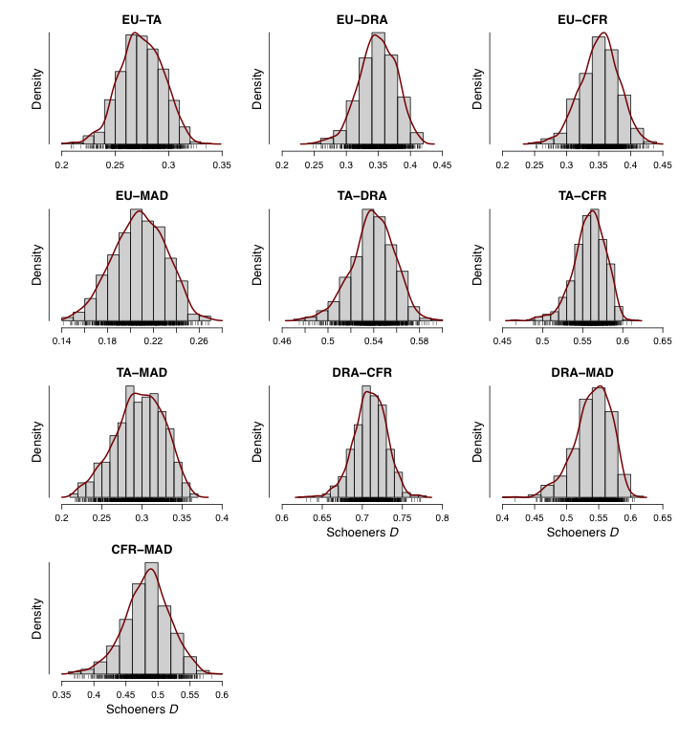

Table S7. Median of pairwise climate similarity (Schoener’s D) for combined PC axis 1 and 2 between biogeographic areas (used in the biogeographic analysis to define the niche similarity model).
Area | E | T | M | D | C
E | 1 | 0.2741537 | 0.2082148 | 0.3488249 | 0.3527277
T | 0.2741537 | 1 | 0.2981096 | 0.5396060 | 0.5599753
M | 0.2082148 | 0.2981096 | 1 | 0.5434733 | 0.4846330
D | 0.3488249 | 0.5396060 | 0.5434733 | 1 | 0.7104079
C | 0.3527277 | 0.5599753 | 0.4846330 | 0.7104079 | 1

