Table S1: PredicinePLUSTM 180-gene panel

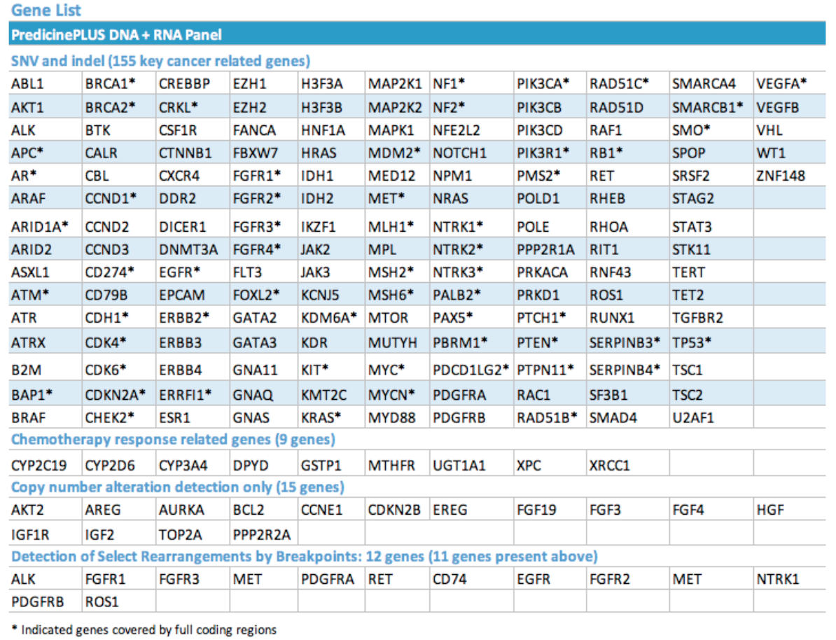

Table S2: Treatment data and sites of disease
Patient | Prior Therapy in Metastatic Setting | Number of Prior Therapies | Sites(s) of Disease
1 | capecitabine, docetaxel/carboplatin/trastuzumab/pertuzumab | 2 | liver, lung, bone
2 | palbociclib/letrozole, vinorelbine/capecitabine | 2 | liver, bone, LN, soft/soft tissue
3 | palbociclib/fulvestrant, durvalumab/tremelimumab (clinical trial), ixempra/capecitabine | 3 | liver, bone, LN
4 | cisplatin/radiation (clinical trial) | 1 | bone
5 | none | 0 | skin/soft tissue
6 | fulvestrant, fulvestrant/palbociclib, letrozole, capecitabine | 4 | bone, serosa
7 | carboplatin/paclitaxel, palbociclib/letrozole, liposomal doxorubicin | 3 | lung, LN
8 | carboplatin/abraxane, pembrolizumab/capecitabine (clinical trial) | 2 | bone, LN, lung
9 | anastrozole | 1 | bone, LN
10 | palbociclib/letrozole | 1 | liver, lung, bone
11 | tamoxifen, capecitabine, fulvestrant/everolimus, 5-FU/epirubicin/cyclophosphamide, carboplatin/gemcitabine, abraxane/everolimus/trastuzumab/pertuzumab, eribulin/trastuzumab/pertuzumab | 7 | liver, lung, bone
12 | carboplatin/gemcitabine | 1 | bone, LN, serosa
13 | tamoxifen, palbociclib/letrozole | 2 | lung, bone, serosa
14 | none | 0 | liver, bone, LN
15 | exemestane, docetaxel, everolimus, capecitabine, epirubicin/ixabepilone | 5 | bone, lung, CNS
16 | none | 0 | bone
17 | carboplatin/gemcitabine, paclitaxel, capectabine, doxorubicin, eribulin | 5 | lung, LN, skin/soft tissue
18 | vinorelbine, anastrozole, fulvestrant/palbociclib, everolimus/exemestane | 4 | bone, LN, serosa, CNS
19 | docetaxel/trastuzumab/pertuzumab, T-DM1 | 2 | liver, skin/soft tissue, serosa
20 | adriamycin/cyclophosphamide, carboplatin/paclitaxel, eribulin | 3 | liver, bone, LN, skin/soft tissue
21 | anastrozole, fulvestrant, trastuzumab/capecitabine | 3 | liver, bone
22 | carboplatin/paclitaxel, exemestane, letrozole/palbociclib, capecitabine | 4 | liver, bone, LN, serosa

LN: lymph node; CNS: central nervous system

Table S3: Characteristics of Guardant360 validation cohort

Cohort
 | Number of patients | 84
Pathology
IDC |  | 70 (83.3%)
ILC |  | 7 (8.3%)
Unknown |  | 7 (8.3%)
Subtype
 | Luminal | 36 (42.9%)
 | HER2+ | 21 (25.0%)
 | TNBC | 27 (32.1%)
Clinical Subtype
 | IBC | 43 (51.2%)
 | Non-IBC | 41 (48.8%)
Sites of Disease
 | Bone | 39 (46.4%)
 | Visceral | 43 (51.2%)
CTC Clusters
 | Yes | 9 (10.7%)
 | No | 75 (89.3%)

Figure S1: Mutant allele frequency of 100 most common variants in the cohort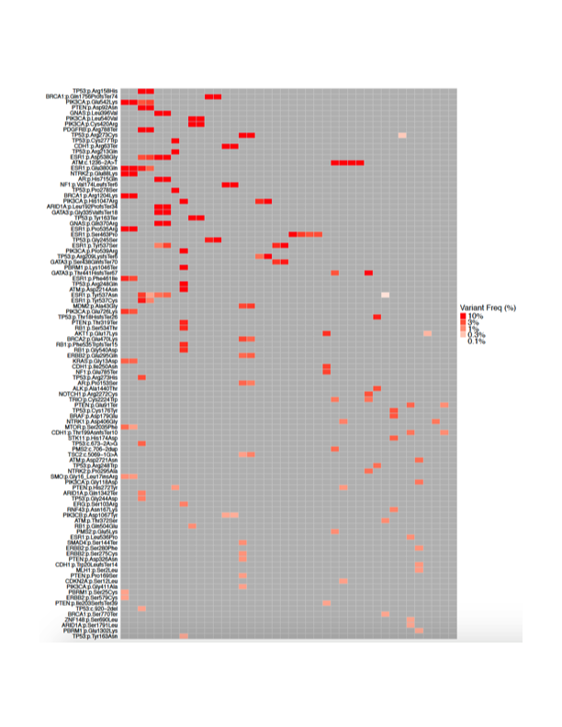

Figure S2: Case vignette demonstrating the potential clinical utility of serial liquid biopsy assessment

Association of a novel circulating tumor DNA next-generating sequencing platform with circulating tumor cells (CTCs) and CTC clusters in metastatic breast cancer

Andrew A. Davis¹, Qiang Zhang¹, Lorenzo Gerratana^{1,2}, Ami N. Shah¹, Youbin Zhan¹, Wenan Qiang¹, Brian S. Finkelman^{1,3}, Lisa Flaum¹, Amir Behdad^{1,3}, William J. Gradishar¹,
Leonidas C. Platanias¹, Massimo Cristofanilli¹

¹Robert H. Lurie Comprehensive Cancer Center, Feinberg School of Medicine, Northwestern University, Chicago IL;
²Department of Medicine, University of Udine, Udine, UD, Italy
³Department of Pathology, Northwestern University, Chicago, IL

