|  |  |  |  |
| --- | --- | --- | --- |
| ‘Xuri’ | ‘Bainiaochaofeng’ | ‘Yulongxishui’ | ‘Daidaichaoxia’ |
| ‘Ziruigong’ | ‘Lvyun’ | ‘Gushajingang’ | ‘Jinlingguan’ |
| ‘Xishanhongri’ | ‘Xiuhuapo’ | ‘Yulanhe’ | ‘Tiangezhuiyu’ |
| ‘Yulingguan’ | ‘Yulouchun’ | ‘Morong’ | ‘Mokui’ |
| ‘Changongguise’ | ‘Luhuayueying’ | ‘Huanshuijingui’ | ‘Bailuhengjiang’ |
| ‘Tianxiayipin’ | ‘Yongshoumo’ | ‘Zixianchuanzhen’ | ‘Moxie’ |
| ‘Yuhudie’ | ‘Hubeixieyang’ | ‘Lvbaoshi’ | ‘Feixueyingchun’ |
| ‘Jinlongxianxuezhua’ | ‘Zhushaguanzhu’ | ‘Jinxiaguan’ | ‘Bingxinzaibao’ |
| ‘Baifenshizi’ | ‘Jinboyongcui’ | ‘Zhinv’ | ‘Huihexianzhu’ |
| ‘Momudan’ | ‘Qiongdaosanyou’ | ‘Biyutuogui’ | ‘Taohongliulv’ |
| ‘Huangguanqiu’ | ‘Jinxiuyuanyang’ | ‘Feizhusanxia’ | ‘Xiaonianjinmei’ |
| ‘Jinsihe’ | ‘Nenhuanghe’ | ‘Xingshitu’ | ‘Qiujuwanhong’ |
| ‘Nijinqiehua’ | ‘Yuemingxingxi’ | ‘Huige’ | ‘Baimaoci’ |
| ‘Yinpantuogui’ | ‘Zichendian’ | ‘Jinfomian’ | ‘Fenghuangyi’ |
| ‘Taobaochunfeng’ | ‘Shibafenghuan’ | ‘Tangyufenfeiwu’ | ‘Taohuahong’ |
| ‘Yuezhonggui’ | ‘Xuetao’ | ‘Hongyun’ | ‘Yuxianyinzhen’ |
| ‘Bingqingyujie’ | ‘Mojianrong’ | ‘Tangyuqinglian’ | ‘Baisongzhen’ |
| ‘Runmianhanqing’ | ‘Hongshiba’ | ‘Huangjinzhuangshi’ | ‘Dianjiangchun’ |
| ‘Damofeiying’ | ‘Molanshuang’ | ‘Annigongzhu’ | ‘Junqi’ |
| ‘Wenbixishang’ | ‘Zhubidianchun’ | ‘Fenzichiguan’ | ‘Tangyuqiuyun’ |
| ‘Zhushahongshuang’ | ‘Fenghuangzhenyu’ | ‘Maguxianrui’ | ‘Zilangfengguang’ |
| ‘Riluojinshan’ | ‘Fenshiba’ | ‘Fengxian’ | ‘Tangyujinqiu’ |
| ‘Qingtangfenxie’ | ‘Jinshitou’ | ‘Oufentuogui’ | ‘Nijinshizi’ |
| ‘Nijinbao’ | ‘Gushuiliuxia’ | ‘Jinxiangyun’ | ‘Jintanzhua’ |
| ‘Fengguanxiapei’ | ‘Jinhongmaoci’ | ‘Tangyuqiushi’ | ‘Zilongwoxue’ |
| ‘Yanzhidianxue’ | ‘Gushuichunxia’ | ‘Zuiwuyangfei’ |  |

**Figure S1** Device images of 103 chrysanthemum cultivars (Top-view image)

Note: The images have been cropped.

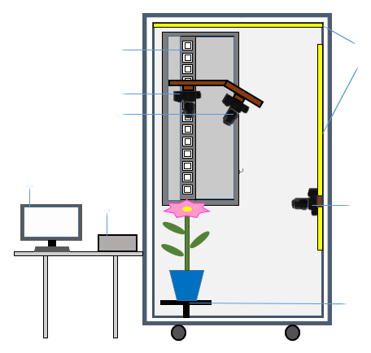

LED light source

Camera 3

The up-down moving device

Camera 1

Camera 2

Control box

Computer monitor

Horizontal rotation platform

**Figure S2** Schematic diagram of the chrysanthemum image acquisition device

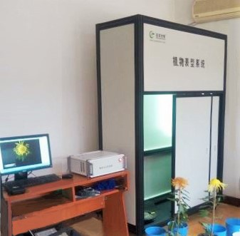

**Figure S3** Automatic chrysanthemum image acquisition device