**Additional file**

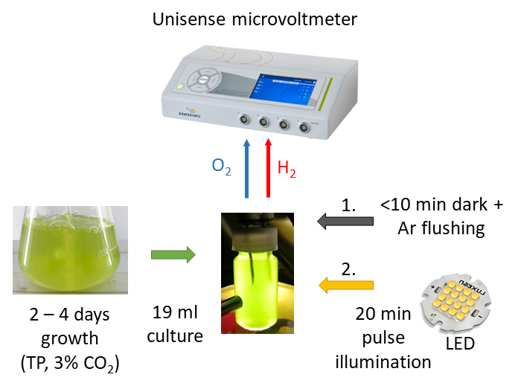

**S1**: Schematic experimental set-up of short-term pulse illumination experiments. 19 ml of *C. reinhardtii* wt and *flv* mutant cultures grown in TP medium for 2 days in 50 µmol photons m-2 s-1 bubbling with 3% CO2 were withdrawn and subjected to less than 10 min darkness together with Ar purging before the 20 min pulse illumination experiments.

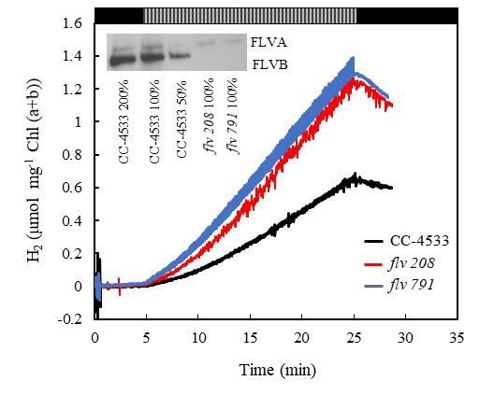

**S2**. Short-term H2 photoproduction under 1 s light / 9 s dark pulse illumination protocol in two different knock-out *flv* mutant lines. Cells were grown for 2 days at 50 µmol photons m-2 s-1 in TP medium bubbling with 3% CO2, transferred to a vial equipped with H2 and O2 sensors, flushed with Ar. The intensity of light pulses was around 250 µmol photons m-2 s-1. H2 yields during 10 min dark anaerobic adaptation phase, 20 min H2 photoproduction phase and 3 min dark H2 uptake phase in CC-4533, *flv* 208 and *flv* 791. Experiments have been performed in 3 independent replicates and are presented exemplary. The inset shows the verification of both *flv* mutant lines, *flv* 208 and *flv* 791, by immunoblot analysis.

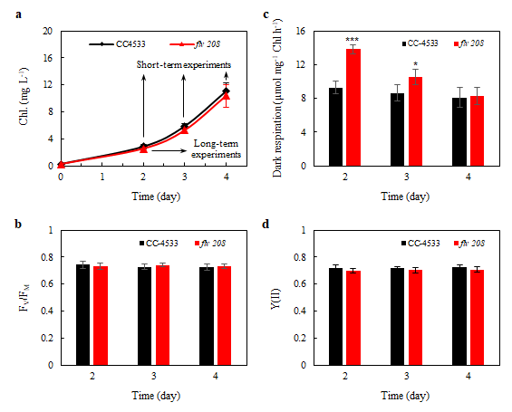

**S3**: Photosynthetic characteristics of *C. reinhardtii* wt and *flv* mutant cultures grown in TP medium for 4 days in 50 µmol photons m-2 s-1 bubbling with 3% CO2. (a) Chl concentration (mg L-1) over a growth period of 4 days. The arrows show when the cultures were withdrawn for further treatments in the long- or short-term experiments. (b) Maximum quantum efficiency of PSII (FV/FM), (c) dark respiration and (d) effective yield of PSII (Y(II)) during 3 days of growth. Experiments have been performed in 5 independent replicates (+/- SD). (b, d) No statistical significance between wt CC-4533 and *flv* 208. (c) Statistical significance levels: *p < 0.05; ***p < 0.001.

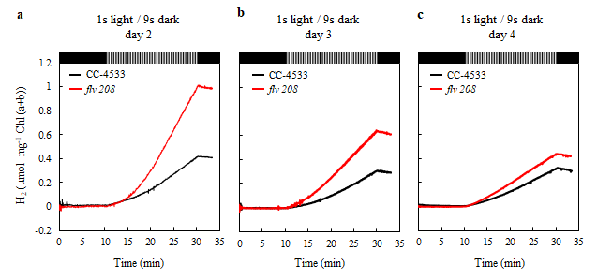

**S4**: Short-term hydrogen photoproduction yield over 4 days of cultivation. H2 photoproduction is induced by the 1/9 pulse protocol in *C. reinhardtii* wt CC-4533 and the *flv* 208 mutant grown in TP medium for (a) 2 days, (b) 3 days and (c) 4 days under 50 µmol photons m-2 s-1 bubbling with 3% CO2. The curves depicts H2 level during 10 min dark anaerobic phase, 20 min H2 photoproduction phase and 3 min dark H2 uptake phase. Experiments have been performed in 5 independent replicates and are presented exemplary.

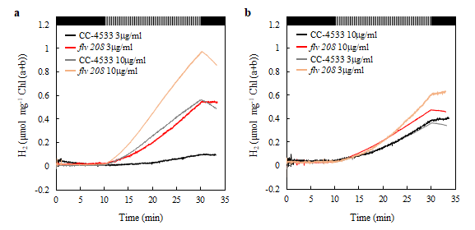

**S5**: Short-term hydrogen photoproduction yield at different Chl concentrations. H2 photoproduction is induced by the 1/9 pulse illumination protocol in *C. reinhardtii* CC-4533 and the *flv* 208 mutant. (a) 2 days old cultures (3 µg Chl ml-1) grown in TP medium under 50 µmol photons m-2 s-1 bubbling with 3% CO2 were concentrated (10 µg Chl ml-1) by centrifugation. (b) 4 days old cultures (10 µg Chl ml-1) grown in TP medium in 50 µmol photons m-2 s-1 bubbling with 3% CO2 were diluted (3 µg Chl ml-1). Experiments have been performed in 3 independent replicates and are presented exemplary.



**S6**: H2 production rates in *C. reinhardtii* CC-4533 and *flv* 208 mutant. (a) Maximal H2 production rates under the 1/9 pulse illumination and 6/9 pulse illumination protocol. (b) H2 production rates during the 1/9 pulse illumination protocol. Cultures were grown 2 days under 50 µmol photons m-2 s-1 bubbling with 3% CO2. The maximal H2 production rates have been obtained within the last 5 min of pulse illumination for 1/9 pulse illumination and within the first 5 min of pulse illumination for 6/9 pulse illumination. Experiments have been performed in 4 independent replicates and rates were calculated as mean of all replicates (+/- SD). Statistical significance level: **p < 0.01.

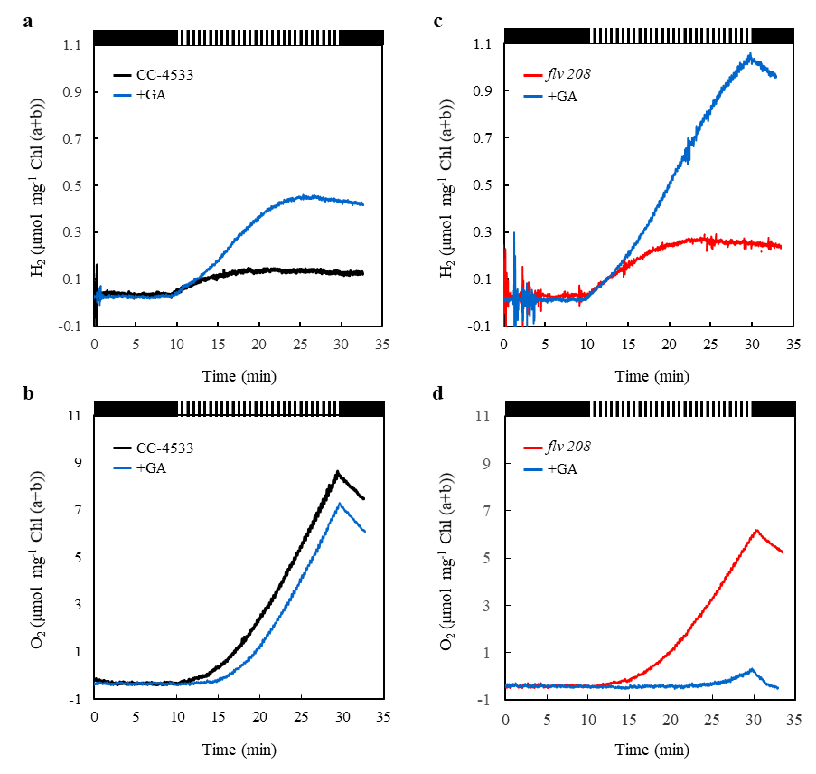

**S7**. Short-term H2 photoproduction under 6 s light / 9 s dark pulse illumination protocol in *C. reinhardtii* CC-4533 and in the *flv* 208 mutant. The other experimental conditions were the same as in Fig. 1. (a and c) H2 yield in the absence and presence of 10 mM glycolaldehyde (GA). (b and d) Simultaneous monitoring of O2 yield in the absence and presence of GA. Experiments have been performed in 3 independent replicates and exemplary measurements are presented.

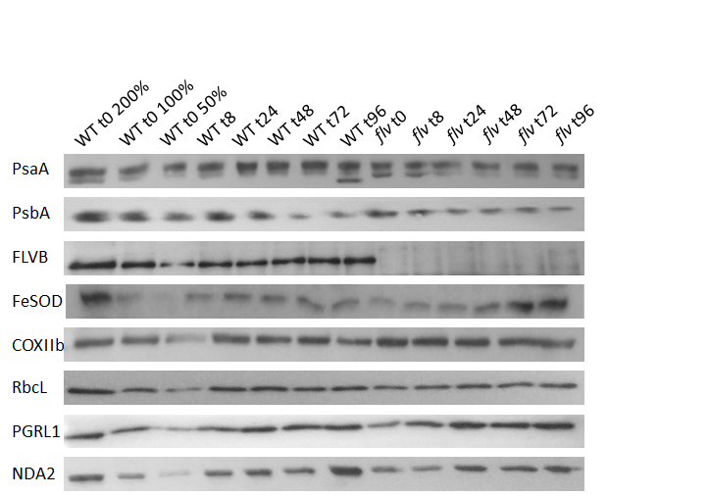

**S8**: Immunoblot analysis of selected proteins from *C. reinhardtii* CC-4533 and *flv* 208 mutant grown under long-term 1/9 pulse illumination H2 production. The western blots shown here are representative of 3 biological replicates.