Additional file 7

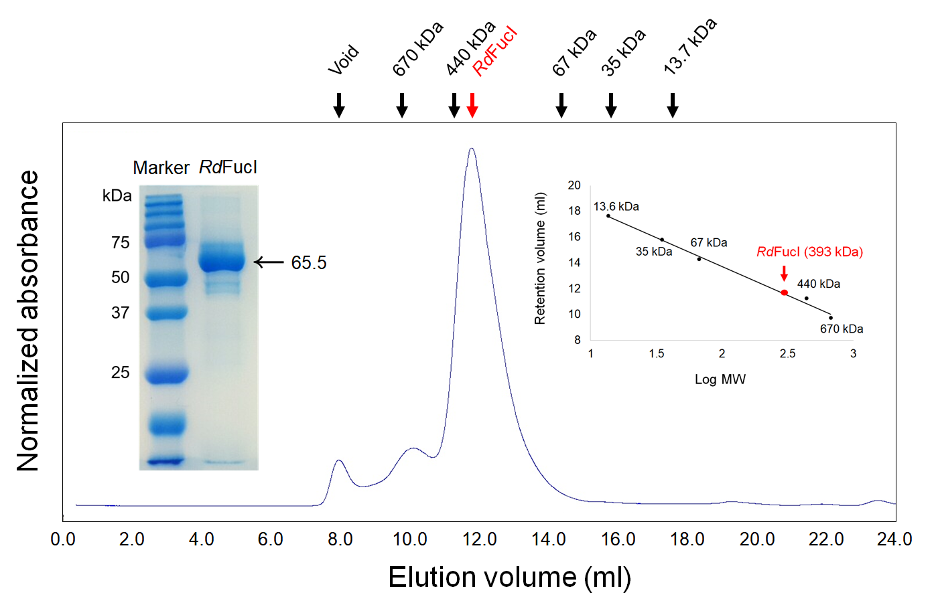

Fig. S5 Analytical gel filtration chromatography profile of RdFucI. The molecular weights of the protein standards are indicated by arrows at the top. The picture on the left represents SDS-PAGE gel analysis of RdFucI purified by affinity chromatography using the His-Trap column

