SUPPLEMENTARY MATERIALS
Supplementary Table 1. 54 to 73 gene panels of ctDNA (Guardant, Inc.)
Supplementary Table 1a. 54 gene panel (N=3 samples).
POINT MUTATIONS |  |  |  | AMPLIFICATIONS
ABL1 | AKT1 | ALK | APC | EGFR
AR | ATM | BRAF | CDKN2A | ERBB2
CDH1 | CSF1R | CTNNB1 | EGFR | MET
ERBB2 | ERBB4 | EZH2 | FBXW7
FGFR1 | FGFR2 | FGFR3 | FLT3
GNA11 | GNAQ | GNAS | HNF1A
HRAS | IDH1 | IDH2 | JAK2
JAK3 | KDR | KIT | KRAS
MET | MLH1 | MPL | MYC
NOTCH1 | NPM1 | NRAS | PDGFRA
PIK3CA | PTEN | PTPN11 | PROC
RB1 | RET | SMAD4 | SMARCB1
SMO | SRC | STK11 | TERT
TP53 | VHL
All exons were sequenced in genes in bold.

Supplementary Table 1b. 68 gene panel (N=18 samples).
POINT MUTATIONS |  |  |  | AMPLIFICATIONS | FUSIONS | INDELS
AKT1 | ALK | APC | AR | AR | ALK | EGFR exon 19 deletions
AFAR | ARID1A | ATM | BRAF | BRAF | NTRK1 | EGFR exon 20 insertions
BRCA1 | BRCA2 | CCDN1 | CCDN2 | CCNE1 | RET
CCNE1 | CDH1 | CDK4 | CDK6 | CDK4 | ROS1
CDKN2A | CDKN2B | CTNNB1 | EGFR | CDK6
ERBB2 | ESR1 | EZH2 | FBXW7 | EGFR
FGFR1 | FGFR2 | FGFR3 | GATA3 | ERBB2
GNA11 | GNAQ | GNAS | HNF1A | FGFR1
HRAS | IDH1 | IDH2 | JAK2 | FGFR2
JAK3 | KIT | KRAS | MAP2K1 | KIT
MAP2K2 | MET | MLH1 | MPL | KRAS
MYC | NF1 | NFE2L2 | NOTCH1 | MET
NPM1 | NRAS | NTRK1 | PDGFRA | MYC
PIK3CA | PTEN | PTPN11 | RAF1 | PDGFRA
RET | RHEB | RHOA | RIT1 | PIK3CA
ROS1 | SMAD4 | SMO | SRC | RAF1
STK11 | TERT | TP53 | VHL
Complete exon coverage for genes in bold.

Supplementary Table 1c. 70 gene panel (N=27 samples).
POINT MUTATIONS |  |  |  | AMPLIFICATIONS | FUSIONS | INDELS
AKT1 | ALK* | APC | AR | AR | ALK | EGFR exon 19 deletions
ARAF | ARID1A | ATM | BRAF | BRAF | FGFR2 | EGFR exon 20 insertions
BRCA1 | BRCA2 | CCND1 | CCND2 | CCND1 | FGFR3 | ERBB2 exon 19 deletions
CCNE1 | CDH1 | CDK4 | CDK6 | CCND2 | NTRK1 | ERBB2 exon 20 insertions
CDKN2A | CDKN2B | CTNNB1 | EGFR | CCNE1 | RET
ERBB2 | ESR1 | EZH2 | FBXW7 | CDK4 | ROS1
FGFR1 | FGFR2* | FGFR3* | GATA3 | CDK6
GNA11 | GNAQ | GNAS | HNF1A | EGFR
HRAS | IDH1 | IDH2 | JAK2 | ERBB2
JAK3 | KIT | KRAS | MAP2K1 | FGFR1
MAP2K2 | MET | MLH1 | MPL | FGFR2
MYC | NF1 | NFE2L2 | NOTCH1 | KIT
NPM1 | NRAS | NTRK1* | PDGFRA | KRAS
PIK3CA | PTEN | PTPN11 | RAF1 | MET
RB1 | RET* | RHEB | RHOA | MYC
RIT1 | ROS1* | SMAD4 | SMO | PDGFRA
SRC | STK11 | TERT | TP53 | PIK3CA
TSC1 | VHL |  |  | RAF1
Complete exon and partial intron coverage for genes in bold. *Genes with asterisk include rearrangements. MET includes exon 14 skipping.

Supplementary Table 1d. 73 gene panel (N=64 samples).
POINT MUTATIONS |  |  |  | AMPLIFICATIONS | FUSIONS | INDELS
AKT1 | ALK | APC | AR | AR | ALK | APC | ARID1A
ARAF | ARID1A | ATM | BRAF | BRAF | FGFR2 | ATM | BRCA1
BRCA1 | BRCA2 | CCND1 | CCND2 | CCND1 | FGFR3 | BRCA2 | CDH1
CCNE1 | CDH1 | CDK4 | CDK6 | CCNE1 | NTRK1 | CDKN2A | EGFR
CDKN2A | CTNNB1 | DDR2 | EGFR | CDK4 | RET | GATA3 | KIT
ERBB2 | ESR1 | EZH2 | FBXW7 | CDK6 | ROS1 | MET | MLH1
FGFR1 | FGFR2 | FGFR3 | GATA3 | EGFR |  | MTOR | NF1
GNA11 | GNAQ | GNAS | HNF1A | ERBB2 |  | PDGFRA | PTEN
HRAS | IDH1 | IDH2 | JAK2 | FGFR1 |  | RB1 | SMAD4
JAK3 | KIT | KRAS | MAP2K1 | FGFR2 |  | STK11 | TP53
MAP2K2 | MAPK1 | MAPK3 | MET | KIT |  | TSC1 | VHL
MLH1 | MPL | MTOR | MYC | KRAS
NF1 | NFE2L2 | NOTCH1 | NPM1 | MET
NRAS | NTRK1 | NTRK3 | PDGFRA | MYC
PIK3CA | PTEN | PTPN11 | RAF1 | PDGFRA
RB1 | RET | RHEB | RHOA | PIK3CA
RIT1 | ROS1 | SMAD4 | SMO | RAF1
STK11 | TERT | TP53 | TSC1
VHL
All clinically relevant exons for 73 genes are sequenced. TERT includes alterations in the promoter region. MET includes exon 14 skipping.

Supplementary Table 2. Genomic alteration and its potential targeted therapies with FDA-approved agents (either on/off-label) or with investigational agents in clinical trials.
Genes | Potential targeted therapies | Supplemental References
Potentially actionable with FDA approved agents (on- or off-label)
AR | AR alteration is potentially targetable with AR inhibitor enzalutamide and anti-androgens (e.g., abiraterone, bicalutamide) | S1-6
ATM | ATM alteration is potentially targetable with PARP inhibitors (e.g., olaparib, niraparib, rucaparib). | S7-10
BRAF | BRAF alteration can be targeted with BRAF inhibitors (e.g. dabrafenib, vemurafenib), MEK inhibitors (e.g. trametinib, cobimetinib), and multiple tyrosine kinase inhibitors (e.g., sorafenib, regorafenib) | S11-20
BRCA1/2 | BRCA alteration is targetable with platinum-based chemotherapy and PARP inhibitors (e.g., olaparib, niraparib, rucaparib). | S21-25
CCND2 | CCND2 may be sensitive to CDK4/6 inhibitors (e.g., palbociclib, abemaciclib, ribociclib). | S26-28
CDK4/6 | CDK6 and its functional homolog, CDK4 mutations are theoretically targetable with CDK4/6 inhibitors (e.g., palbociclib, abemaciclib, ribociclib). | S27-30
CDKN2A | CDKN2 alterations may be sensitive to CDK4/6 inhibitors (e.g., palbociclib, abemaciclib, ribociclib). | S27, 28, 31, 32
EGFR | Erlotinib, in combination with gemcitabine, has also been approved by the FDA for the treatment of locally advanced, unresectable, or metastatic pancreatic cancer. | S33, 34
ERBB2 | ERBB2 alteration is targetable with Her-targeted drugs (e.g., afatinib, lapatinib, neratinib, pertuzumab, trastuzumab). | S35-40
FBXW7 | Although there are conflicting data, FBXW7 aberration stabilizes the mTOR signaling which is potentially targetable with mTOR inhibitors (e.g., everolimus, temsirolimus). | S41-43
FGFR1 | FGFR1 alteration is targetable with multi-kinase inhibitors (e.g., pazopanib, ponatinib, regorafenib, nintedanib, lenvatinib). | S13, 14, 44-48
GNAS | GNAS alteration is potentially targetable with MEK inhibitors (e.g., trametinib, cobimetinib). | S18, 19, 49-51
IDH1 | IDH1 alteration is targetable with IDH1 inhibitors (e.g., ivosidenib). | S52-54
KRAS | KRAS alteration is potentially targetable with MEK inhibitors (e.g., trametinib, cobimetinib). | S50, 55-63
MET | MET alteration is targetable with multi-kinase inhibitors (e.g., cabozantinib, crizotinib). | S64-68
MPL | MPL alterations is associated with increased Jak/Stat signaling. Thus, it may be targetable with JAK inhibitors (e.g., ruxolitinib). | S69-72
MTOR | MTOR alteration is potentially targetable with mTOR inhibitors (e.g., everolimus, temsirolimus). | S73-79
NF1 | NF1 alteration is associated with activation of RAS and downstream pathways. Thus, it may be targetable with MEK inhibitors (e.g., trametinib, cobimetinib). | S18, 19, 80, 81
PIK3CA | PIK3CA alteration is targetable with mTOR inhibitors (e.g., everolimus, temsirolimus). | S78, 79, 82-86
PTEN | PTEN alteration is targetable with mTOR inhibitors (e.g., everolimus, temsirolimus). | S78, 79, 87
TP53 | Retrospective data suggest patients with TP53 mutation had longer progression-free survival with bevacizumab containing regimen when compared to non-bevacizumab containing regimen (median 11.0 vs. 4.0 months, p<0.0001). TP53 alteration status was also predictive of longer progression-free survival among sarcoma patients treated with pazopanib (multi-kinase inhibitor including VEGF) (hazard ratio: 0.38, p = 0.036). Interestingly, multiple regression analysis of transcriptomic data revealed TP53 mutations are associated with higher VEGFA expression (p = 0.0006) suggesting the TP53 as a marker to predict bevacizumab response. | S88-91
Potentially actionable with investigational agents
MYC | MYC alteration is potentially targetable with BET inhibitors (e.g., GSK-525762). | S92-94

Supplementary Table 3. Assessment of genomic uniqueness in ctDNA among patients with pancreatic ductal adenocarcinoma.
Altered gene | Study ID | Characterized alterations
TP53, KRAS, and CDKN2A | 7 | TP53 E56*, KRAS G12V, CDKN2A G23V
 | 51 | TP53 C124*, KRAS G12R, CDKN2A R103fs
TP53 and KRAS | 3 | TP53 R175H, KRAS G12D
 | 14 | TP53 Splice Site SNV, KRAS G12D
 | 31 | TP53 C275F, KRAS G12V
 | 74 | TP53 R248W, KRAS Q61H
 | 76 | TP53 R196*, KRAS Q61H,
 | 87 | TP53 R248W, TP53 R213*, TP53 P222L, KRAS G12C
 | 95 | TP53 R273C, KRAS G12D
 | 96 | TP53 S127F, TP53 A189T, KRAS G12D
 | 101 | TP53 C135G, KRAS G12V
 | 108 | TP53 R158fs, KRAS G12V
TP53 | 24 | TP53 V216M
 | 28 | TP53 Q100R
 | 29 | TP53 H214R
 | 40 | TP53 Y220C
 | 41 | TP53 E285K, TP53 E221K
 | 42 | TP53 I195T
 | 53 | TP53 L93M
 | 55 | TP53 R213*
 | 59 | TP53 R196P
 | 68 | TP53 R196*
 | 71 | TP53 R175H
 | 86 | TP53 R273H
 | 93 | TP53 V218E
 | 102 | TP53 V216M
 | 106 | TP53 Q100fs
KRAS | 8 | KRAS G12R
 | 43 | KRAS Q61H
 | 50 | KRAS G12D
 | 60 | KRAS G12V, KRAS Amplification
 | 64 | KRAS G12V
 | 70 | KRAS G12V
 | 85 | KRAS G12R
 | 88 | KRAS G12V, KRAS Amplification

Supplementary Table 4. Complete list of ctDNA alterations found in patients with pancreatic ductal adenocarcinoma (N=112).
ID | Characterized alteration in ctDNA | Disease status at the time of ctDNA analysis  (all treatment regimens prior to ctDNA)
1 | no characterized alteration detectable | Surgically resectable *blood obtained after surgery
2 | no characterized alteration detectable | Metastatic, locally advanced, or recurrent disease  (capecitabine; gemcitabine + abraxane; FOLFIRINOX)
3 | KRAS G12D, TP53 R175H | Metastatic, locally advanced, or recurrent disease  (no prior chemotherapy)
4 | no characterized alteration detectable | Metastatic, locally advanced, or recurrent disease  (FOLFIRINOX; gemcitabine + abraxane)
5 | no characterized alteration detectable | Surgically resectable *blood obtained before surgery
6 | KRAS G12D, SMAD4 R361C, TP53 H214P, GNAS R201C, ATM R3047Q | Metastatic, locally advanced, or recurrent disease  (no prior chemotherapy)
7 | CDKN2A G23V, KRAS G12V, TP53 E56* | Metastatic, locally advanced, or recurrent disease  (gemcitabine; capecitabine)
8 | KRAS G12R | Metastatic, locally advanced, or recurrent disease  (no prior chemotherapy)
9 | no characterized alteration detectable | Surgically resectable *blood obtained before surgery
10 | no characterized alteration detectable | Surgically resectable *blood obtained after surgery
11 | no characterized alteration detectable | Metastatic, locally advanced, or recurrent disease  (no prior chemotherapy)
12 | TERT Promoter SNV | Metastatic, locally advanced, or recurrent disease  (gemcitabine + abraxane)
13 | no characterized alteration detectable | Metastatic, locally advanced, or recurrent disease  (no prior chemotherapy)
14 | TP53 Splice Site SNV, KRAS G12D | Metastatic, locally advanced, or recurrent disease  (no prior chemotherapy)
15 | PIK3CA E545K | Metastatic, locally advanced, or recurrent disease  (no prior chemotherapy)
16 | GNAS R201H, KRAS G12V, TP53 L265P | Metastatic, locally advanced, or recurrent disease  (no prior chemotherapy)
17 | no characterized alteration detectable | Surgically resectable *blood obtained before surgery
18 | AR R775H | Metastatic, locally advanced, or recurrent disease  (FOLFIRINOX)
19 | KRAS G12V, TP53 R306*, PIK3CA E545K, NF1 K1444E | Metastatic, locally advanced, or recurrent disease  (no prior chemotherapy)
20 | no characterized alteration detectable | Surgically resectable *blood obtained after surgery
21 | no characterized alteration detectable | Metastatic, locally advanced, or recurrent disease  (no prior chemotherapy)
22 | KRAS G12D, TP53 C176F, PTEN R13Q | Metastatic, locally advanced, or recurrent disease  (no prior chemotherapy)
23 | no characterized alteration detectable | Metastatic, locally advanced, or recurrent disease  (no prior chemotherapy)
24 | TP53 V216M | Metastatic, locally advanced, or recurrent disease  (no prior chemotherapy)
25 | no characterized alteration detectable | Metastatic, locally advanced, or recurrent disease  (no prior chemotherapy)
26 | MPL W515L, TP53 C141Y | Surgically resectable *blood obtained before surgery
27 | NF1 I679fs, GNAS R201C | Metastatic, locally advanced, or recurrent disease  (gemcitabine + abraxane)
28 | TP53 Q100R | Metastatic, locally advanced, or recurrent disease  (no prior chemotherapy)
29 | TP53 H214R | Surgically resectable *blood obtained after surgery
30 | CCND2 amplification | Surgically resectable *blood obtained before surgery
31 | TP53 C275F, KRAS G12V | Metastatic, locally advanced, or recurrent disease  (no prior chemotherapy)
32 | no characterized alteration detectable | Surgically resectable *blood obtained after surgery
33 | TP53 R213L, FBXW7 R385H | Metastatic, locally advanced, or recurrent disease  (5FU+ abraxane + oxaliplatin + bevacizuamb; gemcitabine + abraxane; 5FU)
34 | KRAS G12V, MYC amplification | Metastatic, locally advanced, or recurrent disease  (gemcitabine)
35 | TP53 S215R, MYC amplification | Metastatic, locally advanced, or recurrent disease  (no prior chemotherapy)
36 | no characterized alteration detectable | Metastatic, locally advanced, or recurrent disease  (no prior chemotherapy)
37 | no characterized alteration detectable | Metastatic, locally advanced, or recurrent disease  (FOLFIRINOX; gemcitabine + abraxane)
38 | RB1 E282*, TP53 R273C, KRAS G12D | Surgically resectable *blood obtained before surgery
39 | TP53 R282W, KRAS G12R, CDKN2A W15*, ERBB2 amplification, CDK4 amplification, KRAS amplification | Metastatic, locally advanced, or recurrent disease  (no prior chemotherapy)
40 | TP53 Y220C | Metastatic, locally advanced, or recurrent disease  (gemcitabine + carboplatin)
41 | TP53 E285K, TP53 E221K | Metastatic, locally advanced, or recurrent disease  (no prior chemotherapy)
42 | TP53 I195T | Metastatic, locally advanced, or recurrent disease  (no prior chemotherapy)
43 | KRAS Q61H | Metastatic, locally advanced, or recurrent disease  (FOLFIRINOX; gemcitabine + abraxane)
44 | no characterized alteration detectable | Metastatic, locally advanced, or recurrent disease  (capecitabine)
45 | no characterized alteration detectable | Metastatic, locally advanced, or recurrent disease  (no prior chemotherapy)
46 | no characterized alteration detectable | Metastatic, locally advanced, or recurrent disease  (no prior chemotherapy)
47 | CDKN2A R80*, KRAS G12D | Metastatic, locally advanced, or recurrent disease  (abraxane + palbociclib; gemcitabine + erlotinib; palbociclib + trametinib + anakinra; palbociclib + trametinib + afatinib)
48 | no characterized alteration detectable | Metastatic, locally advanced, or recurrent disease  (capecitabine)
49 | KRAS G12R, SMAD4 R361G, CDK6 amplification, EGFR amplification | Metastatic, locally advanced, or recurrent disease  (gemcitabine + abraxane)
50 | KRAS G12D | Metastatic, locally advanced, or recurrent disease  (gemcitabine + capecitabine; abraxane)
51 | KRAS G12R, TP53 C124*, CDKN2A R103fs | Metastatic, locally advanced, or recurrent disease  (FOLFIRINOX)
52 | no characterized alteration detectable | Metastatic, locally advanced, or recurrent disease  (no prior chemotherapy)
53 | TP53 L93M | Metastatic, locally advanced, or recurrent disease  (no prior chemotherapy)
54 | TP53 V172F, CCNE1 amplification, BRAF amplification, EGFR amplification, CDK6 amplification | Metastatic, locally advanced, or recurrent disease  (gemcitabine)
55 | TP53 R213* | Metastatic, locally advanced, or recurrent disease  (no prior chemotherapy)
56 | no characterized alteration detectable | Metastatic, locally advanced, or recurrent disease  (FOLFIRINOX)
57 | no characterized alteration detectable | Metastatic, locally advanced, or recurrent disease  (gemcitabine)
58 | KRAS G12L, FGFR1 amplification | Metastatic, locally advanced, or recurrent disease  (no prior chemotherapy)
59 | TP53 R196P | Surgically resectable *blood obtained before surgery
60 | KRAS G12V, KRAS amplification | Metastatic, locally advanced, or recurrent disease  (no prior chemotherapy)
61 | KRAS G12R, TP53 P223L, MYC amplification | Metastatic, locally advanced, or recurrent disease  (no prior chemotherapy)
62 | no characterized alteration detectable | Metastatic, locally advanced, or recurrent disease  (gemcitabine + abraxane; capecitabine)
63 | GNAS R201H | Metastatic, locally advanced, or recurrent disease  (FOLFIRINOX; gemcitabine + abraxane)
64 | KRAS G12V | Metastatic, locally advanced, or recurrent disease  (no prior chemotherapy)
65 | KRAS G12D, TP53 G105V, GNAS R201C, KRAS Amplification, MYC Amplification, MET Amplification | Metastatic, locally advanced, or recurrent disease  (no prior chemotherapy)
66 | no characterized alteration detectable | Surgically resectable *blood obtained before surgery
67 | IDH1 R132C | Metastatic, locally advanced, or recurrent disease  (gemcitabine + abraxane)
68 | TP53 R196* | Metastatic, locally advanced, or recurrent disease  (capecitabine)
69 | no characterized alteration detectable | Metastatic, locally advanced, or recurrent disease  (gemcitabine + abraxane; capecitabine + irinotecan)
70 | KRAS G12V | Metastatic, locally advanced, or recurrent disease  (no prior chemotherapy)
71 | TP53 R175H | Metastatic, locally advanced, or recurrent disease  (gemcitabine + abraxane; FOLFOX)
72 | KRAS G12R, TP53 Y220C, TP53 K132E, PIK3CA amplification, CCND2 amplification, CCNE1 amplification | Metastatic, locally advanced, or recurrent disease  (capecitabine + oxaliplatin; capecitabine)
73 | KRAS G12V, TP53 C176W, FBXW7 R465C, FGFR1 amplification, BRAF amplification | Metastatic, locally advanced, or recurrent disease  (no prior chemotherapy)
74 | TP53 R248W, KRAS Q61H | Metastatic, locally advanced, or recurrent disease  (no prior chemotherapy)
75 | no characterized alteration detectable | Metastatic, locally advanced, or recurrent disease  (FOLFIRINOX)
76 | KRAS Q61H, TP53 R196* | Metastatic, locally advanced, or recurrent disease  (no prior chemotherapy)
77 | KRAS G12D, MYC Amplification, CCNE1 Amplification, PIK3CA Amplification, KRAS Amplification | Metastatic, locally advanced, or recurrent disease  (no prior chemotherapy)
78 | no characterized alteration detectable | Metastatic, locally advanced, or recurrent disease  (FOLFIRINOX)
79 | KRAS Q61R, SMAD4 D537Y, TP53 Y163C, KRAS Amplification | Metastatic, locally advanced, or recurrent disease  (no prior chemotherapy)
80 | KRAS G12V, TP53 Y220H, CCNE1 amplification, PIK3CA R401* | Metastatic, locally advanced, or recurrent disease  (gemcitabine + abraxane)
81 | no characterized alteration detectable | Surgically resectable *blood obtained after surgery
82 | no characterized alteration detectable | Metastatic, locally advanced, or recurrent disease  (no prior chemotherapy)
83 | KRAS G12R, TP53 R282W, KRAS Amplification, MYC Amplification, PIK3CA Amplification | Metastatic, locally advanced, or recurrent disease  (no prior chemotherapy)
84 | BRAF G469V | Metastatic, locally advanced, or recurrent disease  (gemcitabine + abraxane + momelotinib; FOLFIRINOX; cediranib + olaparib)
85 | KRAS G12R | Metastatic, locally advanced, or recurrent disease  (gemcitabine + abraxane)
86 | TP53 R273H | Metastatic, locally advanced, or recurrent disease  (no prior chemotherapy)
87 | KRAS G12C, TP53 R248W, TP53 R213*, TP53 P222L | Metastatic, locally advanced, or recurrent disease  (no prior chemotherapy)
88 | KRAS G12V, KRAS Amplification | Metastatic, locally advanced, or recurrent disease  (no prior chemotherapy)
89 | KRAS G12D, KRAS amplification, TP53 C242fs, TP53 H168fs, BRCA2 T3033fs, IDH1 R132H | Metastatic, locally advanced, or recurrent disease  (FOLFIRINOX; gemcitabine + abraxane)
90 | KRAS G12D, TP53 R273P, NF1 N1652K | Metastatic, locally advanced, or recurrent disease  (FOLFIRINOX; capecitabine)
91 | ATM R337H, KRAS G12D | Metastatic, locally advanced, or recurrent disease  (no prior chemotherapy)
92 | BRCA1 Splice Site SNV, KRAS G12V, TP53 S149fs | Metastatic, locally advanced, or recurrent disease  (no prior chemotherapy)
93 | TP53 V218E | Surgically resectable *blood obtained after surgery
94 | no characterized alteration detectable | Metastatic, locally advanced, or recurrent disease  (no prior chemotherapy)
95 | TP53 R273C, KRAS G12D | Metastatic, locally advanced, or recurrent disease  (gemcitabine + abraxane; FOLFIRINOX)
96 | TP53 S127F, KRAS G12D, TP53 A189T | Metastatic, locally advanced, or recurrent disease  (gemcitabine)
97 | GNAS R201H, CDKN2A E27*, TP53 splice Site SNV, KRAS G12D | Metastatic, locally advanced, or recurrent disease  (FOLFIRINOX)
98 | KRAS G12D, GNAS R201H, ATM Splice Site SNV | Metastatic, locally advanced, or recurrent disease  (capecitabine; gemcitabine + abraxane; FOLFOX; 5FU + irinotecan)
99 | KRAS G12D, TP53 P177_C182del, SMAD4 S232fs, CDKN2A H83Y, NF1 Y489C, TP53 R181fs | Metastatic, locally advanced, or recurrent disease  (no prior chemotherapy)
100 | no characterized alteration detectable | Metastatic, locally advanced, or recurrent disease  (no prior chemotherapy)
101 | KRAS G12V, TP53 C135G | Metastatic, locally advanced, or recurrent disease  (capecitabine + oxaliplatin; gemcitabine + abraxane)
102 | TP53 V216M | Surgically resectable *blood obtained before surgery
103 | ARID1A W588fs | Surgically resectable *blood obtained after surgery
104 | KRAS G12V, CDKN2A R80*, CDK6 amplification, SMAD4 V341Fs, TP53 Q331H1 | Metastatic, locally advanced, or recurrent disease  (no prior chemotherapy)
105 | NF1 Splice Site SNV, NF1 I2078fs | Metastatic, locally advanced, or recurrent disease  (no prior chemotherapy)
106 | TP53 Q100fs | Metastatic, locally advanced, or recurrent disease  (gemcitabine + abraxane; FOLFIRINOX)
107 | CDKN2A Splice Site SNV, KRAS G12D, TP53 Y236C, SMAD4 H305fs | Metastatic, locally advanced, or recurrent disease  (no prior chemotherapy)
108 | TP53 R158fs, KRAS G12V | Metastatic, locally advanced, or recurrent disease  (no prior chemotherapy)
109 | no characterized alteration detectable | Surgically resectable *blood obtained before surgery
110 | ATM R3008H, CDK6 amplification, KRAS G12R | Metastatic, locally advanced, or recurrent disease  (no prior chemotherapy)
111 | GNAS R201C, NF1 D1976fs, KRAS G12D, EGFR G1022S, MTOR D258fs | Metastatic, locally advanced, or recurrent disease  (no prior chemotherapy)
112 | no characterized alteration detectable | Metastatic, locally advanced, or recurrent disease  (no prior chemotherapy)

Supplementary Table 5. Comparisons of ctDNA parameters between refractory and treatment naïve cases (N=94 with advanced pancreatic ductal adenocarcinoma).
Parameters | Patients with ≥1 chemotherapy regimen prior to blood draw for ctDNA  (N=40) | Patients with no chemotherapy regimen prior to blood draw for ctDNA  (N=54) | P-value
Number of characterized alterations  Median (range) | 1 (0-6) | 2 (0-6) | 0.27
≥1 characterized ctDNA alteration detected  TP53 alteration  KRAS alteration | 29 (73%)  16 (40.0%)  17 (43%) | 41 (76%)  29 (54%)  31 (57%) | 0.81  0.22  0.21
Maximum %ctDNA per patient  Median (range) (%) | 0.3 (0.0-62.5) | 0.6 (0.0-64.6) | 0.29
Total %ctDNA per patient  Median (range) (%) | 0.5 (0.0-92.5) | 0.9 (0.0--86.6) | 0.34

Supplementary Table 6. Patients who had full concordant results between ctDNA and tissue DNA analyses.
ID | All characterized alterations in ctDNA | Disease status and intervention at the time of ctDNA analysis | All characterized alterations in tissue DNA | Disease status and intervention at the time of ctDNA analysis | Tissue biopsy site | Time between blood draw and tissue biopsy
51 | CDKN2A R103fs, KRAS G12R, TP53 C124* | Metastatic  Blood obtained after disease progression from 1st line therapy | CDKN2A p16INK4a R103fs*40 and p14ARF A117fs*52, KRAS G12R, TP53 C124* | Metastatic  Tissue obtained before 1st line therapy | Metastatic site (liver) | 5.9 month
61 | KRAS G12R, MYC Amplification, TP53 P223L | Metastatic  Blood obtained before 1st line therapy | KRAS G12R, MYC amplification, TP53 P223fs*24 | Metastatic  Tissue obtained before 1st line therapy | Metastatic site (liver) | 0.4 months
79 | KRAS Amplification, KRAS G61R, SMAD4 D537Y, TP53 Y163C | Metastatic  Blood obtained before 1st line therapy | KRAS Q61R, SMAD4 D537Y, TP53 Y163C | Metastatic  Tissue obtained before 1st line therapy | Metastatic site (liver) | 1.0 months
97 | CDKN2A E27*, GNAS R201H, KRAS G12D, TP53 splice Site SNV | Metastatic  Blood obtained before 2nd line therapy | CDKN2A p16INK4a E27*, GNAS R201H, KRAS G12D, TP53 splice site 919+2T>G | Metastatic  Tissue obtained during 1st line therapy | Metastatic site (liver) | 4.6 months

Supplementary Figure 1. Consort diagram for tumors assessed by next-generation sequencing of DNA.
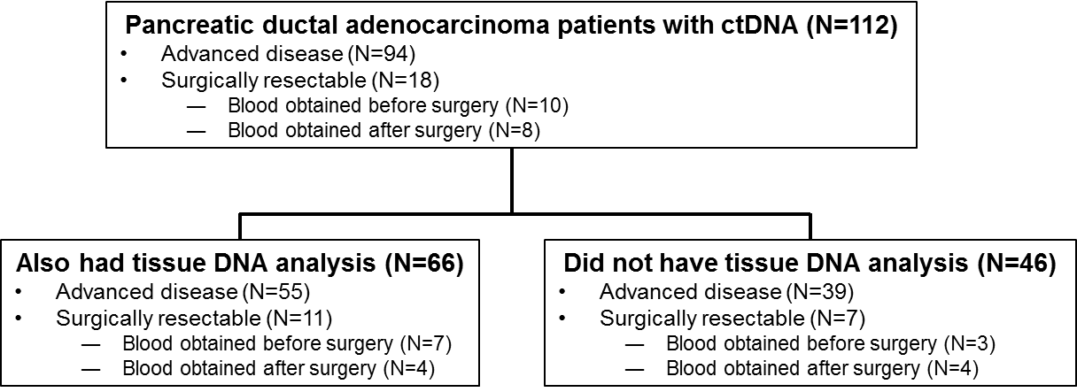

Supplementary Figure 2. Kaplan-Meier curve for overall survival from advanced disease depending on %ctDNA dichotomized at median (for total %ctDNA for all alterations) among patients with advanced PDAC (N=94).
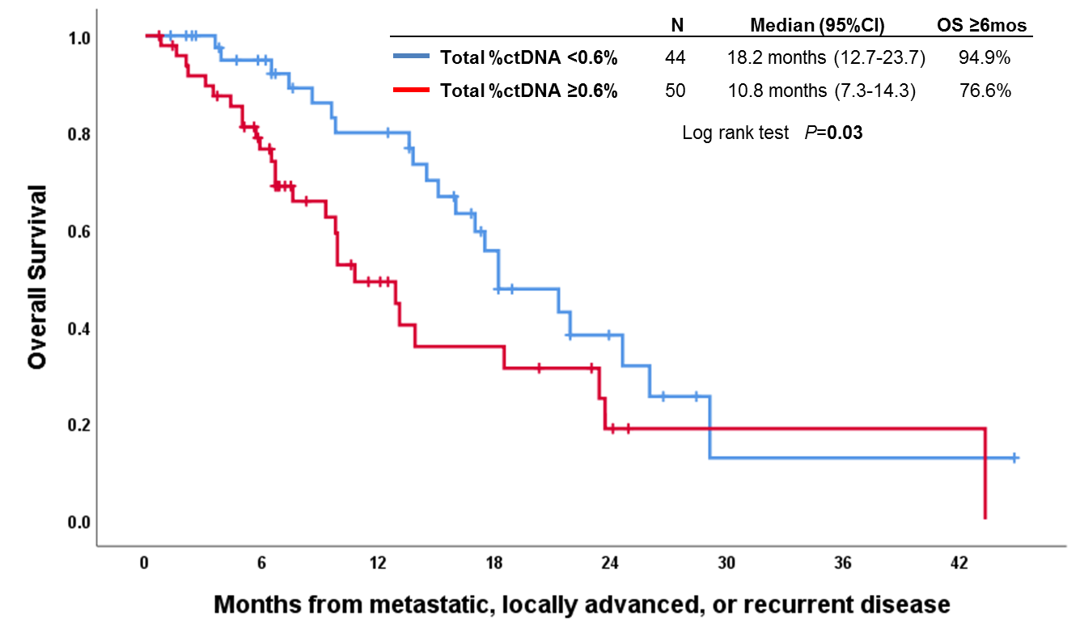

Supplementary Figure 3. Kaplan-Meier curve for overall survival from ctDNA analysis stratified by ctDNA sequencing panel.
Supplementary Figure 3a. 73-gene panel [N=52].
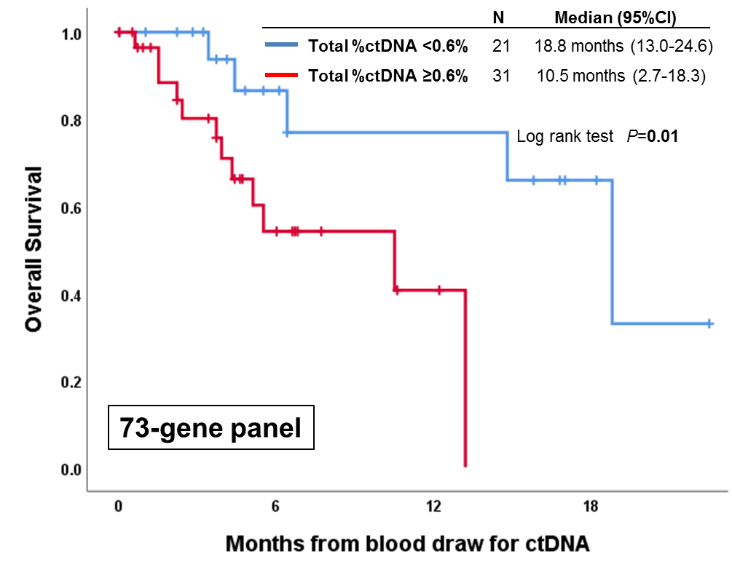

Supplementary Figure 3b. 54-70-gene panels [N=42].
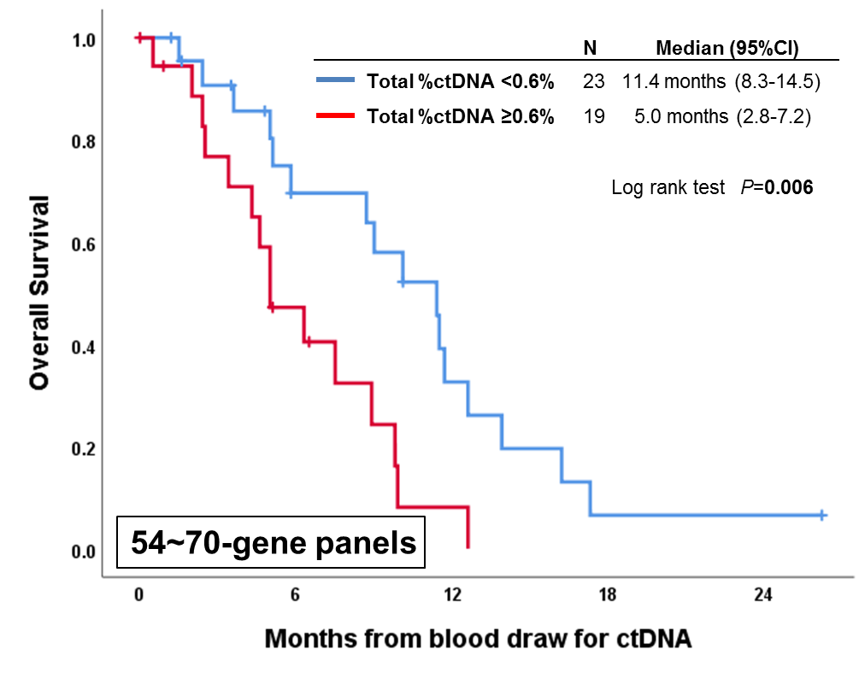

SUPPLEMENTAL REFERENCES
1. Helsen C, Van den Broeck T, Voet A, et al. Androgen receptor antagonists for prostate cancer therapy. Endocr Relat Cancer 2014;21:T105-18.
2. Gelman IH. Androgen receptor activation in castration-recurrent prostate cancer: the role of Src-family and Ack1 tyrosine kinases. Int J Biol Sci 2014;10:620-6.
3. Sharifi N. Mechanisms of androgen receptor activation in castration-resistant prostate cancer. Endocrinology 2013;154:4010-7.
4. Sartor O. Combination therapy: Abiraterone prolongs survival in metastatic prostate cancer. Nat Rev Clin Oncol 2011;8:515-6.
5. Scher HI, Fizazi K, Saad F, et al. Increased survival with enzalutamide in prostate cancer after chemotherapy. N Engl J Med 2012;367:1187-97.
6. Akaza H, Hinotsu S, Usami M, et al. Combined androgen blockade with bicalutamide for advanced prostate cancer: long-term follow-up of a phase 3, double-blind, randomized study for survival. Cancer 2009;115:3437-45.
7. Peng G, Lin SY. Exploiting the homologous recombination DNA repair network for targeted cancer therapy. World J Clin Oncol 2011;2:73-9.
8. Weston VJ, Oldreive CE, Skowronska A, et al. The PARP inhibitor olaparib induces significant killing of ATM-deficient lymphoid tumor cells in vitro and in vivo. Blood 2010;116:4578-87.
9. Riabinska A, Daheim M, Herter-Sprie GS, et al. Therapeutic targeting of a robust non-oncogene addiction to PRKDC in ATM-defective tumors. Sci Transl Med 2013;5:189ra78.
10. Michels J, Vitale I, Saparbaev M, et al. Predictive biomarkers for cancer therapy with PARP inhibitors. Oncogene 2014;33:3894-907.
11. Aprile G, Macerelli M, Giuliani F. Regorafenib for gastrointestinal malignancies : from preclinical data to clinical results of a novel multi-target inhibitor. BioDrugs 2013;27:213-24.
12. Wilhelm SM, Dumas J, Adnane L, et al. Regorafenib (BAY 73-4506): a new oral multikinase inhibitor of angiogenic, stromal and oncogenic receptor tyrosine kinases with potent preclinical antitumor activity. Int J Cancer 2011;129:245-55.
13. Grothey A, Van Cutsem E, Sobrero A, et al. Regorafenib monotherapy for previously treated metastatic colorectal cancer (CORRECT): an international, multicentre, randomised, placebo-controlled, phase 3 trial. Lancet 2013;381:303-12.
14. Demetri GD, Reichardt P, Kang YK, et al. Efficacy and safety of regorafenib for advanced gastrointestinal stromal tumours after failure of imatinib and sunitinib (GRID): an international, multicentre, randomised, placebo-controlled, phase 3 trial. Lancet 2013;381:295-302.
15. Bruix J, Qin S, Merle P, et al. Regorafenib for patients with hepatocellular carcinoma who progressed on sorafenib treatment (RESORCE): a randomised, double-blind, placebo-controlled, phase 3 trial. Lancet 2017;389:56-66.
16. Flaherty KT, Puzanov I, Kim KB, et al. Inhibition of mutated, activated BRAF in metastatic melanoma. N Engl J Med 2010;363:809-19.
17. Flaherty KT, Infante JR, Daud A, et al. Combined BRAF and MEK inhibition in melanoma with BRAF V600 mutations. N Engl J Med 2012;367:1694-703.
18. Flaherty KT, Robert C, Hersey P, et al. Improved survival with MEK inhibition in BRAF-mutated melanoma. N Engl J Med 2012;367:107-14.
19. Larkin J, Ascierto PA, Dreno B, et al. Combined vemurafenib and cobimetinib in BRAF-mutated melanoma. N Engl J Med 2014;371:1867-76.
20. Dummer R, Ascierto PA, Gogas HJ, et al. Encorafenib plus binimetinib versus vemurafenib or encorafenib in patients with BRAF-mutant melanoma (COLUMBUS): a multicentre, open-label, randomised phase 3 trial. Lancet Oncol 2018;19:603-615.
21. Hollis RL, Churchman M, Gourley C. Distinct implications of different BRCA mutations: efficacy of cytotoxic chemotherapy, PARP inhibition and clinical outcome in ovarian cancer. Onco Targets Ther 2017;10:2539-2551.
22. Kim G, Ison G, McKee AE, et al. FDA Approval Summary: Olaparib Monotherapy in Patients with Deleterious Germline BRCA-Mutated Advanced Ovarian Cancer Treated with Three or More Lines of Chemotherapy. Clin Cancer Res 2015;21:4257-61.
23. Swisher EM, Lin KK, Oza AM, et al. Rucaparib in relapsed, platinum-sensitive high-grade ovarian carcinoma (ARIEL2 Part 1): an international, multicentre, open-label, phase 2 trial. Lancet Oncol 2017;18:75-87.
24. Mirza MR, Monk BJ, Herrstedt J, et al. Niraparib Maintenance Therapy in Platinum-Sensitive, Recurrent Ovarian Cancer. N Engl J Med 2016;375:2154-2164.
25. Tutt A, Robson M, Garber JE, et al. Oral poly(ADP-ribose) polymerase inhibitor olaparib in patients with BRCA1 or BRCA2 mutations and advanced breast cancer: a proof-of-concept trial. Lancet 2010;376:235-44.
26. Gong X, Litchfield LM, Webster Y, et al. Genomic Aberrations that Activate D-type Cyclins Are Associated with Enhanced Sensitivity to the CDK4 and CDK6 Inhibitor Abemaciclib. Cancer Cell 2017;32:761-776.e6.
27. DeMichele A, Clark AS, Tan KS, et al. CDK 4/6 inhibitor palbociclib (PD0332991) in Rb+ advanced breast cancer: phase II activity, safety, and predictive biomarker assessment. Clin Cancer Res 2015;21:995-1001.
28. Sherr CJ, Beach D, Shapiro GI. Targeting CDK4 and CDK6: From Discovery to Therapy. Cancer Discov 2016;6:353-67.
29. Lapenna S, Giordano A. Cell cycle kinases as therapeutic targets for cancer. Nat Rev Drug Discov 2009;8:547-66.
30. Malumbres M, Pevarello P, Barbacid M, et al. CDK inhibitors in cancer therapy: what is next? Trends Pharmacol Sci 2008;29:16-21.
31. Zhang Y, Xiong Y, Yarbrough WG. ARF promotes MDM2 degradation and stabilizes p53: ARF-INK4a locus deletion impairs both the Rb and p53 tumor suppression pathways. Cell 1998;92:725-34.
32. Stone S, Jiang P, Dayananth P, et al. Complex structure and regulation of the P16 (MTS1) locus. Cancer Res 1995;55:2988-94.
33. Moore MJ, Goldstein D, Hamm J, et al. Erlotinib plus gemcitabine compared with gemcitabine alone in patients with advanced pancreatic cancer: a phase III trial of the National Cancer Institute of Canada Clinical Trials Group. J Clin Oncol 2007;25:1960-6.
34. Senderowicz AM, Johnson JR, Sridhara R, et al. Erlotinib/gemcitabine for first-line treatment of locally advanced or metastatic adenocarcinoma of the pancreas. Oncology (Williston Park) 2007;21:1696-706; discussion 1706-9, 1712, 1715.
35. Bang YJ, Van Cutsem E, Feyereislova A, et al. Trastuzumab in combination with chemotherapy versus chemotherapy alone for treatment of HER2-positive advanced gastric or gastro-oesophageal junction cancer (ToGA): a phase 3, open-label, randomised controlled trial. Lancet 2010;376:687-97.
36. Jones KL, Buzdar AU. Evolving novel anti-HER2 strategies. Lancet Oncol 2009;10:1179-87.
37. Baselga J, Cortes J, Kim SB, et al. Pertuzumab plus trastuzumab plus docetaxel for metastatic breast cancer. N Engl J Med 2012;366:109-19.
38. Verma S, Miles D, Gianni L, et al. Trastuzumab emtansine for HER2-positive advanced breast cancer. N Engl J Med 2012;367:1783-91.
39. Gelmon KA, Boyle FM, Kaufman B, et al. Lapatinib or Trastuzumab Plus Taxane Therapy for Human Epidermal Growth Factor Receptor 2-Positive Advanced Breast Cancer: Final Results of NCIC CTG MA.31. J Clin Oncol 2015;33:1574-83.
40. Modjtahedi H, Cho BC, Michel MC, et al. A comprehensive review of the preclinical efficacy profile of the ErbB family blocker afatinib in cancer. Naunyn Schmiedebergs Arch Pharmacol 2014;387:505-21.
41. Mao JH, Kim IJ, Wu D, et al. FBXW7 targets mTOR for degradation and cooperates with PTEN in tumor suppression. Science 2008;321:1499-502.
42. Jardim DL, Wheler JJ, Hess K, et al. FBXW7 mutations in patients with advanced cancers: clinical and molecular characteristics and outcomes with mTOR inhibitors. PLoS One 2014;9:e89388.
43. Myers AP, Filiaci VL, Zhang Y, et al. Tumor mutational analysis of GOG248, a phase II study of temsirolimus or temsirolimus and alternating megestrol acetate and tamoxifen for advanced endometrial cancer (EC): An NRG Oncology/Gynecologic Oncology Group study. Gynecol Oncol 2016;141:43-8.
44. Sternberg CN, Davis ID, Mardiak J, et al. Pazopanib in locally advanced or metastatic renal cell carcinoma: results of a randomized phase III trial. J Clin Oncol 2010;28:1061-8.
45. Motzer RJ, Hutson TE, Glen H, et al. Lenvatinib, everolimus, and the combination in patients with metastatic renal cell carcinoma: a randomised, phase 2, open-label, multicentre trial. Lancet Oncol 2015;16:1473-1482.
46. Schlumberger M, Tahara M, Wirth LJ, et al. Lenvatinib versus placebo in radioiodine-refractory thyroid cancer. N Engl J Med 2015;372:621-30.
47. van der Graaf WT, Blay JY, Chawla SP, et al. Pazopanib for metastatic soft-tissue sarcoma (PALETTE): a randomised, double-blind, placebo-controlled phase 3 trial. Lancet 2012;379:1879-86.
48. Cortes JE, Kim DW, Pinilla-Ibarz J, et al. A phase 2 trial of ponatinib in Philadelphia chromosome-positive leukemias. N Engl J Med 2013;369:1783-96.
49. Wilson CH, McIntyre RE, Arends MJ, et al. The activating mutation R201C in GNAS promotes intestinal tumourigenesis in Apc(Min/+) mice through activation of Wnt and ERK1/2 MAPK pathways. Oncogene 2010;29:4567-75.
50. Cox AD, Fesik SW, Kimmelman AC, et al. Drugging the undruggable RAS: Mission possible? Nat Rev Drug Discov 2014;13:828-51.
51. Ideno N, Yamaguchi H, Ghosh B, et al. GNAS(R201C) Induces Pancreatic Cystic Neoplasms in Mice That Express Activated KRAS by Inhibiting YAP1 Signaling. Gastroenterology 2018;155:1593-1607.e12.
52. DiNardo CD, Stein EM, de Botton S, et al. Durable Remissions with Ivosidenib in IDH1-Mutated Relapsed or Refractory AML. N Engl J Med 2018;378:2386-2398.
53. MacKenzie ED, Selak MA, Tennant DA, et al. Cell-permeating alpha-ketoglutarate derivatives alleviate pseudohypoxia in succinate dehydrogenase-deficient cells. Mol Cell Biol 2007;27:3282-9.
54. Rohle D, Popovici-Muller J, Palaskas N, et al. An inhibitor of mutant IDH1 delays growth and promotes differentiation of glioma cells. Science 2013;340:626-30.
55. Janne PA, van den Heuvel MM, Barlesi F, et al. Selumetinib Plus Docetaxel Compared With Docetaxel Alone and Progression-Free Survival in Patients With KRAS-Mutant Advanced Non-Small Cell Lung Cancer: The SELECT-1 Randomized Clinical Trial. Jama 2017;317:1844-1853.
56. Adjei AA, Cohen RB, Franklin W, et al. Phase I pharmacokinetic and pharmacodynamic study of the oral, small-molecule mitogen-activated protein kinase kinase 1/2 inhibitor AZD6244 (ARRY-142886) in patients with advanced cancers. J Clin Oncol 2008;26:2139-46.
57. Manchado E, Weissmueller S, Morris JPt, et al. A combinatorial strategy for treating KRAS-mutant lung cancer. Nature 2016;534:647-51.
58. Infante JR, Somer BG, Park JO, et al. A randomised, double-blind, placebo-controlled trial of trametinib, an oral MEK inhibitor, in combination with gemcitabine for patients with untreated metastatic adenocarcinoma of the pancreas. Eur J Cancer 2014;50:2072-81.
59. Lito P, Saborowski A, Yue J, et al. Disruption of CRAF-mediated MEK activation is required for effective MEK inhibition in KRAS mutant tumors. Cancer Cell 2014;25:697-710.
60. Hochster HS, Uboha N, Messersmith W, et al. Phase II study of selumetinib (AZD6244, ARRY-142886) plus irinotecan as second-line therapy in patients with K-RAS mutated colorectal cancer. Cancer Chemother Pharmacol 2015;75:17-23.
61. Blumenschein GR, Jr., Smit EF, Planchard D, et al. A randomized phase II study of the MEK1/MEK2 inhibitor trametinib (GSK1120212) compared with docetaxel in KRAS-mutant advanced non-small-cell lung cancer (NSCLC)dagger. Ann Oncol 2015;26:894-901.
62. Zhu Z, Aref AR, Cohoon TJ, et al. Inhibition of KRAS-driven tumorigenicity by interruption of an autocrine cytokine circuit. Cancer Discov 2014;4:452-65.
63. Falchook GS, Lewis KD, Infante JR, et al. Activity of the oral MEK inhibitor trametinib in patients with advanced melanoma: a phase 1 dose-escalation trial. Lancet Oncol 2012;13:782-9.
64. Traynor K. Cabozantinib approved for advanced medullary thyroid cancer. Am J Health Syst Pharm 2013;70:88.
65. Hart CD, De Boer RH. Profile of cabozantinib and its potential in the treatment of advanced medullary thyroid cancer. Onco Targets Ther 2013;6:1-7.
66. Choueiri TK, Escudier B, Powles T, et al. Cabozantinib versus Everolimus in Advanced Renal-Cell Carcinoma. N Engl J Med 2015;373:1814-23.
67. Mazieres J, Zalcman G, Crino L, et al. Crizotinib therapy for advanced lung adenocarcinoma and a ROS1 rearrangement: results from the EUROS1 cohort. J Clin Oncol 2015;33:992-9.
68. Solomon BJ, Mok T, Kim DW, et al. First-line crizotinib versus chemotherapy in ALK-positive lung cancer. N Engl J Med 2014;371:2167-77.
69. Verstovsek S, Mesa RA, Gotlib J, et al. A double-blind, placebo-controlled trial of ruxolitinib for myelofibrosis. N Engl J Med 2012;366:799-807.
70. Verstovsek S, Mesa RA, Gotlib J, et al. The clinical benefit of ruxolitinib across patient subgroups: analysis of a placebo-controlled, Phase III study in patients with myelofibrosis. Br J Haematol 2013;161:508-16.
71. O'Sullivan JM, Harrison CN. JAK-STAT signaling in the therapeutic landscape of myeloproliferative neoplasms. Mol Cell Endocrinol 2017;451:71-79.
72. Kleppe M, Kwak M, Koppikar P, et al. JAK-STAT pathway activation in malignant and nonmalignant cells contributes to MPN pathogenesis and therapeutic response. Cancer Discov 2015;5:316-31.
73. Wagle N, Grabiner BC, Van Allen EM, et al. Activating mTOR mutations in a patient with an extraordinary response on a phase I trial of everolimus and pazopanib. Cancer Discov 2014;4:546-53.
74. Li H, Zeng J, Shen K. PI3K/AKT/mTOR signaling pathway as a therapeutic target for ovarian cancer. Arch Gynecol Obstet 2014;290:1067-78.
75. Laplante M, Sabatini DM. mTOR signaling in growth control and disease. Cell 2012;149:274-93.
76. Feng Z, Zhang H, Levine AJ, et al. The coordinate regulation of the p53 and mTOR pathways in cells. Proc Natl Acad Sci U S A 2005;102:8204-9.
77. Zaytseva YY, Valentino JD, Gulhati P, et al. mTOR inhibitors in cancer therapy. Cancer Lett 2012;319:1-7.
78. Janku F, Wheler JJ, Westin SN, et al. PI3K/AKT/mTOR inhibitors in patients with breast and gynecologic malignancies harboring PIK3CA mutations. J Clin Oncol 2012;30:777-82.
79. Janku F, Hong DS, Fu S, et al. Assessing PIK3CA and PTEN in early-phase trials with PI3K/AKT/mTOR inhibitors. Cell Rep 2014;6:377-87.
80. Lodish MB, Stratakis CA. Endocrine tumours in neurofibromatosis type 1, tuberous sclerosis and related syndromes. Best Pract Res Clin Endocrinol Metab 2010;24:439-49.
81. Hattori S, Ohmi N, Maekawa M, et al. Antibody against neurofibromatosis type 1 gene product reacts with a triton-insoluble GTPase activating protein toward ras p21. Biochem Biophys Res Commun 1991;177:83-9.
82. Janku F, Tsimberidou AM, Garrido-Laguna I, et al. PIK3CA mutations in patients with advanced cancers treated with PI3K/AKT/mTOR axis inhibitors. Mol Cancer Ther 2011;10:558-65.
83. Loi S, Michiels S, Baselga J, et al. PIK3CA genotype and a PIK3CA mutation-related gene signature and response to everolimus and letrozole in estrogen receptor positive breast cancer. PLoS One 2013;8:e53292.
84. Mackay HJ, Eisenhauer EA, Kamel-Reid S, et al. Molecular determinants of outcome with mammalian target of rapamycin inhibition in endometrial cancer. Cancer 2014;120:603-10.
85. Hortobagyi GN, Chen D, Piccart M, et al. Correlative Analysis of Genetic Alterations and Everolimus Benefit in Hormone Receptor-Positive, Human Epidermal Growth Factor Receptor 2-Negative Advanced Breast Cancer: Results From BOLERO-2. J Clin Oncol 2016;34:419-26.
86. Moynahan ME, Chen D, He W, et al. Correlation between PIK3CA mutations in cell-free DNA and everolimus efficacy in HR(+), HER2(-) advanced breast cancer: results from BOLERO-2. Br J Cancer 2017;116:726-730.
87. Wu R, Hu TC, Rehemtulla A, et al. Preclinical testing of PI3K/AKT/mTOR signaling inhibitors in a mouse model of ovarian endometrioid adenocarcinoma. Clin Cancer Res 2011;17:7359-72.
88. Koehler K, Liebner D, Chen JL. TP53 mutational status is predictive of pazopanib response in advanced sarcomas. Ann Oncol 2016;27:539-43.
89. Said R, Hong DS, Warneke CL, et al. P53 mutations in advanced cancers: clinical characteristics, outcomes, and correlation between progression-free survival and bevacizumab-containing therapy. Oncotarget 2013;4:705-14.
90. Schwaederle M, Lazar V, Validire P, et al. VEGF-A Expression Correlates with TP53 Mutations in Non-Small Cell Lung Cancer: Implications for Antiangiogenesis Therapy. Cancer Res 2015;75:1187-90.
91. Wheler JJ, Janku F, Naing A, et al. TP53 Alterations Correlate with Response to VEGF/VEGFR Inhibitors: Implications for Targeted Therapeutics. Mol Cancer Ther 2016;15:2475-2485.
92. Mertz JA, Conery AR, Bryant BM, et al. Targeting MYC dependence in cancer by inhibiting BET bromodomains. Proc Natl Acad Sci U S A 2011;108:16669-74.
93. Wyce A, Ganji G, Smitheman KN, et al. BET inhibition silences expression of MYCN and BCL2 and induces cytotoxicity in neuroblastoma tumor models. PLoS One 2013;8:e72967.
94. Delmore JE, Issa GC, Lemieux ME, et al. BET bromodomain inhibition as a therapeutic strategy to target c-Myc. Cell 2011;146:904-17.

