Additional file

Title: Cellular hypoxia promotes osteogenic differentiation of mesenchymal stem cells and bone defect healing via STAT3 signaling

Authors: Xin Yu, Qilong Wan, Xiaoling Ye, Yuet Chen, Janak L. Pathak, Zubing Li

Journal: Cellular and Molecular Biology Letters

Figure S1

Figure S1. Quantitative analysis of western blots for protein expression in BMSCs on day 7 (Figure 2E). A – Col1α1. B – RUNX2. C – ALP. D – OSX. H1, H3, H5 and H7 represent hypoxia for 1, 3, 5 and 7 days, respectively. Inhibitor: STAT3 inhibitor. Data of quantitative analysis are the means ± SD from 5 independent experiments, n = 5. Significant effect of treatment, *p < 0.05, **p < 0.01 ***p < 0.001 compared with the control group.

Figure S2

Figure S2. Quantitative analysis of western blots for protein expression in BMSCs after 3 h of culture (Figure 3A). A – HIF-1α/GAPDH. B – pSTAT3/tSTAT3. Data of quantitative analysis are the means ± SD from 3 independent experiments, n = 5. Inhibitor: STAT3 inhibitor. Significant effect of treatment, *p < 0.05, **p < 0.01 ***p < 0.001 compared with the control group; ###p < 0.001 compared with the CoCl₂ group.

Figure S3

Figure S3. Quantitative analysis of western blots for protein expression in BMSCs on day 7 (Figure 4E). A – Col1α1. B – RunX2. C – ALP. D – Osx. H1, H3, H5 and H7 represent hypoxia for 1, 3, 5 and 7 days, respectively. Inhibitor: STAT3 inhibitor. Data of quantitative analysis are the means ± SD from 5 independent experiments, n = 5. Significant effect of treatment compared to the control group: *p < 0.05, **p < 0.01 and ***p < 0.001; the CoCl₂ group: ###p < 0.001; and the CoCl₂ + inhibitor group: &&&p < 0.001.

Figure S4

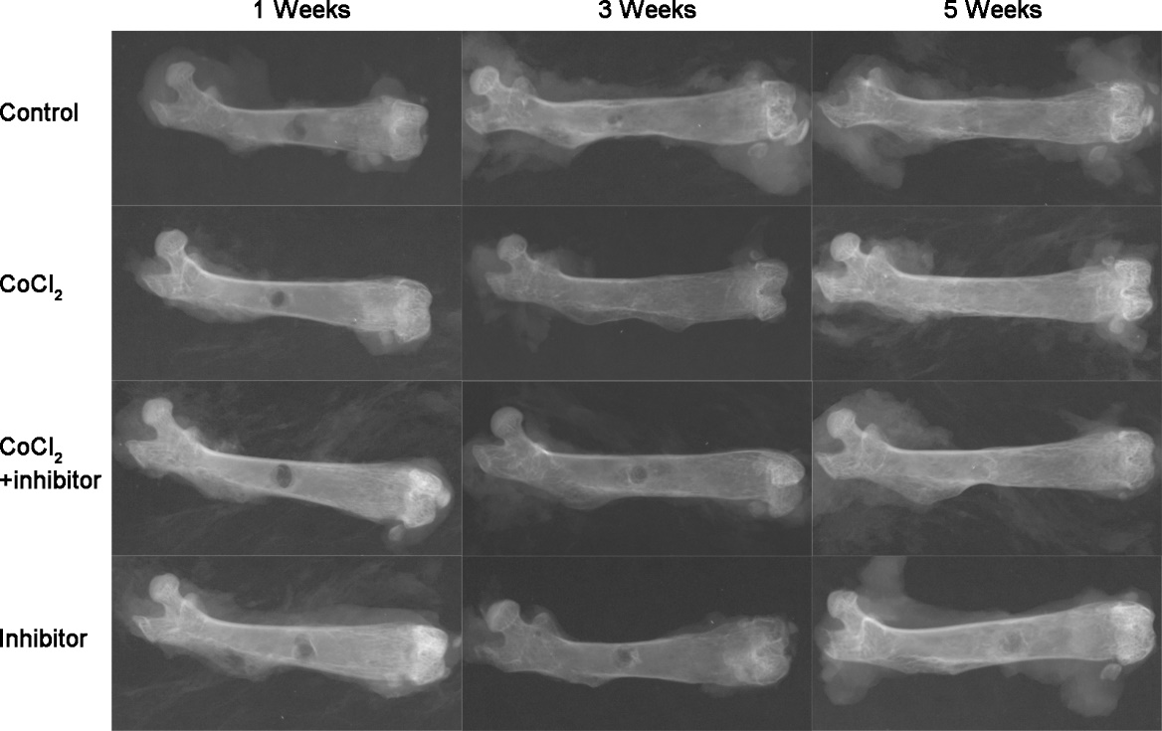

Figure S4. Representative X-Ray images of mice femurs with bone defects. Inhibitor: STAT3 inhibitor.

