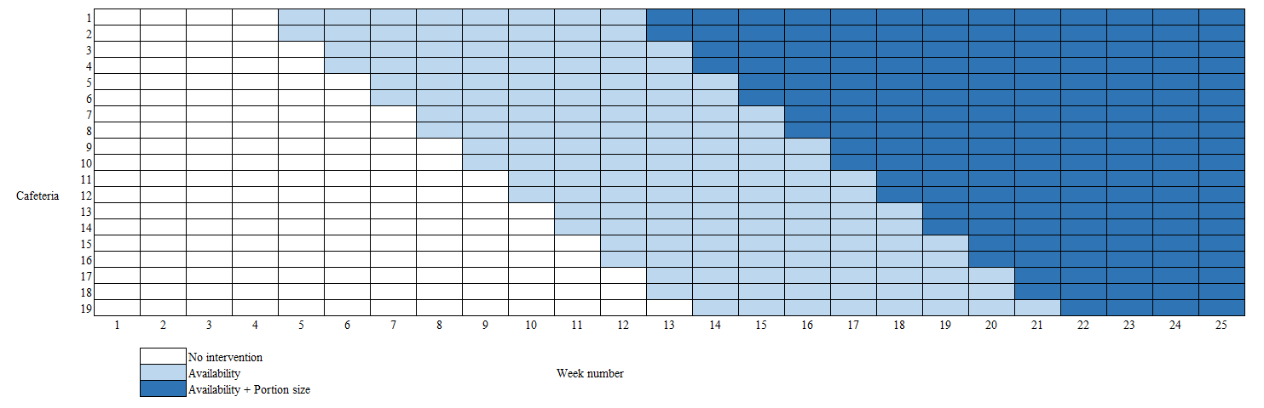
Additional file 2: Figure S1. Study design

