Supporting material for: Kernelized Logistic Matrix Factorization based on Similarity Network Fusion for Predicting Virus-host Association
Dan Liu^{1, 2}, Yingjun Ma^{1,2}, Xingpeng Jiang^{1,2*} and Tingting He^{1,2*}
¹School of Computer, Central China Normal University, Wuhan, Hubei, China
²Hubei Provincial Key Laboratory of Artificial Intelligence and Smart Learning，Central China Normal University, Wuhan, Hubei, China

*Corresponding Author: Xingpeng Jiang, xpjiang@mail.ccnu.edu.cn
Tingting He, tthe@mail.ccnu.edu.cn

Email addresses:
DL: liudan@mails.ccnu.edu.cn
YM: yingjunma@mails.ccnu.edu.cn
XH: huxiaohua@mail.ccnu.edu.cn
TH: tthe@mail.ccnu.edu.cn
XJ: xpjiang@mail.ccnu.edu.cn

Figure S1. The trend chart of AUPR values vary with the factorization factor $k$.

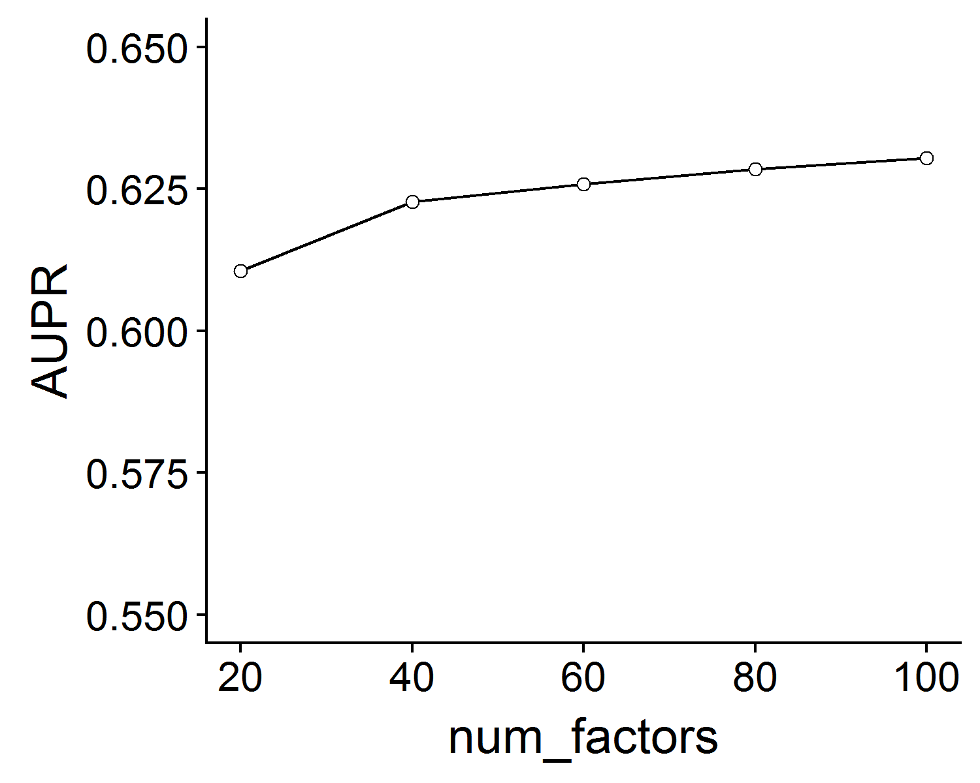

Figure S2. The trend chart of AUPR values vary with regularization parameters $α$and $β$.

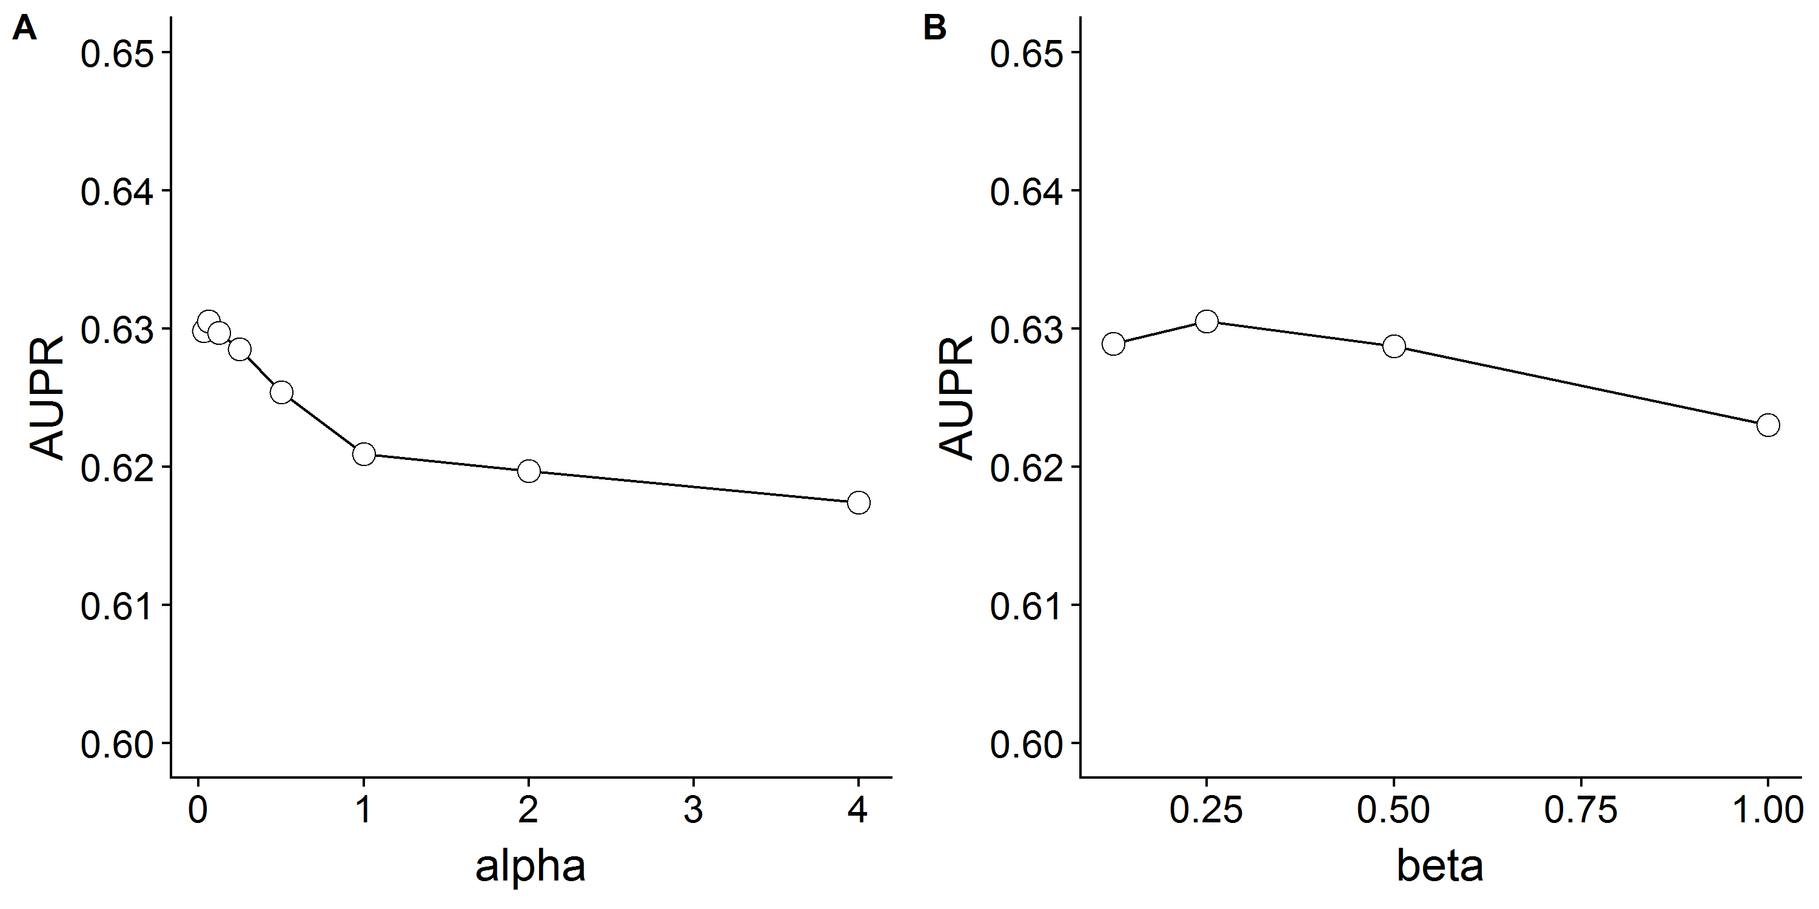

Figure S3. The trend chart of AUPR values vary with the inverse of the variance $λ$.

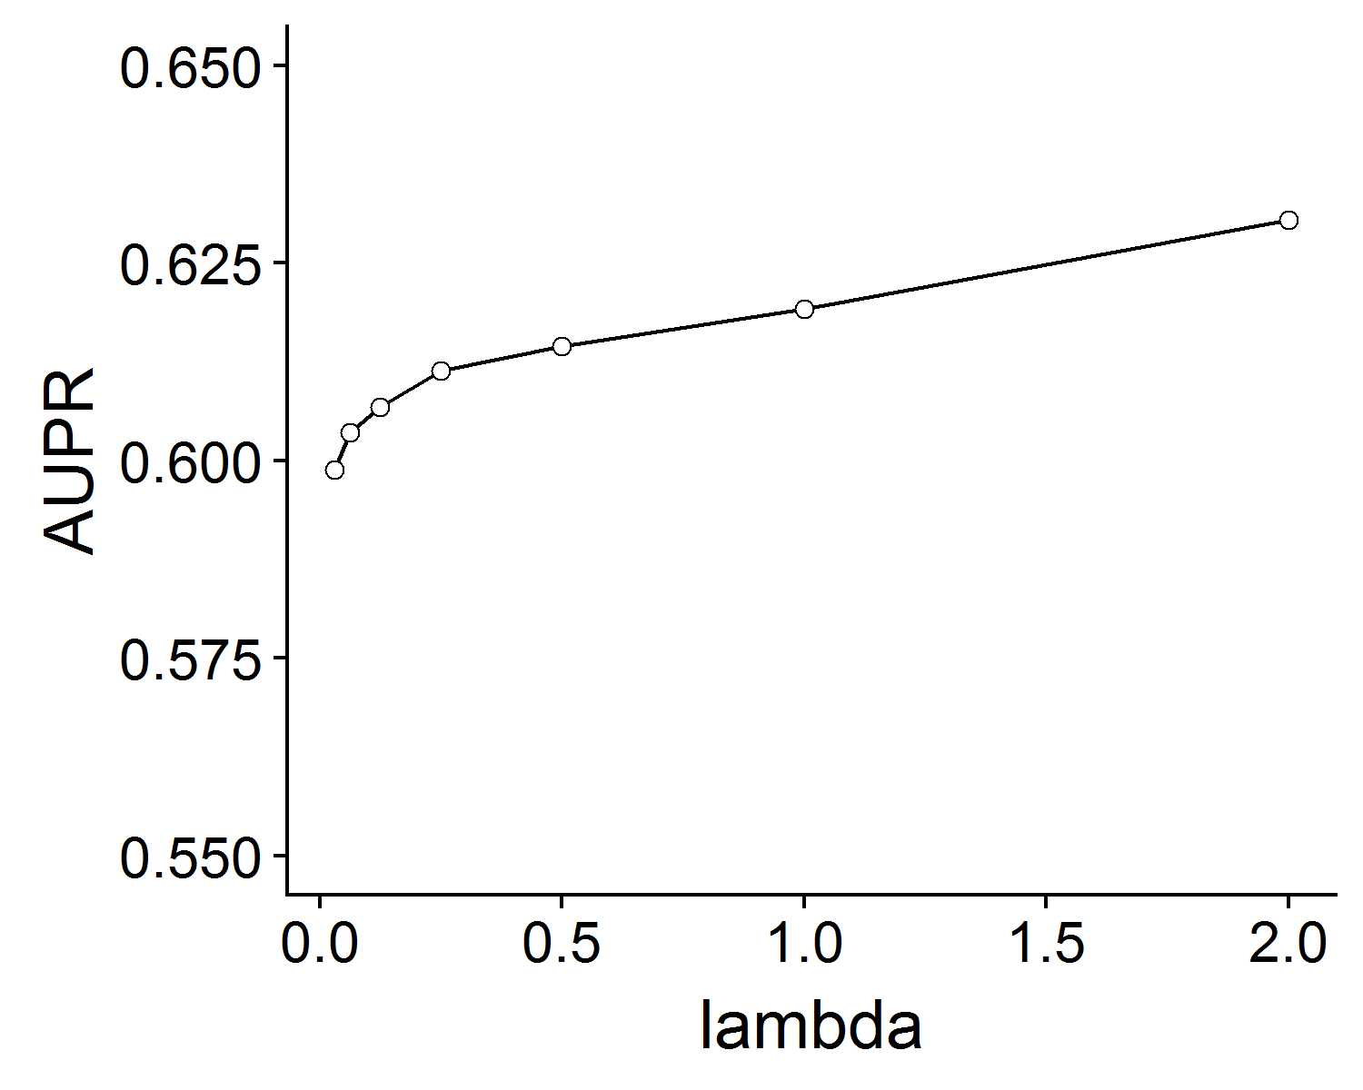

Figure S4. The trend chart of AUPR values vary with the learning rate parameter $γ$.

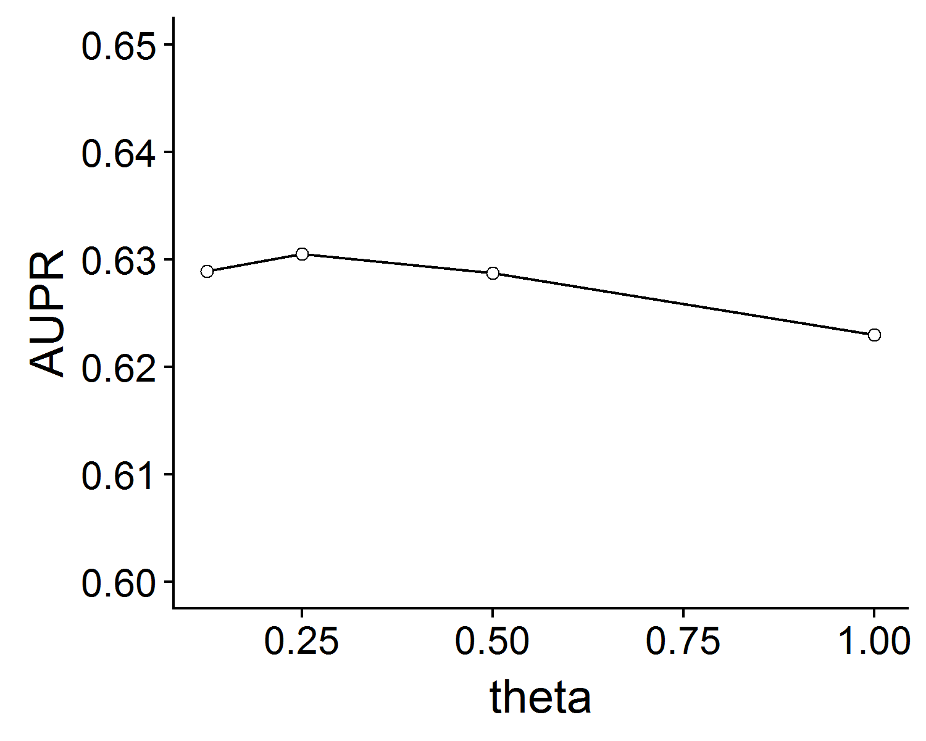

Figure S5. The trend chart of AUPR values vary with the neighbor number parameter $K$.

