Additional file

Facile aqueous-phase synthesis of Ag-Cu-Pt-Pd quadrometallic nanoparticles

Zengmin Tang ¹, Byung Chul Yeo ², Sang Soo Han ², Tae-Jin Lee³, Suk Ho Bhang³, Woo-Sik Kim ^{1,}*, Taekyung Yu ^{1,}*

¹ Department of Chemical Engineering, College of Engineering, Kyung Hee University, Yongin 17104, Republic of Korea
² Center for Computational Science, Korea Institute of Science and Technology (KIST), Hwarangno 14-gil 5, Seongbuk-gu, Seoul 02792, Republic of Korea
³ School of Chemical Engineering, Sungkyunkwan University, Suwon 16419, Republic of Korea

* Correspondence: wskim@khu.ac.kr, tkyu@khu.ac.kr.

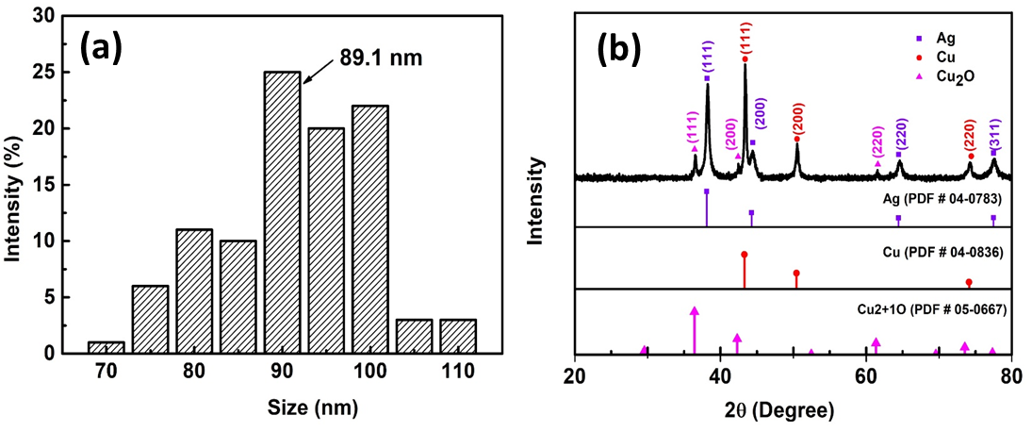

Figure S1. (a) size distribution of nanoparticles, (b) XRD patterns of synthesized Cu-Ag-Pt-Pd nanoparticles.

Table S1. ICP data of Cu-Ag-Pt-Pd nanoparticle
Sample | Metal | Mass concentration | percentage
Cu-Ag-Pt-Pd | Pd | 1.92 mg/L | 0.68%
 | Pt | 3.55 mg/L | 1.26%
 | Ag | 96.9 mg/L | 34.32%
 | Cu | 180 mg/L | 63.74%

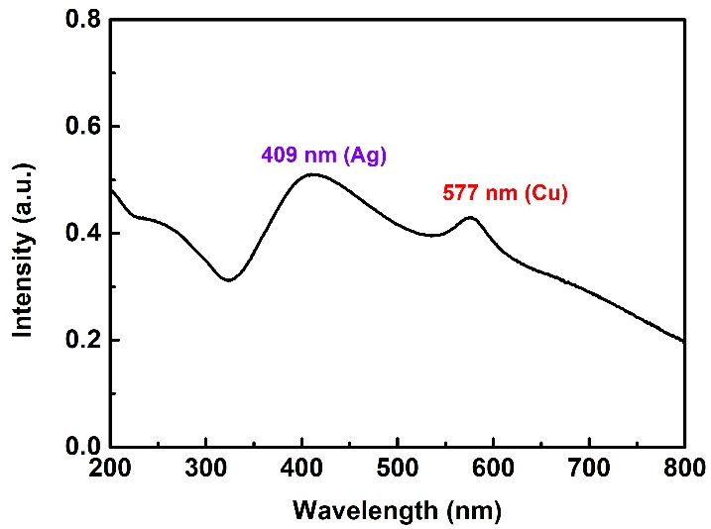
Figure S2. UV-vis spectrum of prepared Ag-Cu bimetallic nanoparticles.

