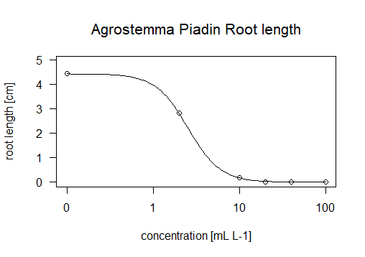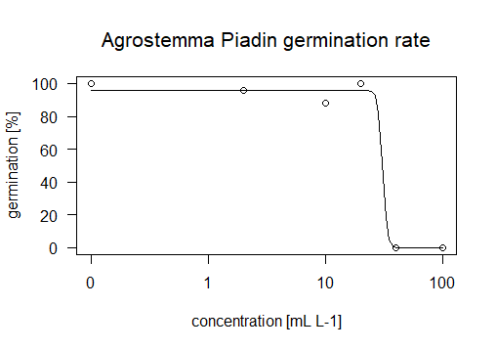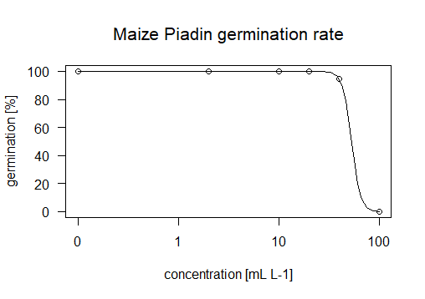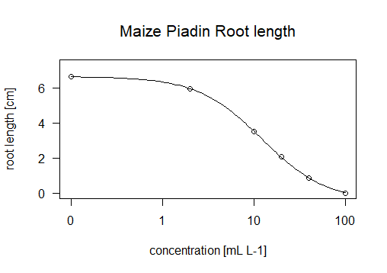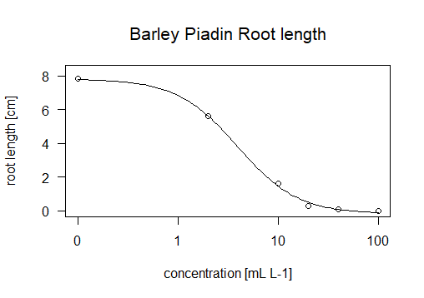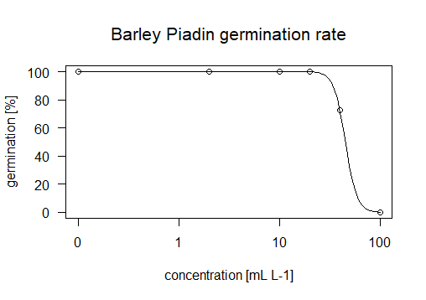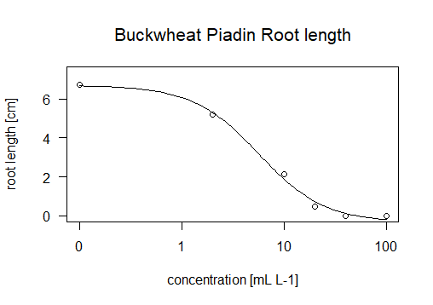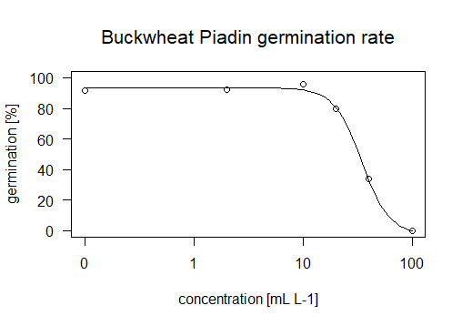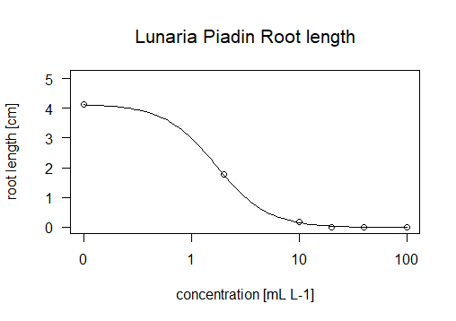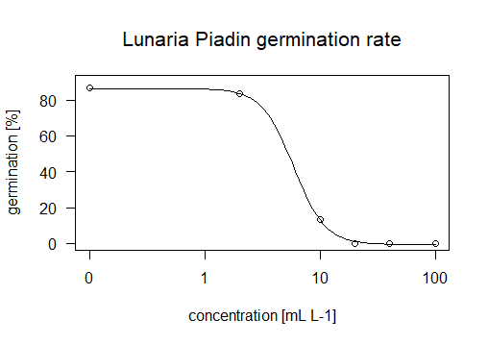

concentration [mL L-1]

concentration [mL L-1]

a)

b)

c)

d)

e)

Figure S1: Inhibition of root length (left) and germination rate (right) of different plant species exposed to different concentrations of Piadin: a) *Agrostemma githago*, b) *Fagopyrum esculentum*, c) *Hordeum vulgare*, d) *Lunaria annua*, e) *Zea mays*. The regression curves were modelled using a log logistic function with four parameters (n=3)

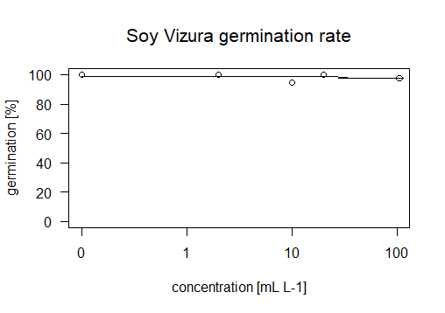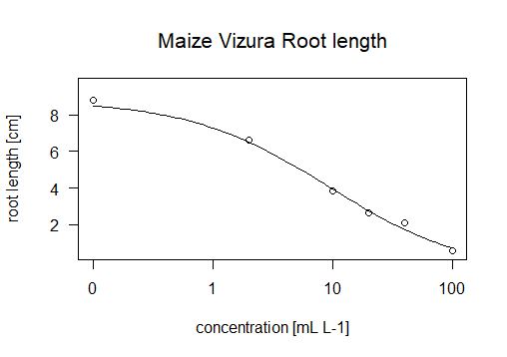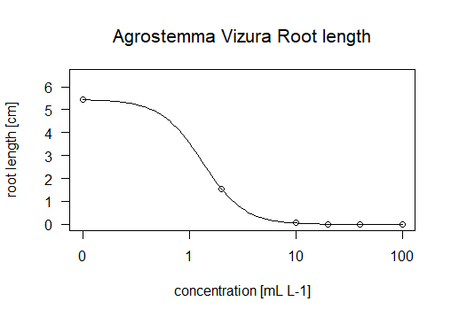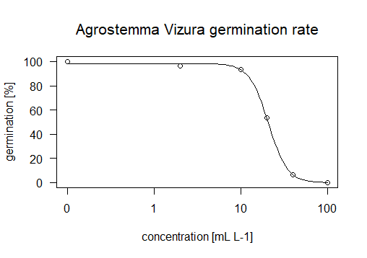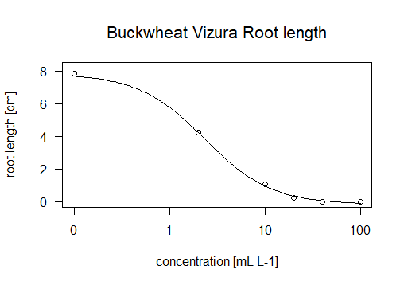

concentration [mL L-1]

concentration [mL L-1]

a)

b)

c)

d)

e)

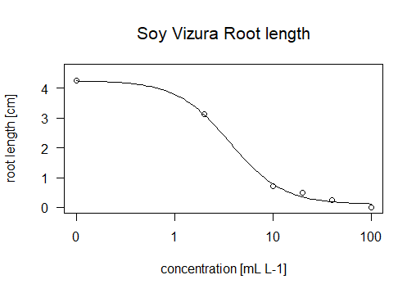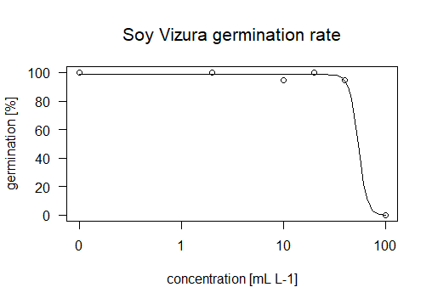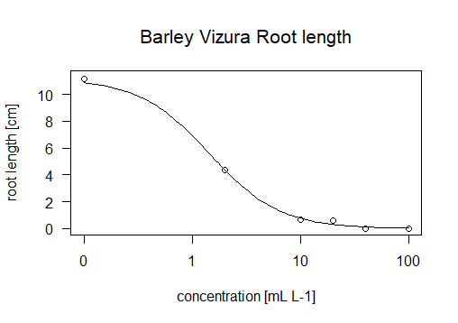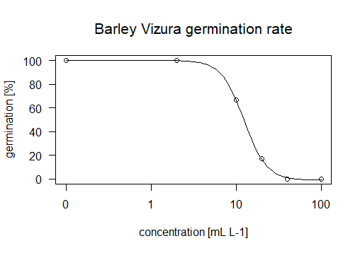

Figure S2: Inhibition of root length (left) and germination rate (right) of different plant species exposed to different concentrations of Vizura: a) *Agrostemma githago*, b) *Fagopyrum esculentum*, c) *Hordeum vulgare*, d) *Lunaria annua*, e) *Zea mays*. The regression curves were modelled using a log logistic function with four parameters (n=3)

c)

b)

a)

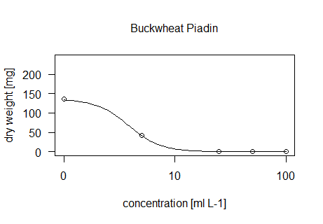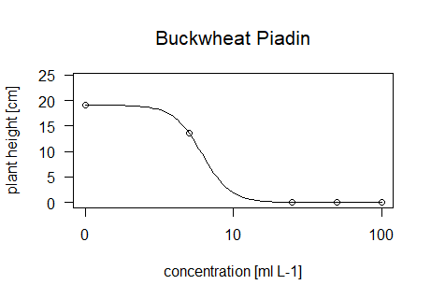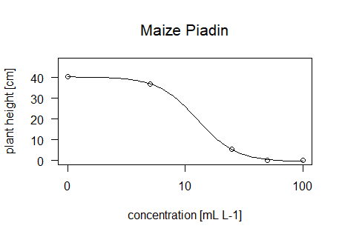

concentration [mL L-1]

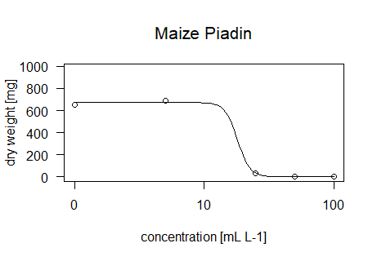

concentration [mL L-1]

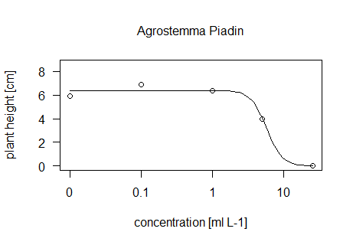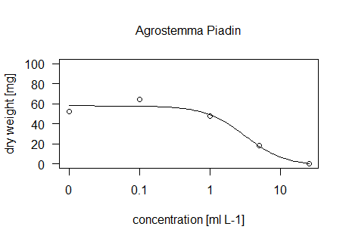

Figure S3: Inhibition of plant height (left) and dry weight (right) of different plant species exposed to different concentrations of Piadin: a) *Agrostemma githago*, b) *Fagopyrum esculentum*, c) *Zea mays*. The regression curves were modelled using a log logistic function with four parameters (n=3)

concentration [mL L-1]

concentration [mL L-1]

a)

b)

c)

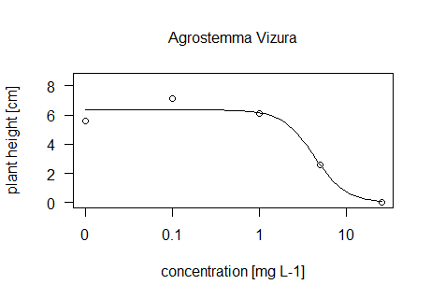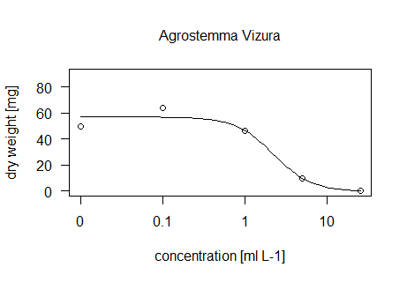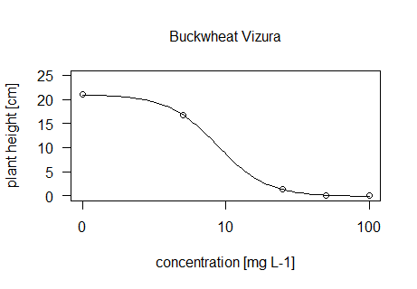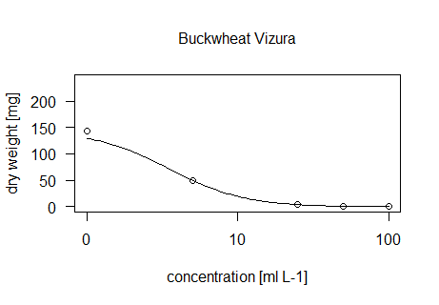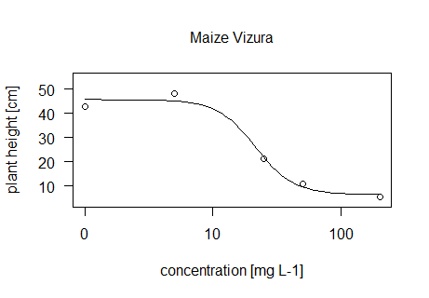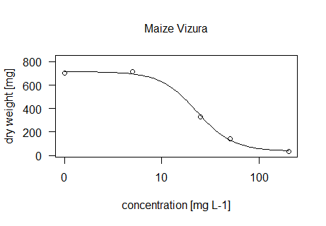

Figure S4: Inhibition of plant height (left) and dry weight (right) of different plant species exposed to different concentrations of Vizura: a) Agrostemma githago, b) Fagopyrum esculentum, c) Zea mays. The regression curves were modelled using a log logistic function with four parameters (n=3)