Title:
1α, 25-dihydroxy Vitamin D3 containing fractions of Catharanthus roseus leaf aqueous extract inhibit preadipocyte differentiation and induce lipolysis in 3T3-L1 cells
Author information:
Anuj Kumar Borah, Archana Singh, Rafika Yasmin, Robin Doley, Venkata Satish Kumar Mattaparthi, and Sougata Saha*.
* Correspondence: sougata.saha@bt.nitdgp.ac.in, sougatasaha2009@gmail.com
----------------------------------------------------------------------------------------------------------------

Supplementary Material

Table S1. Phytochemical analysis of CRACE.
Test Name | Test For | CRACE
Foam test | Saponins | +ve
Phosphomolybdic Acid test | Phenolic | +ve
Ferric chloride test | Phenolic | +ve
NaOH test | Flavonoids | +ve
Shinoda test | Flavonoids | -ve
Zn-HCl test | Flavonoids | -ve
Braemer’s test | Tannins | +ve
Salkowski test | Steroids | -ve
Fehling test | Reducing Sugars | +ve
Iodine test | Non-reducing sugars | -ve
Bradford test | Proteins | +ve
Total phenolic content/ mg of extract CRACE | 54.6 µg equivalent of Gallic acid
Total flavonoid content/ mg of extract CRACE | 26.5 µg equivalent of Quercetin
Total tannin content /mg of extract CRACE | 392.619 µg equivalent of Tannic acid

Table S2. Primer sequences.
Primer | Primer sequence 5’-3’ | Gene Sequence ID | Amplicon Size (bp)
PPARγ1 F | TCACGTTCTGACAGGACT | NM_001127330.2 | 283
PPARγ1 R | CCATTGGGTCAGCTCTTGTG
PPARγ2 F | GCACTGCCTATGAGCACTTC | NM_011146.3 | 211
PPARγ2 R | CCATTGGGTCAGCTCTTGTG
C/EBP β F | CAAGCTGAGCGACGAGTACA | NM_009883.4 | 157
C/EBP β R | CAGCTGCTCCACCTTCTTCT
C/EBP δ F | CGCAGACAGTGGTGAGCTTG | NM_007679.4 | 193
C/EBP δ F | CTTGCGCACAGCGATGTTGTT
C/EBP α F | GTGGACAAGAACAGCAACGAG | NM-007678.3 | 223
C/EBP α R | TGACCAAGGAGCTCTCAG
FABP4 F | CCCAACATGATCATCAGCGTAAA | NM_024406.2 | 193
FABP4 R | TCGACTTTCCATCCCACTTCT
PLN.1 F | GGCCAAAGAGACAGCAGAATATG | NM_175640.2 | 237
PLN.1 R | GTTTGCATGGTGTGTCGAGAA
GLUT4 F | CCAGTATGTTGCGGATGCTATG | AB008453.1 | 213
GLUT4 R | TCATTCTCATCTGGCCCTAAGT
LPL F | GGCCCAGCAACATTATCCAG | NM008509 | 224
LPL R | ACTCAAAGTTAGGCCCAGCT
ATGL F | ATCCCTCCTTCAACCTGGTG | AY731699 | 224
ATGL R | GAGGGTAGGAGGAATGAGGC
HSL F | AGGACAGGACAGCAAGGTAC | NM_010719 | 169
HSL R | GTTCTTGAGGTAGGGCTCGT
FAS F | TCTGTGCCCGTCGTCTATAC | NM-007988 | 187
FAS R | GGAGGTATGCTCGCTTCTCT
LIPIN 1 F | ACAACAGCAGCTCCTCTACT | NM_172950.3 | 268
LIPIN 1 R | CGTGCTCTTCATCACTGGAG
GPD F | ACTGAGATCATCAACACTCA | NM_010271.2 | 214
GPD R | CCCCCTTAATAAGAGATATG
G0S2 F | TAGTGAAGCTATACGTGCTG | NM_008059.3 | 157
G0S2 R | AGGGACTGCTGTTCACAC
ABHD5 F | GGGTTAAGTCTAGTGCAGCG | NM_026179.2 | 233
ABHD5 R | GATCGGGCTCCAAAGATCAC
ACLY F | TGGTCTATTCAATTTCTACG | NM_001199296.1 | 155
ACLY R | GAACTCTATATCACCCCACT
KLF5 F | ACTGGCCTCTACAAATCCCA | NM_009769.4 | 298
KLF5 R | TCGAACTGGGCATGTCTAGA
KLF7 F | CAGTGACCTCATTAACGCCG | AF338369.1 | 244
KLF7 R | TTTTCAGGGCATGTGTCAGC
GATA3 F | GAGGTGACTGCGGACCAG | NM_008091.3 | 234
GATA3 R | GTGGTGGGTCGGAGGATAC
GATA2 F | ATGTCCAGCAAATCCAAGAAGAG | NM-008090.5 | 161
GATA2 R | AGGATGTGTCCAGAGTGACTAAA
Adiponectin F | AAGGACAAGGCCGTTCTCT | NM_009605.5 | 219
Adiponectin R | TATGGGTAGTTGCAGTCAGTTGG
AdPLA2 F | AAAGAACTGCTGTGCCATGT | BC024581.1 | 207
AdPLA2 R | GACCTGATCACTCCGAGGAA
GAPDH F | CGACTTCAACAGCAACTCCCACTCTTCC | GU214026.1 | 174
GAPDH R | TGGGTGGTCCAGGGTTTCTTACTCCTT
N.B. For designing of primer against PPAR γ1 PPAR γ2 and GAPDH complete mRNA sequences of the respective transcripts were used. For rest of the genes being assayed CDS of corresponding gene was utilized to design the primers.

Supplementary figures:

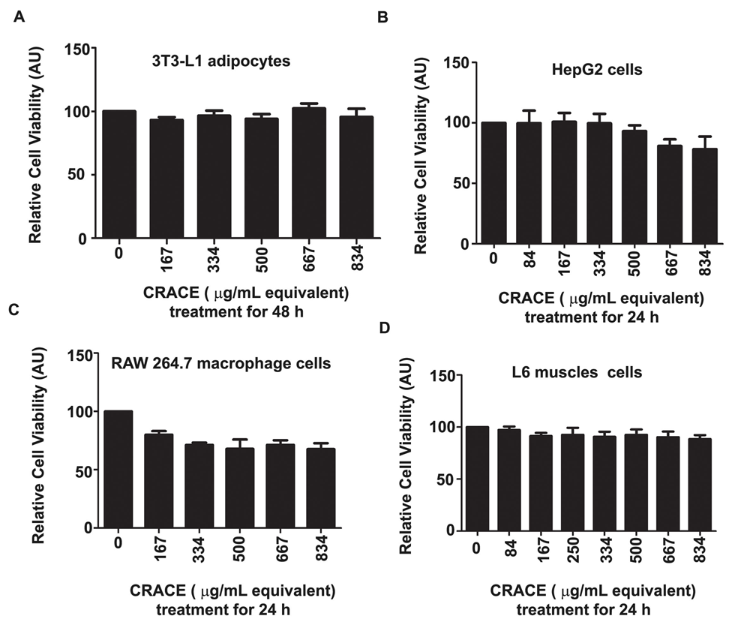

Figure S1. CRACE was non-cytotoxic to a number of tested cells at tested doses. A. CRACE was non-toxic to mature 3T3-L1 adipocytes at tested dose of 167 µg/ml to 834 µg/ml equivalents during 48 h treatment. B. CRACE did not affect cell survivability of cultured HepG2 hepatocytes. CRACE exposure of mentioned doses for 24h did no harm the hepatocytes. C. 24h CRACE treatment at tested doses was non-cytotoxic to RAW 264.7 macrophages. D. CRACE at tested doses was non-cytotoxic to L6 rat muscle cells. All cytotoxicity results were from MTT assay. Values in the bar diagram are mean ± SEM, n = 3.

