ADDITIONAL INFORMATION

Additional file 1. Immunophenotypic characterization of BM-MSC and WJ-MSC. Boxes represent median and 5-95 percentiles. N=3 for each cell type.
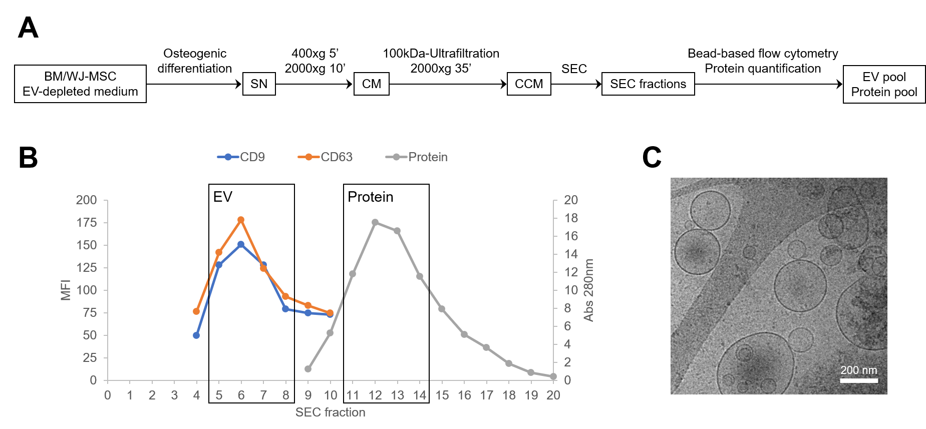
Additional file 2. EV and protein fractions isolation and characterization. (A) Scheme of the methodological procedure followed for EV and protein isolation from BM-MSC and WJ-MSC conditioned media. CCM, concentrated conditioned media; CM, conditioned media; EV, extracellular vesicles; SEC, size exclusion chromatography; SN, cell culture supernatant. (B) Example of representative elution profile obtained for CD9 and CD63 EV markers quantification by bead-based flow cytometry (left axis) and for protein elution monitoring by absorption at 280 nm (right axis) in the different SEC fractions. MFI, mean fluorescence intensity. (C) Cryo-EM images confirming EVs presence in pooled EV fractions. Scale bar: 200 nm.

