Additional file 1

Table S1. Sequences of siCD90 and shCD90
siCD90-1 | Sense: CGAAUCCCAUGAGCUCCAAdTdT
 | Anti-sense: UUGGAGCUCAUGGGAUUCGdTdT
siCD90-2 | Sense: GCCAUGAGAAUAACACCAAdTdT
 | Anti-sense: UUGGUGUUAUUCUCAUGGCdTdT
siControl | Sense: UUCUCCGAACGUGUCACGUTT
 | Anti-sense: ACGUGACACGUUCGGAGAATT
shCD90 (GenePharma) | CGAAUCCCAUGAGCUCCAA
shControl (GenePharma) | TTCTCCGAACGTGTCACGT
shCD90 (Genechem) | CGAATCCCATGAGCTCCAA
shControl (Genechem) | TTCTCCGAACGTGTCACGT

Table S2. Primer pairs used in qPCR
Nanog | Sense: CGGTGGCAGAAAAACCAGTG
 | Anti-sense: AAGGCTTCCAGATGCGTTCA
Sox2 | Sense: GGCAAGGCAGAGAAGAGAGTG
 | Anti-sense: TCTGGCGGAGAATAGTTGGG
Oct4 | Sense: TGATCCTCGAACCTGGCTA
 | Anti-sense: CTCAGGCTGCAAAGTCTCC
CD90 | Sense: TGCTCTCAGTCTTGCAGGTG
 | Anti-sense: TGGATGGAGTTATCCTTGGTGTT
C/EBPα | Sense: TTGAAGCACAATCGATCCATCC
 | Anti-sense: GCACACTGCCATTGCACAAG
Adiponectin | Sense: CCTGTTCCTCTTAATCCTGCCCA
 | Anti-sense: ATCTCCTTTCTCTCCCTTCTCTCCA
PPAR-γ | Sense: GGAGCCTAAGTTTGAGTTTGCTGTG
 | Anti-sense: TGCAGCAGGTTGTCTTGGATG
αP2 | Sense: GTGGGATGGAAAGTCGACCA
 | Anti-sense: ATCCAGGCCTCTTCCTTTGG
Leptin | Sense:TCAAGCAGTGCCTATCCAGAAAGTC
 | Anti-sense:GGGTGAAGCCCAGGAATGAAGTC
GAPDH | Sense: GTGTTTCCTCGTCCCGTAGA
 | Anti-sense: ATGAAGGGGTCGTTGATGGC
18S rRNA | Sense: GCCTGAGAAACGGCTACCACAT
 | Anti-sense: CCGCTCCCAAGATCCAACTACG

Figure S1. Inhibitory effect of CD90 silencing on AKT activation. S-ADSCs were transfected with siCD90 or siControl for 24 h, and stimulated with insulin (100nM) for different time periods. Protein levels of p-AKT, AKT were detected by western blot.
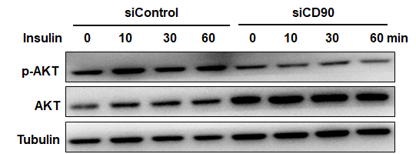

Figure S2. Infection of S-ADSCs with GFP-tagged shControl or shCD90 lentivirus. S-ADSCs were infected with GFP-tagged shControl or shCD90 lentivirus (GenePharma). The infection efficiency was determined by GFP signals under fluorescence microscope. BF, bright field. Scale bar = 100μm.
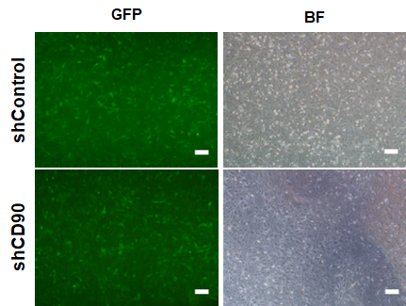

Figure S3. Influence of shCD90 lentivirus on WAT weight. GFP-tagged shControl or shCD90 lentivirus (Genechem) was injected into bilateral inguinal fat pads (7.0×10⁶ TU per point, 3 points per fat pad) of male mice at the age of 8 weeks, respectively. WAT weight was measured after 4 weeks of treatment.
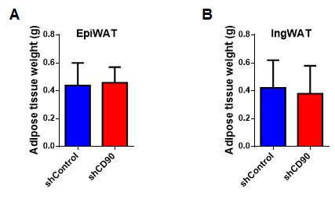

Figure S4. Expression of CyclinD1 and Leptin in WAT. A-C The expression of CD90 (A), CyclinD1 (B) and Leptin (C) in inguinal, axillary SAT and epididymal, mesenteric VAT from mice fed on normal diet (GSE53307). D,E The expression of CyclinD1 (D) and Leptin (E) in adipocytes and SVCs of epididymal VAT from mice fed on short-term of normal or high-fat diet (GSE65557). F The expression of CyclinD1 in SAT and omental VAT from obese patients (GSE20950).

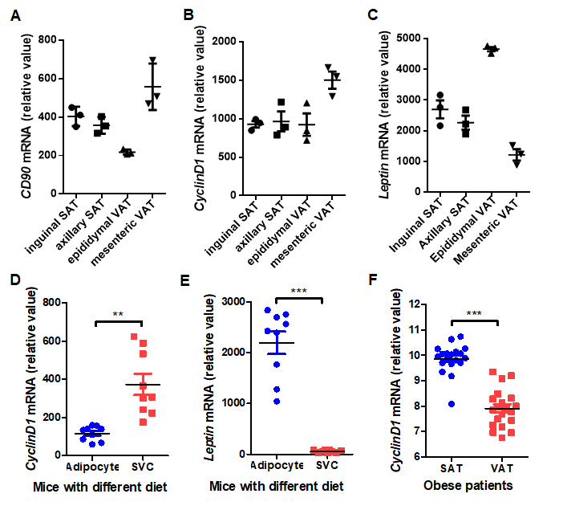

Figure S5. Contribution of CD90 overexpression to AKT activation in ADSCs. A CD90-Flag (Genechem) were overexpressed on ADSCs from human omental adipose tissue by lentiviral infection, protein levels of CD90-Flag, p-AKT, AKT and CyclinD1 were detected by western blot. Anti-Flag Ab was used to detect the expression of CD90-Flag. B ADSCs overexpressing CD90-Flag were incubated with MK2206 (2μM) for 16 h, protein levels of CD90-Flag, p-AKT, AKT and CyclinD1 were detected by western blot.
