Supplementary Data
Materials and Methods

Cells and reagents
Dulbecco’s Modified Eagle Medium (DMEM) (Fisher Scientific, PA, USA) was supplemented with 10% fetal bovine serum (FBS) (Gemini Bio-Products, CA, USA), 1% non-essential amino-acids, 1% sodium pyruvate, 1% streptomycin and 1% L-glutamine (Gemini Bio-Products, CA, USA) and used as the complete medium for cultures of the rat dental pulp and gingival cells. DMEM complete medium supplemented with Na-β-glycerophosphate (10mM) and ascorbic acid (50 µg/ml) (Sigma Aldrich, St. Louis, MO) was used for the cultures of the dental pulp stromal/stem cells (DPSCs). Oral squamous cell carcinoma (OSCCs) were dissociated and grown from the tongue tumors of patients at UCLA [1], and were cultured with RPMI 1640 media 10% FBS, 1.4% sodium pyruvate, 1,4% non-essential amino acids, 1% antibiotic-antimycotic.

Isolation and cultures of dental pulp stromal cells
The extracted dental pulp tissues from control and bleaching and/or NAC groups were treated with 0.1% collagenase II (Sigma Aldrich, MO) and 0.25% trypsin EDTA (1mM) (Invitrogen, CA) at 37°C for 60 minutes to obtain single cell suspensions of the pulp cells. Cells were then washed twice using DMEM complete media and re-suspended in complete medium (DMEM supplemented with 10% FBS, 1% antibiotic-antimycotic, 1% non-essential amino acids, 1% Na pyruvate). Dental pulp stromal cells were then cultured with ascorbic acid (50 μg/ml) and Na-β-glycerophosphate (10 mM) (Sigma Aldrich, MO) with or without dexamethasone (10⁻⁸M) [2] to induce differentiation as indicated in the result section. The cells were then cultured at 37°C in 5% CO₂, and they were passaged and used in the experiments at 80-90 % confluency.

Isolation and culture of rat palatal gingival cells
8-week old male Sprague-Dawley rats were divided into 3 groups. The palatal tissues were used to test the effects of bleaching agents on soft tissues immediately after euthanasia. The palatal gingival tissues were washed with saline before the bleaching agent was applied. Control group did not receive any treatments, and the bleaching agents were applied to the palatal tissues of rats. In bleaching agent + NAC group, NAC was applied to the palatal tissues of rats before they were washed and bleached. After 4 hours of treatments the palatal tissues were rinsed with sterile saline, excised and minced and were dissociated using 0.1% collagenase II (Sigma Aldrich, MO) and 0.25% trypsin EDTA (1mM) (Invitrogen, CA) at 37°C for 60 minutes to obtain single cell suspensions. The palatal cells were cultured in DMEM complete medium supplemented with 200 U/ml of collagenase II (Sigma Aldrich, MO). The cells were incubated for about 48 hours without agitation at 37°C. After 48 hours the supernatants were collected, centrifuged and the cells were cultured in DMEM complete medium.

Alkaline Phosphatase (ALP) staining
DPSCs were washed twice with PBS and incubated with 120 mM of Tris buffer (pH = 8.4) containing 0.9 mM Napthol AS-M Phosphate and 1.8 mM Fast Red TR (both purchased from Sigma, MO) at 37˚C. After 30 mins incubation, cells were washed three times with PBS and then fixed with 1 ml of cold ethanol (100%) for 30 minutes. The wells containing the stained cells were scanned using an Epson scanner 1250.

Figure Legends
Figure S1: NAC protects DPSCs and OSCCs from cell death induced by different concentrations of bleaching agents containing hydrogen peroxide.
DPSCs obtained from human teeth were cultured (0.2 million/ml) overnight in 12 well plates, before they were treated with different concentrations of bleaching agents containing hydrogen peroxide as shown in the figure in the presence and absence of NAC (20mM) for 24 hours. Afterwards DPSCs were detached and their viability was determined using propidium iodide (PI) staining followed by flow cytometric analysis. One of 3 representative experiments is shown in this figure (A). Oral squamous carcinoma cells (OSCCs) as representative cells for oral epithelial cells were cultured (0.2 million/ml) in 12 well plates overnight before they were treated with different concentrations of bleaching agents containing hydrogen peroxide as shown in the figure in the presence of NAC-S (20mM) and NAC-N (20mM) for 24 hours. Afterwards OSCCs were detached, and the viability of cells was determined after PI staining followed by flow cytometric analysis. One of 3 representative experiments is shown in this figure (B).

Figure S2: NAC protects DPSCs from growth inhibition after bleaching in rats.
8-week old male rats (n=9) were divided into three groups; No bleaching agent- control (left panel) (n=3), bleaching agent only (middle panel) (n=3) and bleaching agent with NAC (20 mM) (right panel) (n=3) were applied. Two hours after applying the bleaching agent, the teeth were extensively washed with sterilized saline, extracted, cracked, and the pulp tissue were extracted, washed with PBS, and DPSCs were isolated as described in the Materials and Methods section. DPSCs from each group were cultured in media with a combination of Na-β-glycerophosphate (10 mM) and ascorbic acid (50 μg/ml) for 4 weeks after which photographs were taken using an inverted microscope (Mag. 20X) (A). Rat DPSCs were prepared as described in Fig. S2A. DPSCs were cultured for five weeks, after which they were trypsinized, and the cell numbers were determined for each group by microscopic analysis (B). Rat DPSCs were prepared as described in Fig. S2A. DPSCs were cultured for five weeks, after which they were stained with Alkaline Phosphatase staining as described in Material and Method section (C).

Figure S3: NAC protects the gingival cells from undergoing cell death in the presence of bleaching agents in rats.
8-week old male rats (n=9) were divided into three groups; No bleaching agent- control (left panel) (n=3), bleaching agent only (middle panel) (n=3) and bleaching agent with NAC (right panel) (n=3) were applied. Four hours after application, the palatal tissue was extensively washed with sterilized saline, and the tissues were removed surgically and treated with 0.25% trypsin-EDTA and 0.1% collagenase to prepare single cell suspensions as described in the Materials and Methods section. The single cells obtained were then cultured in DMEM complete media for 5 weeks after which photographs were taken using an inverted microscope (Mag. 20X) (A). Rat palatal cells were prepared as described in Fig. S3A, after which they were trypsinized, and the cell numbers were determined for each group using microscopy (B).

Figure S4: NAC protects DPSCs from the growth inhibition by the over-the-counter bleaching strips in rats.
8-weeks old male rats (n=6) were divided into two groups; No bleaching agent- control (left panel) (n=3), and bleaching agent only (right panel) (n=3) were applied. 9 hours after applying the bleaching strips, the teeth were washed extensively with sterilized saline, cracked, and the pulp tissues were extracted, and DPSCs were isolated as described in the Materials and Methods section. DPSCs from each group were cultured in DMEM complete media with a combination of Na-β-glycerophosphate (10 mM) and ascorbic acid (50 μg/ml) for 4 weeks after which photographs were taken using an inverted microscope (Mag. 20X) (A). Rat DPSCs were prepared as described in Fig. S4A, after which they were cultured for five weeks before they were stained, and the levels of Alkaline Phosphatase staining were determined in each group (B).

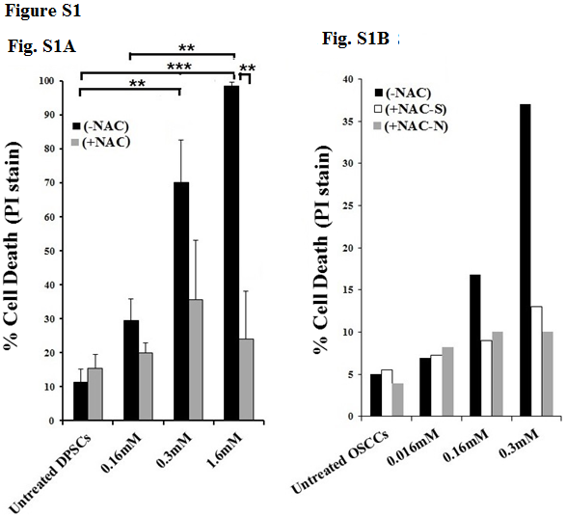

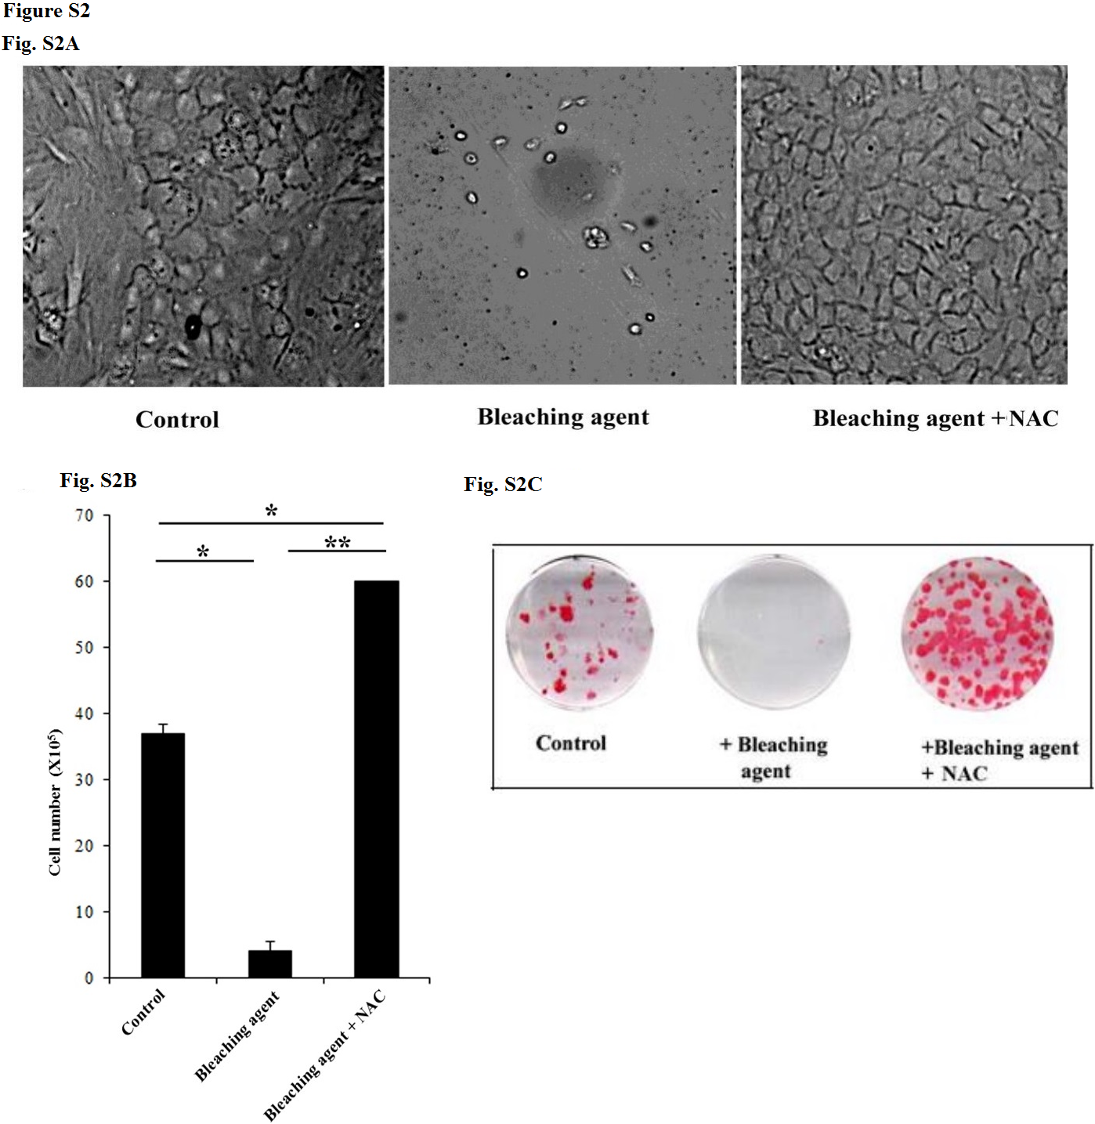

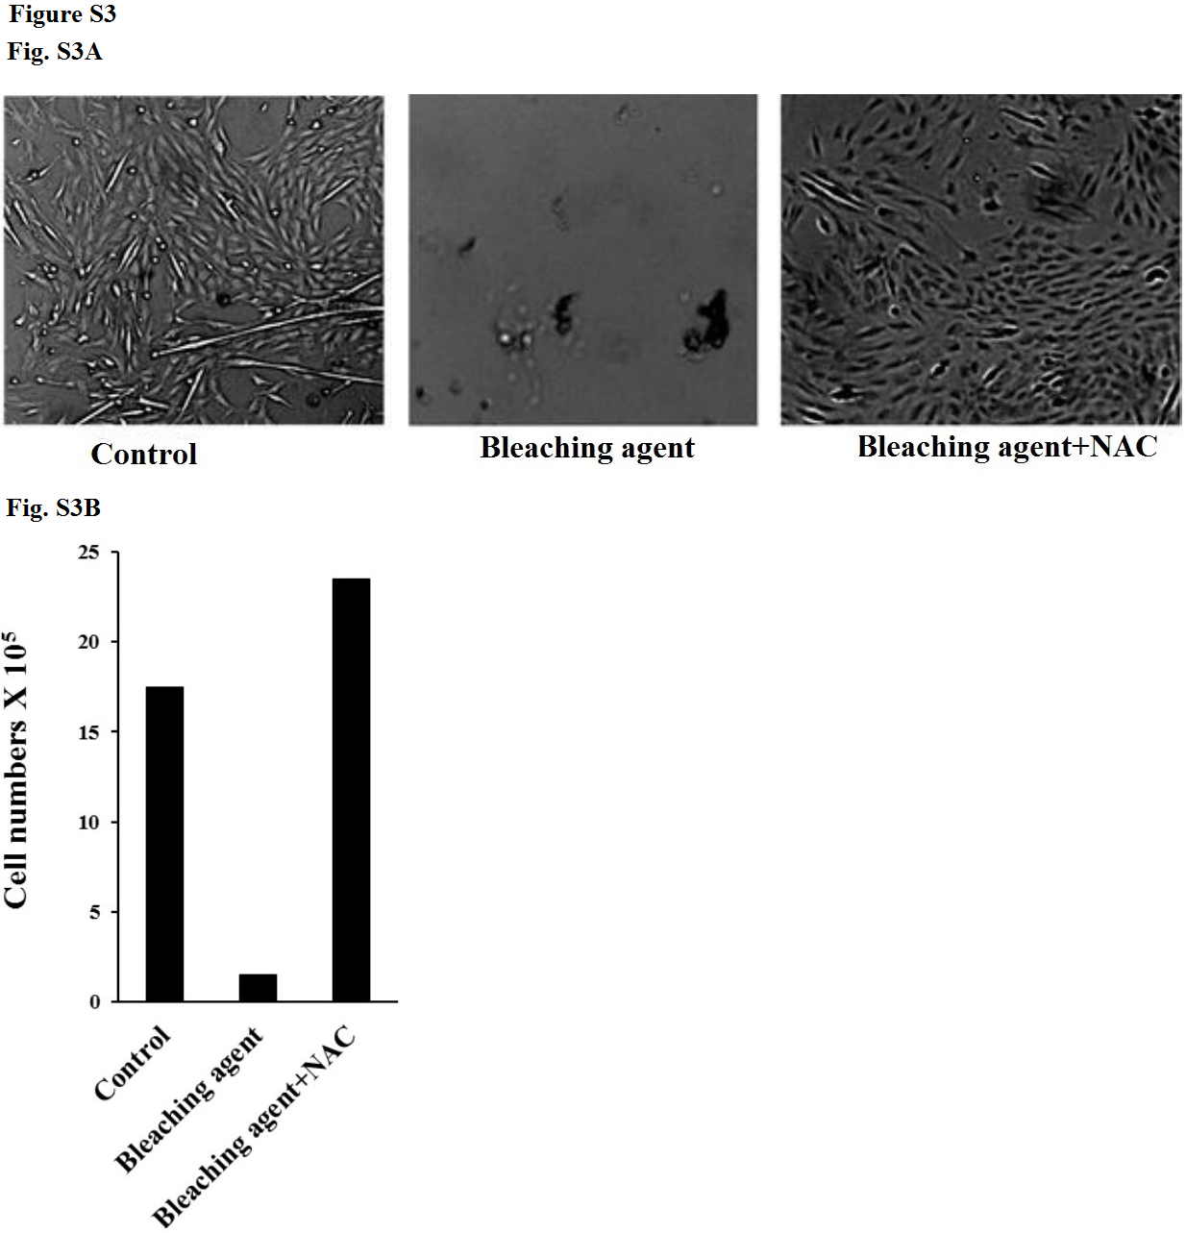

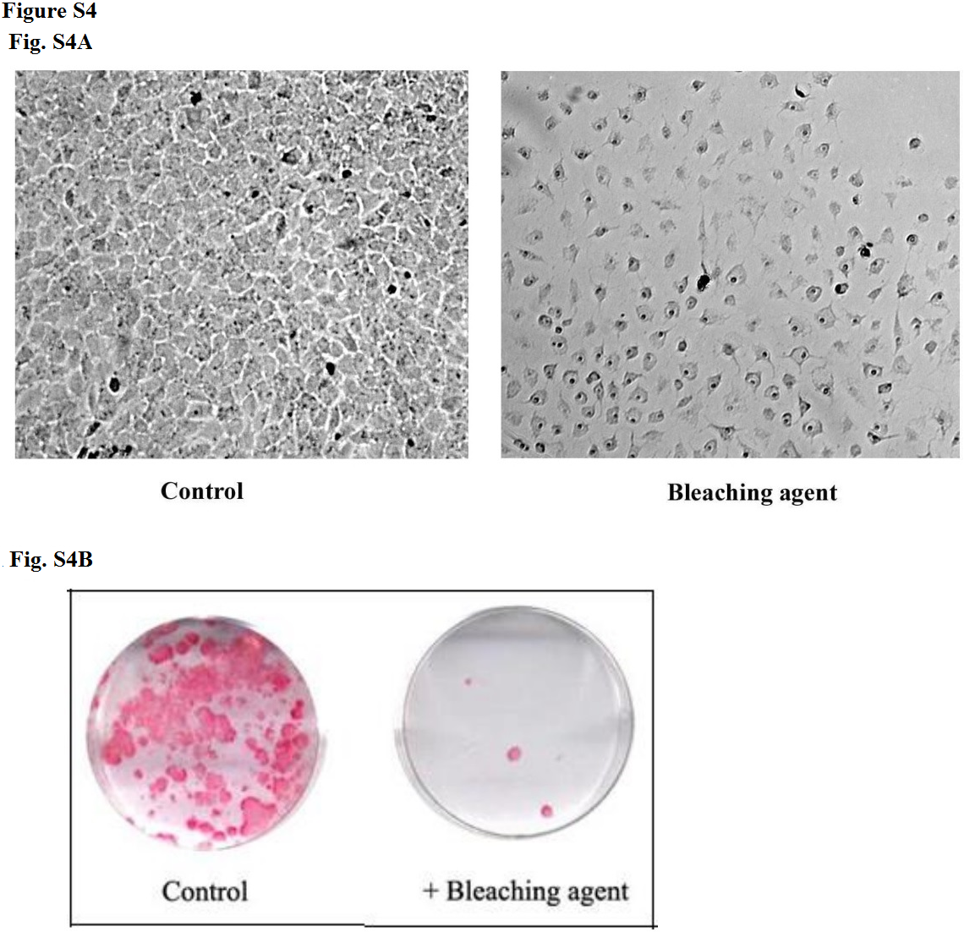

References

1. Tseng, H.C., et al., Increased lysis of stem cells but not their differentiated cells by natural killer cells; de-differentiation or reprogramming activates NK cells. PLoS One, 2010. 5(7): p. e11590.
2. Nakamura, H., et al., Molecular and biomechanical characterization of mineralized tissue by dental pulp cells on titanium. J Dent Res, 2005. 84(6): p. 515-20.

