Embase: 2327
('cardiopulmonary bypass'/exp OR 'systemic pulmonary shunt'/exp OR 'cardiopulmonary bypass':ab,ti OR 'heart-lung bypass':ab,ti OR 'heart lung bypass':ab,ti OR 'heart-lung bypasses':ab,ti OR 'cardiopulmonary bypasses':ab,ti OR fontan:ab,ti OR 'mitral valve':ab,ti OR 'cardiac surgery':ab,ti OR 'lung transplantation'/exp OR 'lung transplantation':ab,ti OR 'lung grafting':ab,ti OR 'heart surgery'/exp) AND ('nitric oxide'/exp OR 'nitric oxide':ab,ti) AND ('randomized controlled trial'/exp OR 'controlled clinical trial'/exp OR randomized:ti,ab OR placebo:ti,ab OR 'drug therapy':lnk OR randomly:ti,ab OR trial:ti,ab OR groups:ti,ab)

Pubmed: 535
("Cardiopulmonary Bypass"[Mesh] OR Cardiopulmonary Bypass[tw] OR Heart-Lung Bypass[tiab] OR Heart Lung Bypass[tiab] OR Heart-Lung Bypasses[tiab] OR Cardiopulmonary Bypasses[tiab] OR "Lung Transplantation"[Mesh] OR Lung Transplantation*[tiab] OR Lung Grafting*[tiab] OR Fontan [tiab] OR “mitral valve”[tiab] OR “cardiac surgery”[tiab]) AND ("Nitric Oxide"[Mesh] OR "Nitric Oxide"[tiab]) AND ("randomized controlled trial"[pt] OR "controlled clinical trial"[pt] OR randomized[tiab] OR placebo[tiab] OR "drug therapy"[sh] OR randomly[tiab] OR trial[tiab] OR groups[tiab])

Web of science: 2344
('cardiopulmonary bypass' OR 'systemic pulmonary shunt' OR 'cardiopulmonary bypass' OR 'heart-lung bypass' OR 'heart lung bypass' OR 'heart-lung bypasses' OR 'cardiopulmonary bypasses' OR fontan OR 'mitral valve' OR 'cardiac surgery' OR 'lung transplantation' OR 'lung transplantation' OR 'lung grafting') AND ('nitric oxide' OR 'nitric oxide') AND ('randomized controlled trial' OR 'controlled clinical trial' OR randomized OR placebo OR 'drug therapy':lnk OR randomly OR trial OR groups)

CENTRAL: 154
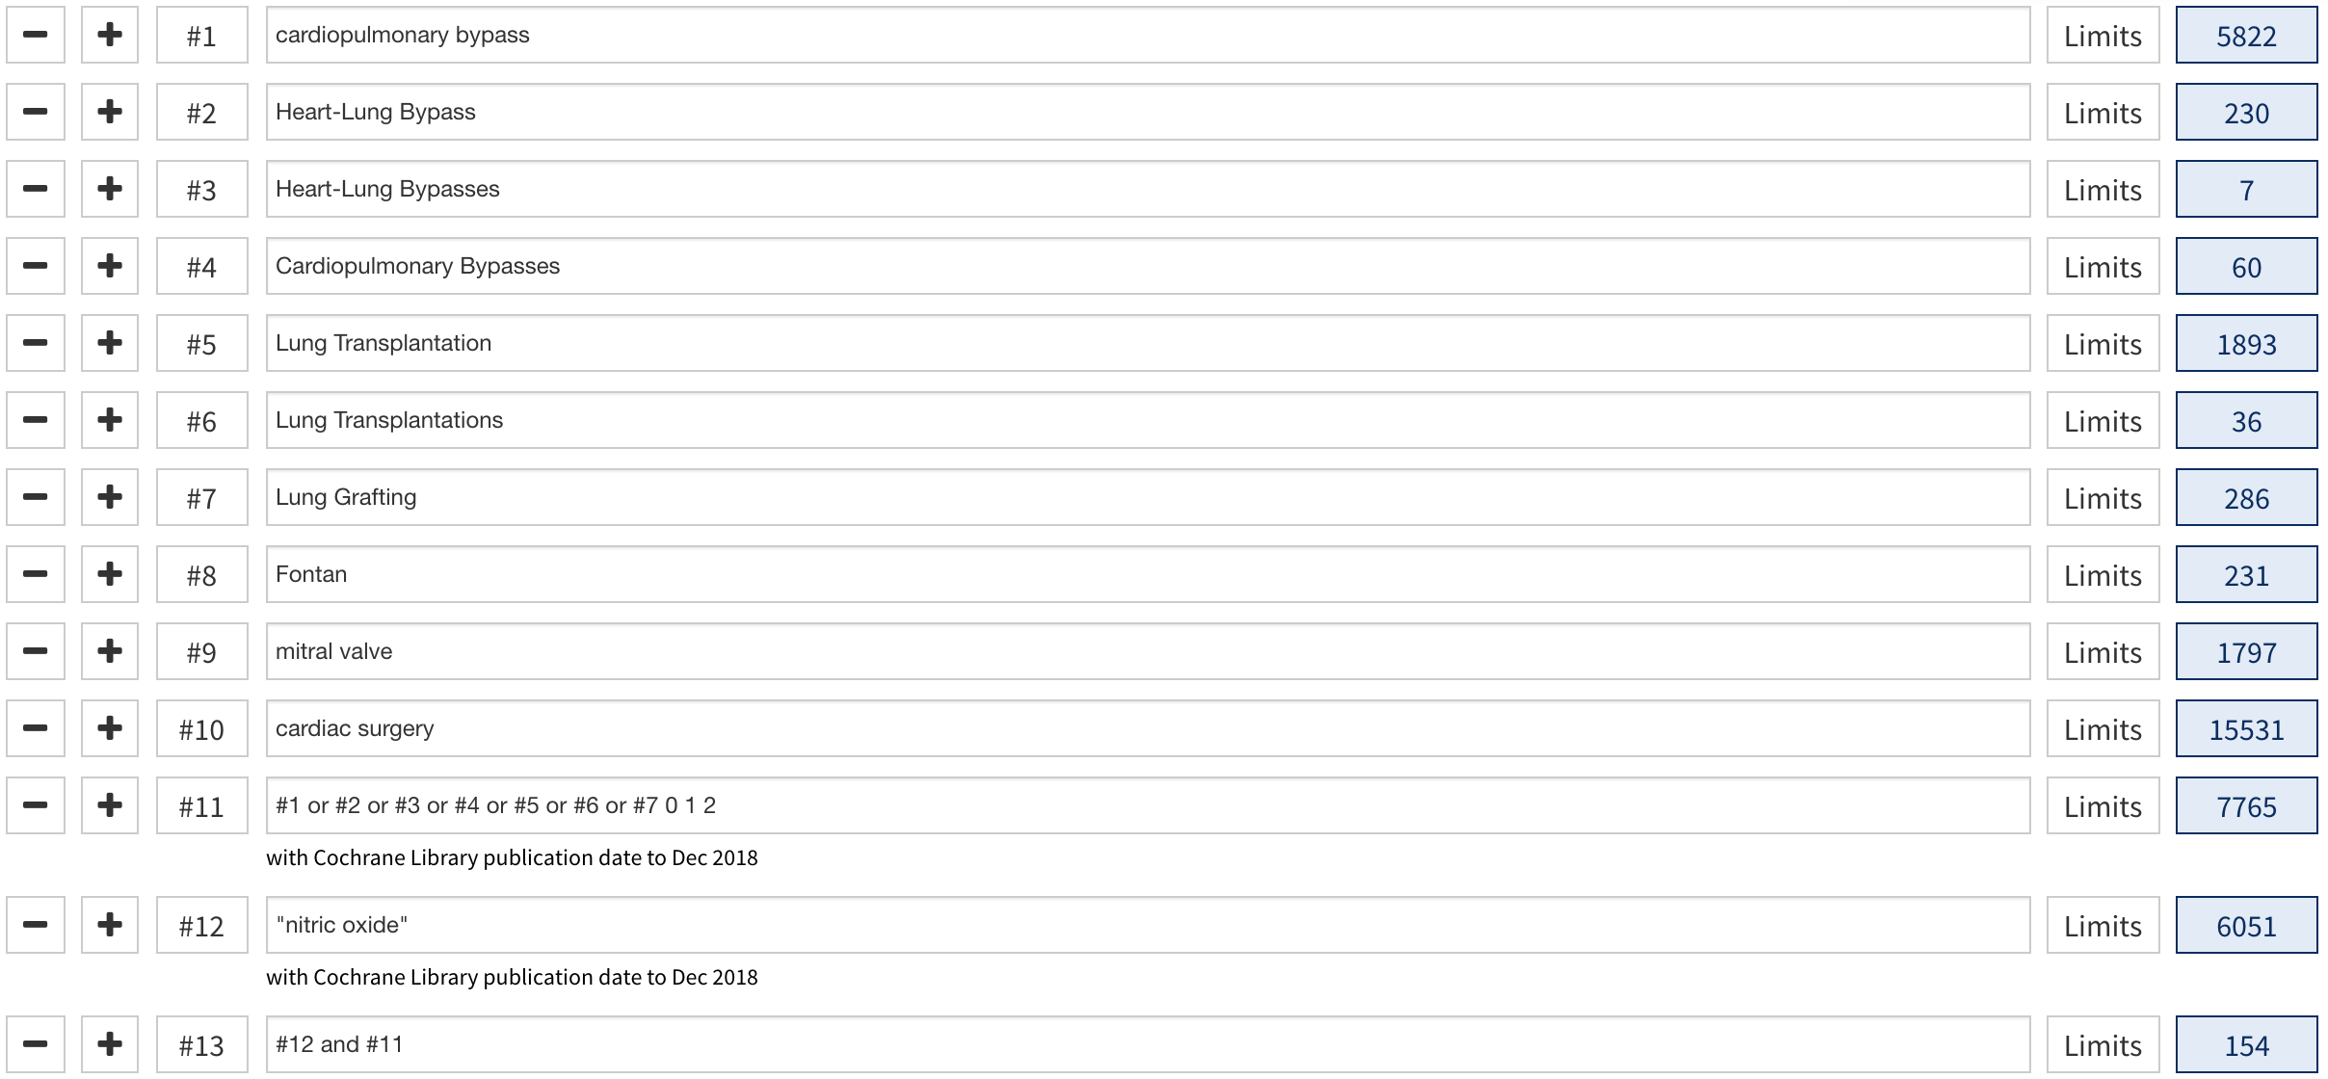
ClinicalTrial.gov: 16
Nitric oxide and cardiopulmonary bypass

